NUTRIENT SAMPLING IN PETRONILA CREEK
Final Report CBBEP Project No. 2433
August 2024


Prepared by:
Nueces River Authority
500 IH 69, Suite 805,
Robstown, TX 78380
(361) 653-2110

Courtney Taylor Jessica Wright
ctaylor@nueces-ra.org jwright@nueces-ra.org

Submitted to:


Coastal Bend Bays and Estuaries Program
1305 N Shoreline Blvd, Suite 205 Corpus Christi, Texas 78401

Table of Contents
List of Figures 3
Executive Summary 0
Introduction 2
Watershed Characteristics 5
Description 5
Climate 6
Locations 6
Hydrological 6
Meteorological data 7
Sample collection 7
Sample Analysis 7
Results 8
Precipitation 8
Streamflow 10
Water Quality Monitoring 11
Data Results for Nutrients 11
Conclusion 52
Ammonia 52
Nitrate-Nitrogen 52
Nitrite-Nitrogen 53
Dissolved Total Kjedahl Nitrogen (Dissolved TKN) 53
Total Kjedahl Nitrogen (TKN) 53
Total Phosphorus 53
Chlorophyll-a 54
Pheophytin 54
Recommendations 54
Appendix A: Photographs of Monitoring Stations 55
Station 21928 – Petronila Tributary @ FM 70 (Cefe #1) 55
Station 21929 – Petronila Tributary @ FM 70 (Cefe #2) 57
Station 13030 – Petronila Tributary @ FM 70 59
Station 13093 – Petronila Creek @ FM 70 61
Station 21596 – Petronila Tributary @ FM 892 63
Station 18642 – Petronila Tributary @ FM 892 65
Station 13094 – Petronila Creek @ FM 892 66
Station 21931 – Petronila Tributary @ FM 3354 67
Station 13095 - Petronila Creek @ CR 232 69
Station 13032 – Petronila Tributary @ CR 18 & CR 75 71
Station 13096 – Petronila Creek @ FM 665 72
Station 18484 – Petronila Tributary @ CR 24 74
Station 21594 – Petronila Tributary @ CR 233 76
Appendix B: Wastewater Discharge Permits 78

List of Figures
Figure 1. Station 21598 along Petronila Creek 1
Figure 2. TCEQ screening levels for nutrient parameters. 2
Figure 3. Cause and impacts of excess nutrient parameters. 3
Figure 4. Petronila Creek Watershed. 5
Figure 5. Map of sampling stations in Petronila Creek Above Tidal Segment 2204 6
Figure 6. Monthly rainfall totals for January 2020 through July 2024. 8
Figure 7. Drought status in September 2021 9
Figure 8. Drought status in August 2022 9
Figure 9. Drought status in July 2023 9
Figure 10. Drought status in July 2024 9
Figure 11. Streamflow at Petronila Creek above Tidal 10
Figure 12. Station 13030 Ammonia results January 2020 – May 2024 12
Figure 13. Station 13032 Ammonia results January 2020 – May 2024 13
Figure 14. Station 13093 Ammonia results January 2020 – May 2024 14
Figure 15. Station 13094 Ammonia results January 2020 – May 2024 15
Figure 16. Station 13095 Ammonia results January 2020 – May 2024 16
Figure 17. Station 13096 Ammonia results January 2020 – May 2024 17
Figure 18. Station 18484 Ammonia results January 2020 – May 2024 18
Figure 19. Station 18642 Ammonia results January 2020 – May 2024 19
Figure 20. Station 21594 Ammonia results January 2020 – May 2024 20
Figure 21. Station 21596 Ammonia results January 2020 – May 2024 21
Figure 22. Station 21598 Ammonia results January 2020 – May 2024 22
Figure 23. Station 21929 Ammonia results January 2020 – May 2024 23
Figure 24. Station 21931 Ammonia results January 2020 – May 2024 24
Figure 25. Station 13030 Nitrate results January 2020 – May 2024 25
Figure 26. Station 13032 Nitrate results January 2020 – May 2024 26
Figure 27. Station 13093 Nitrate results January 2020 – May 2024 27
Figure 28. Station 13094 Nitrate results January 2020 – May 2024 28
Figure 29. Station 13095 Nitrate results January 2020 – May 2024 29
Figure 30. Station 13096 Nitrate results January 2020 – May 2024 30
Figure 31. Station 18484 Nitrate results January 2020 – May 2024 31
Figure 32. Station 18642 Nitrate results January 2020 – May 2024 32
Figure 33. Station 21594 Nitrate results January 2020 – May 2024 33
Figure 34. Station 21596 Nitrate results January 2020 – May 2024 34
Figure 35. Station 21598 Nitrate results January 2020 – May 2024 35
Figure 36. Station 21929 Nitrate results January 2020 – May 2024 36
Figure 37. Station 21931 Nitrate results January 2020 – May 2024 37
Figure 38. Station 13030 Nitrite results January 2020 – May 2024 38
Figure 39. Station 13032 Nitrite results January 2020 – May 2024 39
Figure 40. Station 13093 Nitrite results January 2020 – May 2024 40
Figure 41. Station 13094 Nitrite results January 2020 – May 2024 41
Figure 42. Station 13095 Nitrite results January 2020 – May 2024 42
Figure 43. Station 13096 Nitrite results January 2020 – May 2024 43
Figure 44. Station 18484 Nitrite results January 2020 – May 2024 44
Figure 45. Station 18642 Nitrite results January 2020 – May 2024 45
Figure 46. Station 21594 Nitrite results January 2020 – May 2024 46
Figure 47. Station 21596 Nitrite results January 2020 – May 2024 47
Figure 48. Station 21598 Nitrite results January 2020 – May 2024 48
Figure 49. Station 21929 Nitrite results January 2020 – May 2024 49
Figure 50. Station 21931 Nitrite results January 2020 – May 2024 50
Figure 51. Station 13030 DTKN & TKN results January 2020 – May 2024 51
Figure 52. Station 13032 DTKN & TKN results January 2020 – May 2024 52
Figure 53. Station 13093 DTKN & TKN results January 2020 – May 2024 53
Figure 54. Station 13094 DTKN & TKN results January 2020 – May 2024 54
Figure 55. Station 13095 DTKN & TKN results January 2020 – May 2024 55
Figure 56. Station 13096 DTKN & TKN results January 2020 – May 2024 56
Figure 57. Station 18484 DTKN & TKN results January 2020 – May 2024 57
Figure 58. Station 18642 DTKN & TKN results January 2020 – May 2024 58
Figure 59. Station 21594 DTKN & TKN results January 2020 – May 2024 59
Figure 60. Station 21596 DTKN & TKN results January 2020 – May 2024 60
Figure 61. Station 21598 DTKN & TKN results January 2020 – May 2024 61
Figure 62. Station 21929 DTKN & TKN results January 2020 – May 2024 62
Figure 63. Station 21931 DTKN & TKN results January 2020 – May 2024 63
Figure 64. Station 13030 Total Phosphorus results January 2020 – May 2024 64
Figure 65. Station 13032 Total Phosphorus results January 2020 – May 2024 65
Figure 66. Station 13093 Total Phosphorus results January 2020 – May 2024 66
Figure 67. Station 13094 Total Phosphorus results January 2020 – May 2024 67
Figure 68. Station 13095 Total Phosphorus results January 2020 – May 2024 68
Figure 69. Station 13096 Total Phosphorus results January 2020 – May 2024 69
Figure 70. Station 18484 Total Phosphorus results January 2020 – May 2024 70
Figure 71. Station 18642 Total Phosphorus results January 2020 – May 2024 71
Figure 72. Station 21594 Total Phosphorus results January 2020 – May 2024 72
Figure 73. Station 21596 Total Phosphorus results January 2020 – May 2024 73
Figure 74. Station 21598 Total Phosphorus results January 2020 – May 2024 74
Figure 75. Station 21929 Total Phosphorus results January 2020 – May 2024 75
Figure 76. Station 21931 Total Phosphorus results January 2020 – May 2024 76
Figure 77. Station 13030 Chlorophyll-a & Pheophytin results January 2020 – May 2024 77
Figure 78. Station 13032 Chlorophyll-a & Pheophytin results January 2020 – May 2024 78
Figure 79. Station 13093 Chlorophyll-a & Pheophytin results January 2020 – May 2024 79
Figure 80. Station 13094 Chlorophyll-a & Pheophytin results January 2020 – May 2024 80
Figure 81. Station 13095 Chlorophyll-a & Pheophytin results January 2020 – May 2024 81
Figure 82. Station 13096 Chlorophyll-a & Pheophytin results January 2020 – May 2024 82
Figure 83. Station 18484 Chlorophyll-a & Pheophytin results January 2020 – May 2024 83
Figure 84. Station 18642 Chlorophyll-a & Pheophytin results January 2020 – May 2024 84
Figure 85. Station 21594 Chlorophyll-a & Pheophytin results January 2020 – May 2024 85
Figure 86. Station 21596 Chlorophyll-a & Pheophytin results January 2020 – May 2024 86
Figure 87. Station 21598 Chlorophyll-a & Pheophytin results January 2020 – May 2024 87
Figure 88. Station 21929 Chlorophyll-a & Pheophytin results January 2020 – May 2024 88
Figure 89. Station 21931 Chlorophyll-a & Pheophytin results January 2020 – May 2024 89

Executive Summary

Petronila Creek Above Tidal is a 44-mile-long creek in coastal South Texas that flows from its headwaters in western Nueces County to the confluence of Tunas Creek in eastern Kleberg County. The tidal portion of the creek drains to Baffin Bay through Cayo Del Mazón and Alazan Bay, located on the northern portion of Baffin Bay. Petronila Creek Above Tidal is listed in the 2020 Texas Integrated Report for Surface Water Quality as having elevated levels of chloride, sulfate, total dissolved solids, bacteria (E. coli), and chlorophyll-a concentrations. The integrated report also lists the tidal portion of the creek as having excessive concentrations of bacteria (enterococcus) and chlorophyll-a. The receiving waterbody, Baffin Bay, is listed for excessive concentrations of chlorophyll-a. To determine the nutrient contributions of surface water entering Baffin Bay from Petronila Creek and its tributaries, three previous studies titled “Nutrient Sampling in Petronila Creek” were conducted prior to this study. CBBEP Project #2003 was conducted from January through December 2020 and CBBEP Project #2133 was conducted from February 2021 through July 2021. CBBEP #2233 was conducted from September 2021 through August 2022. CBBEP Project #2333 runs from September 2022 through August 2023. CBBEP #2433 was collected from September 2023 through August 2024. Water quality data for Project #2433 were collected monthly from September 2023 through August 2024 at 13 stations that are located throughout the southeastern portion of the watershed, east of US 77. Four surface water quality monitoring stations are located on the main stem of the creek and nine stations are located on the tributaries of the creek. All water monitoring occurred during low flow conditions. Flow rates at the main stem creek sites ranged between 0.5 ft³/s and 3.0 ft³/s and tributary stations ranged from <0.1 ft³/s to 0.2 ft³/s. Nutrient parameters analyzed for the study include ammonia, nitrate-nitrogen, nitrite-nitrogen, total phosphorus (TP), total kjeldahl nitrogen (TKN), dissolved kjeldahl nitrogen (DTKN), chlorophyll-a, and pheophytin. For this report (#2433), streamflow totals and nutrient concentrations from Projects #2003, #2133, #2233 and #2433 have been included in the data results graphs to show temporal variability from January 2020 through August 2024. Nutrient concentrations were highly variable throughout the study period. A seasonal bias for higher concentrations for ammonia, DTKN, TKN, and TP occurred in spring months. Nitrate-nitrogen showed a seasonal bias in spring and fall months. Chlorophyll-a, and pheophytin showed a seasonal bias toward higher concentrations in winter months.

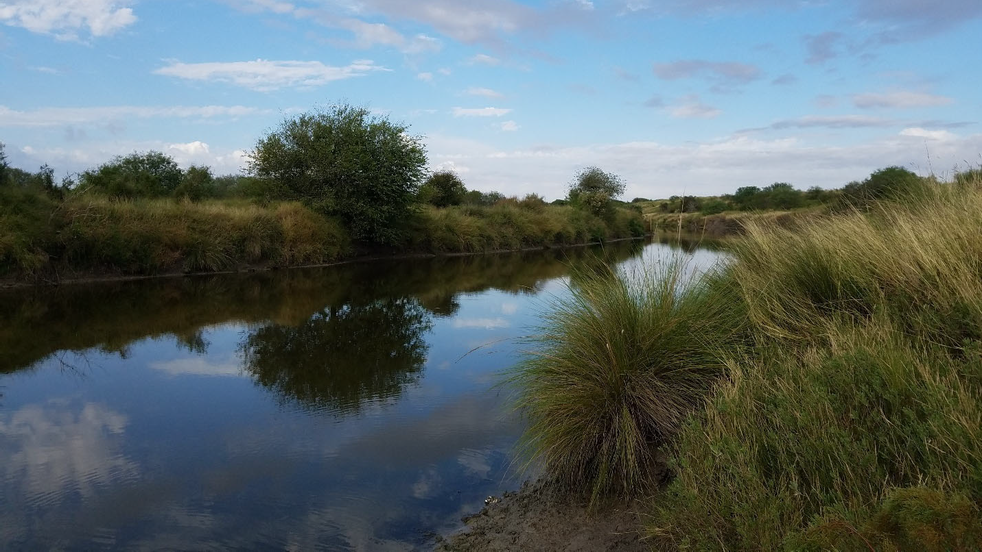
Figure 1. Station 21598 along Petronila Creek

Introduction
Petronila Creek is a tributary to Baffin Bay. Petronila creek feeds into the subsidiary Alazan Bay that extends northeast of Baffin Bay. The health of Baffin Bay has been of great concern to scientists and concerned citizens due to fish kills, water quality problems, and food web changes in the bay. The Baffin Bay Stakeholder Group, formed in 2012 , is composed of scientists from Harte Research Institute (HRI) at Texas A&M University-Corpus Christi, Coastal Bend Bays & Estuaries Program (CBBEP), USDA-NRCS, Texas State Soil & Water Conservation Board, Texas Water Resources Institute, Texas Commission on Environmental Quality (TCEQ), Texas Sea Grant, Texas General Land Office, NRA, and a host of concerned citizens, including commercial and recreational fishermen, ranchers, and business owners. The scientists at HRI have determined that the primary causes of the water quality concerns are due to excessive nutrients in the bay. The Petronila and San Fernando Creeks Watershed Protection Plan (WPP) was approved by EPA in December 2022, providing voluntary management measures to address bacteria impairments on both creeks. Many management measures identified in the WPP will also help reduce nutrient loading to the system.

The surface water quality monitoring in Texas is routinely conducted by the Texas Commission on Environmental Quality (TCEQ) and its Clean Rivers Program (CRP). The Texas Surface Water Quality Standards have established specific criteria designed to protect designated uses of bodies of water including aquatic life, water supply, and recreation. The criteria that TCEQ has used to evaluate the designated uses include temperature, pH, dissolved oxygen, dissolved minerals, bacteria, and toxic substances. However, TCEQ does not have numerical criteria for nutrients in their surface water quality standards. In Texas, nutrient controls have taken the form of narrative criteria, watershed rules, and anti-degradation considerations in permitting actions. TCEQ screens ammonia, nitrate nitrogen, total phosphorus, and chlorophyll (Chl) monitoring data as a preliminary indication of areas of possible concern (TCEQ). The following chart explains the potential causes and impacts when water quality screening levels for certain water quality parameters are not met.

Parameter | Nutrient Screening Levels  for Petronila Creek Above Tidal | Calculation Used for Concern
Ammonia-Nitrogen | 0.33 mg/l | 20% of samples are above the criteria
Nitrate | 1.95 mg/l
Total phosphorus | 0.69 mg/l
Chlorophyll-a | 14.1 µg/l
Figure 2. TCEQ screening levels for nutrient parameters.

Parameter | Cause | Impact
Ammonia | Ammonia is excreted by animals and is produced during the decomposition of plants and animals. It is an ingredient in many fertilizers and is also present in sewage, storm water runoff, certain industrial wastewaters, and runoff from animal feedlots. | Elevated levels of ammonia in the environment can adversely affect fish and invertebrate reproductive capacity and reduced growth of the young.
Nitrates & Total Phosphorus | Nutrients are found in effluent released from wastewater treatment plants (WWTP)s, fertilizers, and agricultural runoff carrying animal waste from farms and ranches. Soil erosion and runoff from farms, lawns, and gardens can add nutrients to the water. | These nutrients increase plant and algae growth. When plants and algae die, the bacteria that decompose them consume dissolved oxygen leaving less available for fish and other living aquatic life. High levels of nitrate and nitrites can produce Nitrite Toxicity, or “brown blood disease,” in fish. This disease reduces the ability of blood to transport oxygen throughout the body.
Chlorophyll-a | Modifications to the riparian zone, human activity that causes increases in organic matter, nutrients, bacteria, and over abundant algae in water. | Chlorophyll-a is the photosynthetic pigment found in all green plants, algae, and cyanobacteria. Elevated levels indicate abundant plant growth which could lead to reduced DO levels.
Figure 3. Cause and impacts of excess nutrient parameters.

Petronila Creek Tidal (TCEQ Segment 2203) is listed in the 2020 Texas Integrated Report for Surface Water Quality as being impaired for bacteria (enterococcus) and having a screening level concern for chlorophyll-a.

The designated uses for Petronila Creek Above Tidal (TCEQ Segment 2204) include primary contact recreation and intermediate aquatic life use. Segment 2204 is listed in TCEQs 2020 Texas Integrated Report for Surface Water Quality as being impaired for chloride, sulfate, total dissolved solids, and bacteria (E. coli). In response to the dissolved mineral impairments, a Total Maximum Daily Load (TMDL) project for TDS, sulfate, and chloride has been developed that includes increased water quality monitoring of the main stem and select tributary stations. The bacteria impairment will likely be analyzed through a standards-review process called a Recreation Use Attainability Analysis (RUAA) in the future. Segment 2204 also has screening level concerns for chlorophyll-a which indicates a possible degradation of water quality due to excessive nutrient loadings.

For the receiving water body, Baffin Bay (TCEQ Segment 2492), surface water quality monitoring by TCEQ has identified an exceedance to the screening level for chlorophyll-a (14.1 µg/l) since 2002. In the last decade, water quality issues resulting in the disruptions of food webs, low dissolved oxygen events, fish kills, and excessive growth of phytoplankton indicators including chlorophyll-a have led to an increase in concern and awareness from the public, academia, and governmental agencies. Scientists at the Harte Research Institute (HRI) at Texas A&M University – Corpus Christi (TAMU-CC) have determined that the primary causes of the water quality concern are due to excessive nutrients in the bay. Efforts to determine the source of nutrient enrichment have centered on the contributions of surface waters from three main tributaries: Petronila, San Fernando, and Los Olmos creeks, all of which have current quarterly water quality monitoring stations funded by TCEQ’s Clean Rivers Program.

To provide further clarity regarding nutrient inputs into the Baffin Bay system, this study presents twelve months of water quality data from thirteen stations. Four stations are located on the main stem and nine are located on the tributaries of the creek. Nutrients analyzed include ammonia, total kjeldahl nitrogen (TKN), dissolved total kjeldahl nitrogen (DTKN), total phosphate (TP), nitrate-nitrogen, nitrite-nitrogen, chlorophyll-a, and pheophytin.

Watershed Characteristics

Description
Petronila Creek Above Tidal (TCEQ Segment 2204) is a shallow creek (< 2.0 m depth) that flows 44 miles from the confluence of Aqua Dulce and Banquete creeks in Nueces County Laureles Ranch in Northern Kleberg County. The watershed area is 675 square miles. The receiving water bodies for Segment 2204 include Petronila Creek Tidal Segment (TCEQ Segment 2203), Cayo Del Mazón, Alazan Bay, and Baffin Bay (TCEQ Segment 2492). The study area is located east of US 77 in the southeastern portion of the watershed. Land use is dominated by cultivated cropland with cotton, corn and sorghum being the most common crops observed. The northwestern end of the watershed is a mixture of cultivated cropland, hay or pasture, shrub or scrub and mixed forest. There are nine regulated dischargers of effluent to Petronila Creek and/or the tributaries of the creek (See Appendix B).
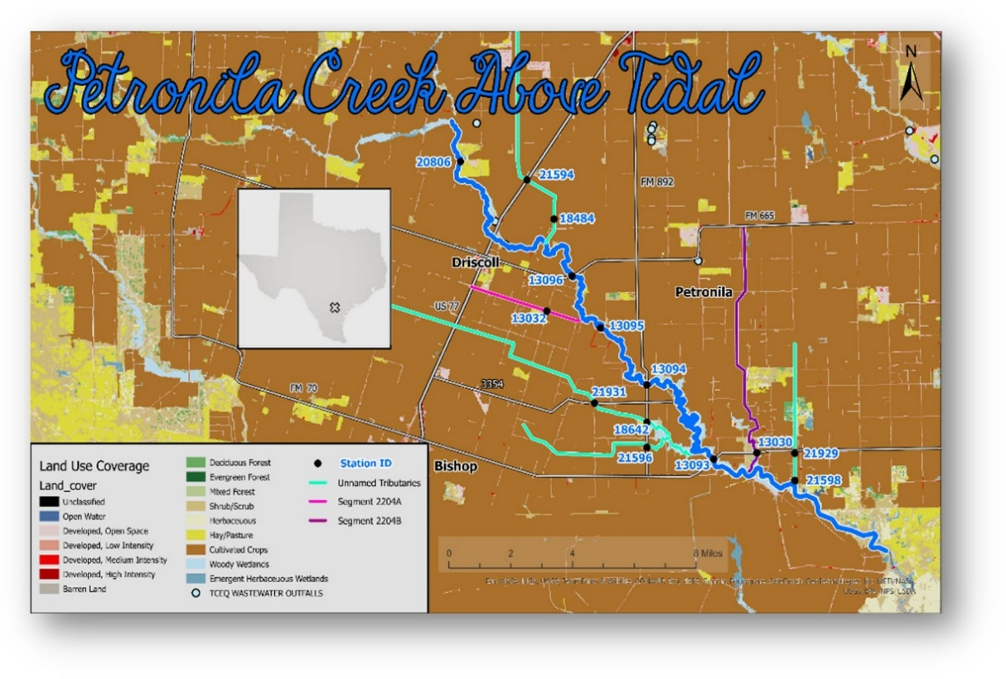
Figure 4. Petronila Creek Watershed.

Climate
The climate in the Petronila Creek Watershed is characterized as subtropical, humid, with hard winter freezes that are uncommon but sufficiently frequent to exclude tropical plant species. Rainfall is sparse throughout the year with an average precipitation of 31.7 inches per year.

Locations
Sampling site locations were identified based on the current sampling locations used in the Petronila Creek Above Tidal TMDL sampling project funded by TCEQ for chloride, sulfate, and total dissolved salts (TDS). There are six tributaries sampled for the project. Three of the tributaries have two sampling stations each including 21594 & 18484, 21931 & 18642, and 21929 & 21598. The other three tributaries (13030, 21596, and 13032) are monitored by a single sampling site. Four stations (13093, 13094, 13095, and 13096) are located on the main stem of the creek.

Hydrological
Streamflow is typically very low in the segment, often measuring between 0.5 and 3.0 ft3/s during dry weather on the main stem of the creek. Streamflow is measured by a USGS stream gauge located on FM 665. This location also serves Station 13096, the uppermost sampling location on the main stem of the creek. Station 13096 is also closest in proximity to the Driscoll WWTP (WQ0011541-001 – City of Driscoll: <100,000 gpd treated domestic wastewater via Petronila Creek). Streamflow at the tributary locations is estimated due to low flow conditions that are of insufficient depth (< 0.05 m) for the operation of a flow meter. A map of sampling stations is provided.
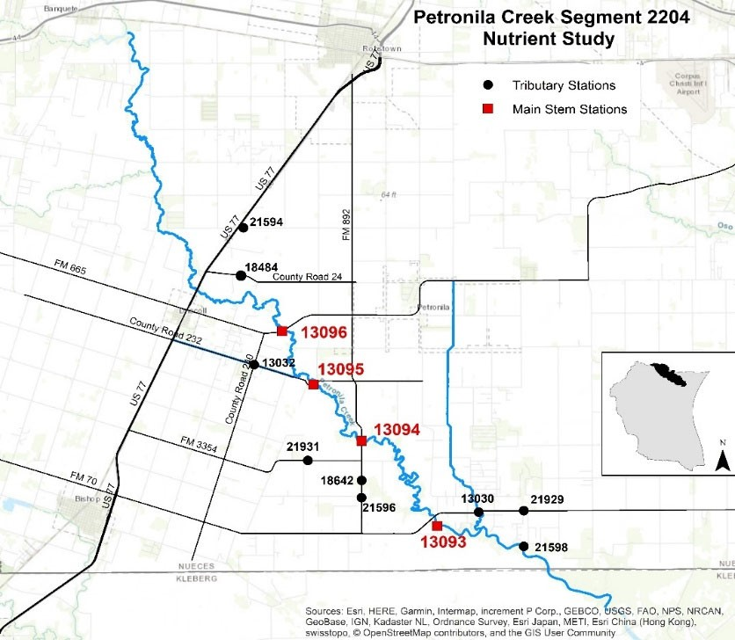
Figure 5. Map of sampling stations in Petronila Creek Above Tidal Segment 2204

Meteorological data
During monthly site visits at each station, NRA field staff recorded meteorological information including air temperature, wind direction, wind velocity and precipitation data including days since last precipitation, amount of precipitation in the past day and past seven days. Monthly precipitation data was provided by the National Weather Service (NWS) and National Oceanic and Atmospheric Administration (NOAA) using the link provided:
https://www.weather.gov/crp/monthlyrainfall

Sample collection
Surface water quality data including field and laboratory data were collected monthly from September 2023 through August 2024 at four sampling stations on the main stem of the creek and at nine sampling stations on the tributaries. At each sampling location, field data including water appearance/odor, water depth, water temperature, pH, dissolved oxygen and specific conductance were obtained using a Hydrolab MS5 datasonde following sampling guidelines found in TCEQs Surface Water Quality Manual Procedures (SWQM) Procedures, Volume 2 (RG-416).

The datasonde was calibrated before each sampling event and post calibrated immediately after returning from the field. Water samples were taken from the centroid of flow (point of maximum flow) at each station using a sample dipper that was pre-rinsed with site sample water. Many of the stations had accessibility issues which required sampling from the bridge top by lowering a 1-gallon bucket into the stream. During high flow, samples were taken from the bridge-top at all but one station (21958) where there was no bridge. During low flow conditions, all stations but one, had sampling depths less than 0.3 m which required a sampling depth of half the total depth. Station 13093 had water deep enough (1.6 m) to require a profile of datasonde readings at 0.3 m below the water surface, at mid depth, and at 0.3 m above the bottom of the water column. Surface water quality samples were collected, preserved with acid when applicable and stored on ice and delivered to the laboratories that afternoon for analysis.

Sample Analysis
Surface water samples were collected and analyzed for nutrient components by two laboratories. Nutrient samples including ammonia, nitrate, nitrite, TKN, dissolved TKN and total phosphorus were analyzed by the City of Corpus Christi Water Utilities Lab (WUL). All analytes were analyzed by the WUL using National Environmental Laboratory Accreditation Program (NELAP) accredited methods. Chlorophyll-a and pheophytin samples were analyzed at the Texas A&M University-Corpus Christi’s Department of Physical and Environmental Science (PENS). NELAP accreditation for chlorophyll-a and pheophytin parameters are not required.

Results

Precipitation
Precipitation totals from January 2020 through July 2024 totaled approximately 100.06 inches according to NOAA estimates. For 2020, May had the highest rainfall total at approximately 5.03 inches. Then in 2021, the highest rainfall total was reported in May at approximately 11.46 inches. In 2022, August reported the highest rainfall at approximately 10.73 inches. April 2023 has the most rainfall at approximately 7.49inches. Then lastly in 2024 July had the precipitation coming in at 4.49 inches. Precipitation amounts in August 2024 were not used in this report due to the final sample collection in the month of August 2024.

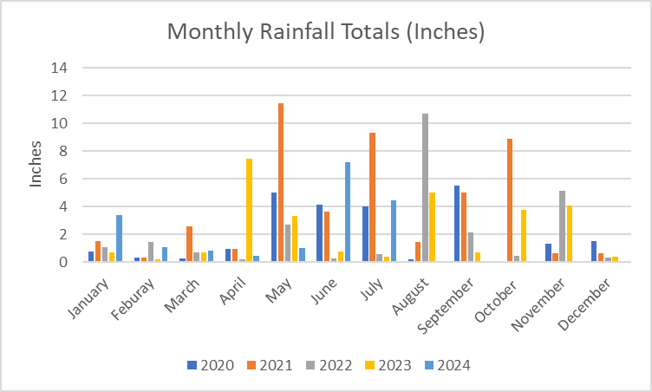
Figure 6. Monthly rainfall totals for January 2020 through July 2024.

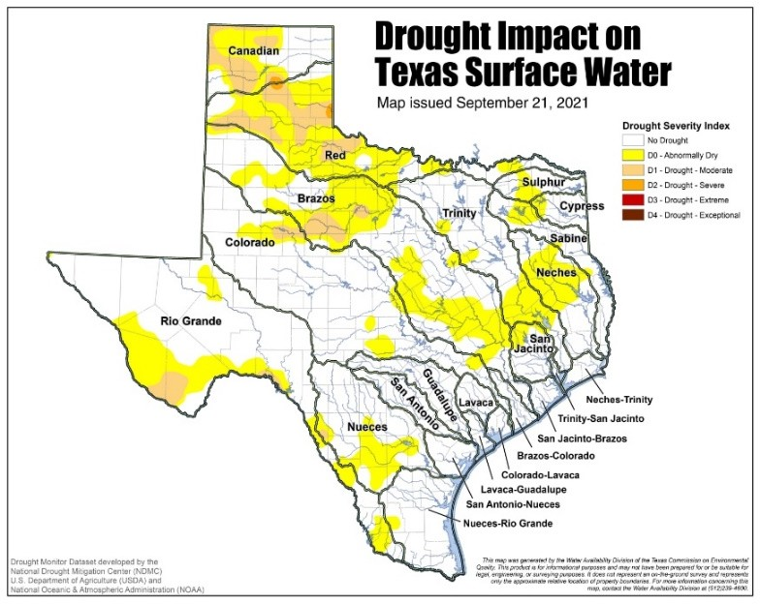
Figure 7. Drought status in September 2021

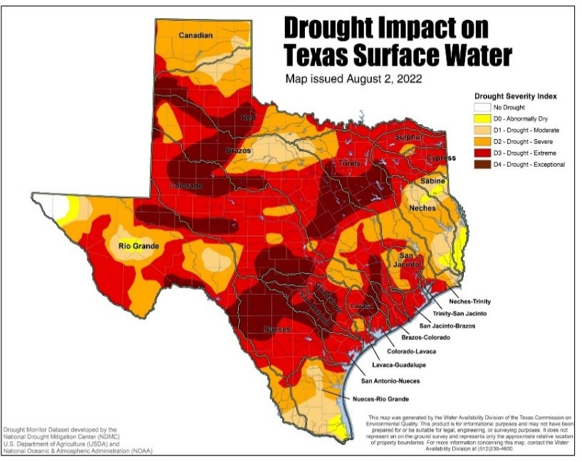
Figure 8. Drought status in August 2022
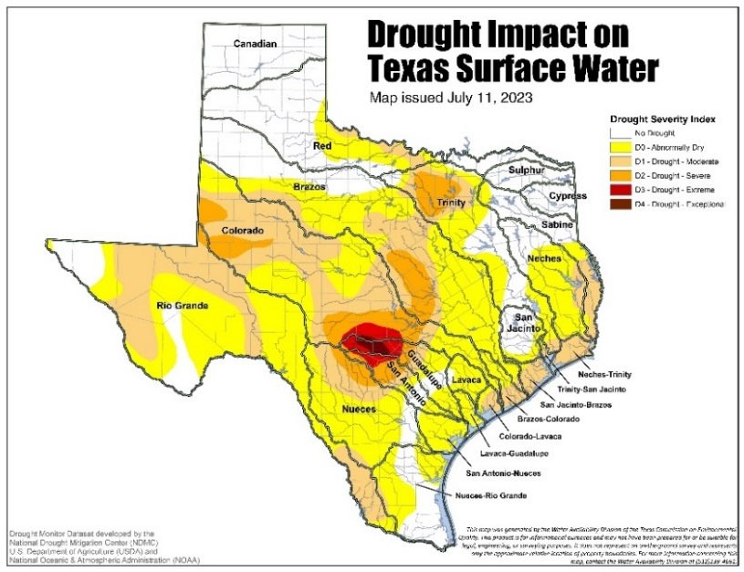
Figure 9. Drought status in July 2023

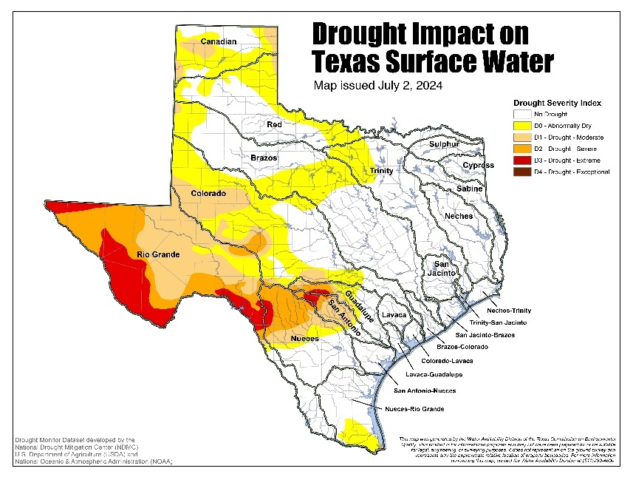
Figure 10. Drought status in July 2024

Streamflow
The Petronila Creek watershed experienced multiple precipitation events throughout the study period. In 2020, the highest precipitation event resulting in streamflow rates spiking to approximately 316 ft³ per second in late June. During 2021, there were quite a few heavy precipitation events occurring between late May and early July. The highest stream flow for 2021 occurred during early July resulting in stream flow rate spiking to approximately 1,980 ft³ per second. For 2022, the highest precipitation event occurred during Early November resulting in streamflow spiking to approximately 858 ft³ per second. In 2023, the highest flow shown was in late April, early May and it had a flow rate of approximately 1450 ft³ per second. So far in 2024, there has been a few rain even the highest being in June that showed the Flow at approximately 600 ft³ per second.

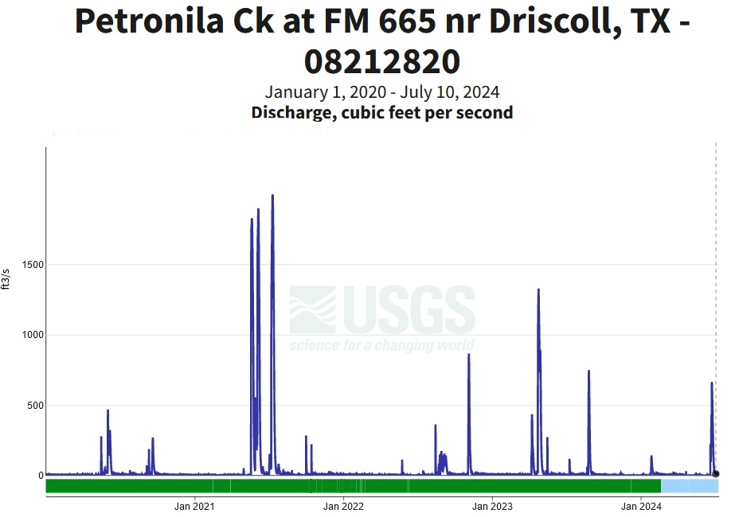
Figure 11. Streamflow at Petronila Creek above Tidal

Water Quality Monitoring
Monitoring data for Project #2433 occurred from September 2023 and ended on August 1, 2024. Precipitation and streamflow data from August 2024 are not used in this report. All sampling occurred under base flow conditions with none being conducted during high flow events up until June 2024. Three sites recorded a high flow rate during that month, stations 13093, 13095, and 13094. These high flow stations are located on the Petronila Creek while the other sites that recorded low flow are located on the tributaries to Petronila. Over the duration of sampling station 21931 has been consistently dry during this study only having discharge during high flow events. Throughout the sampling study seven sampling stations would go between dry/non flowing and flowing events. Those stations are 21929, 13030, 21956, 18642, 21931, 13032, and 21594.

During the time August 2022 through December 2023 no sampling events occurred due to an issue with the contracted lab’s ability to conduct the analyses for ammonia and total phosphorus to meet ambient water reporting limits and QAPP requirements. The lab initially ran samples using a non-QAPP approved method to obtain results and then worked with the project team to utilize a sub-contract lab thereafter. Adherence letters were received by the sub-contracted lab, certifying knowledge of the project requirements as set by the approved QAPP, for total phosphorus (on March 12th, 2024) and ammonia (May 8th, 2024). This resulted in gaps in data collection while the project team worked with the lab and QA personnel to identify solutions. A different lab has been identified for future analysis and the project team is working to finalize a QAPP amendment and corrective action reports accordingly.

Data Results for Nutrients

Please note that ammonia and total phosphorus analysis data was not requested for this project starting in March 2024. For example, Station 13030 has no data from March through May 2024 due to this project not requesting analysis due to City of Corpus Christi lab instrument updating and changeover. Some sample sites (i.e. main stem locations at Stations 13094 and 13096) have data for ammonia and total phosphorus after this date due to another project also being input into SWQMIS database being included here.

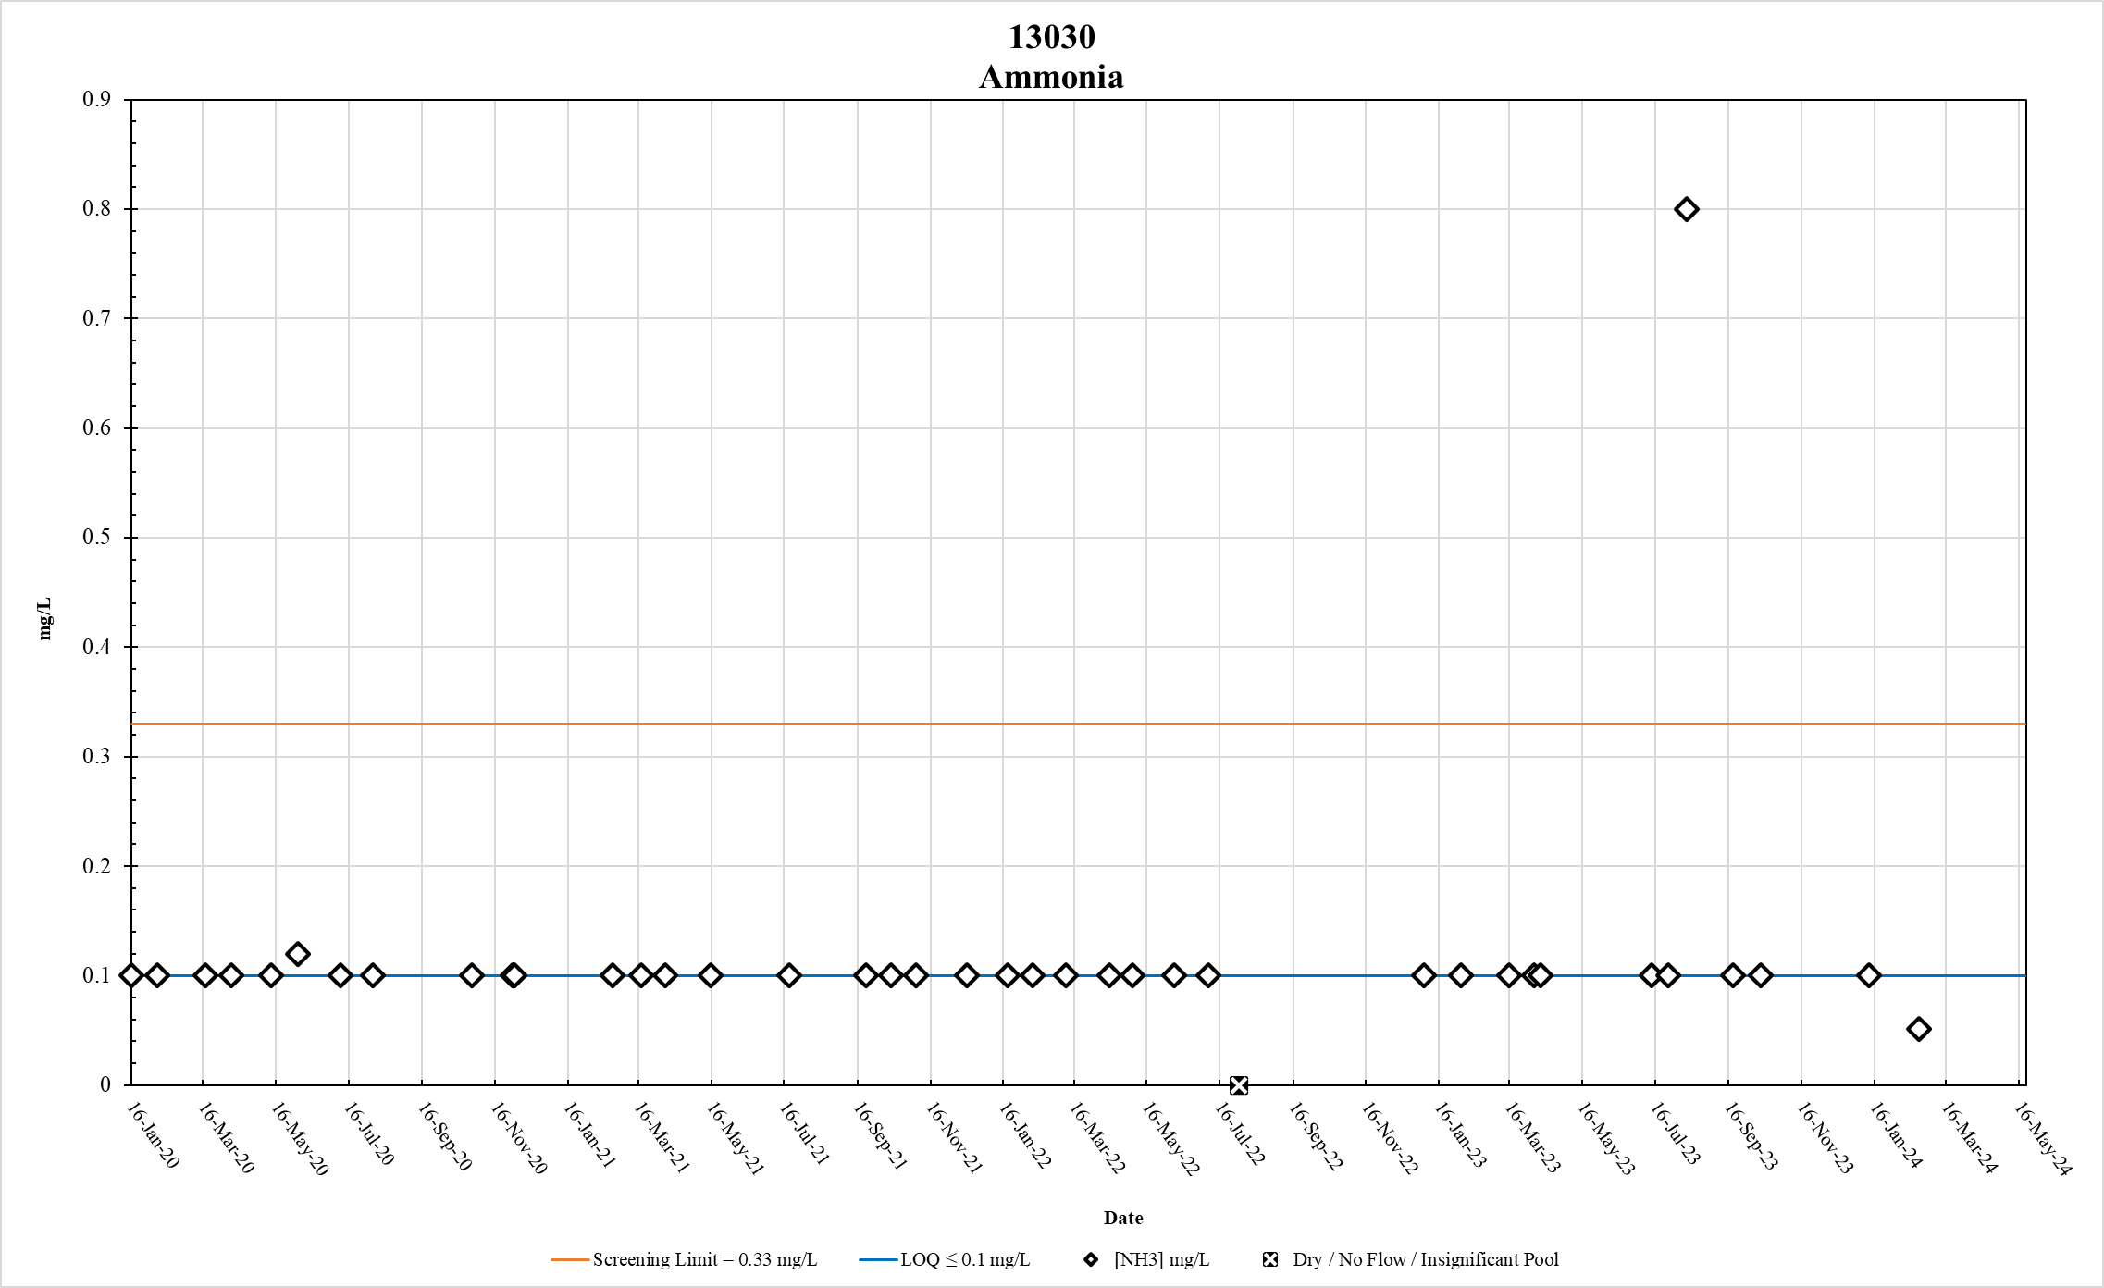
Figure 12. Station 13030 Ammonia results January 2020 – May 2024

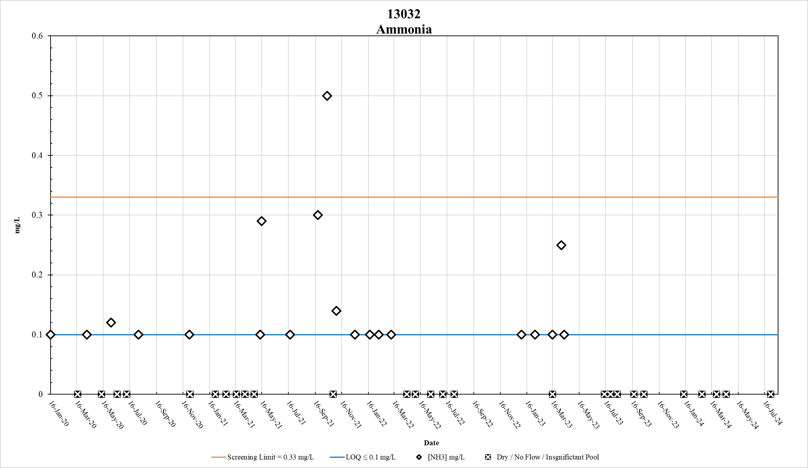
Figure 13. Station 13032 Ammonia results January 2020 – May 2024

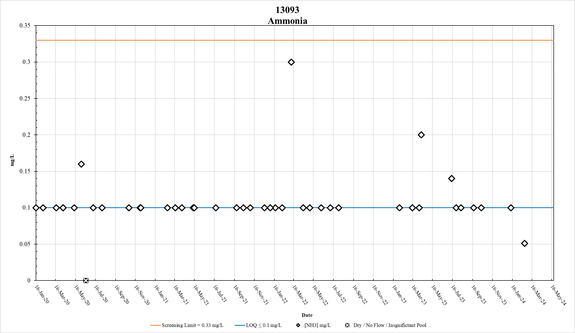
Figure 14. Station 13093 Ammonia results January 2020 – May 2024

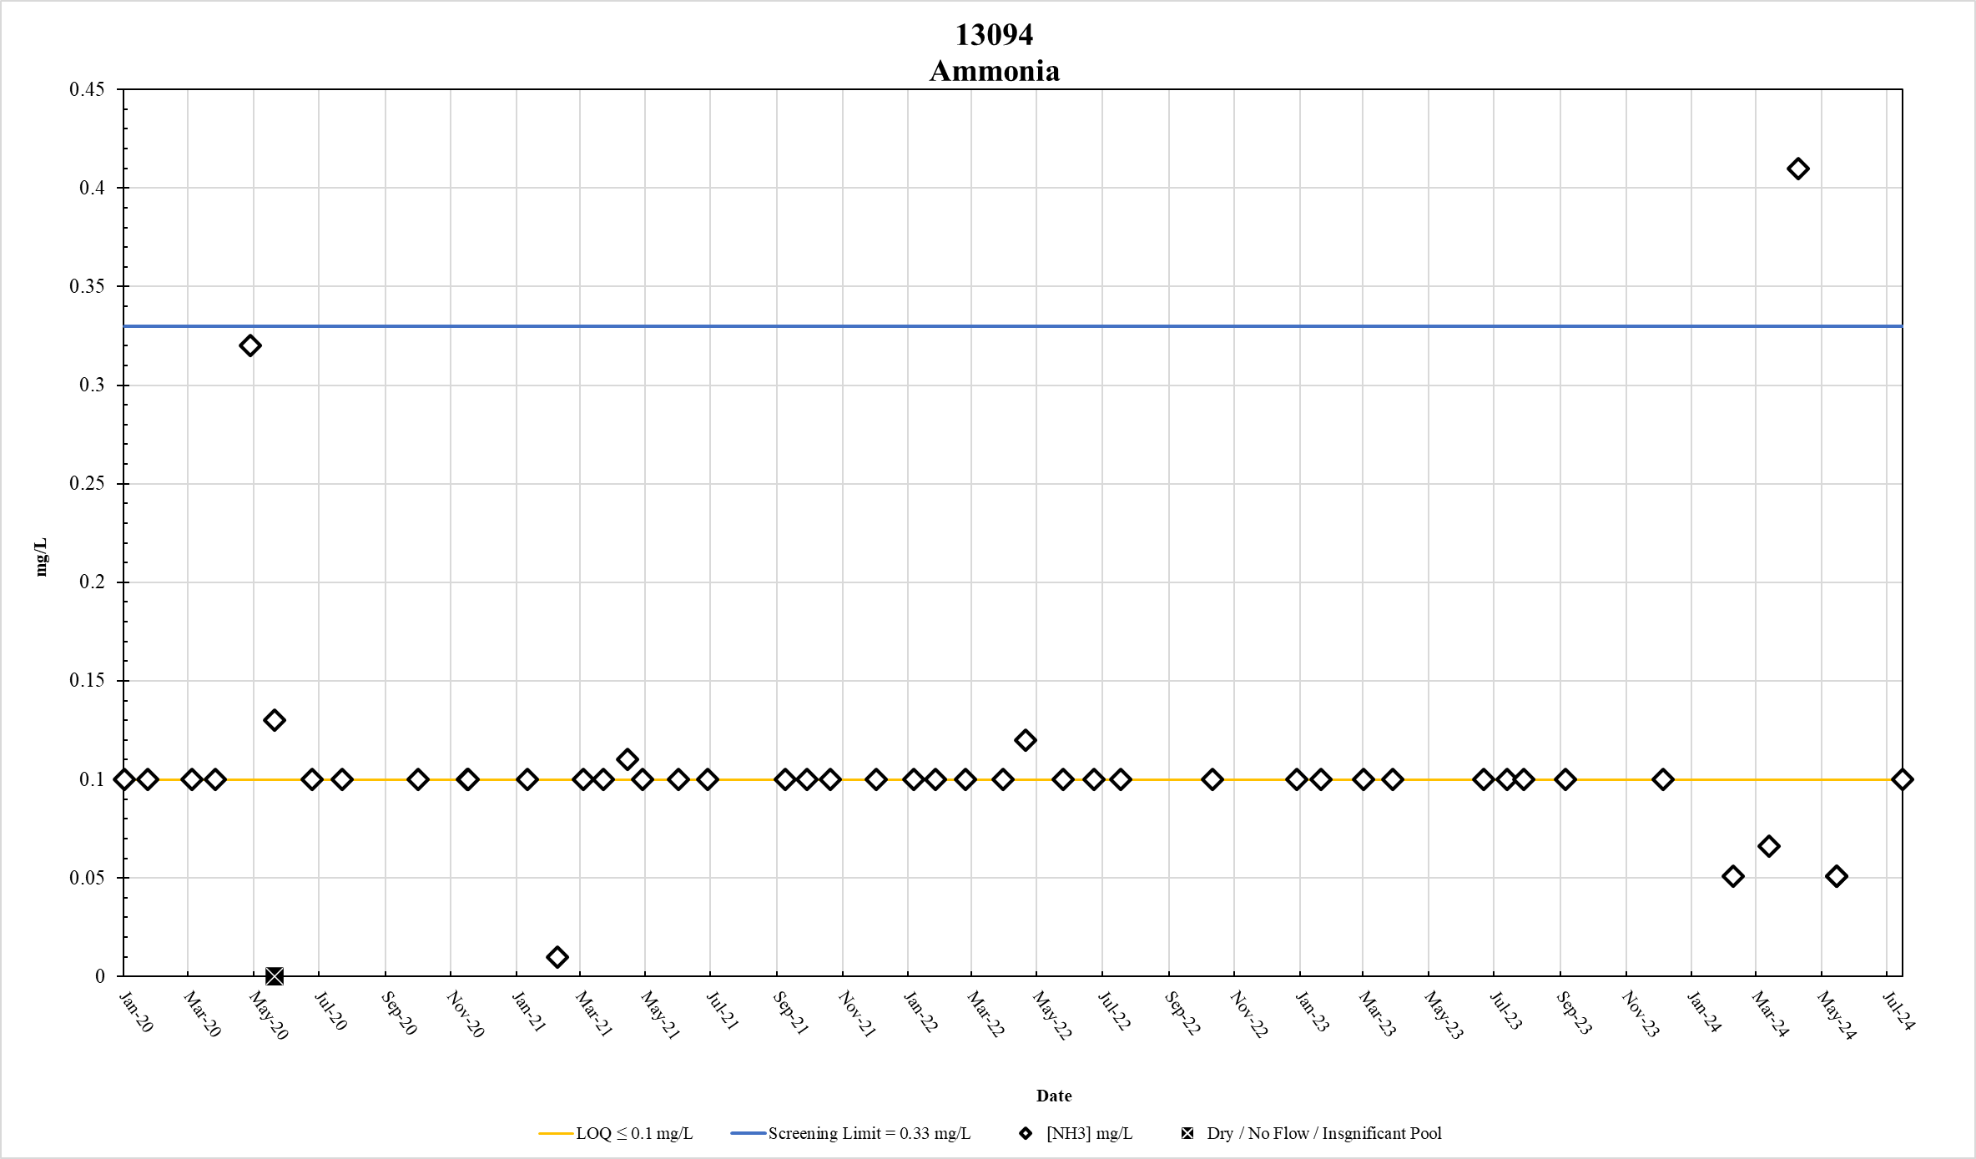
Figure 15. Station 13094 Ammonia results January 2020 – May 2024

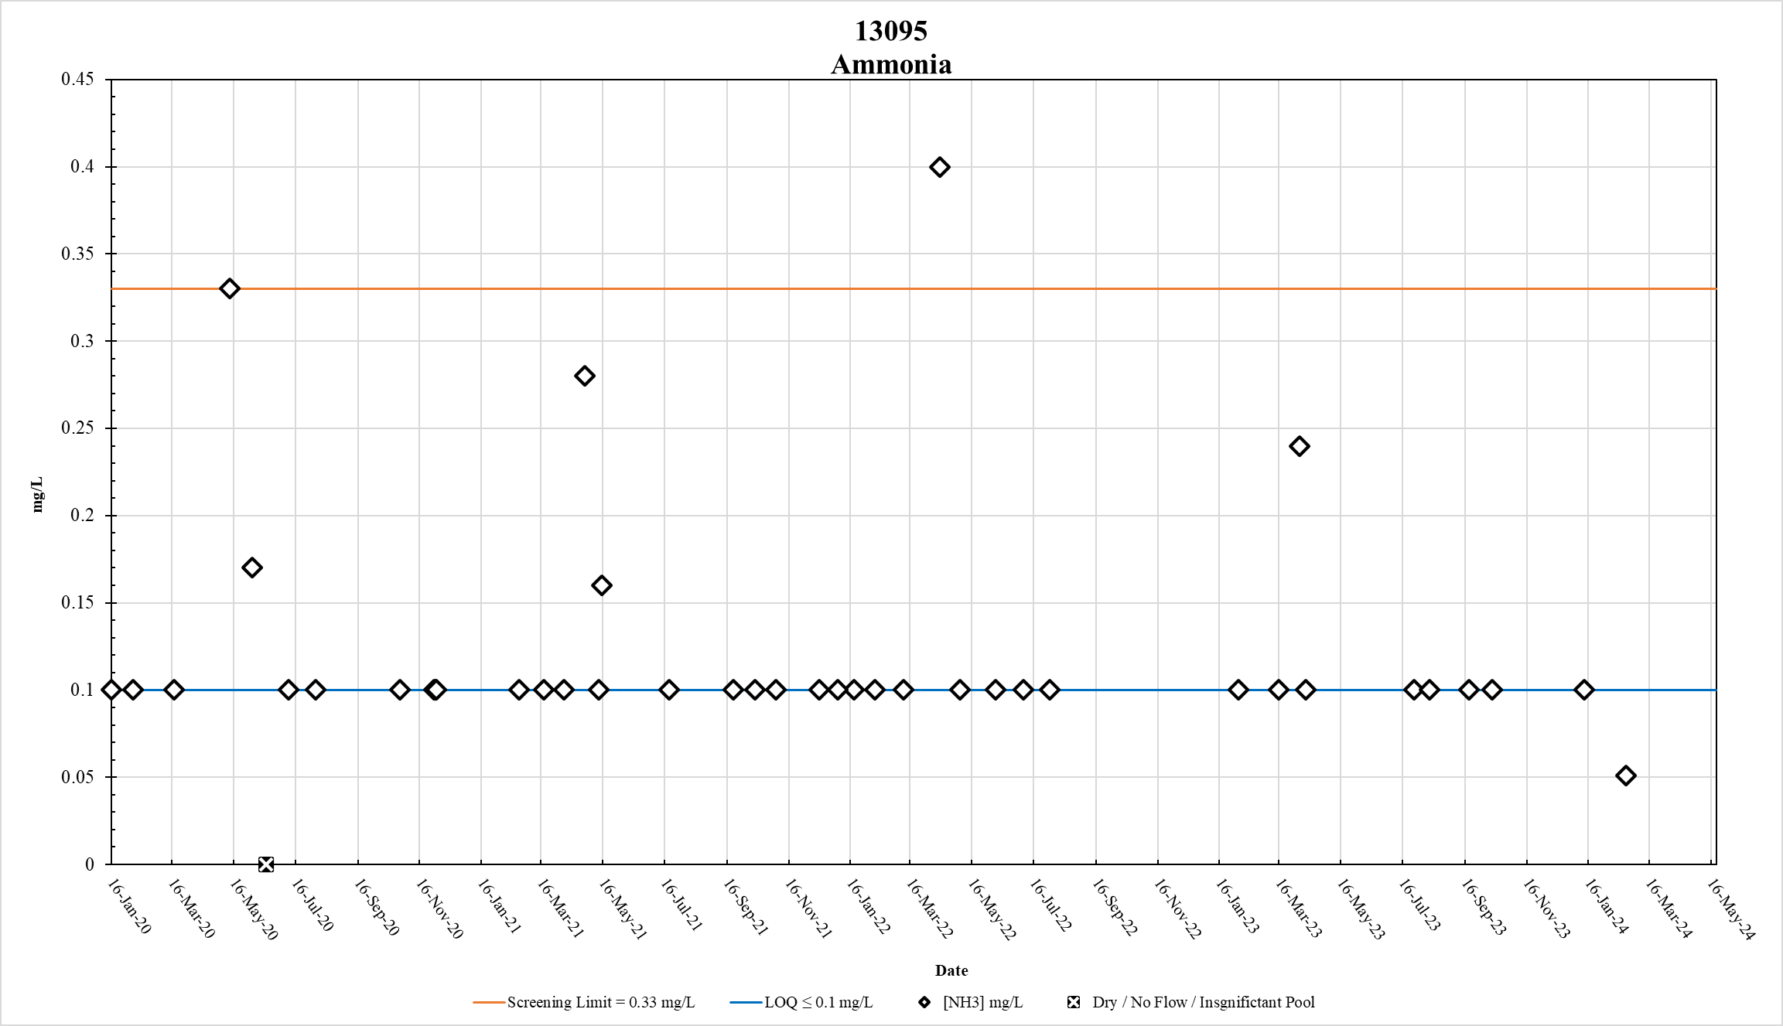
Figure 16. Station 13095 Ammonia results January 2020 – May 2024

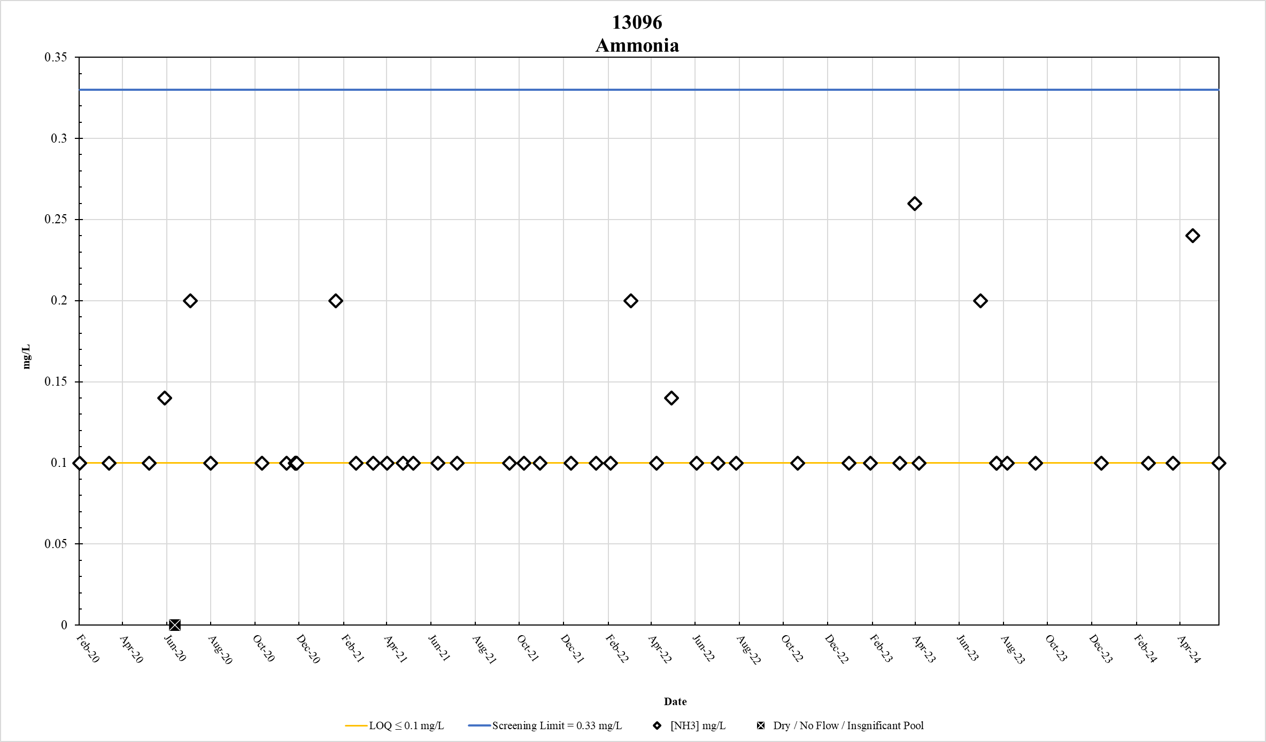
Figure 17. Station 13096 Ammonia results January 2020 – May 2024

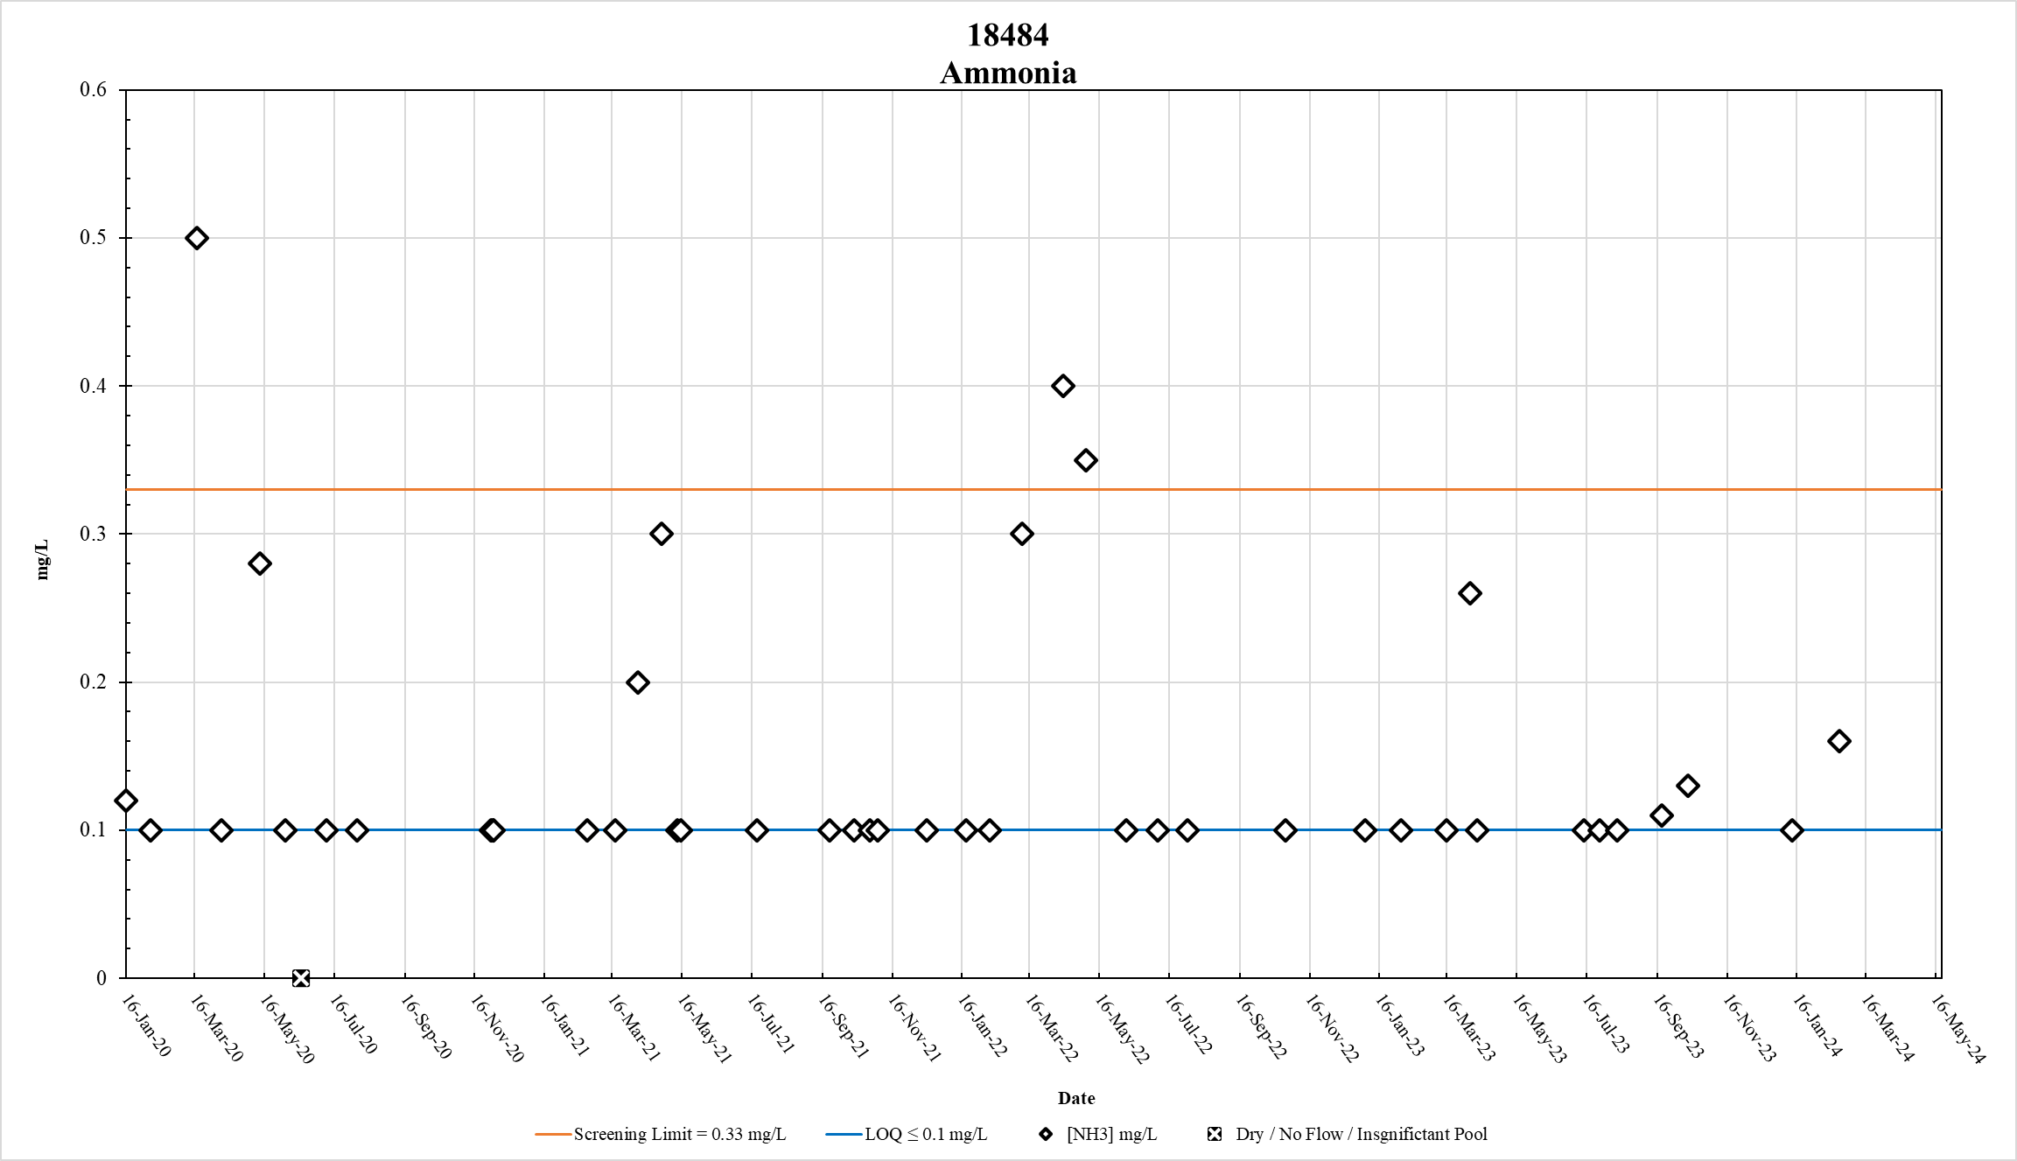
Figure 18. Station 18484 Ammonia results January 2020 – May 2024

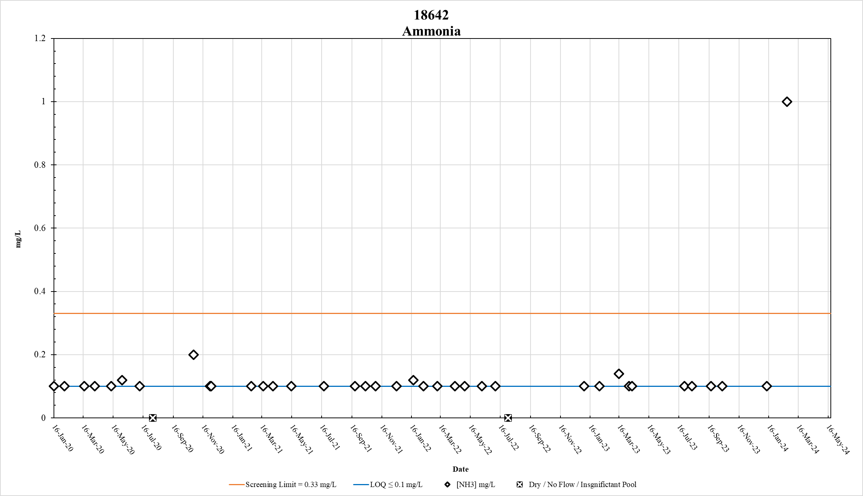
Figure 19. Station 18642 Ammonia results January 2020 – May 2024

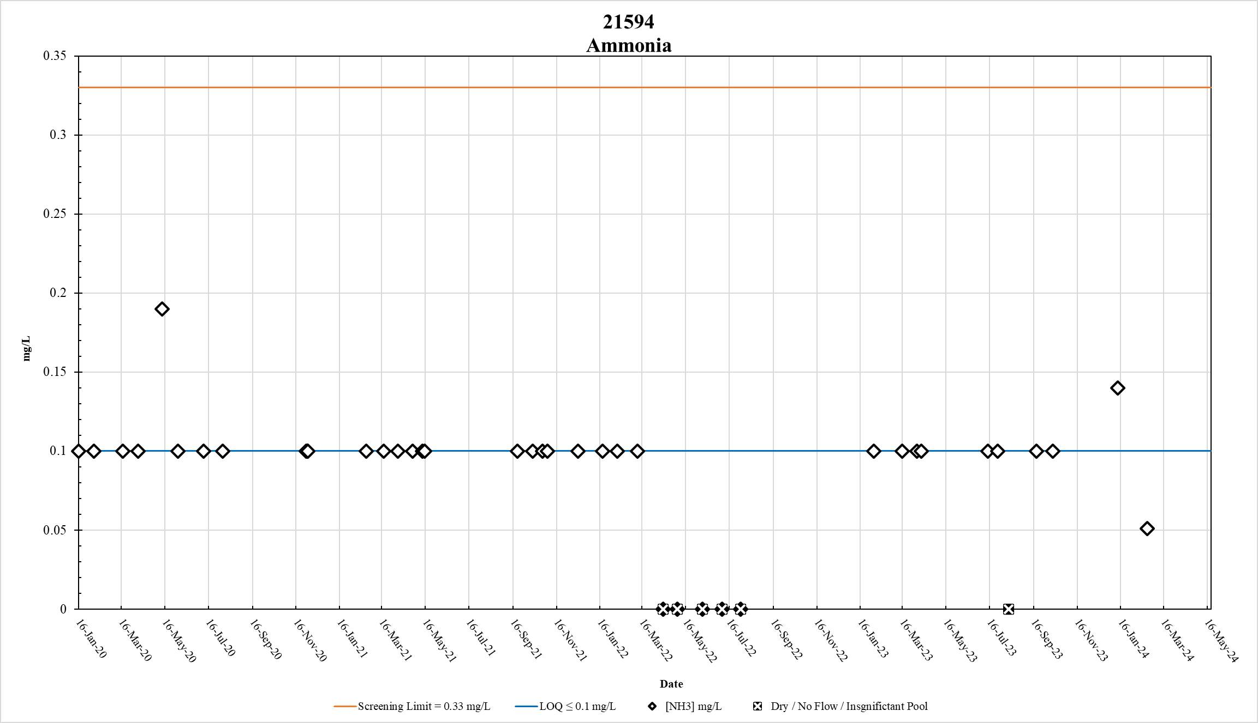
Figure 20. Station 21594 Ammonia results January 2020 – May 2024

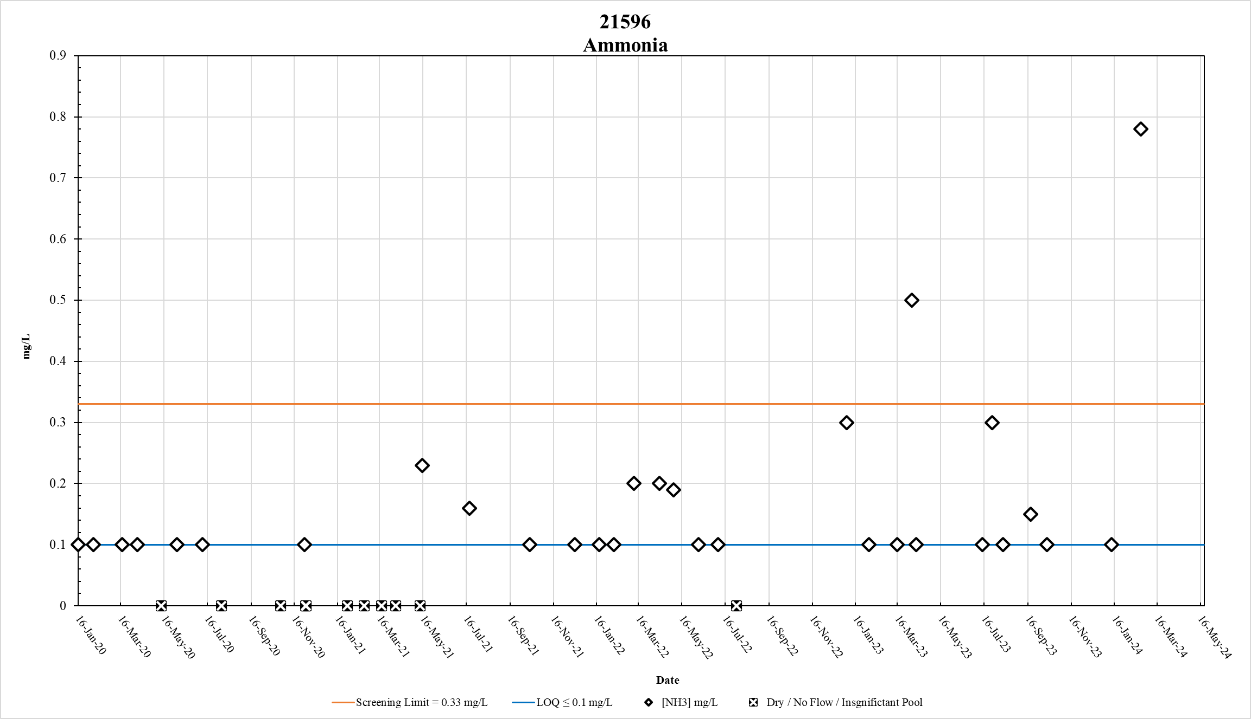
Figure 21. Station 21596 Ammonia results January 2020 – May 2024

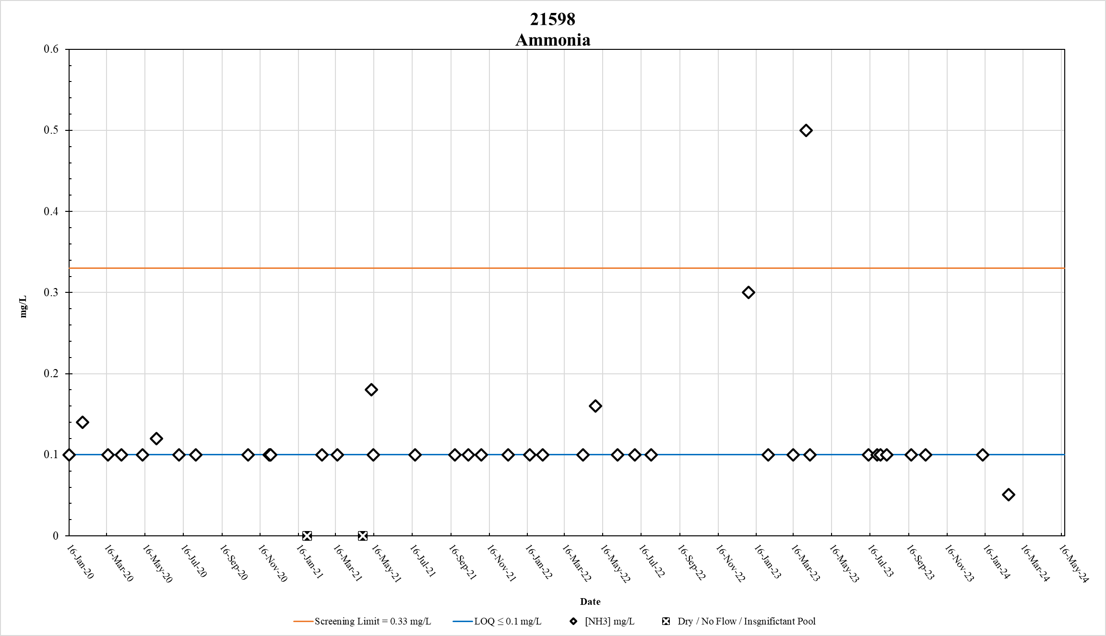
Figure 22. Station 21598 Ammonia results January 2020 – May 2024

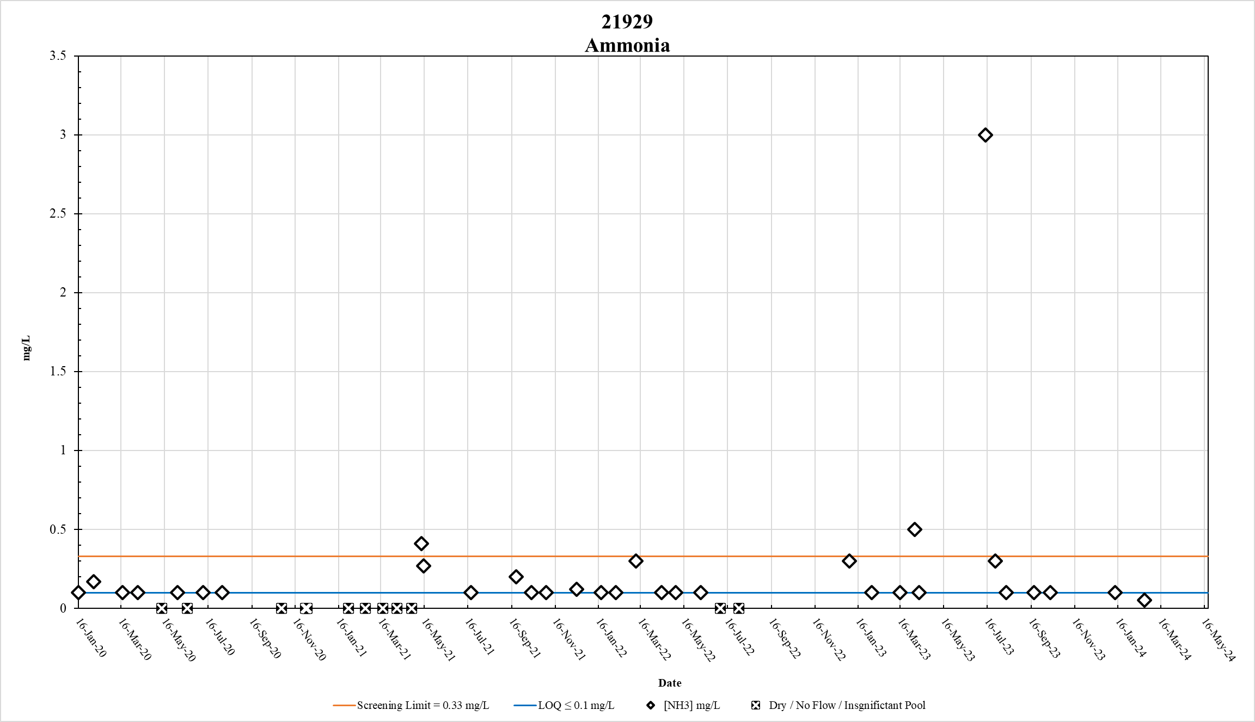
Figure 23. Station 21929 Ammonia results January 2020 – May 2024

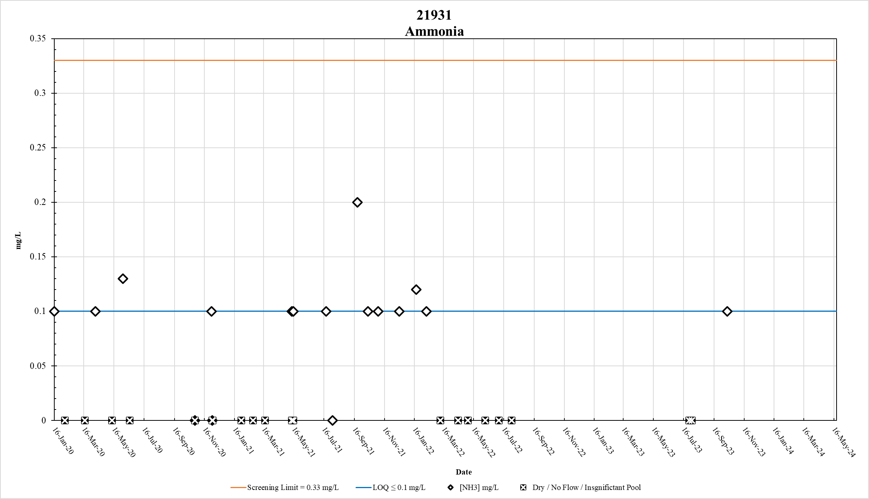
Figure 24. Station 21931 Ammonia results January 2020 – May 2024

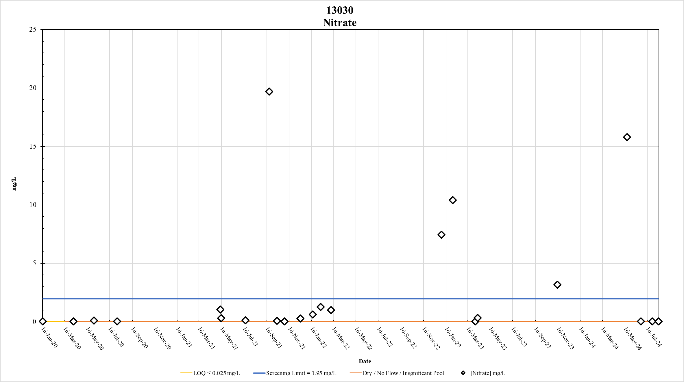
Figure 25. Station 13030 Nitrate results January 2020 – May 2024

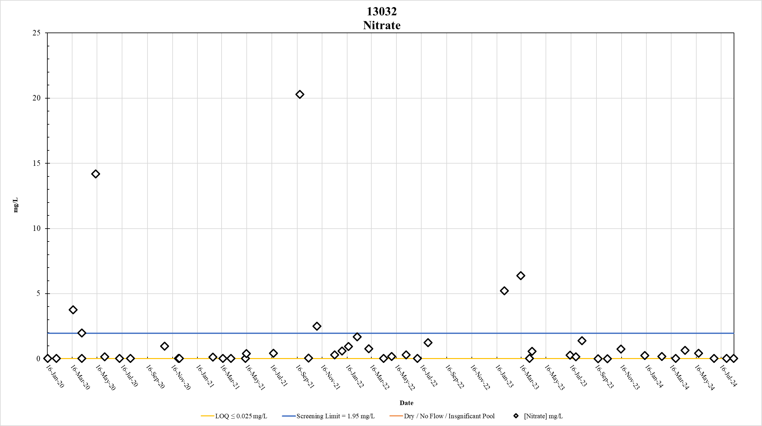
Figure 26. Station 13032 Nitrate results January 2020 – May 2024

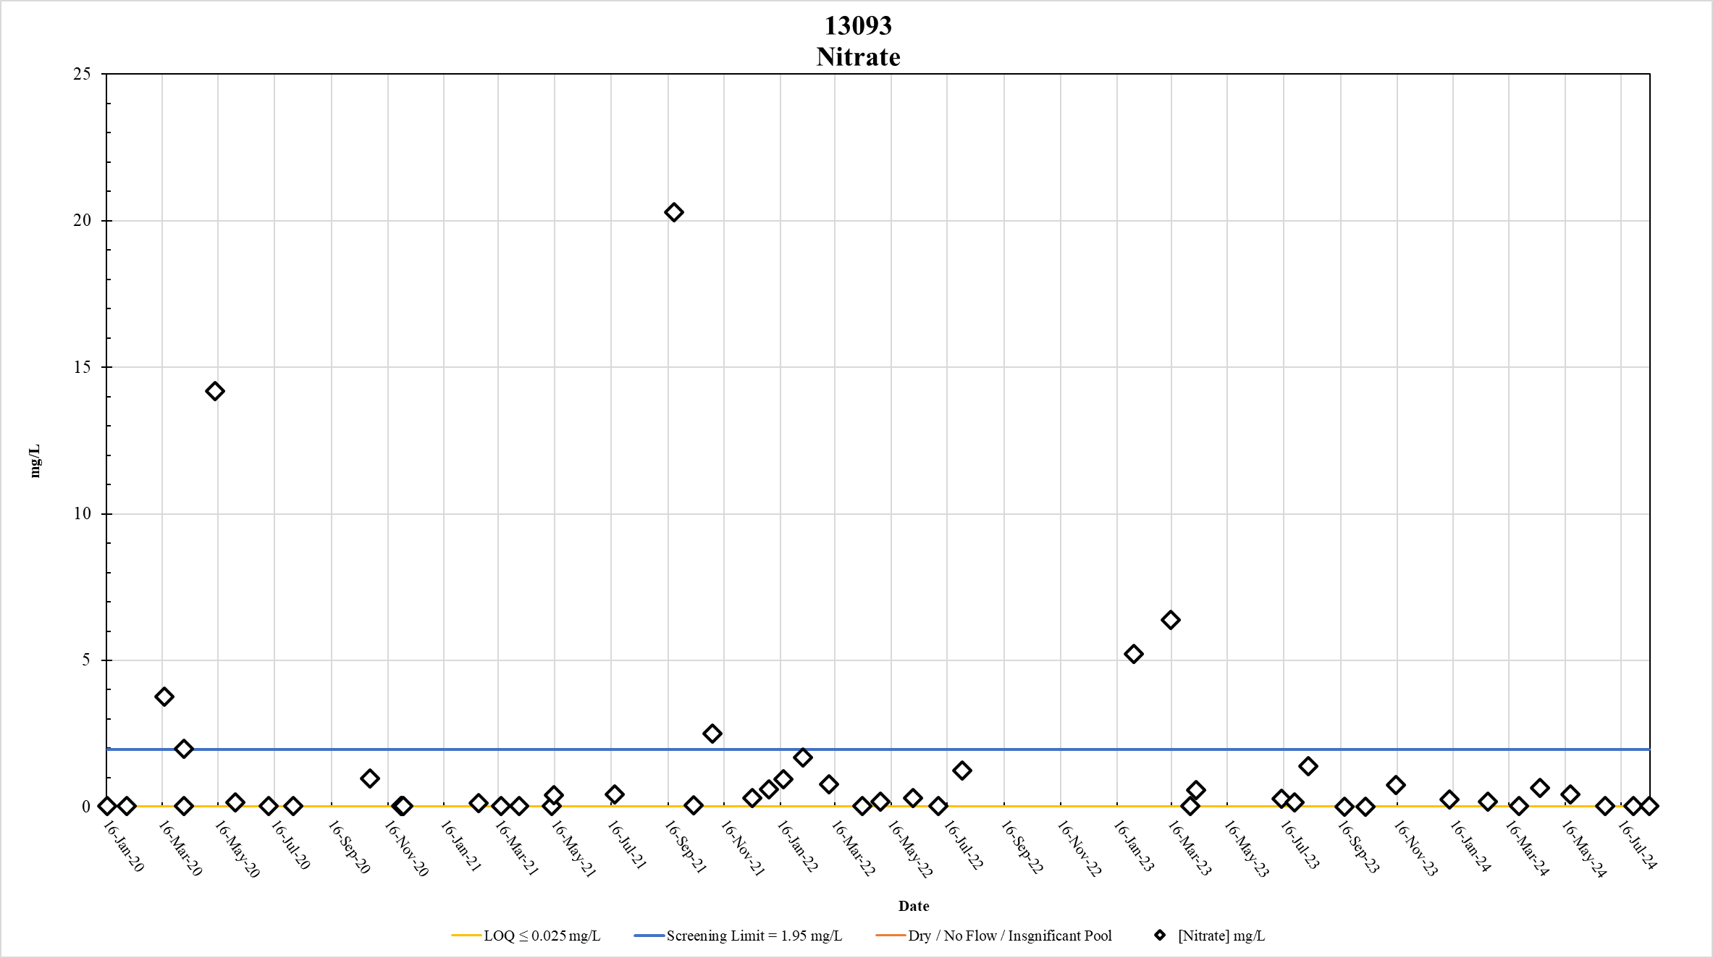

Figure 27. Station 13093 Nitrate results January 2020 – May 2024

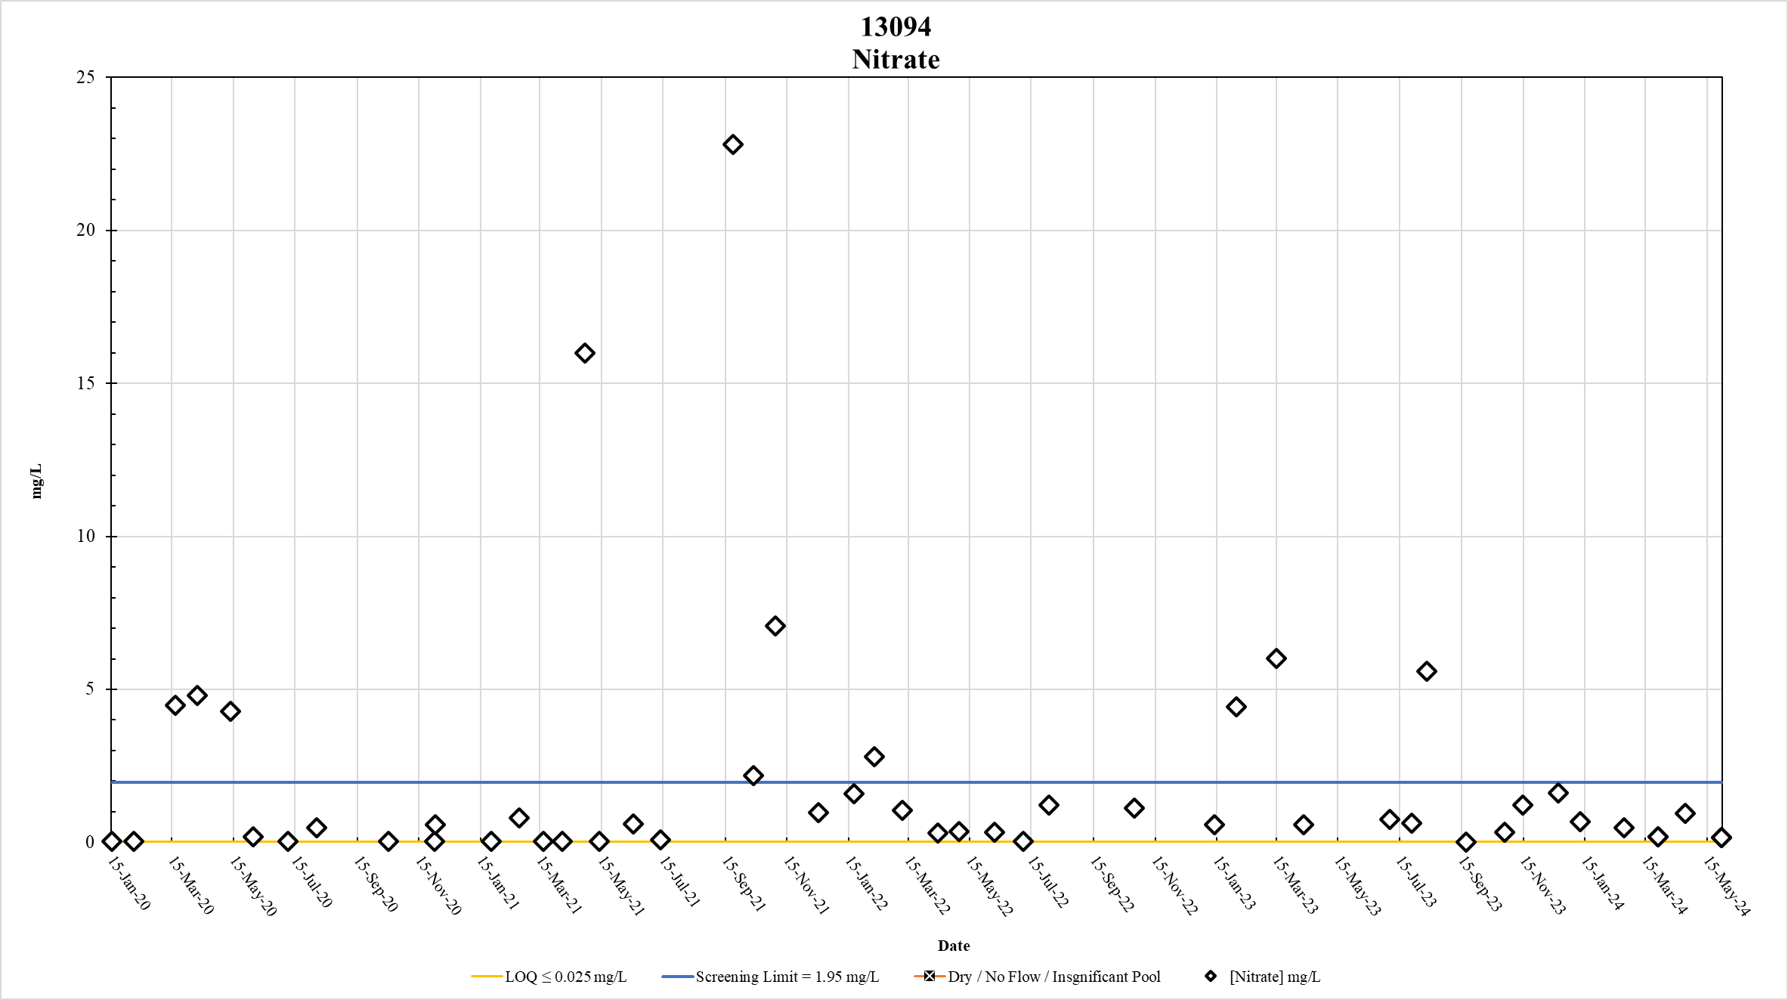
Figure 28. Station 13094 Nitrate results January 2020 – May 2024

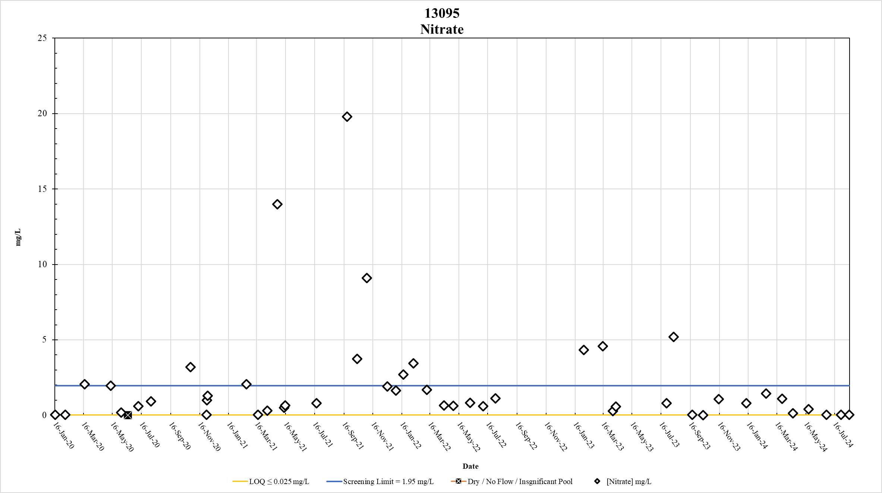
Figure 29. Station 13095 Nitrate results January 2020 – May 2024

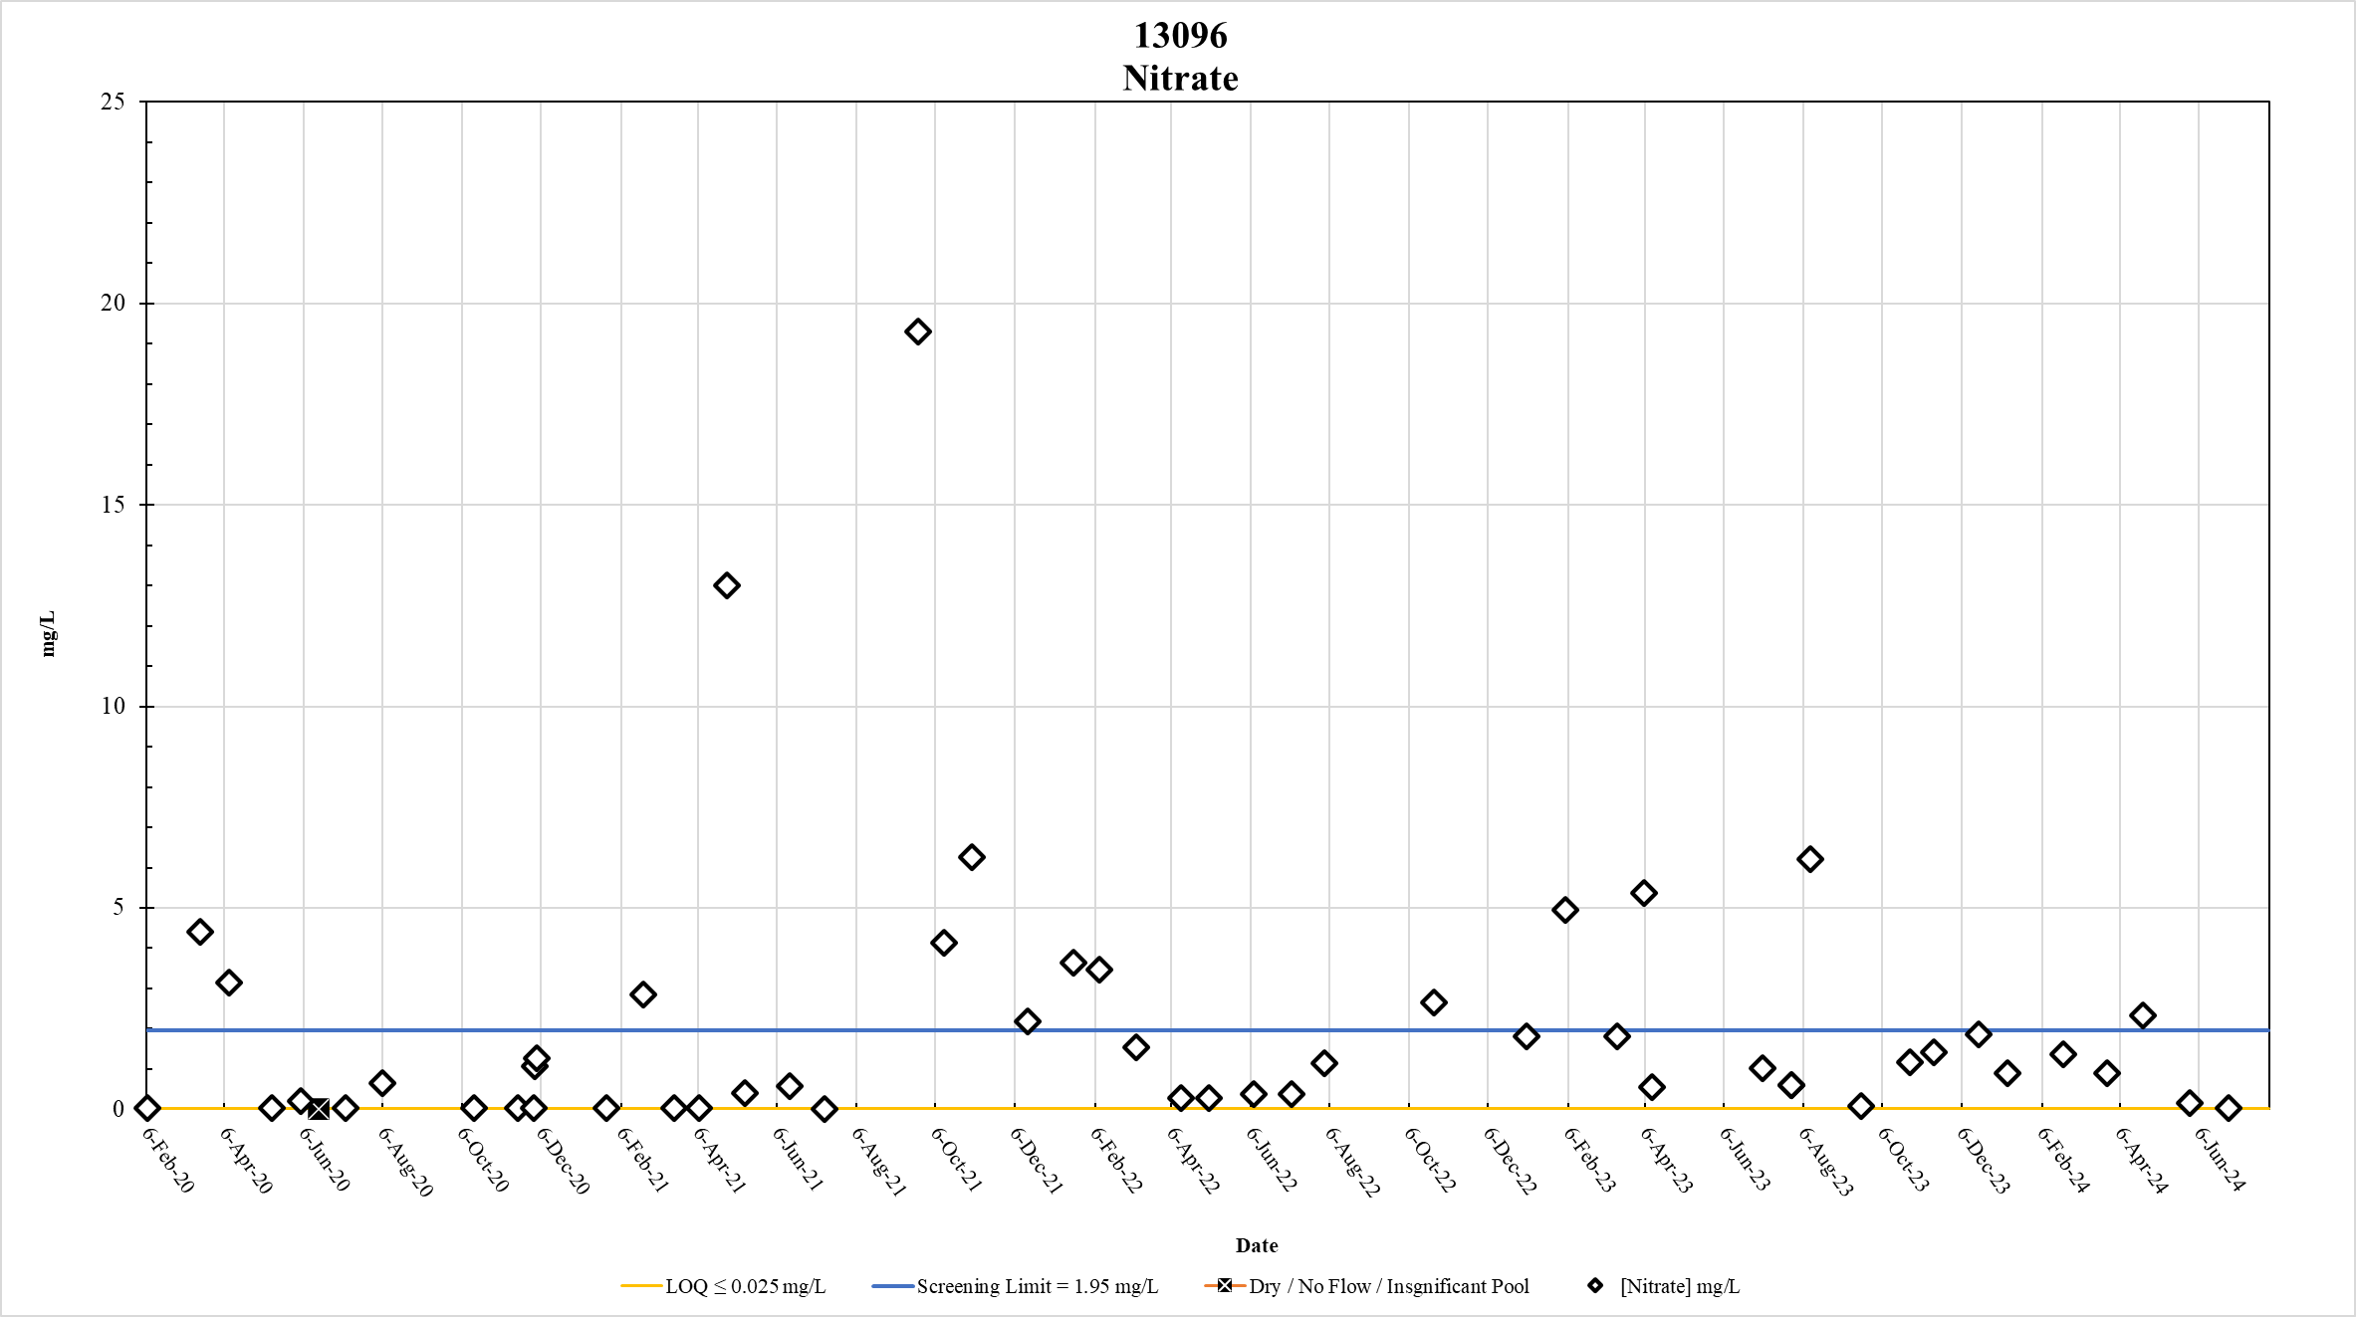
Figure 30. Station 13096 Nitrate results January 2020 – May 2024

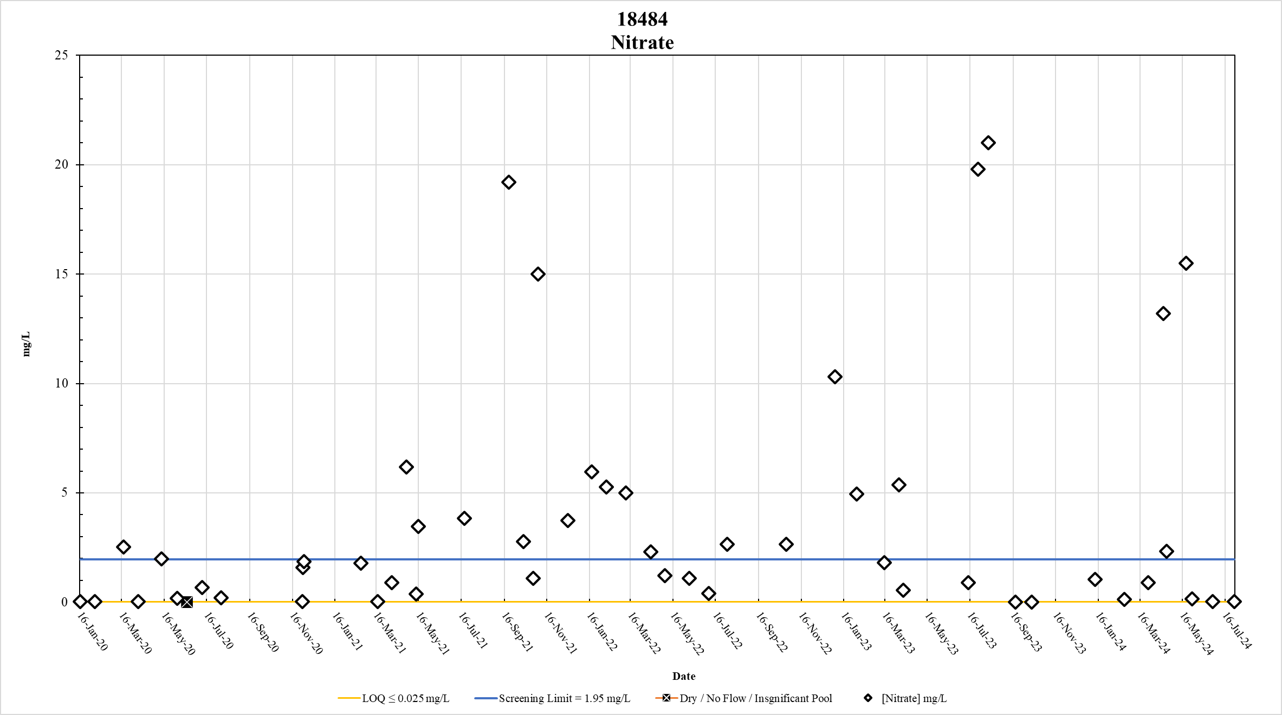
Figure 31. Station 18484 Nitrate results January 2020 – May 2024

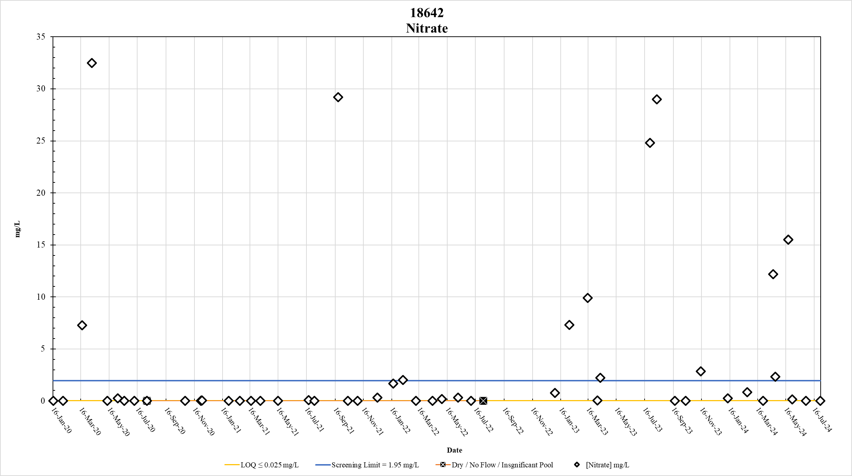
Figure 32. Station 18642 Nitrate results January 2020 – May 2024

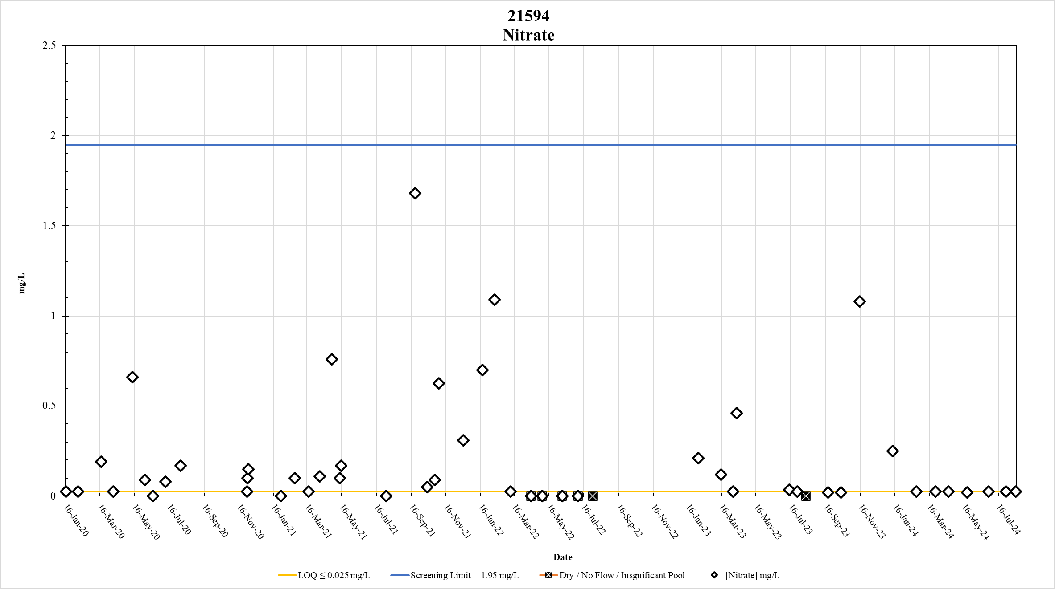

Figure 33. Station 21594 Nitrate results January 2020 – May 2024

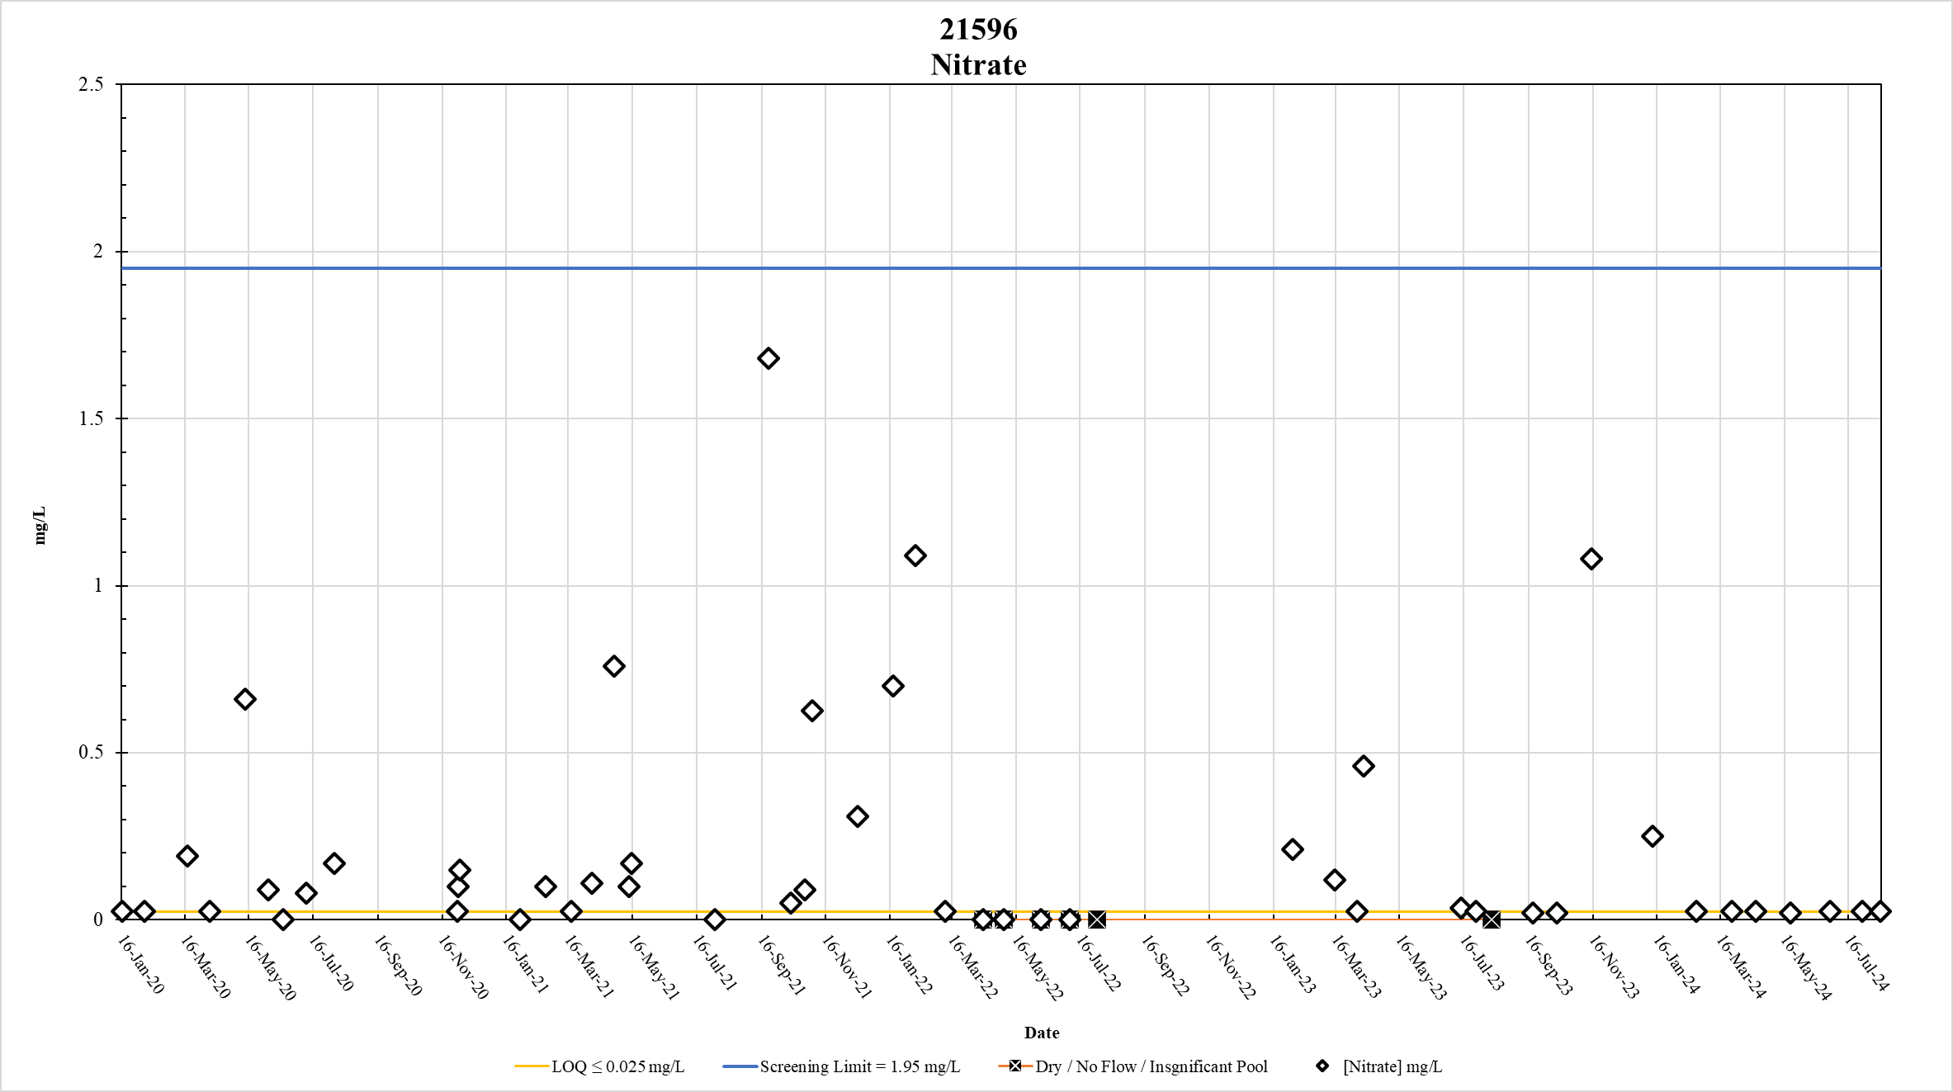
Figure 34. Station 21596 Nitrate results January 2020 – May 2024

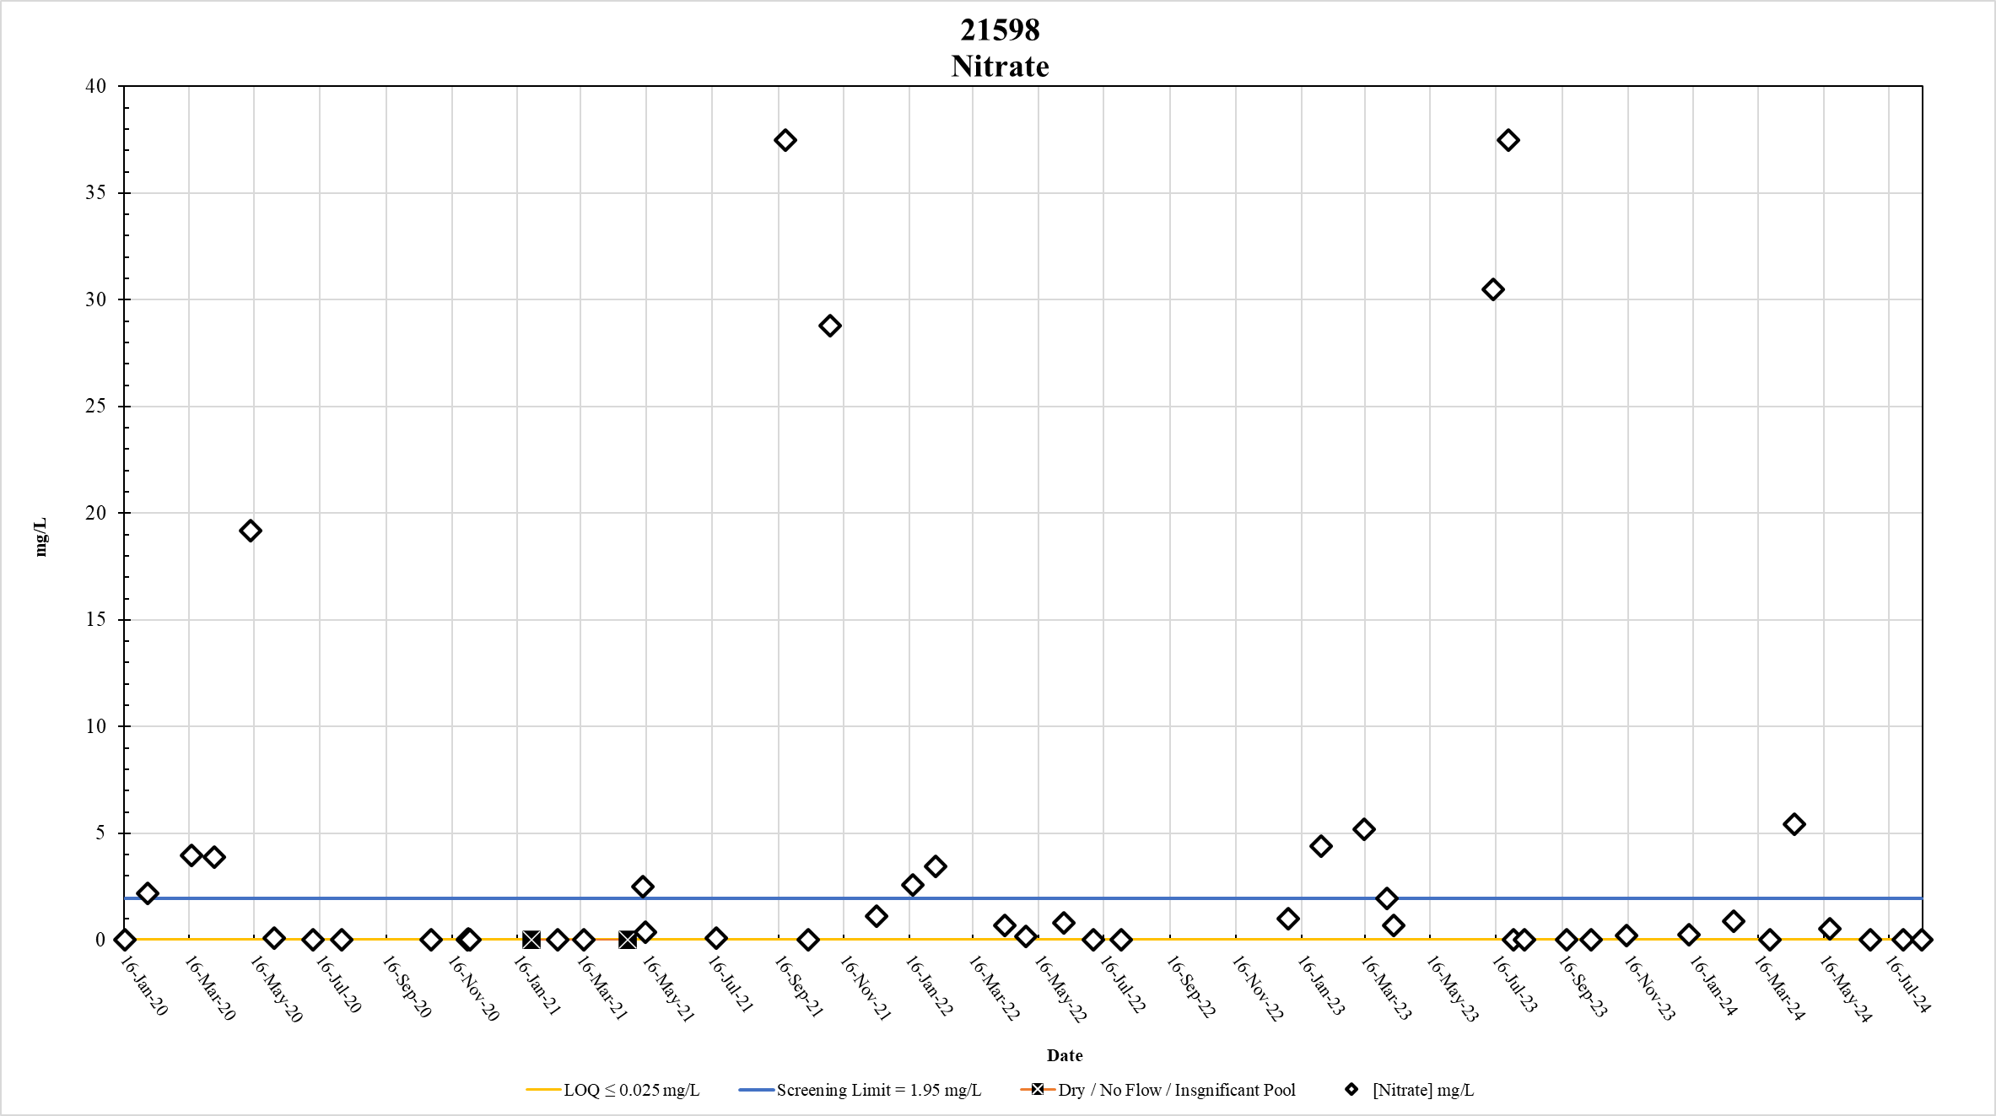
Figure 35. Station 21598 Nitrate results January 2020 – May 2024

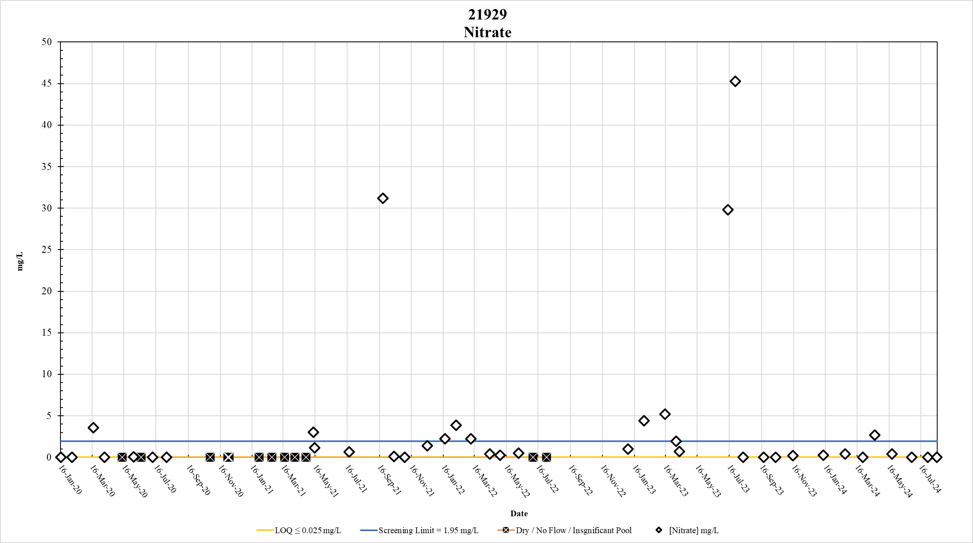
Figure 36. Station 21929 Nitrate results January 2020 – May 2024

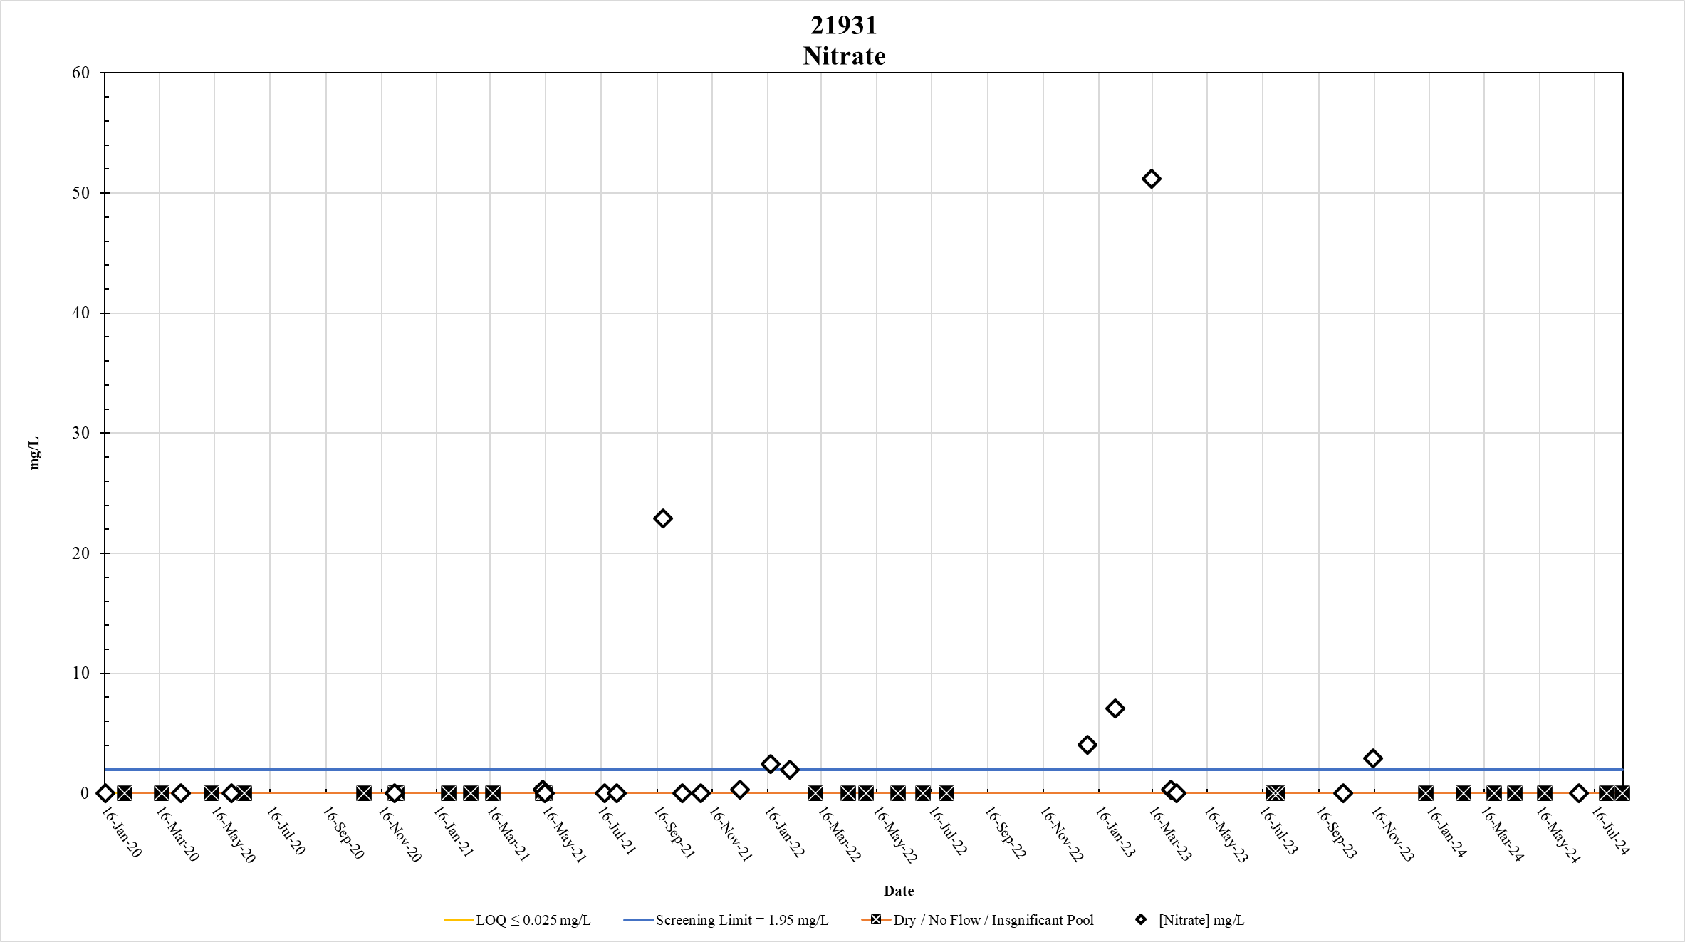
Figure 37. Station 21931 Nitrate results January 2020 – May 2024

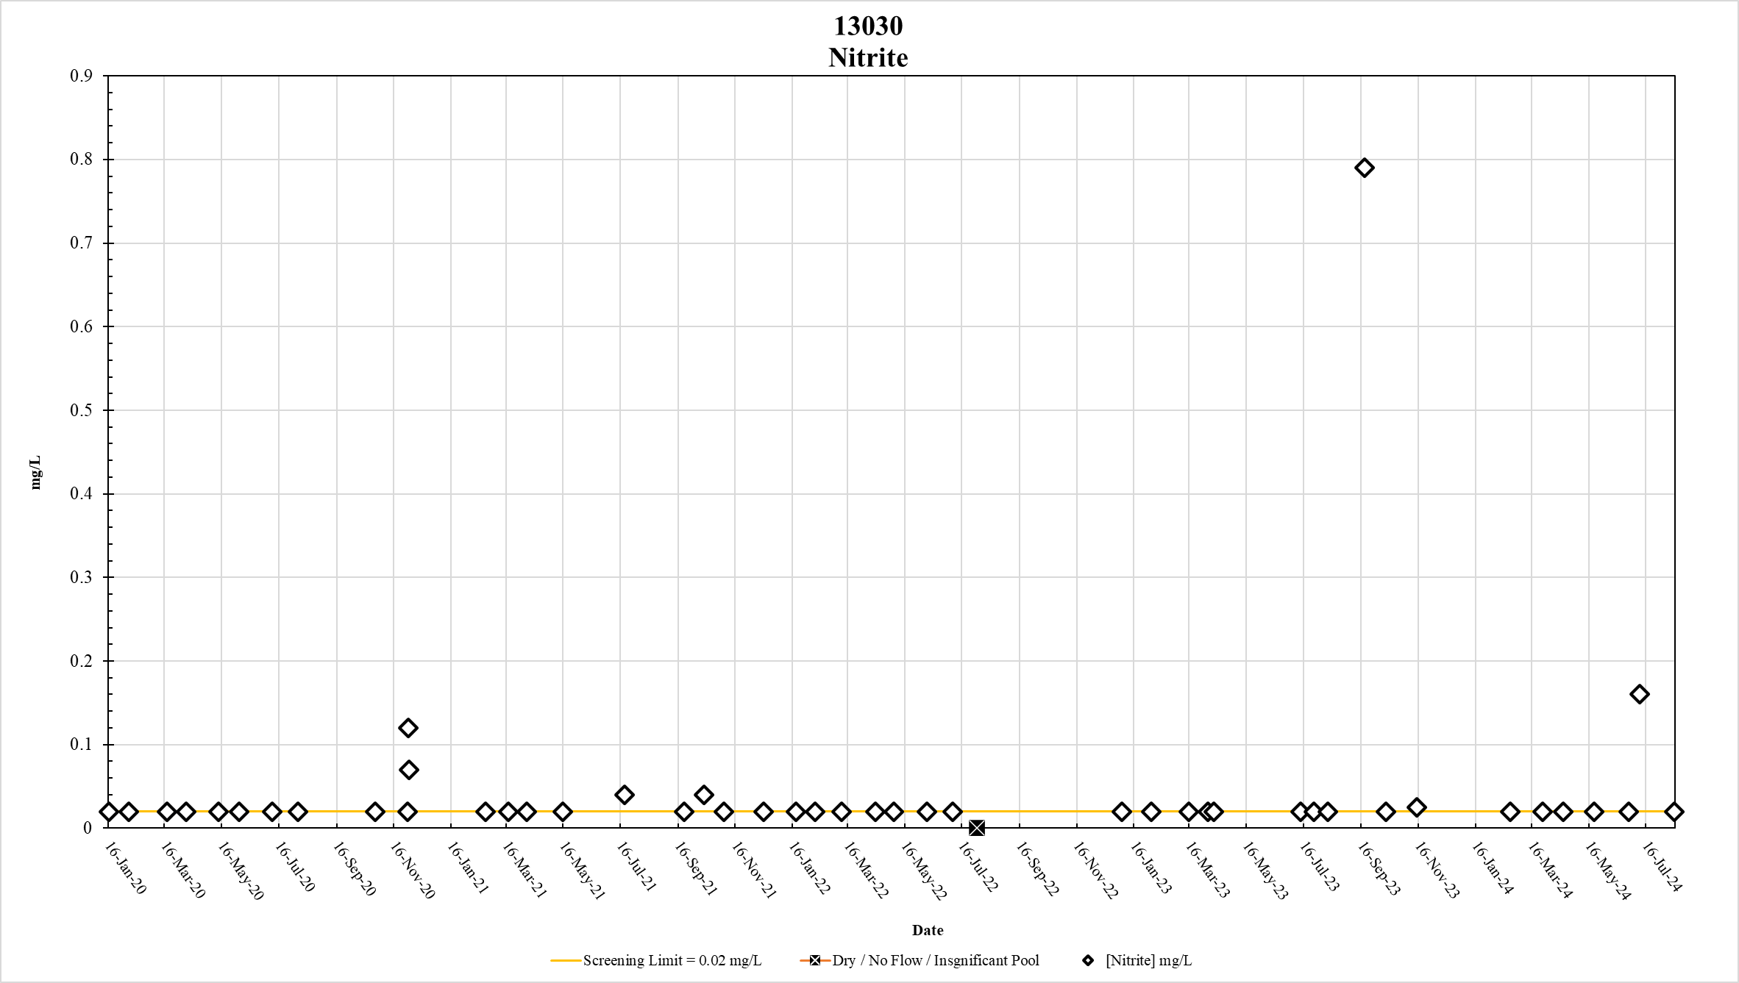
Figure 38. Station 13030 Nitrite results January 2020 – May 2024

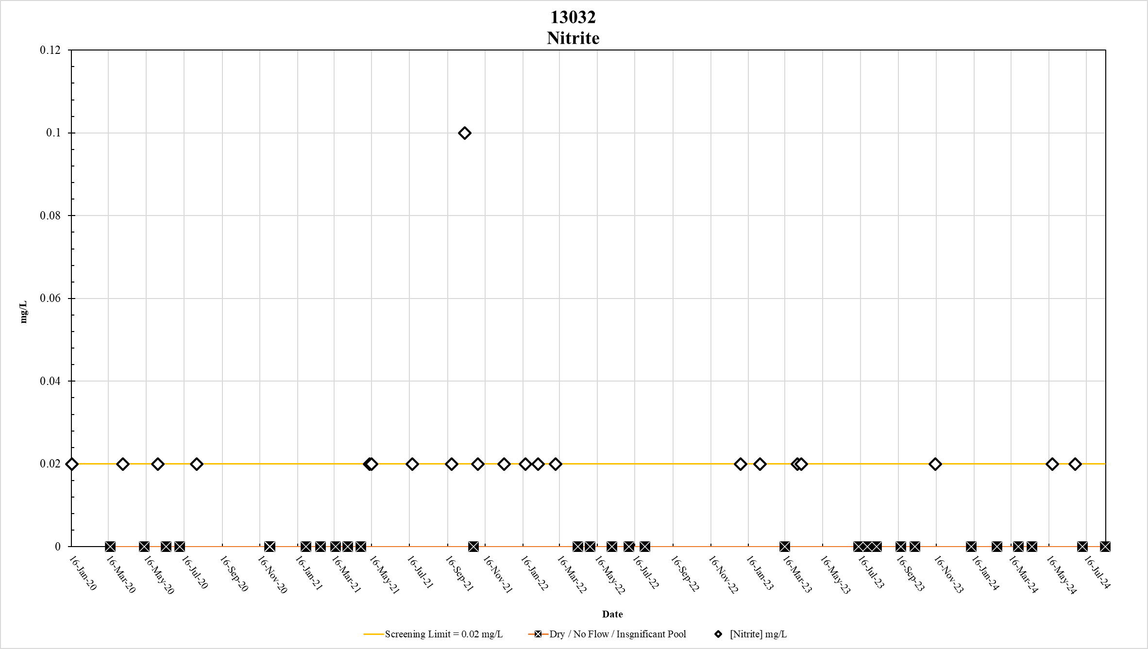
Figure 39. Station 13032 Nitrite results January 2020 – May 2024

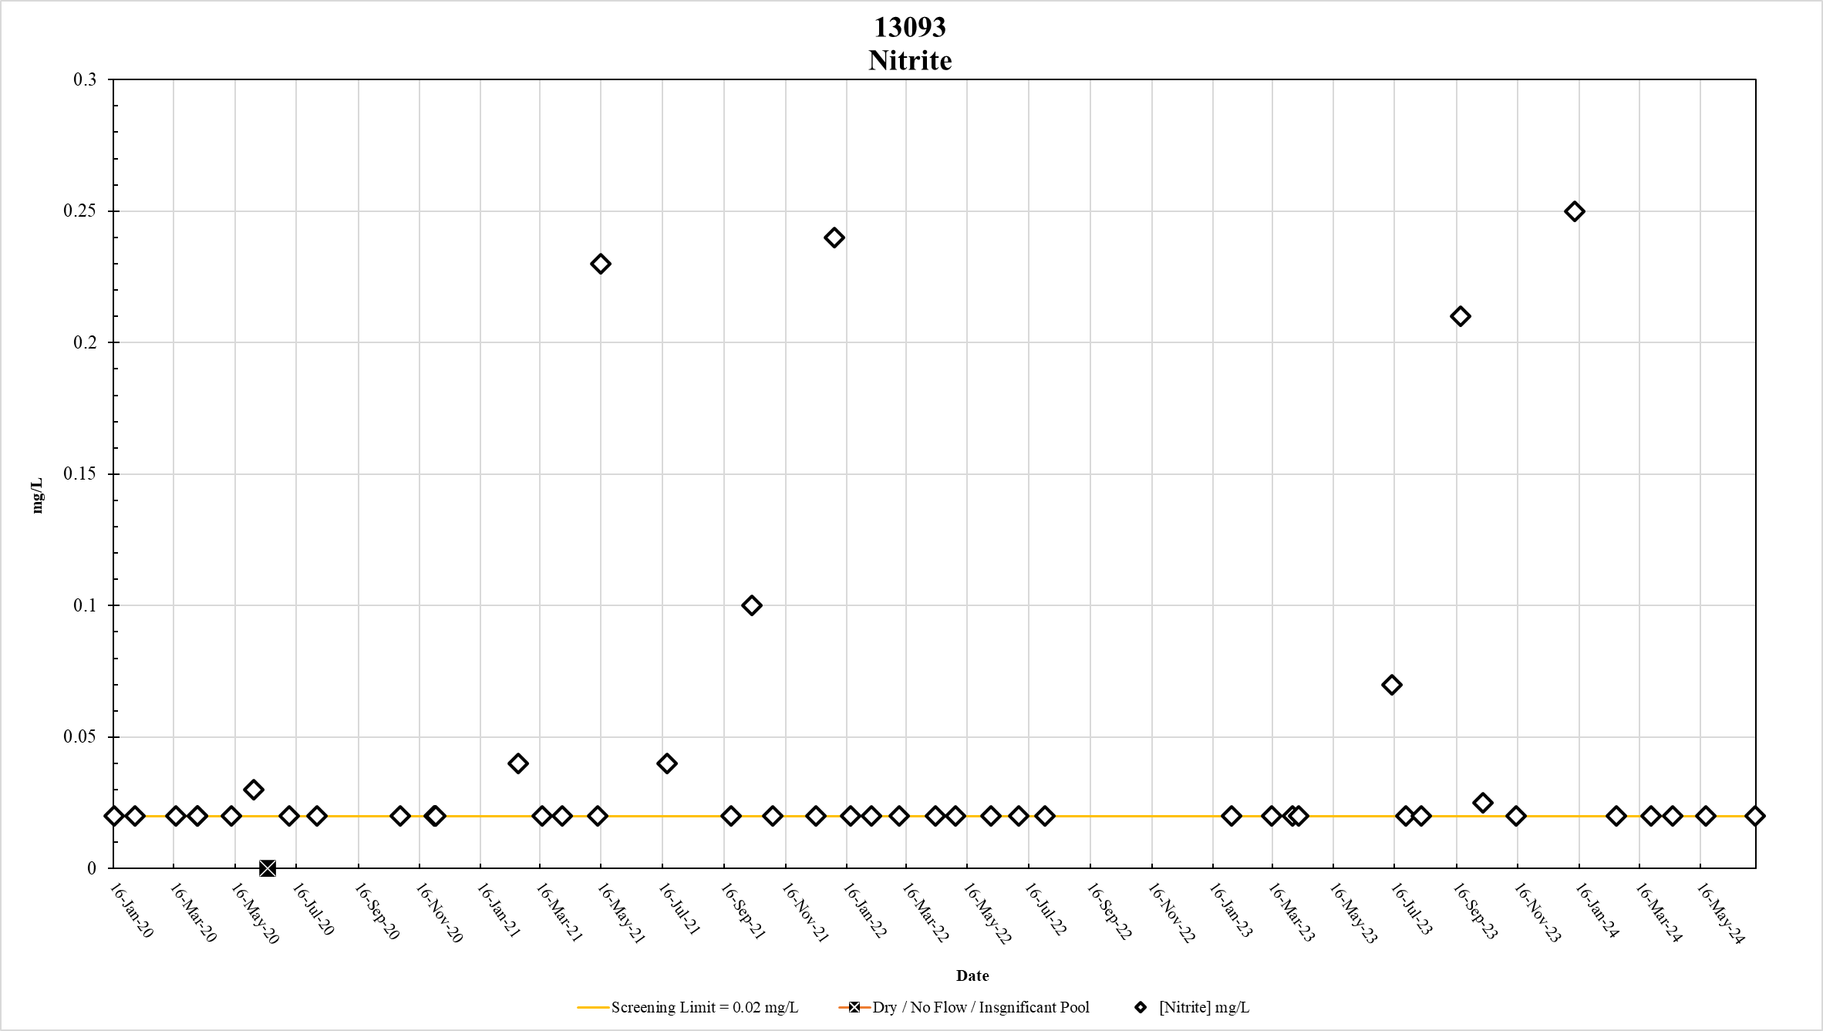
Figure 40. Station 13093 Nitrite results January 2020 – May 2024

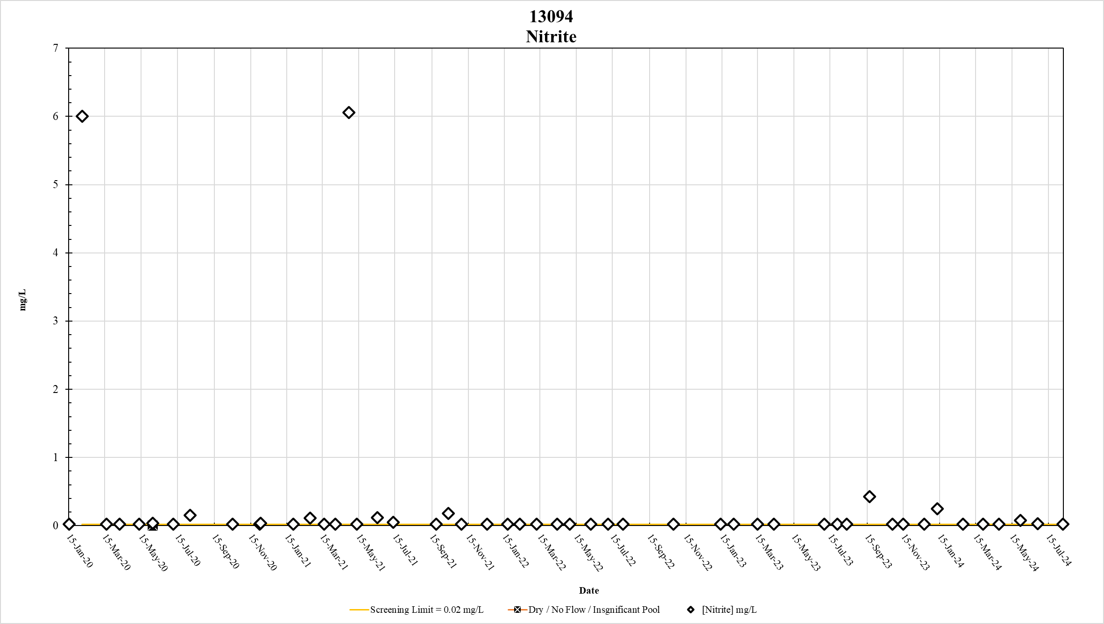
Figure 41. Station 13094 Nitrite results January 2020 – May 2024

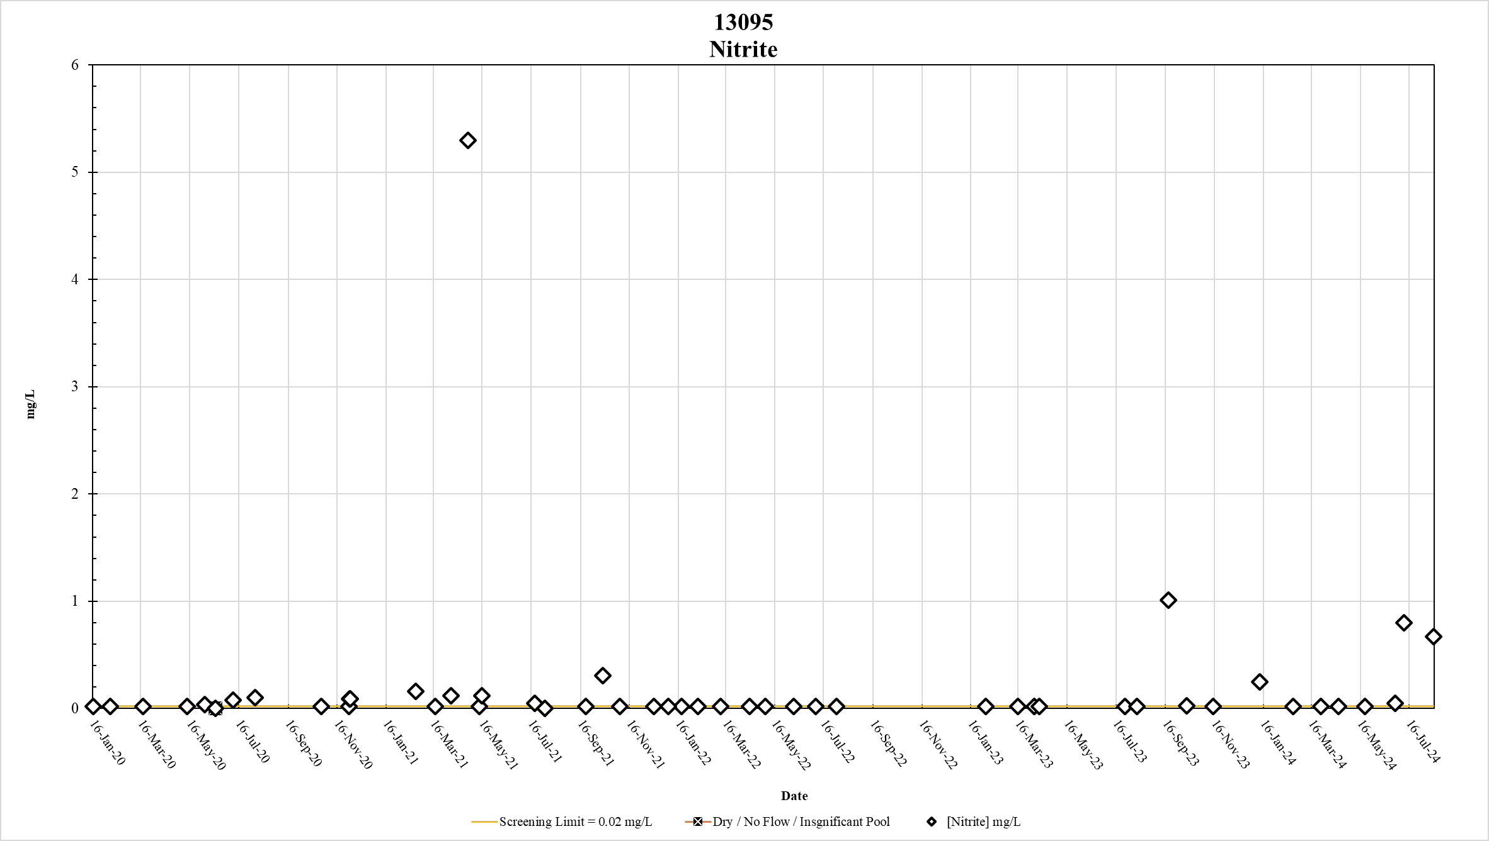
Figure 42. Station 13095 Nitrite results January 2020 – May 2024

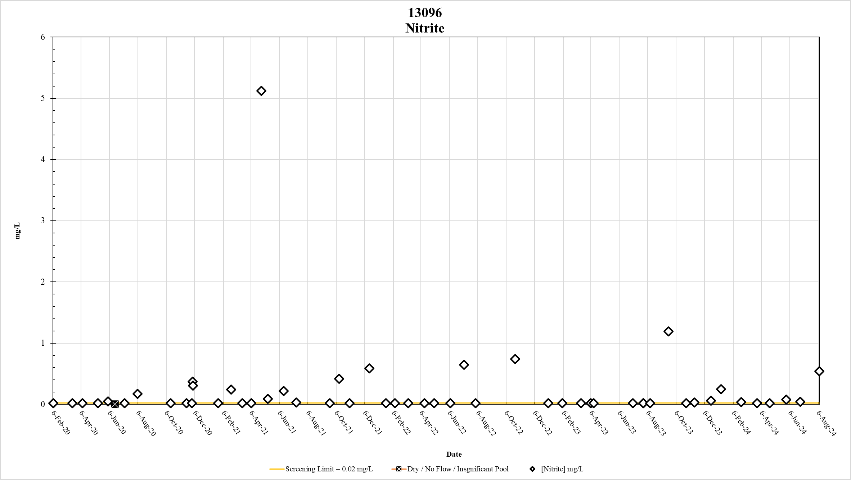
Figure 43. Station 13096 Nitrite results January 2020 – May 2024

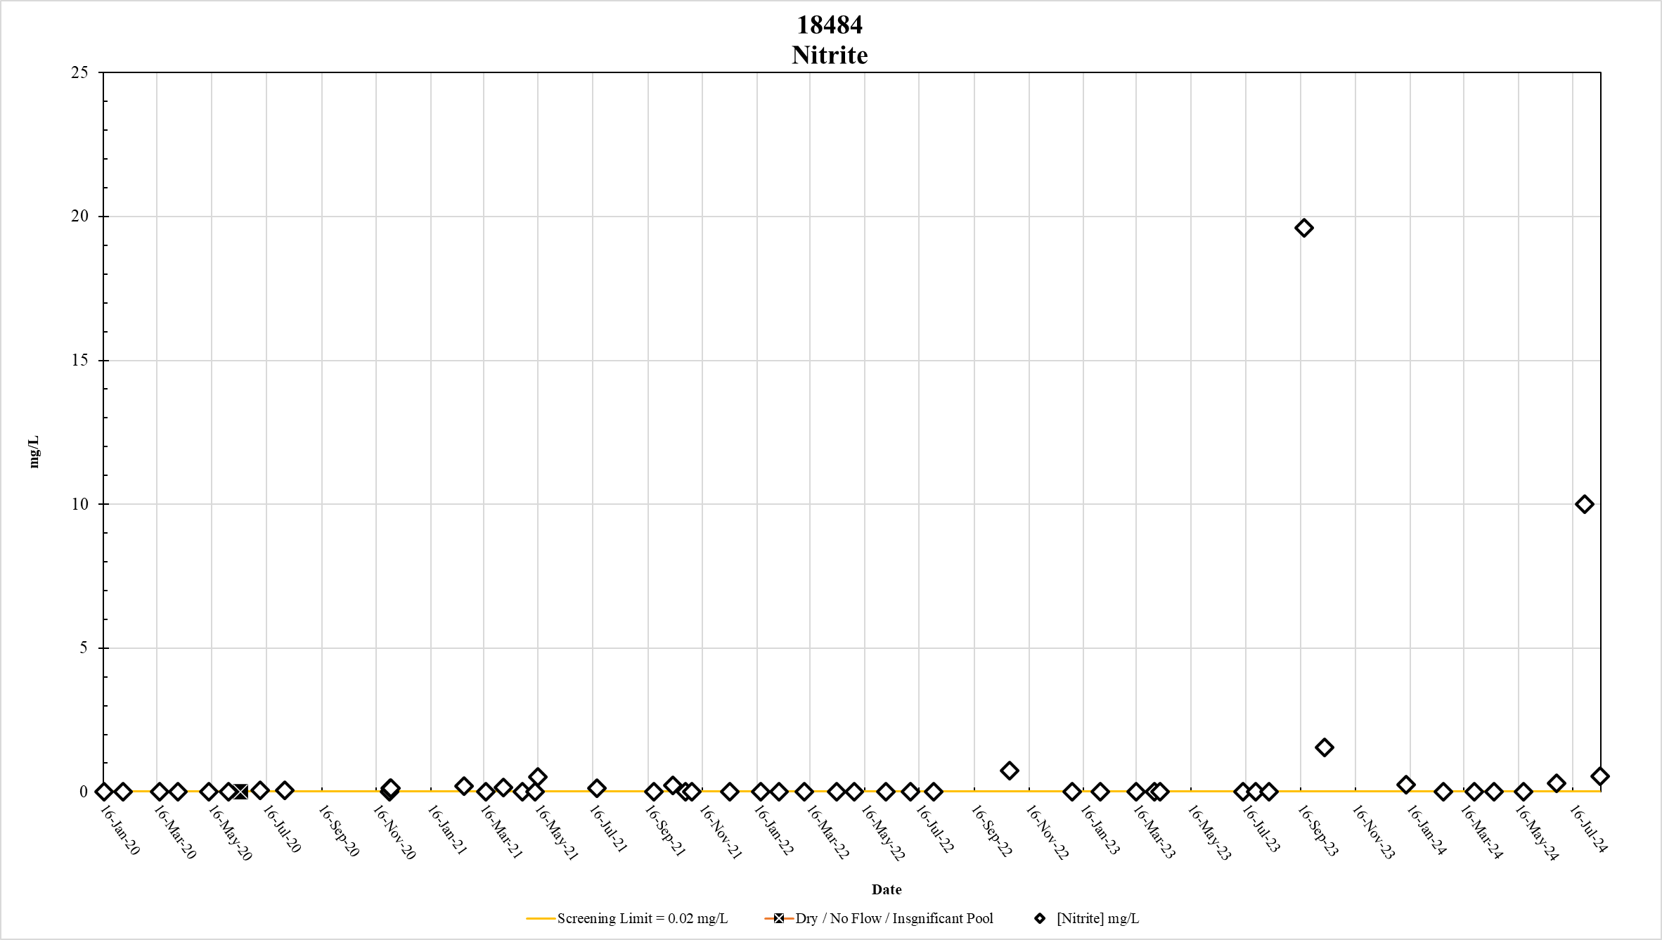
Figure 44. Station 18484 Nitrite results January 2020 – May 2024

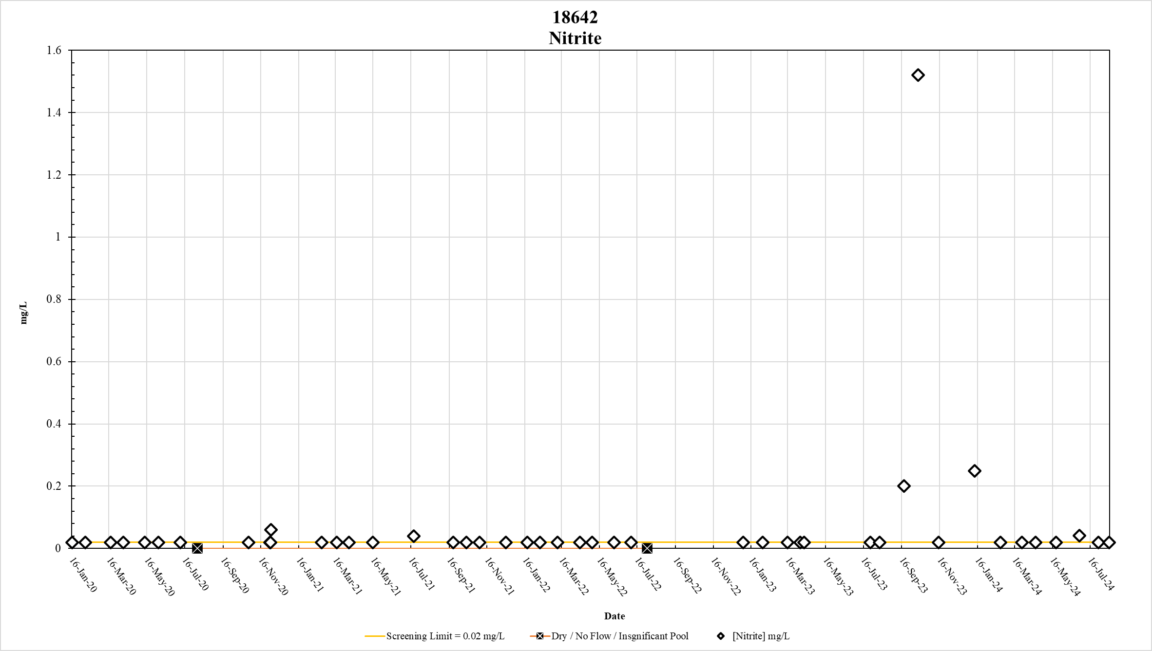
Figure 45. Station 18642 Nitrite results January 2020 – May 2024

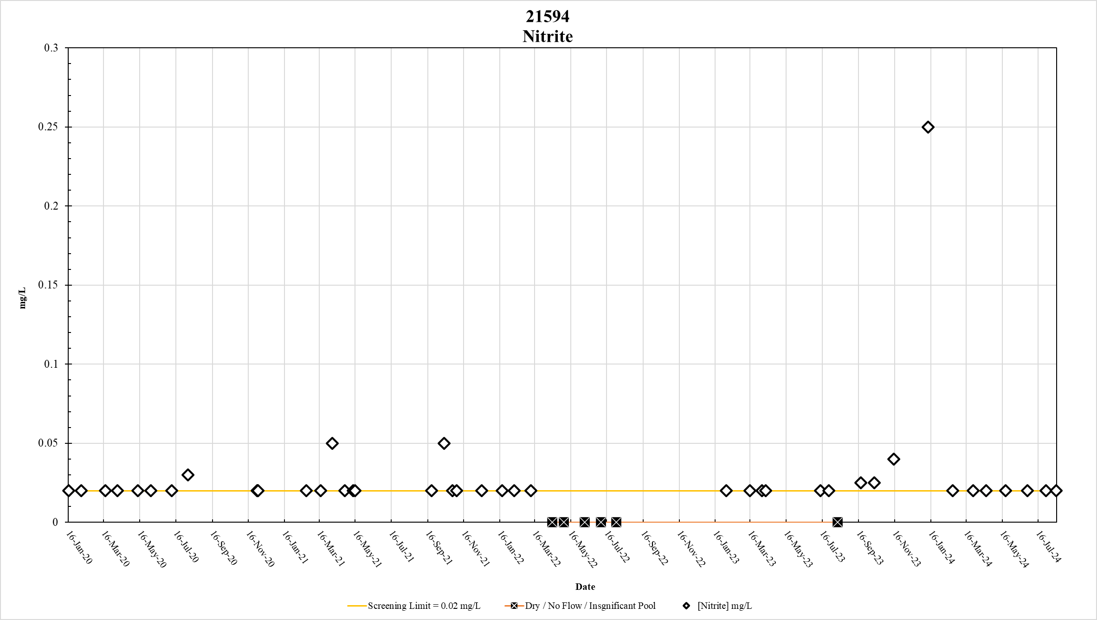
Figure 46. Station 21594 Nitrite results January 2020 – May 2024

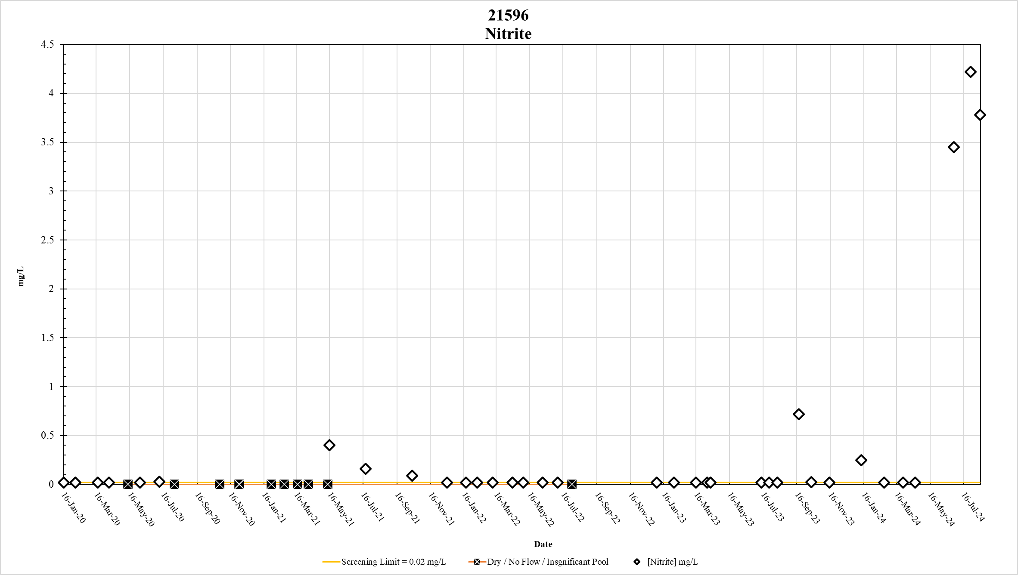
Figure 47. Station 21596 Nitrite results January 2020 – May 2024

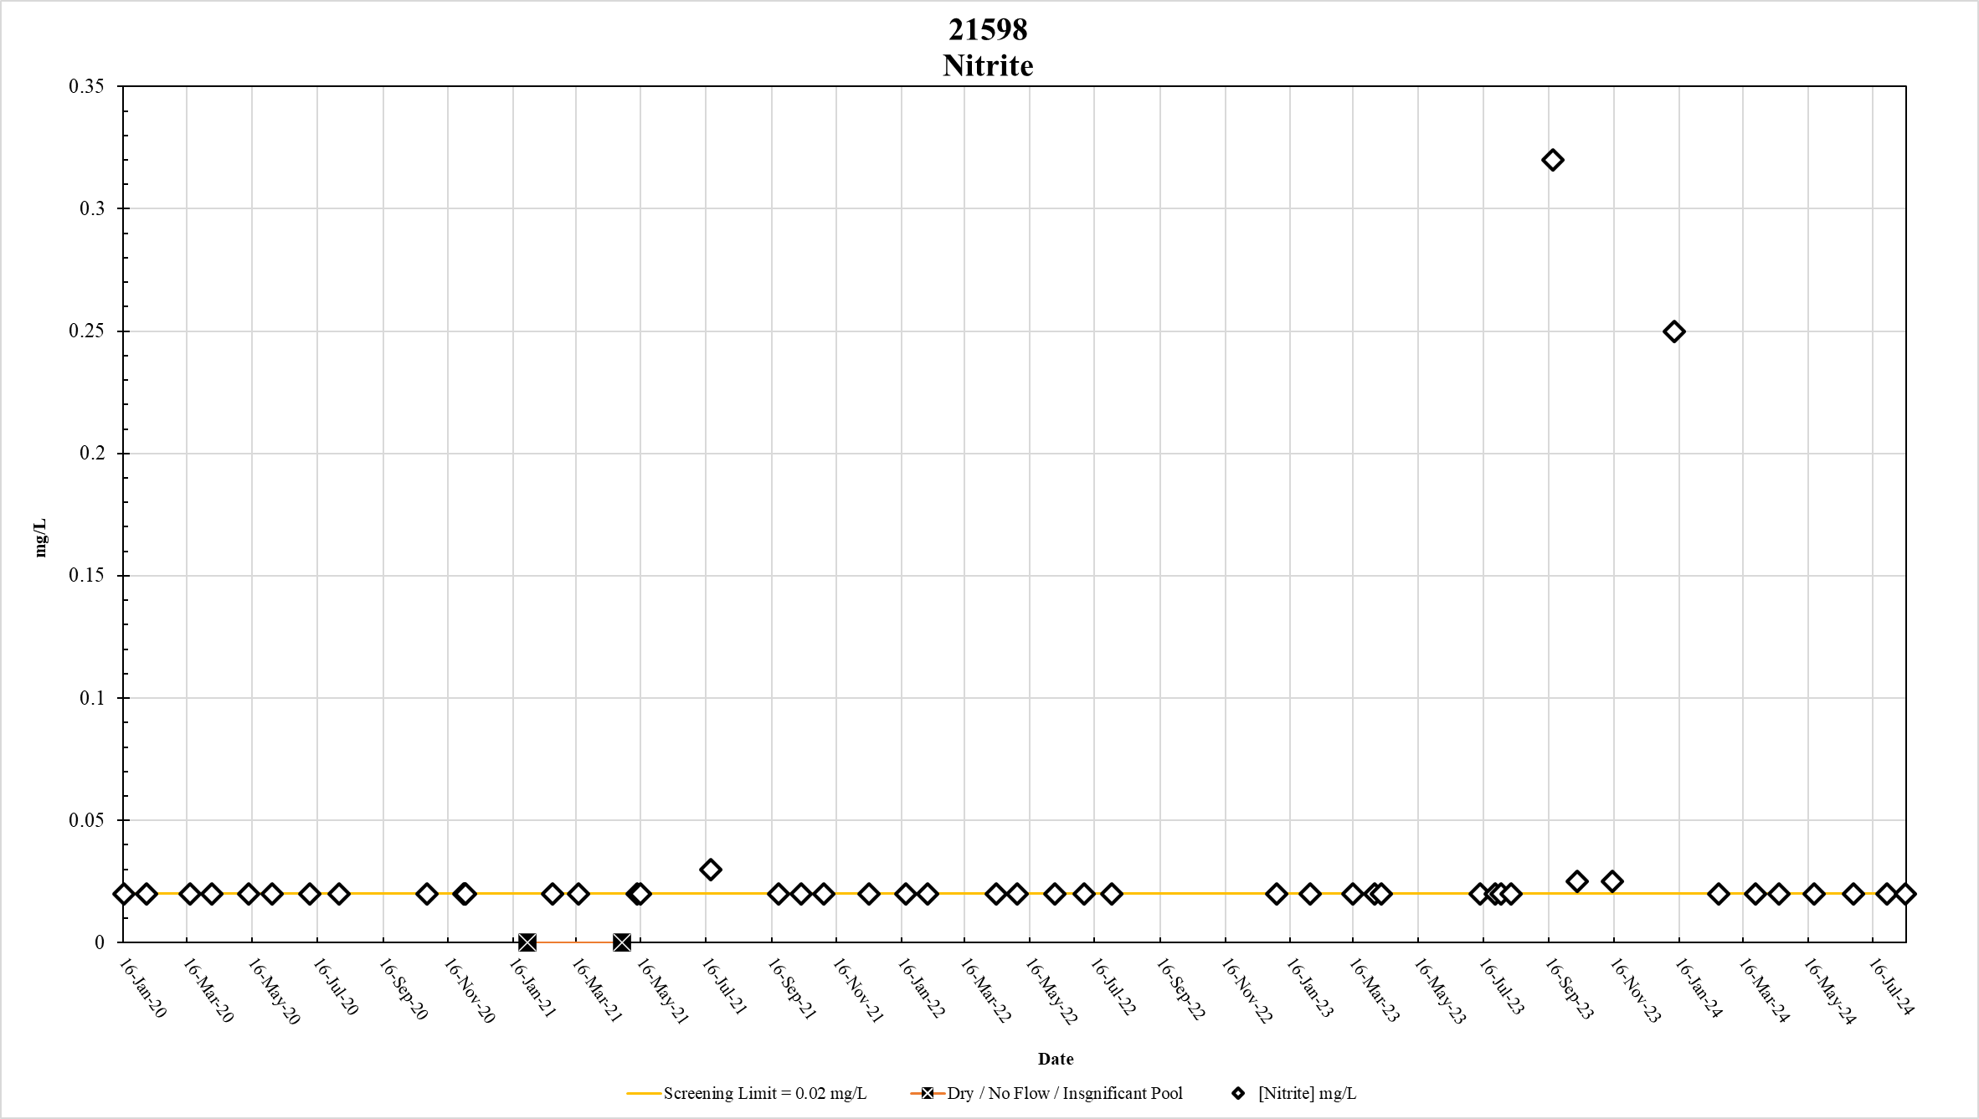
Figure 48. Station 21598 Nitrite results January 2020 – May 2024

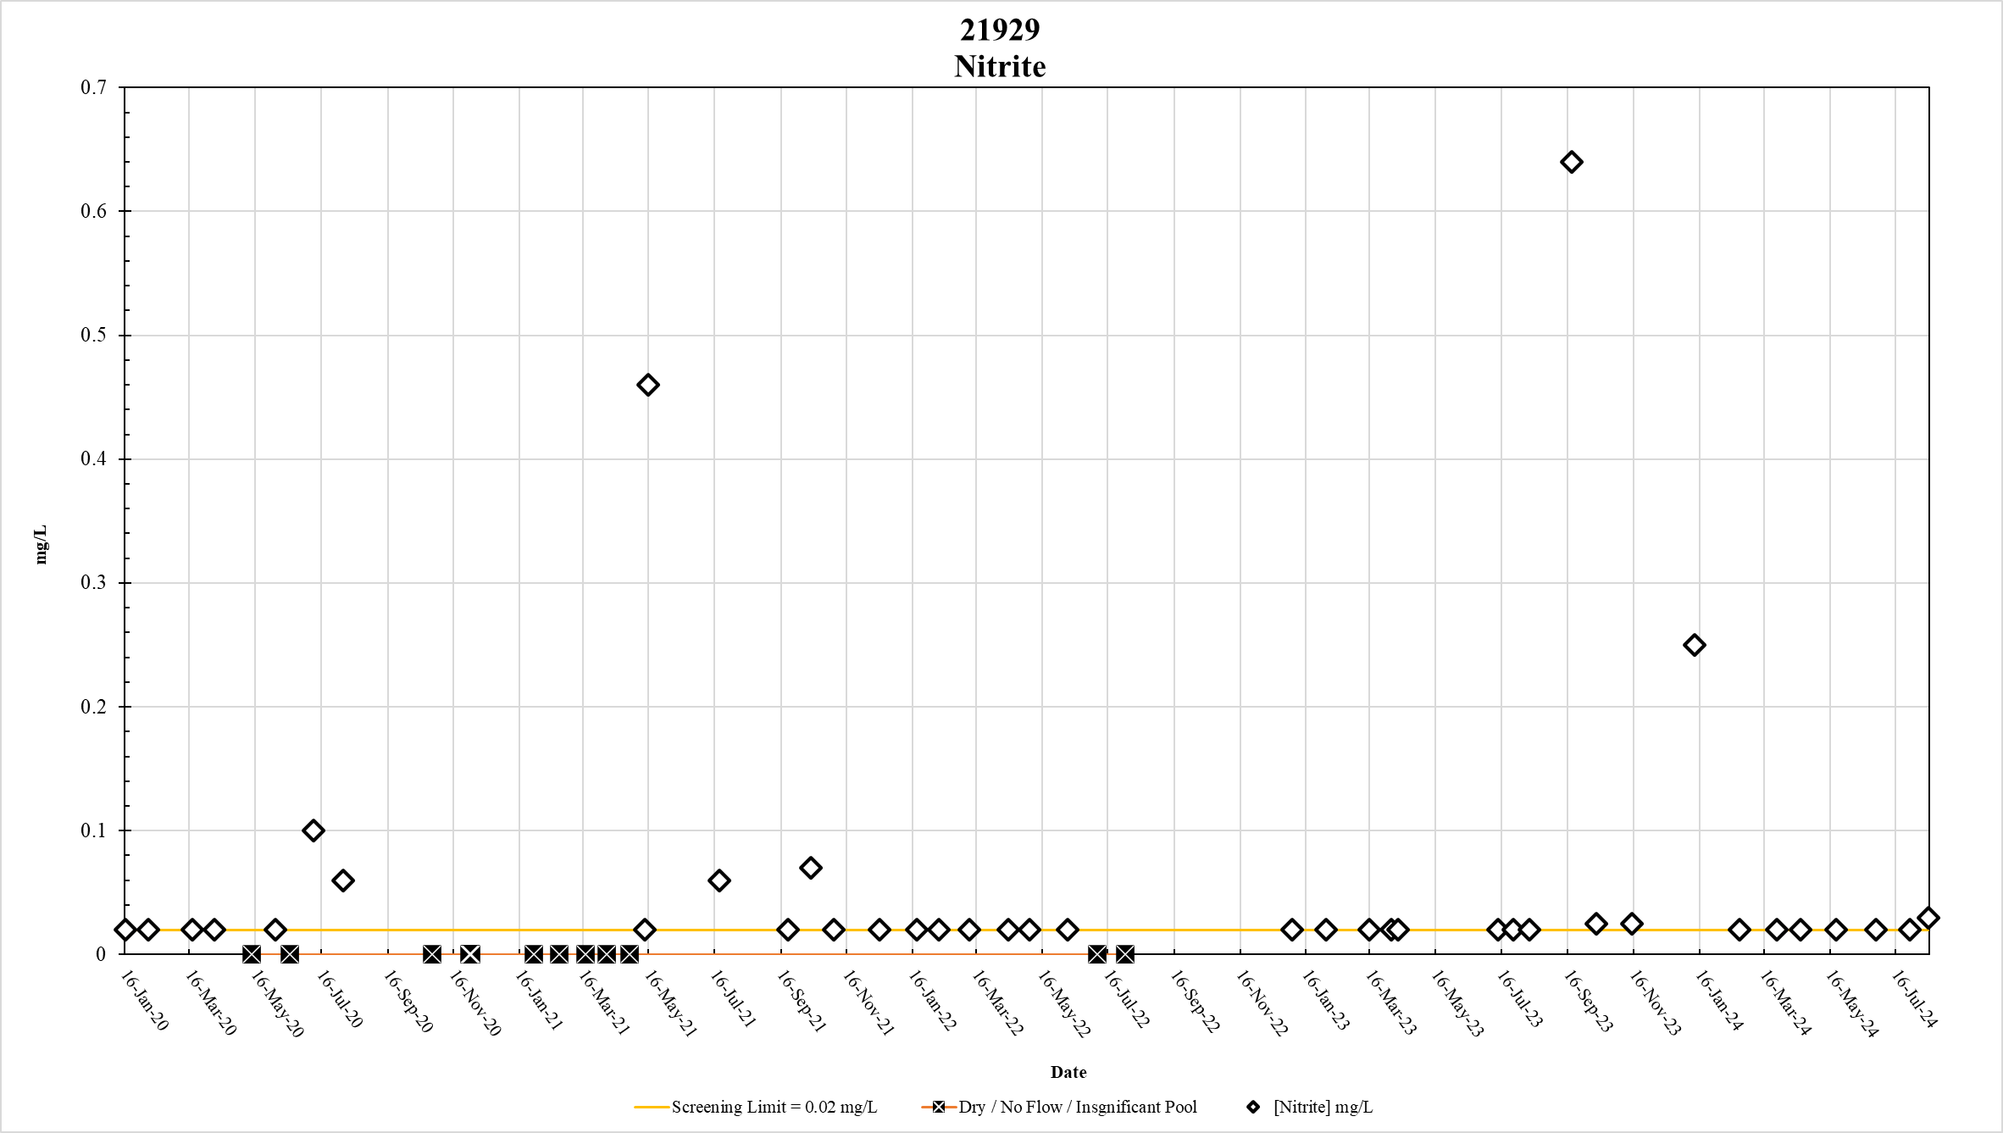
Figure 49. Station 21929 Nitrite results January 2020 – May 2024

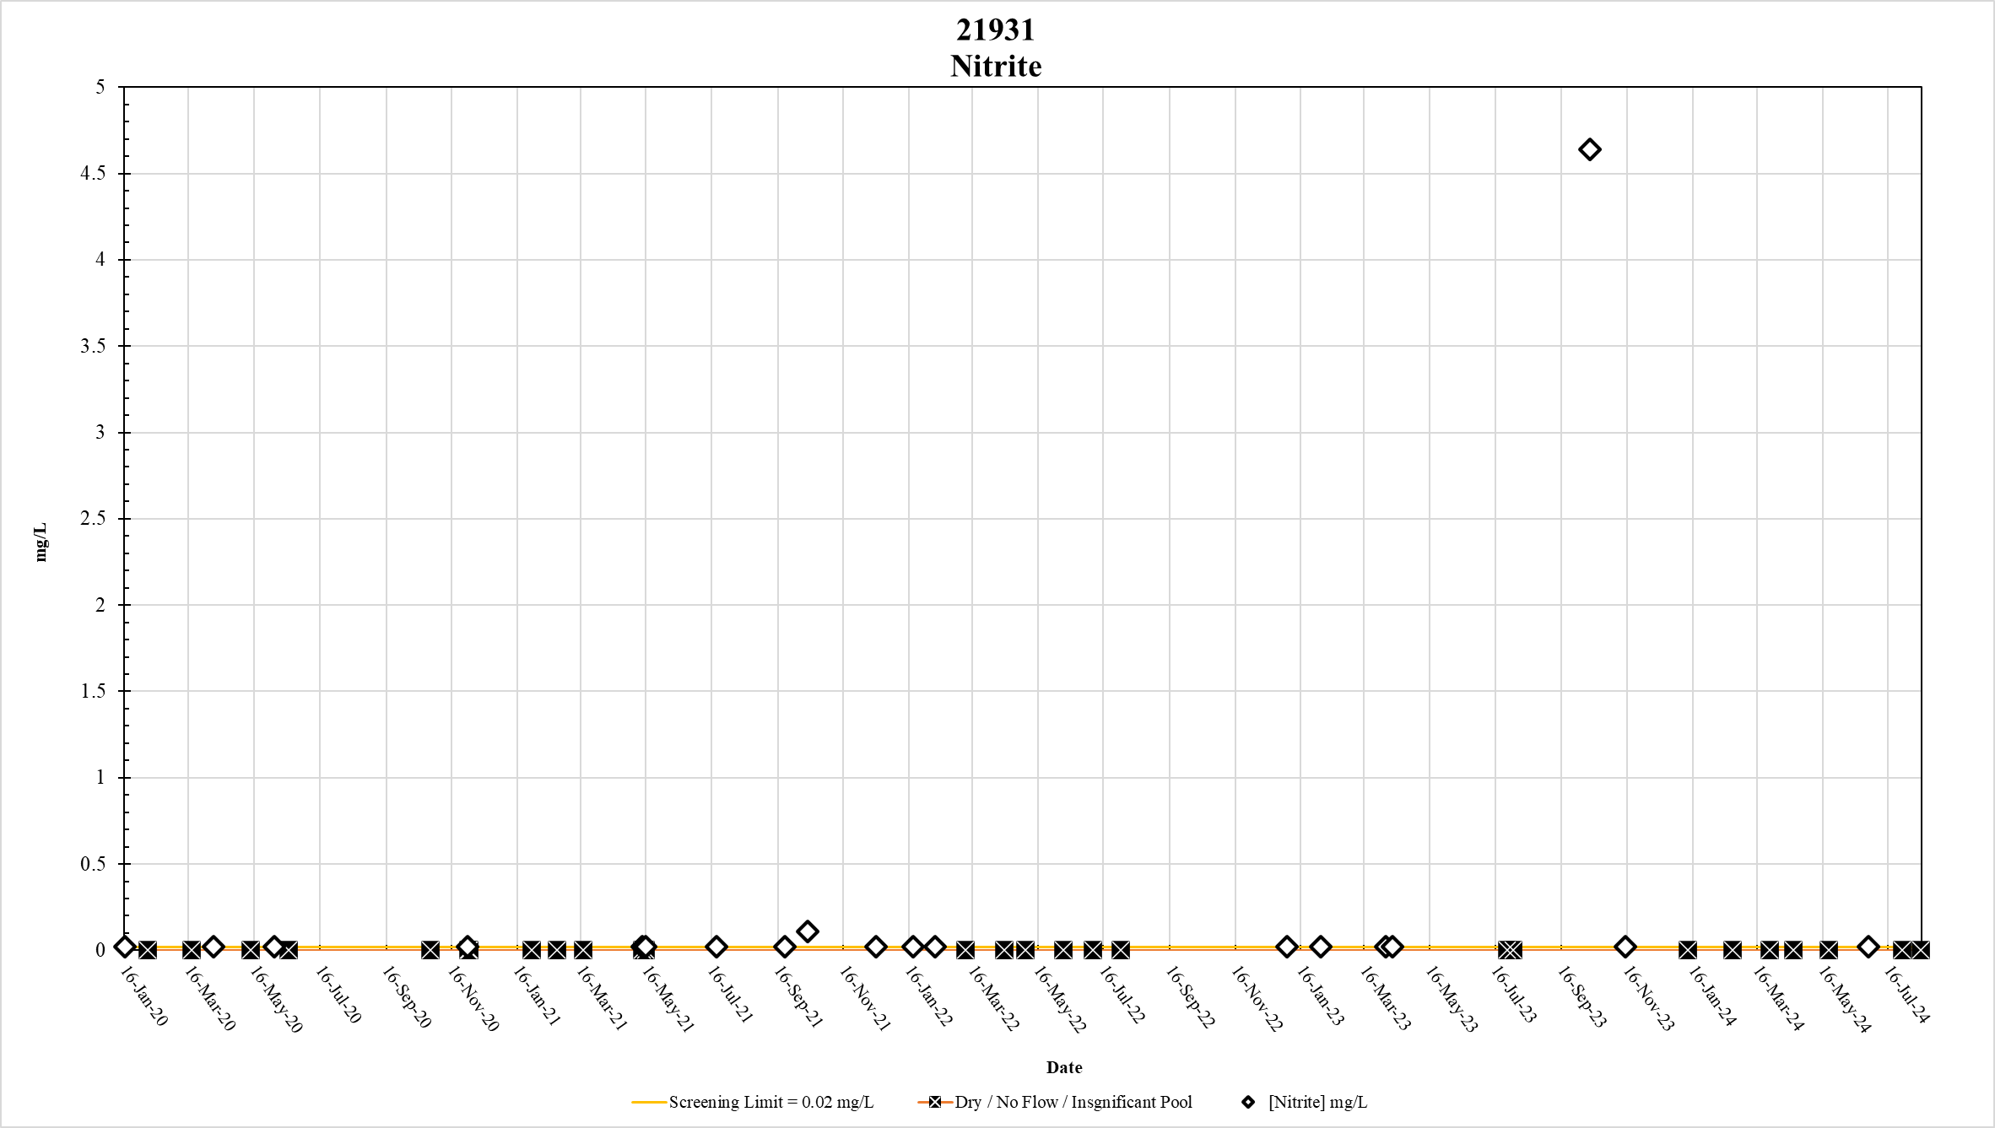
Figure 50. Station 21931 Nitrite results January 2020 – May 2024

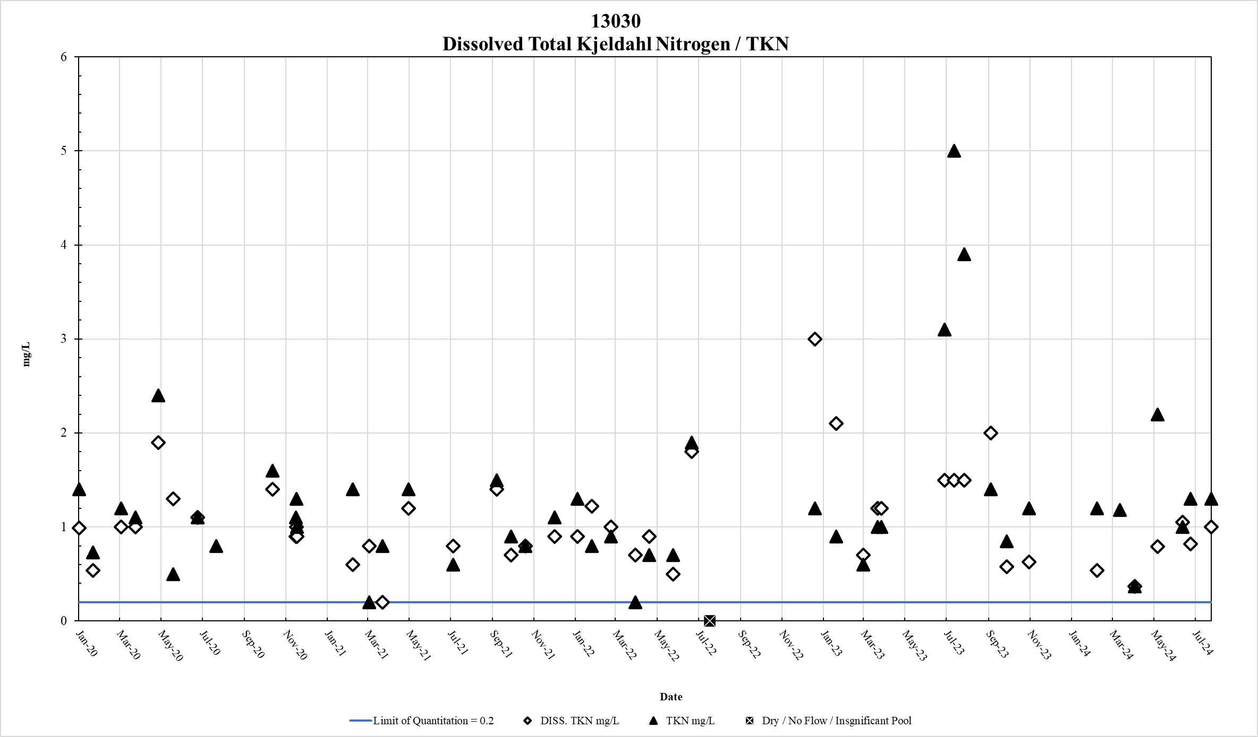
Figure 51. Station 13030 DTKN & TKN results January 2020 – May 2024

.

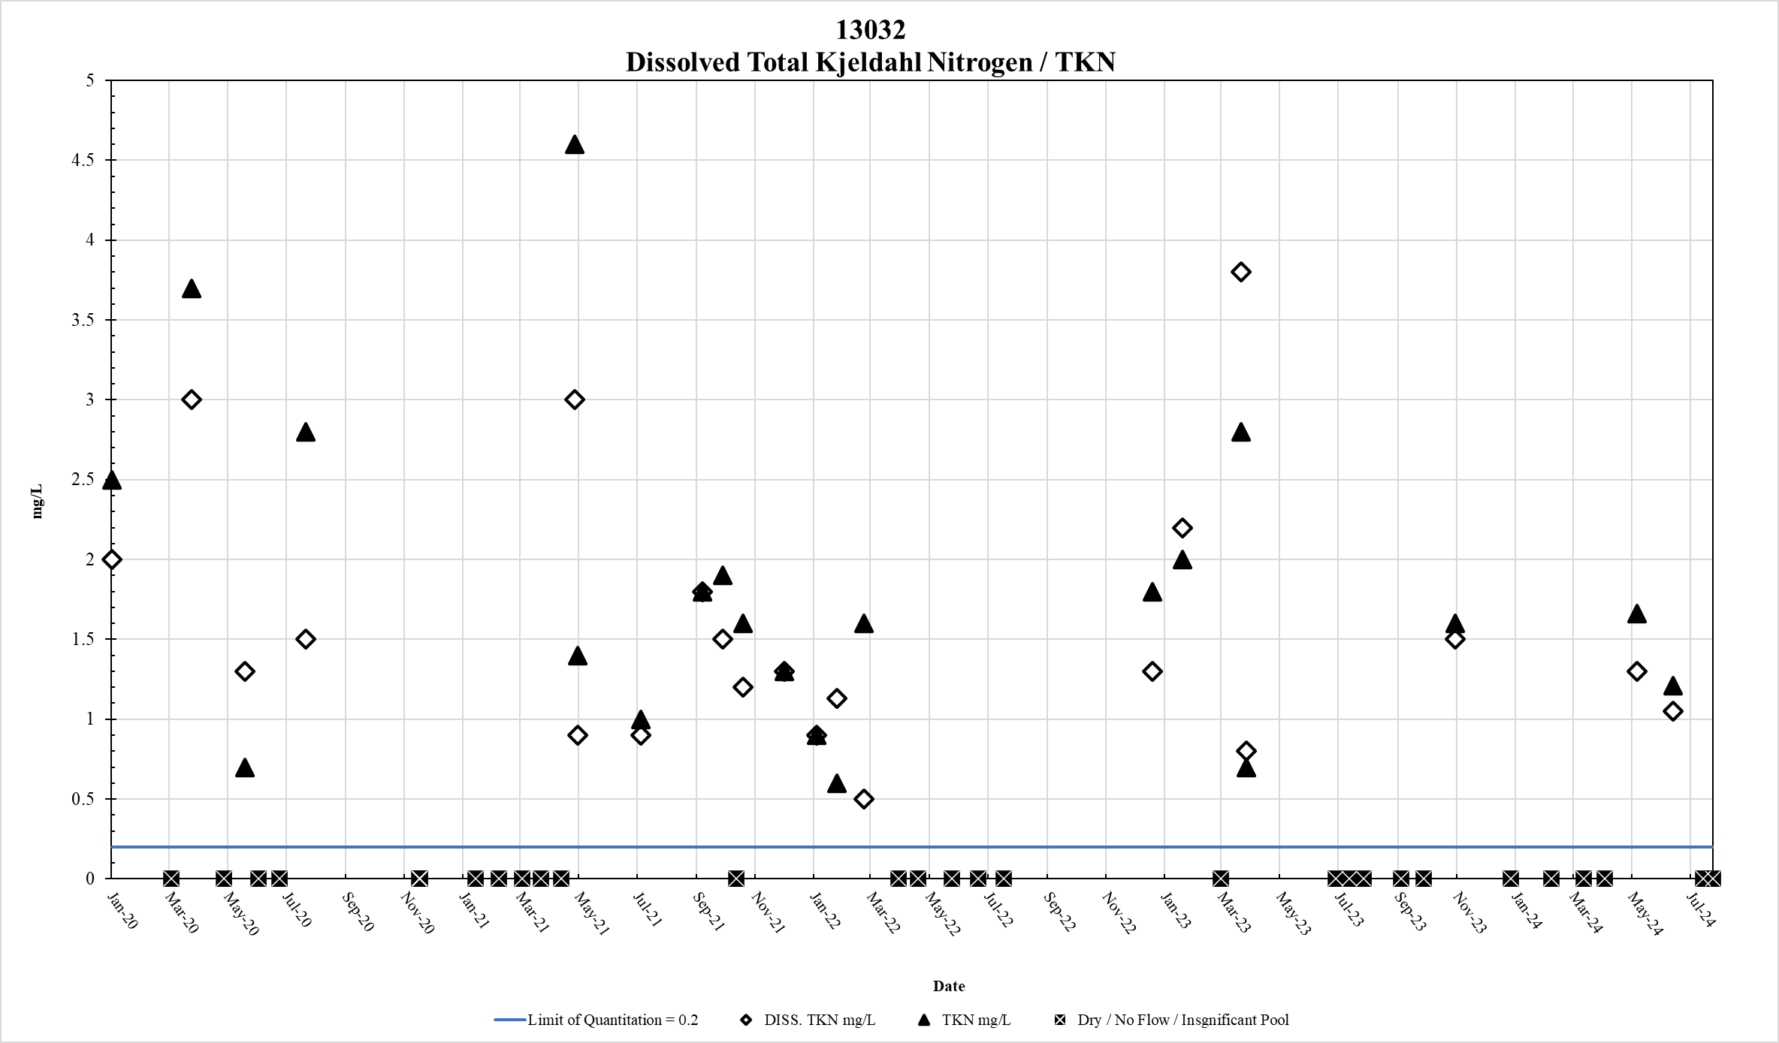
Figure 52. Station 13032 DTKN & TKN results January 2020 – May 2024

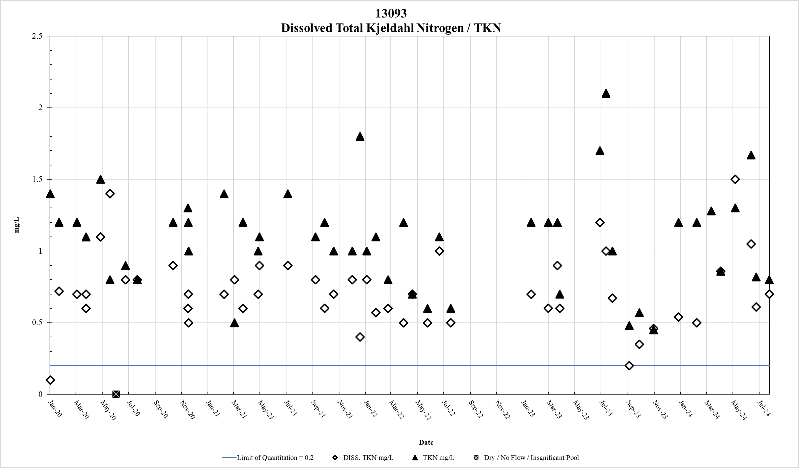

Figure 53. Station 13093 DTKN & TKN results January 2020 – May 2024

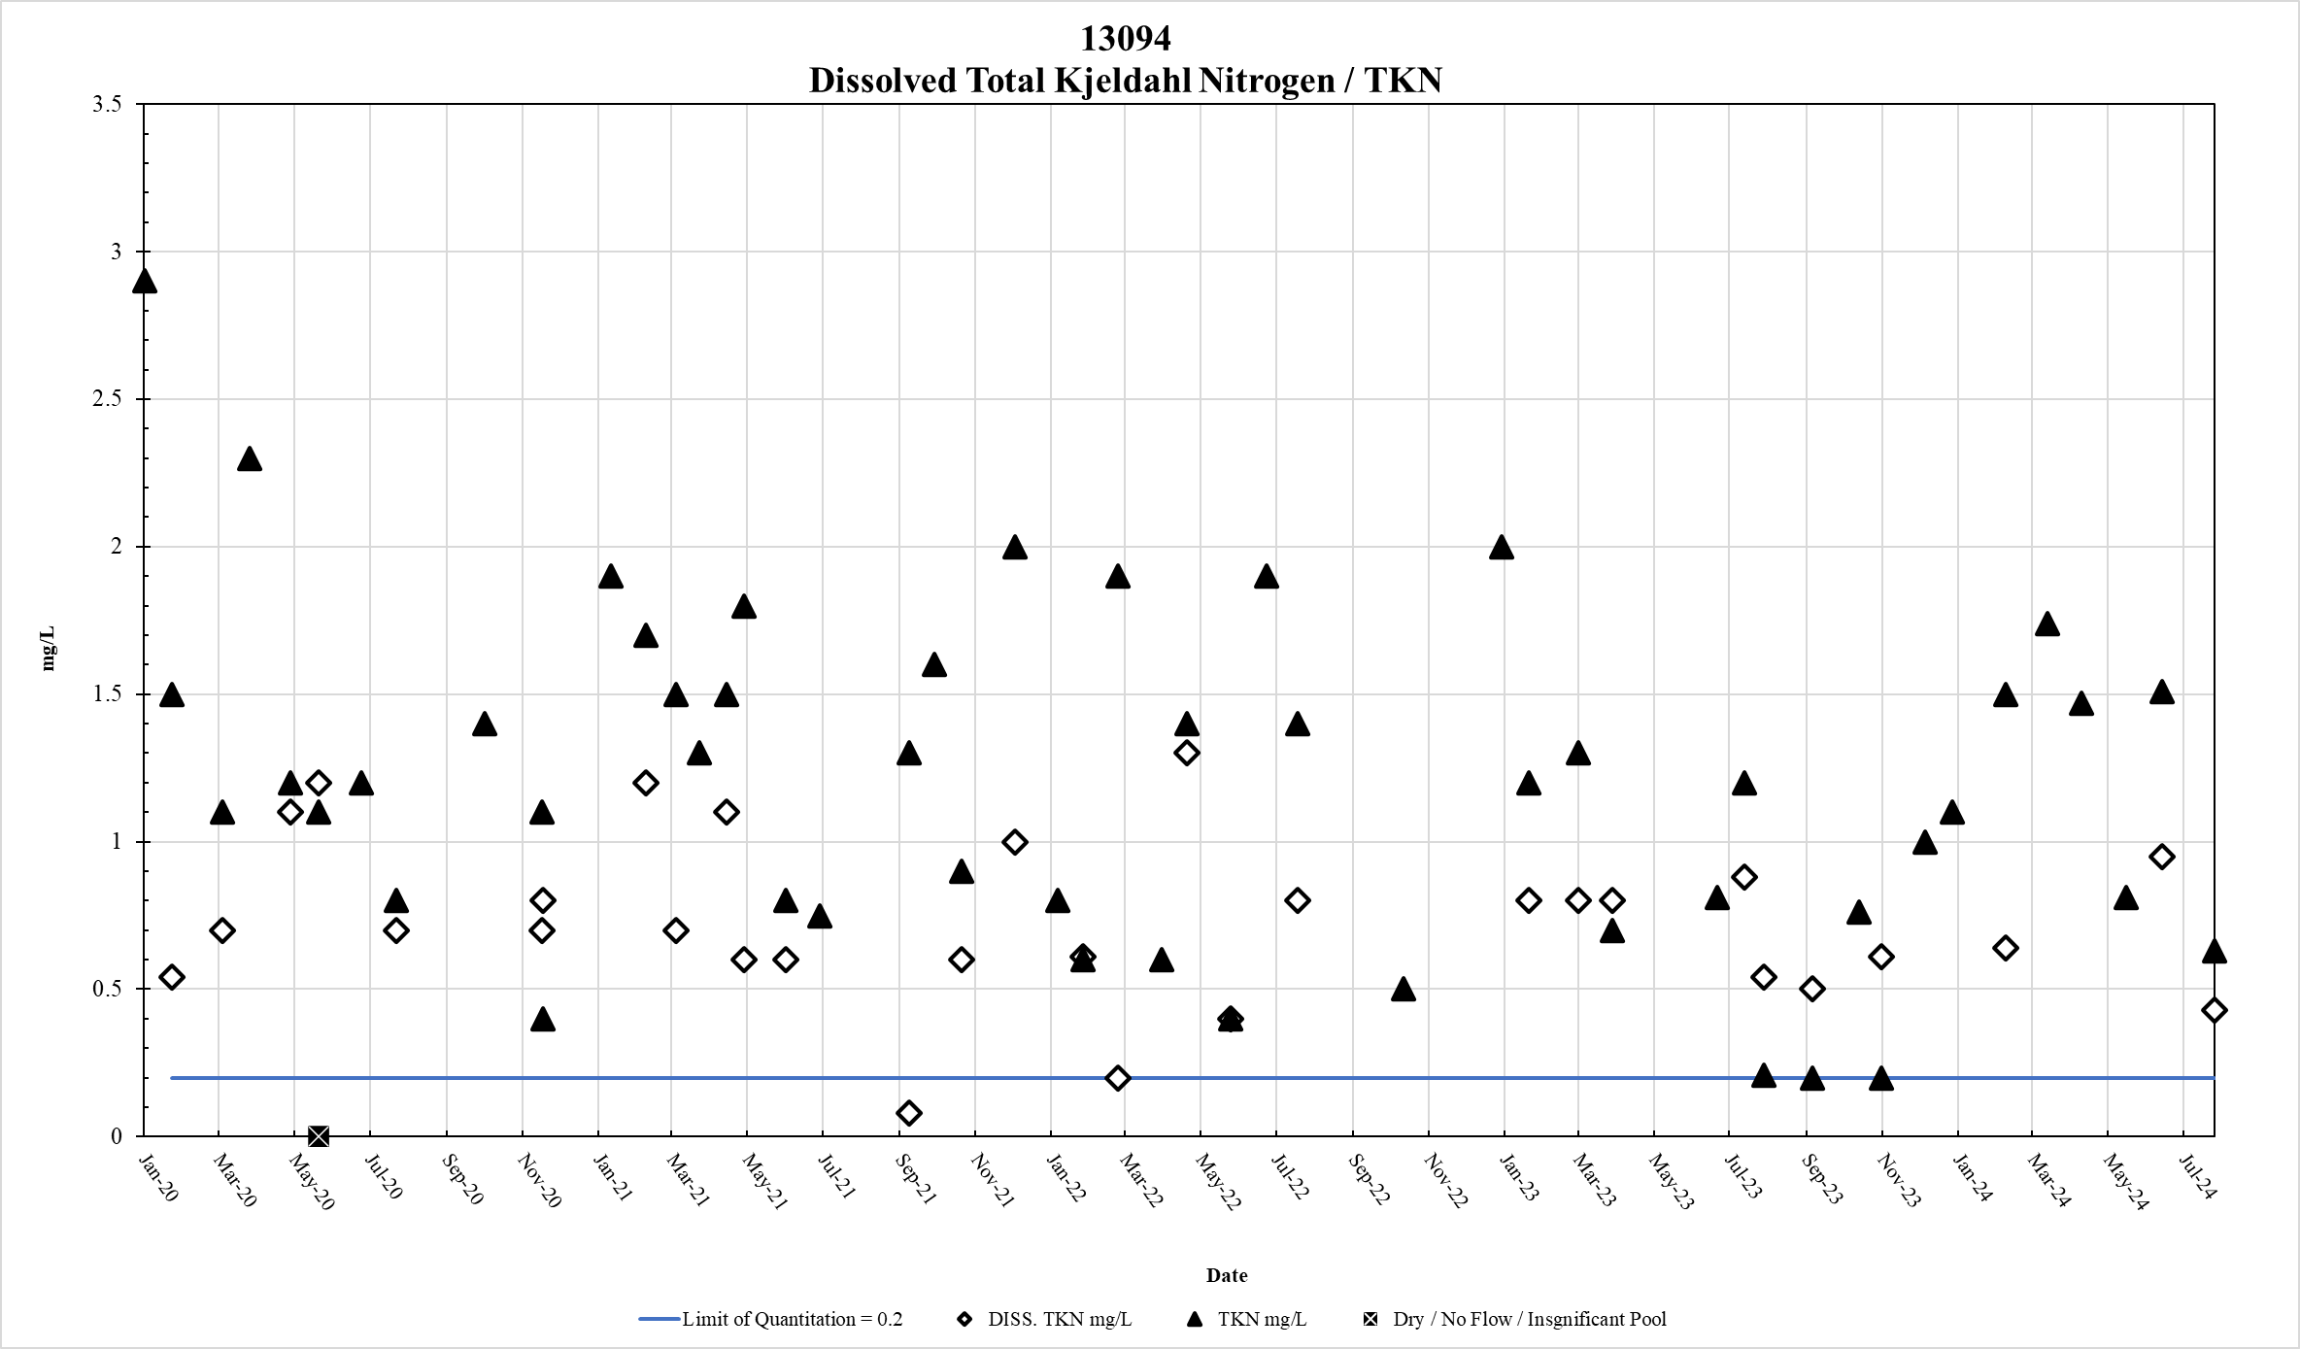
Figure 54. Station 13094 DTKN & TKN results January 2020 – May 2024

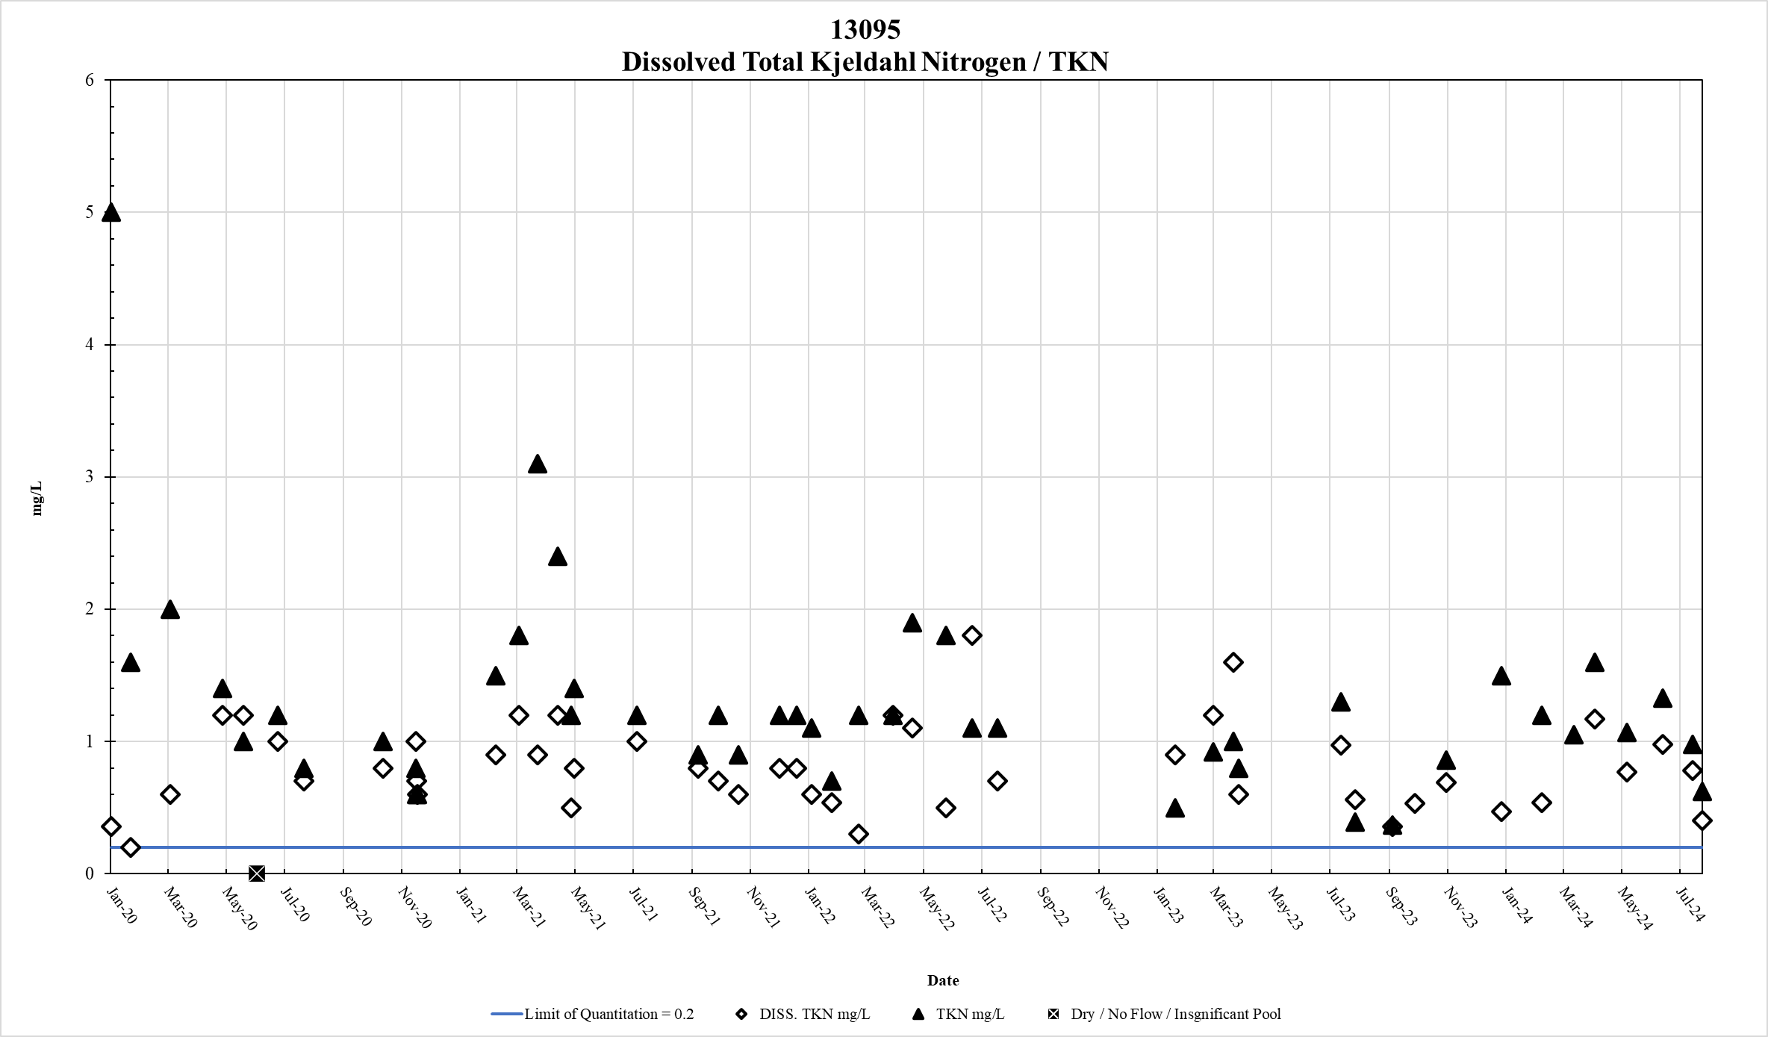
Figure 55. Station 13095 DTKN & TKN results January 2020 – May 2024

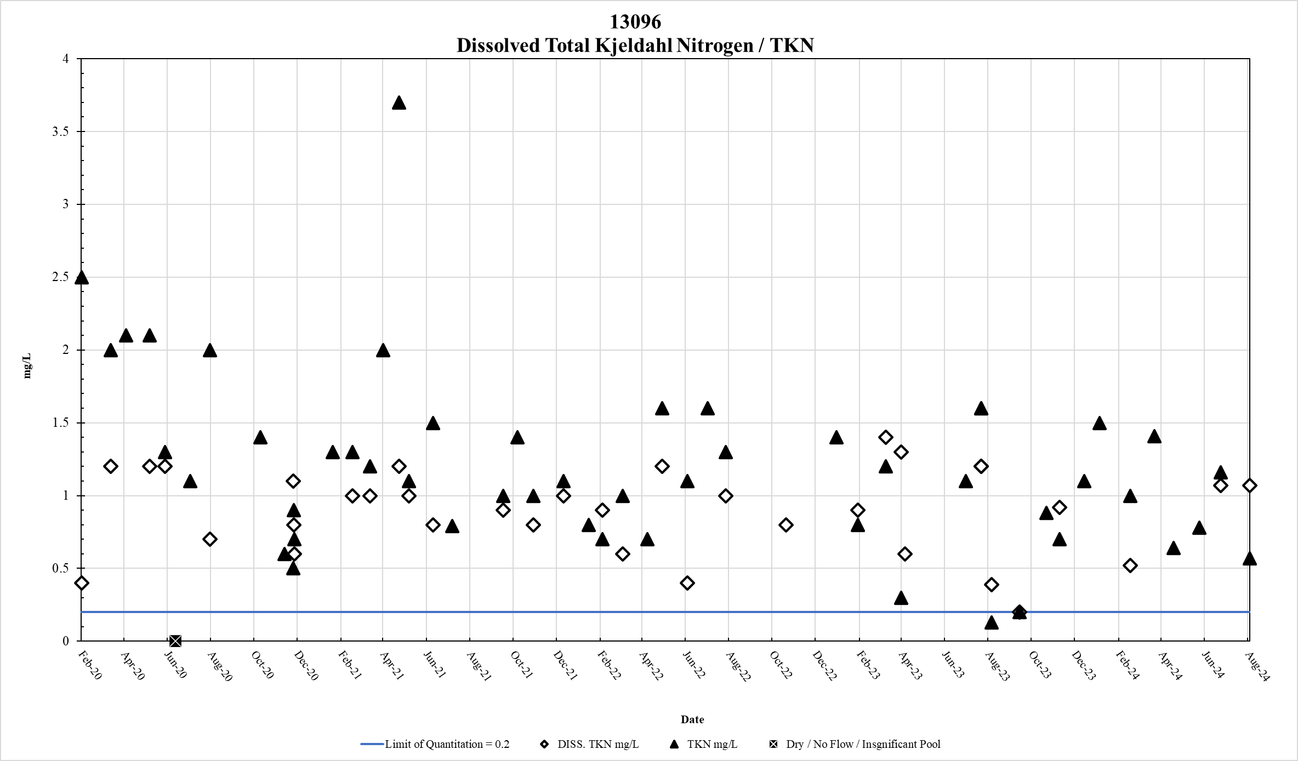
Figure 56. Station 13096 DTKN & TKN results January 2020 – May 2024

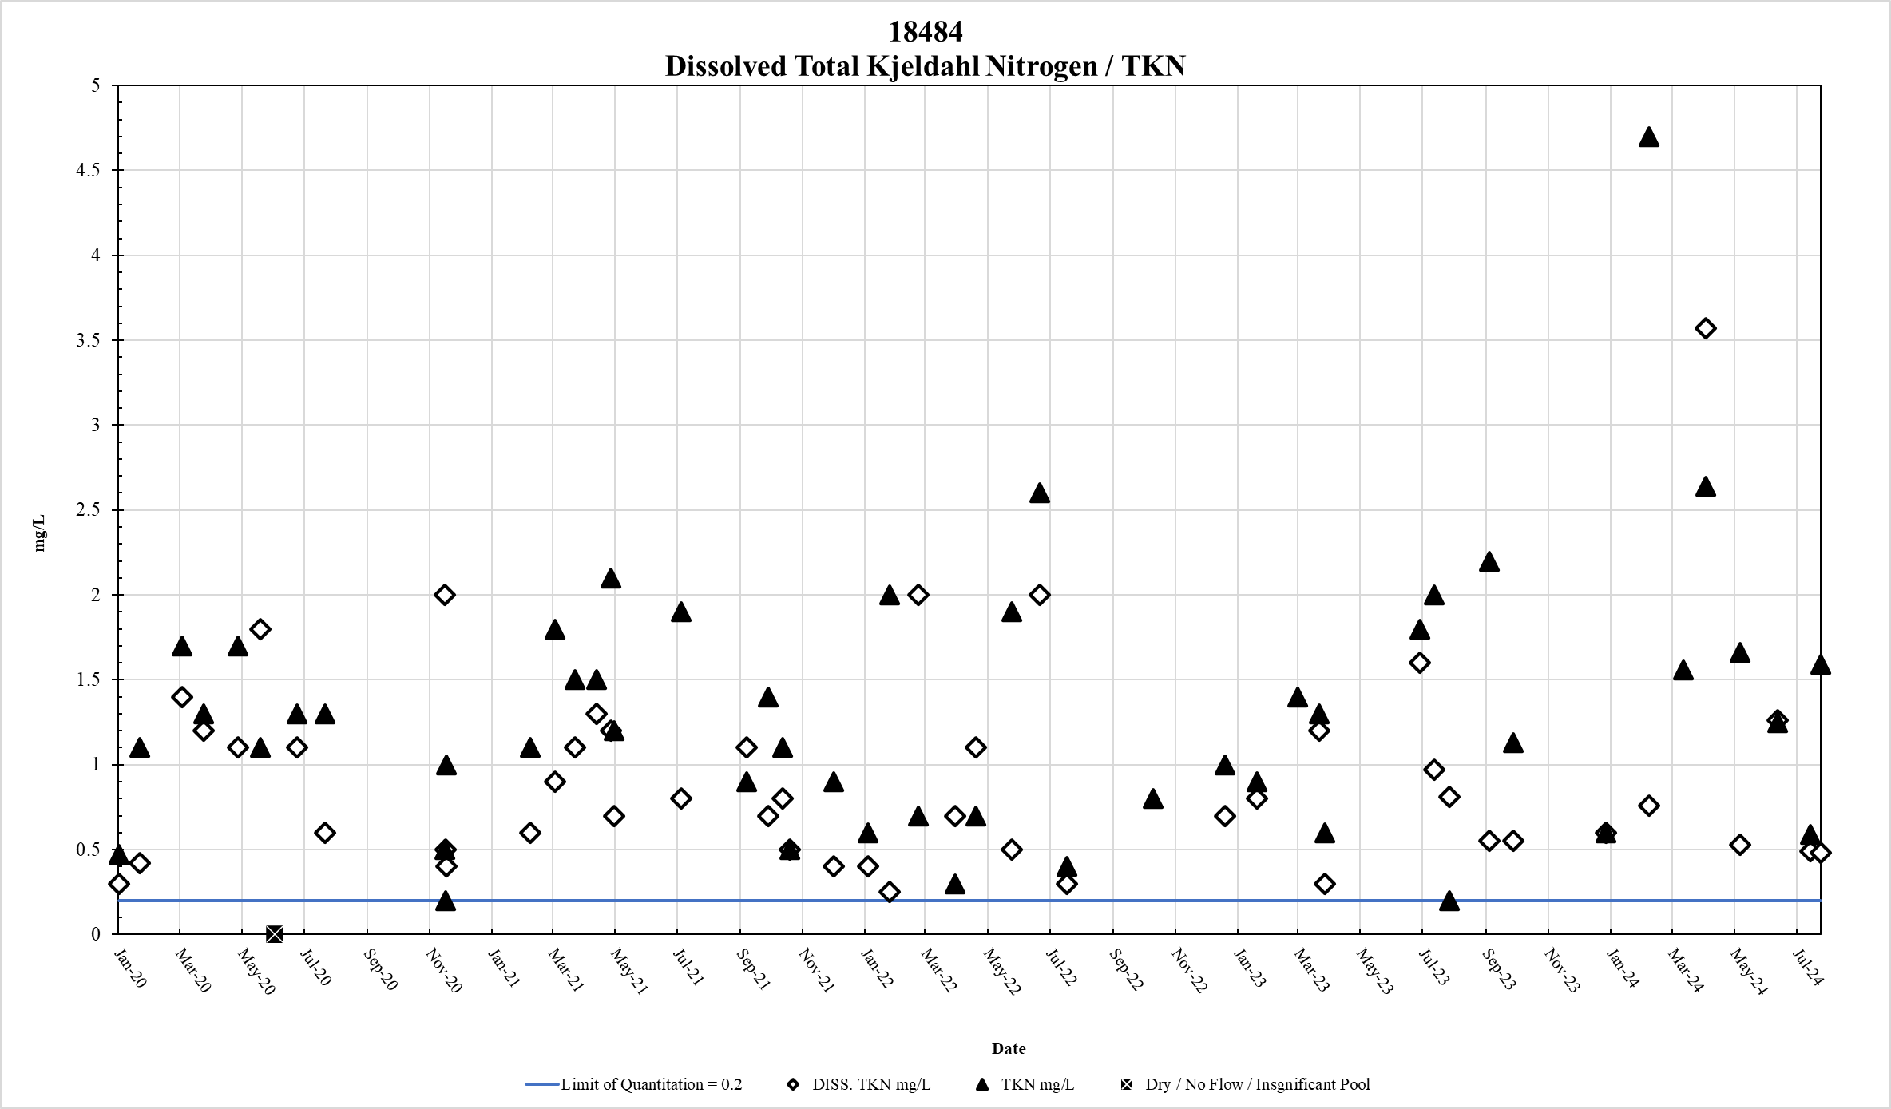
Figure 57. Station 18484 DTKN & TKN results January 2020 – May 2024

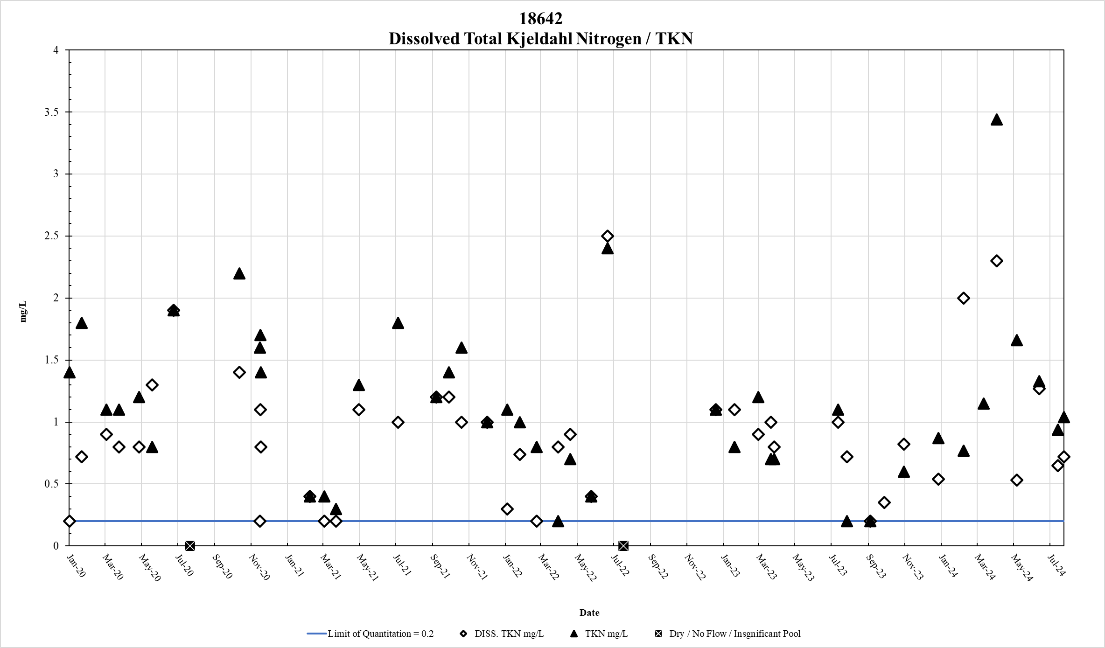
Figure 58. Station 18642 DTKN & TKN results January 2020 – May 2024

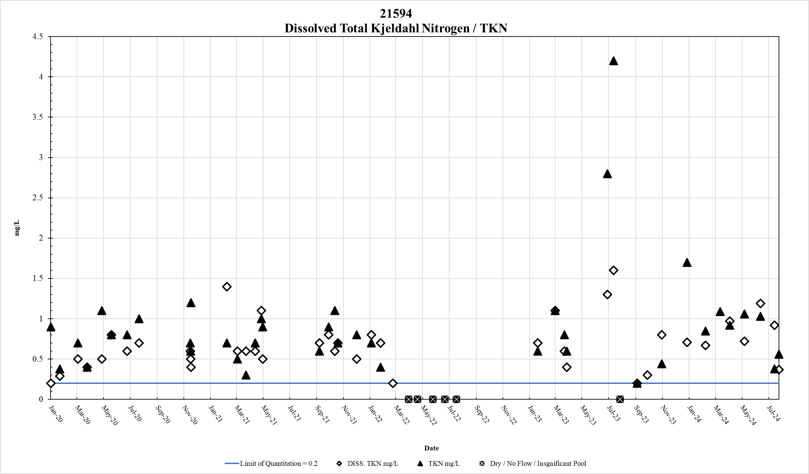
Figure 59. Station 21594 DTKN & TKN results January 2020 – May 2024

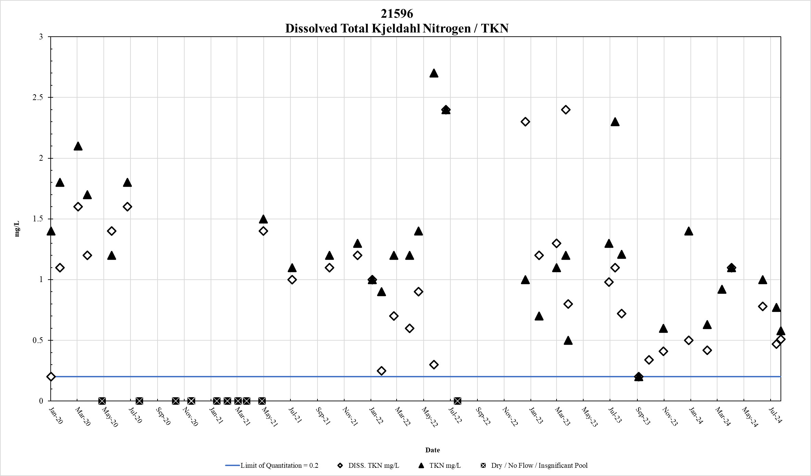
Figure 60. Station 21596 DTKN & TKN results January 2020 – May 2024

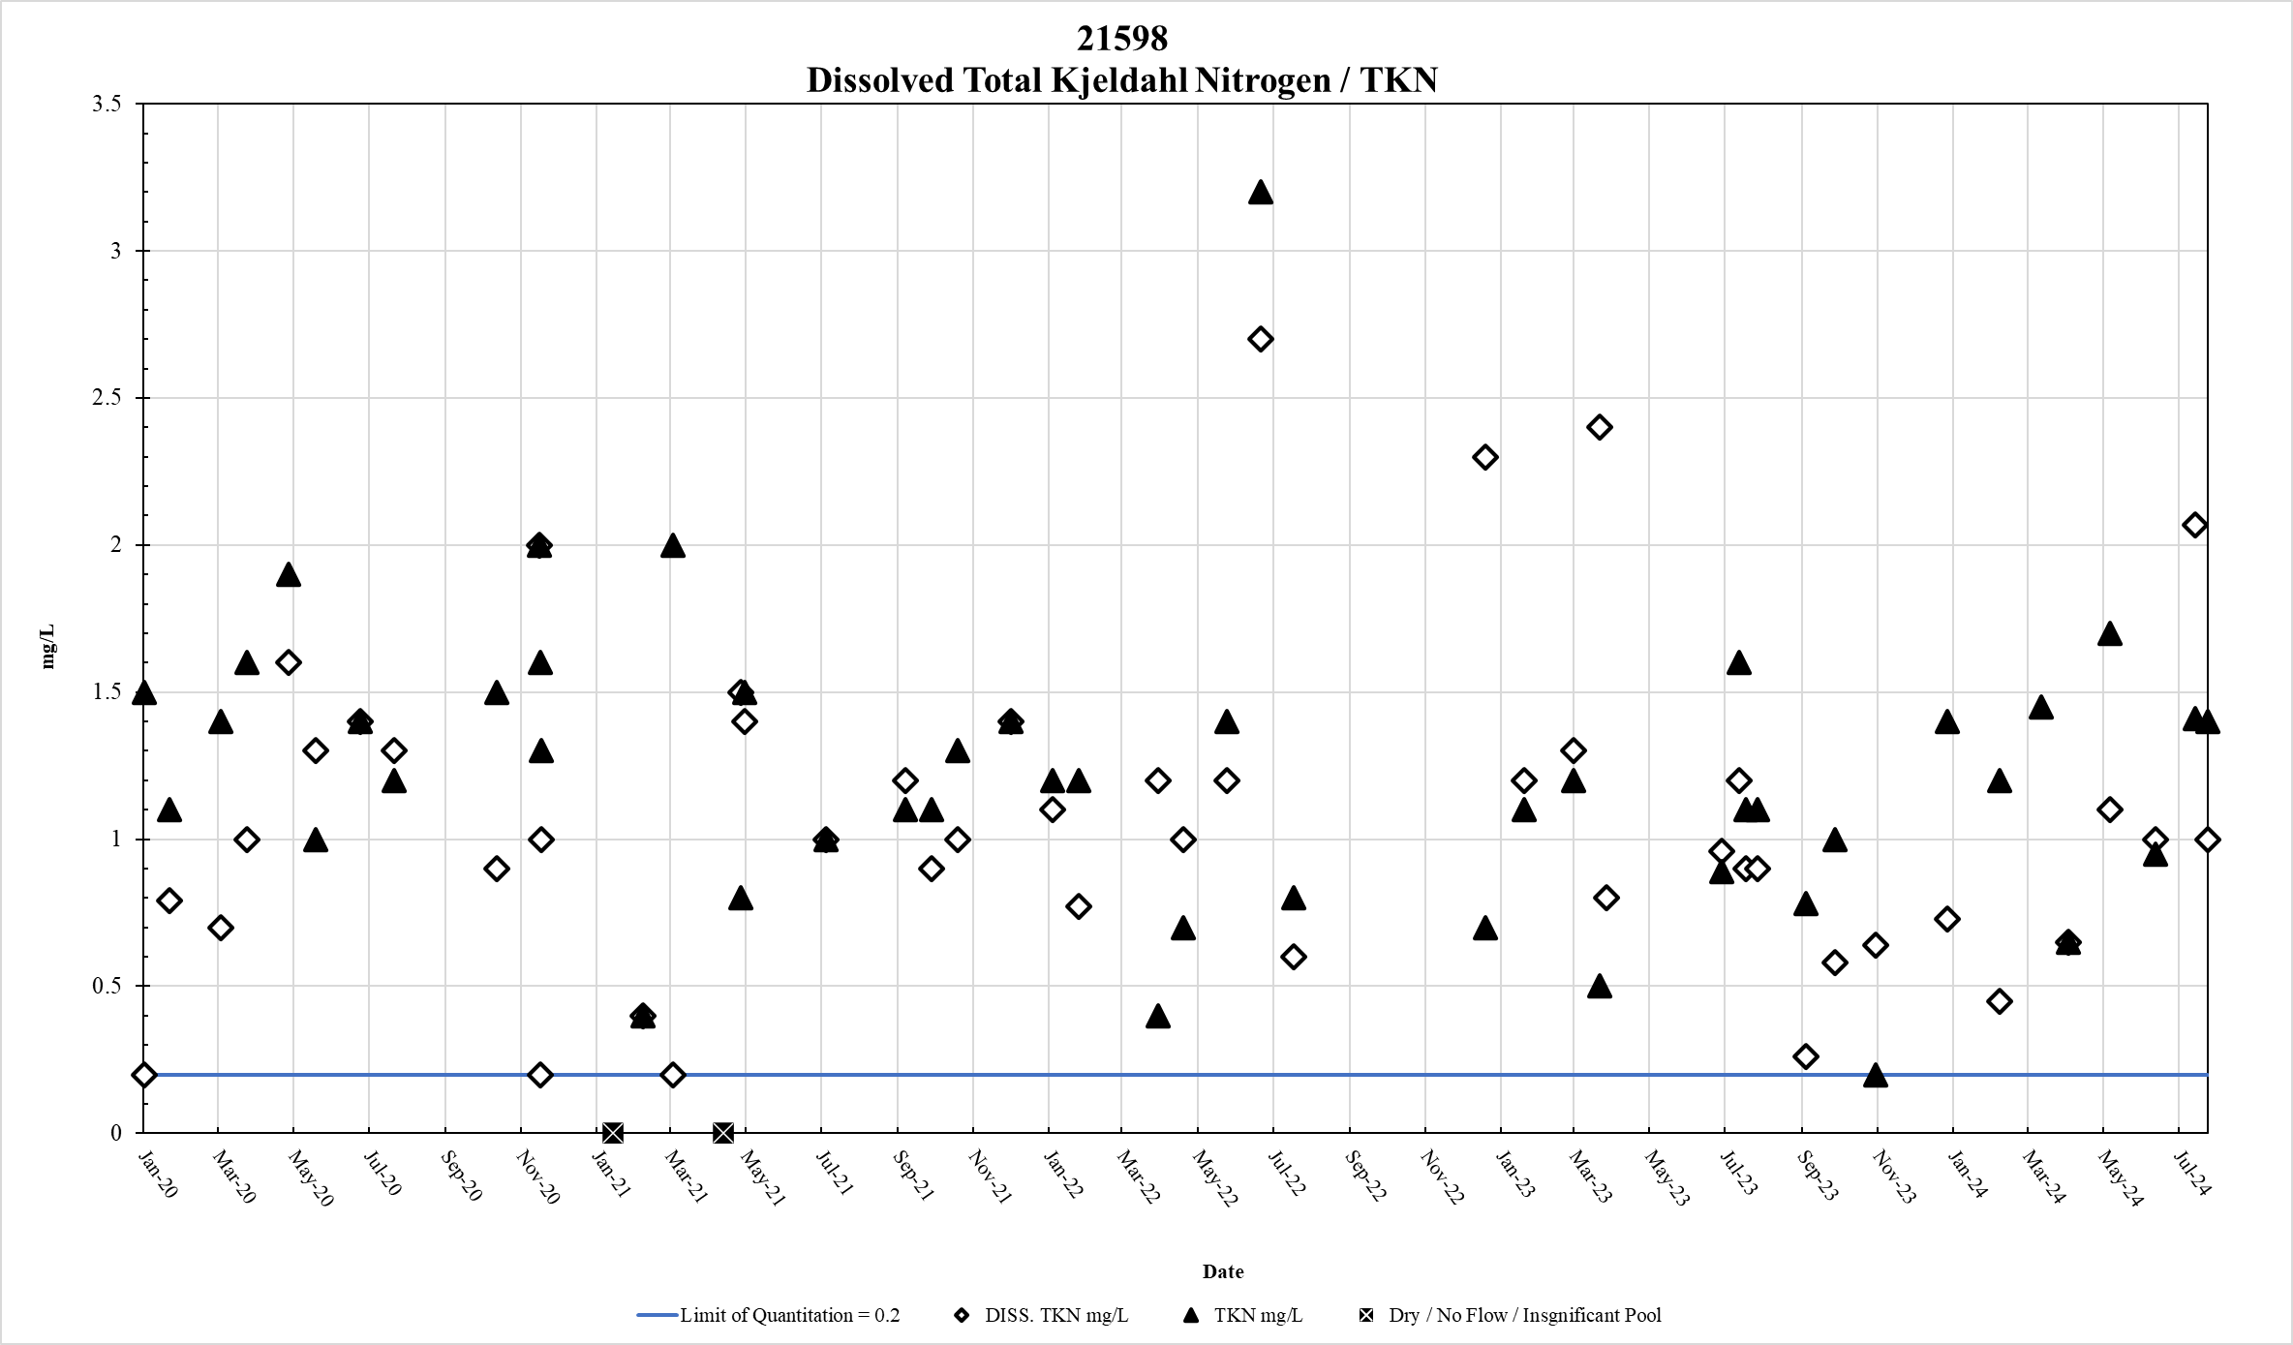
Figure 61. Station 21598 DTKN & TKN results January 2020 – May 2024

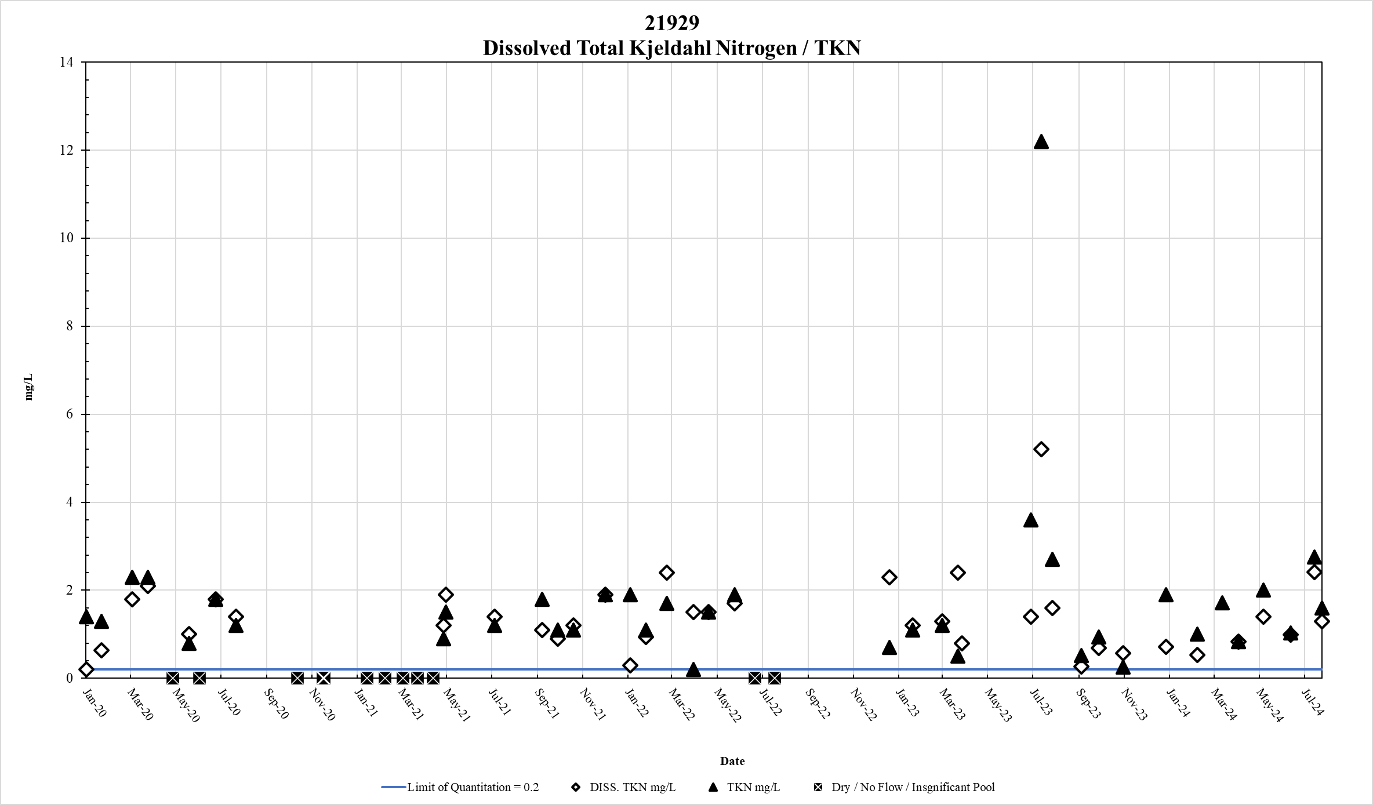
Figure 62. Station 21929 DTKN & TKN results January 2020 – May 2024

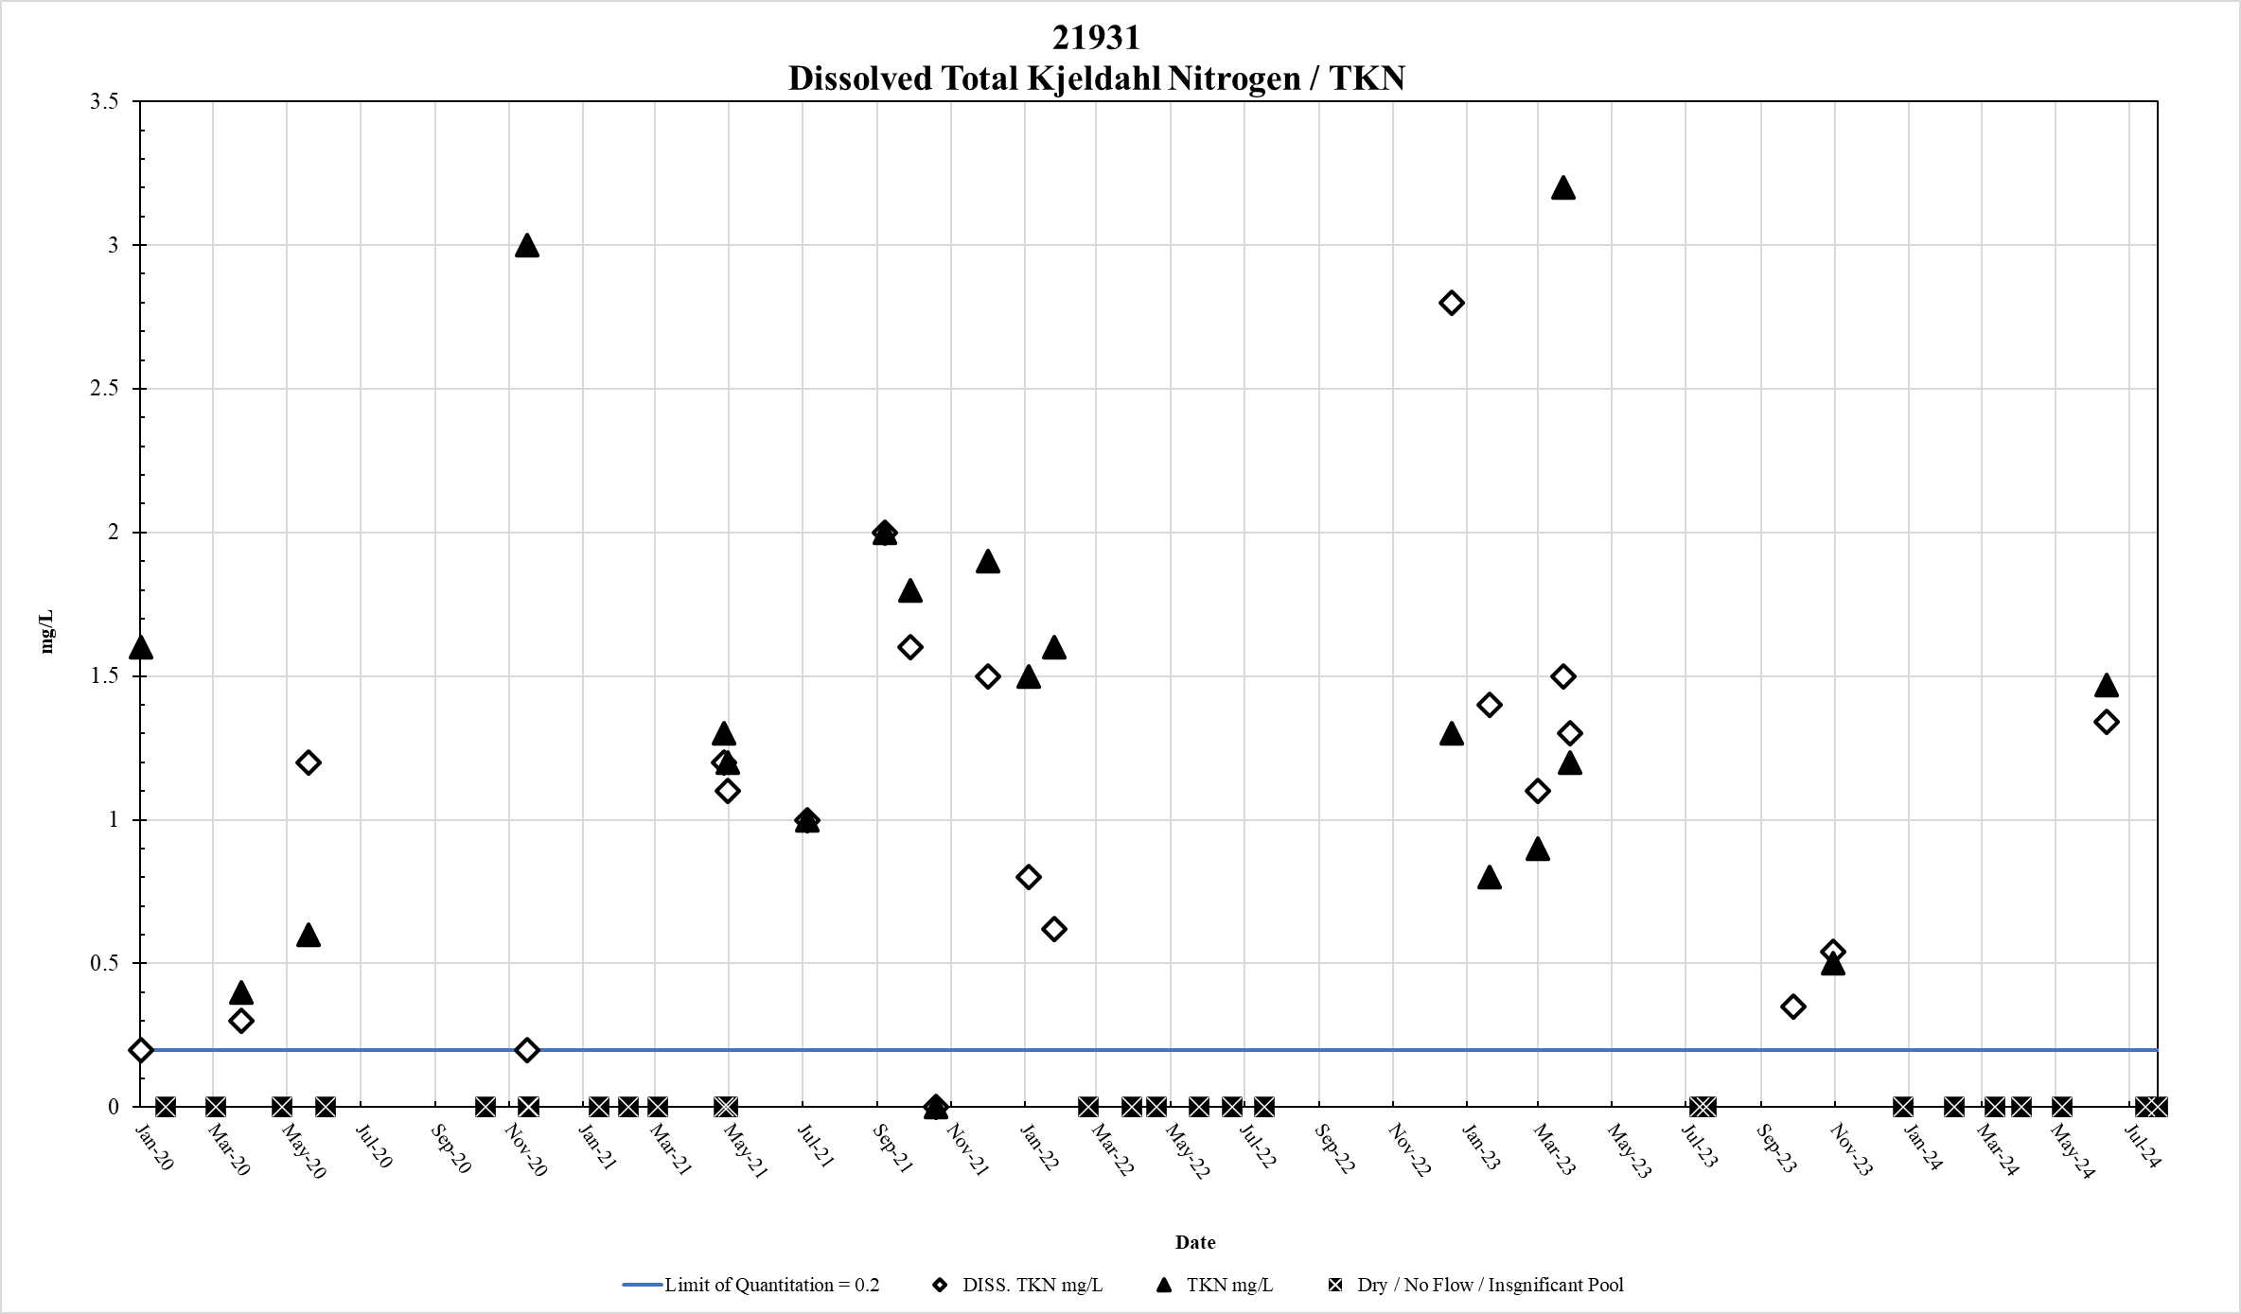
Figure 63. Station 21931 DTKN & TKN results January 2020 – May 2024

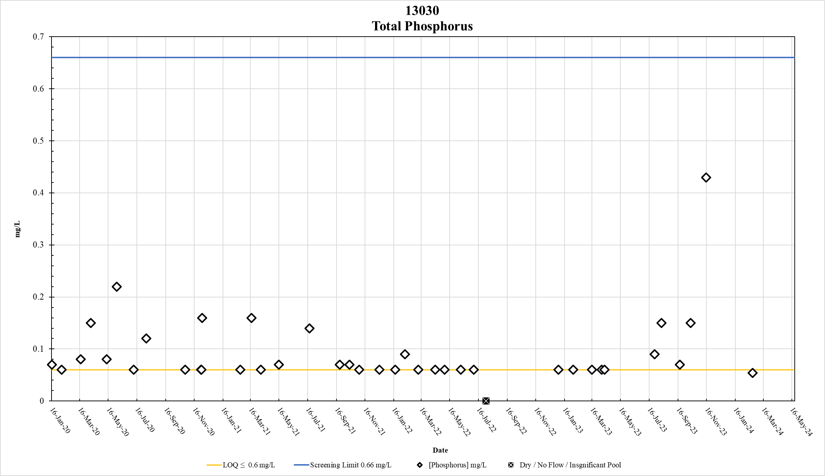
Figure 64. Station 13030 Total Phosphorus results January 2020 – May 2024

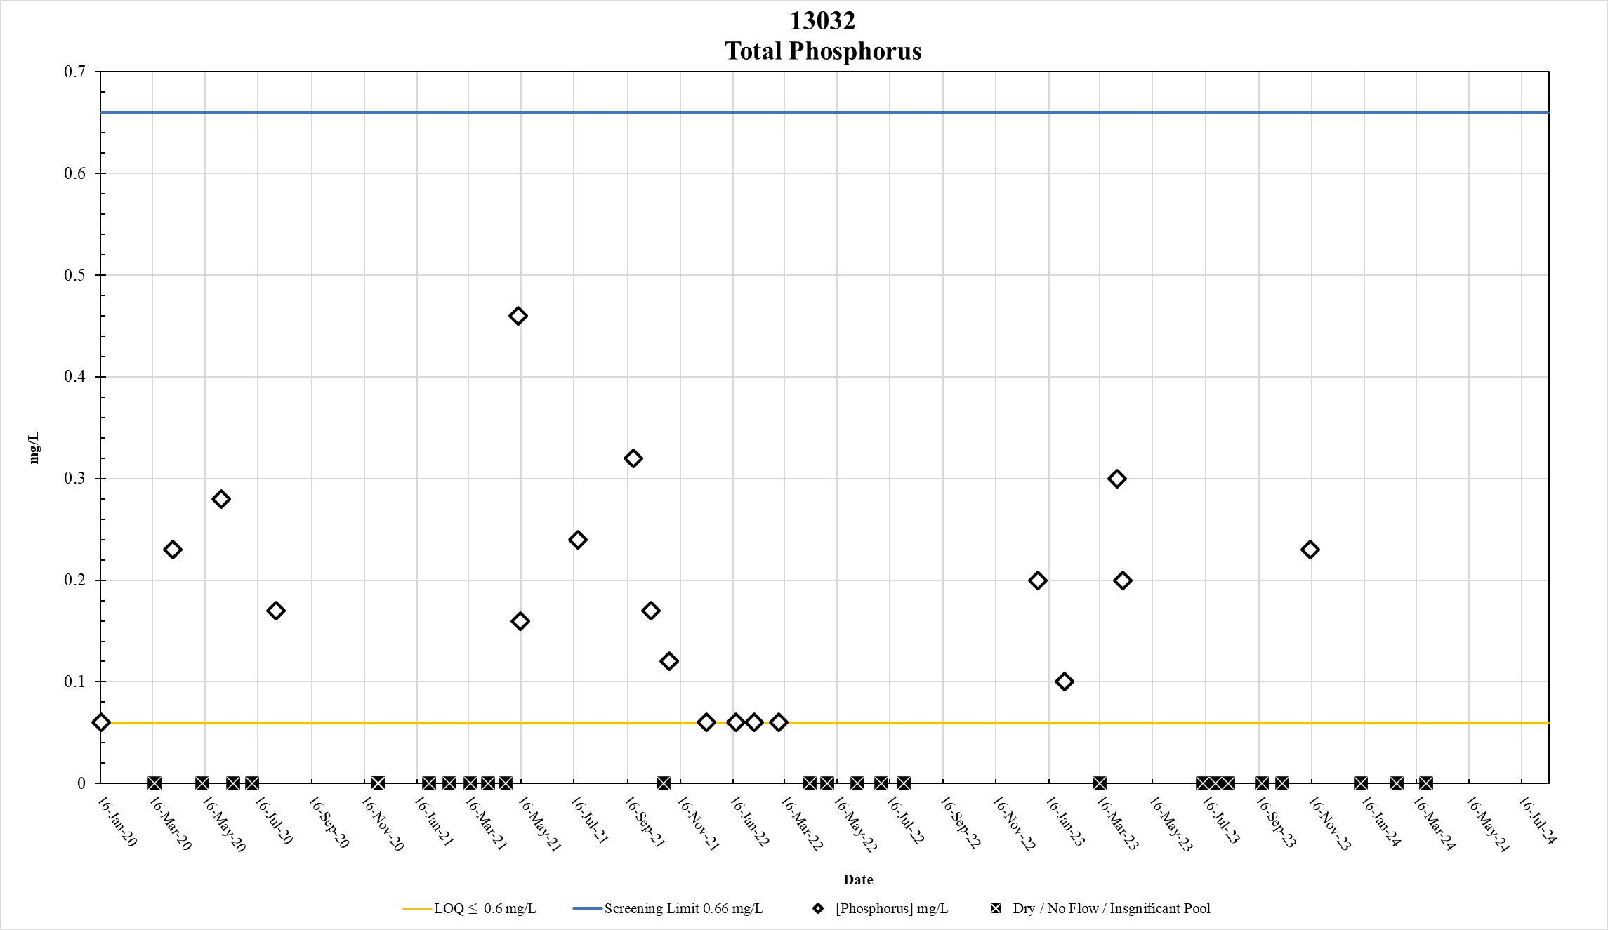
Figure 65. Station 13032 Total Phosphorus results January 2020 – May 2024

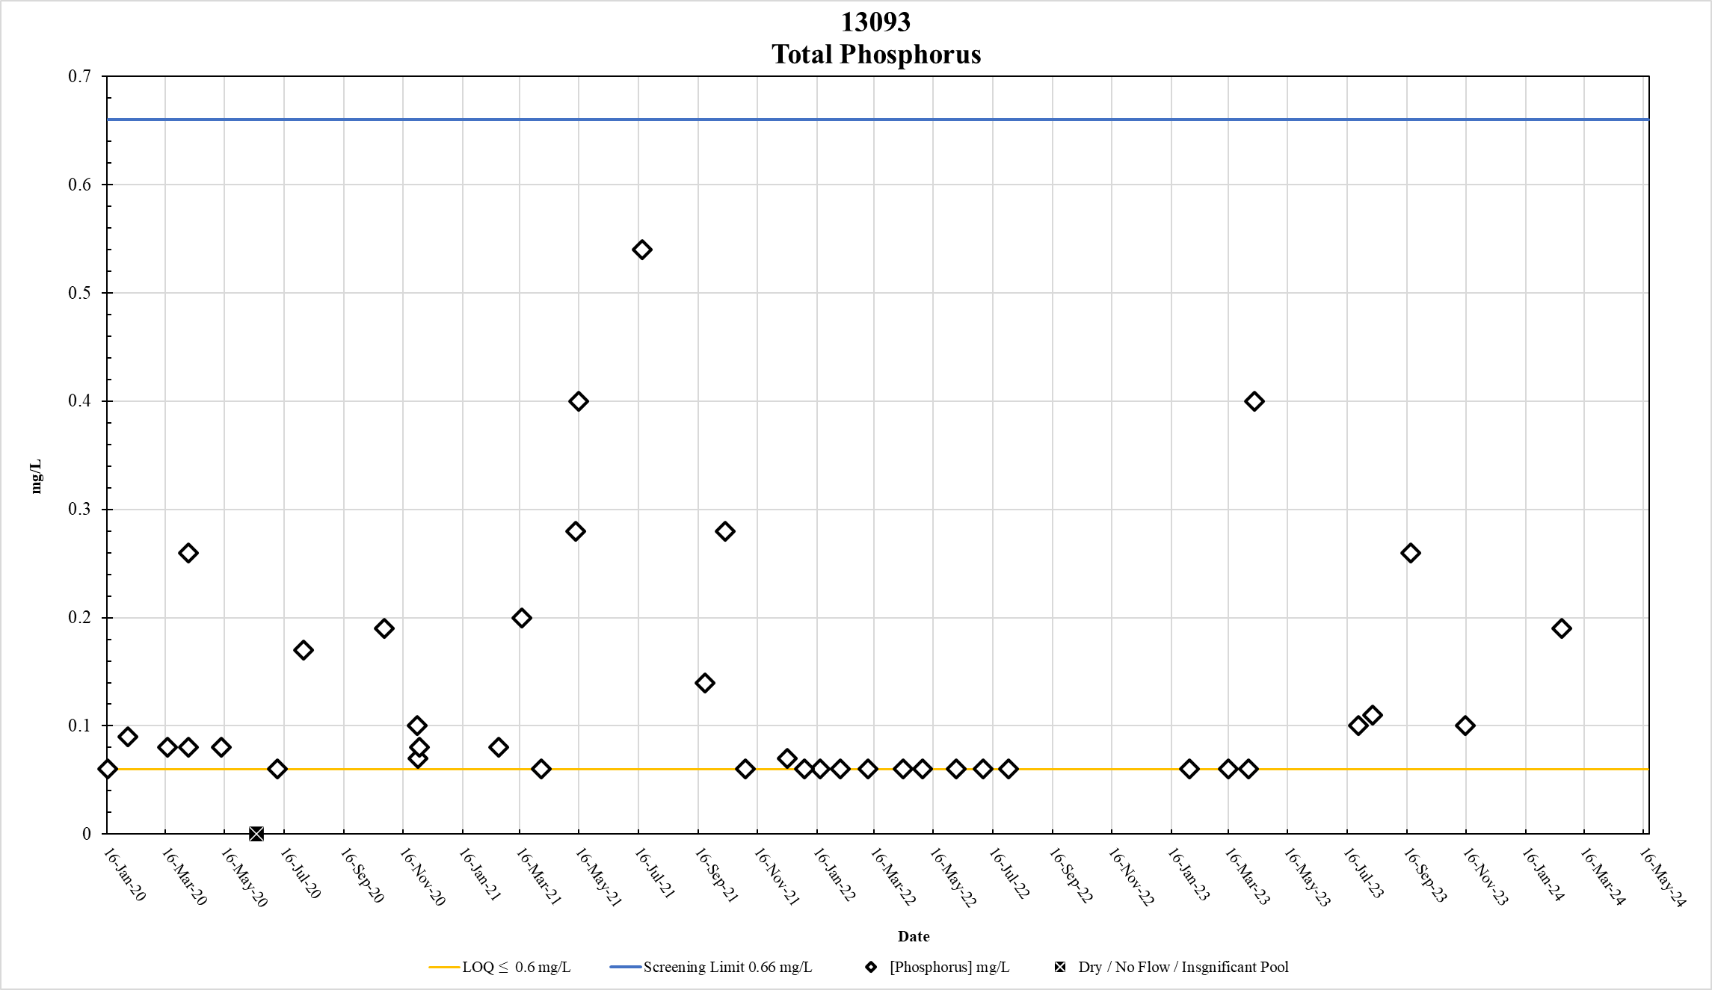
Figure 66. Station 13093 Total Phosphorus results January 2020 – May 2024

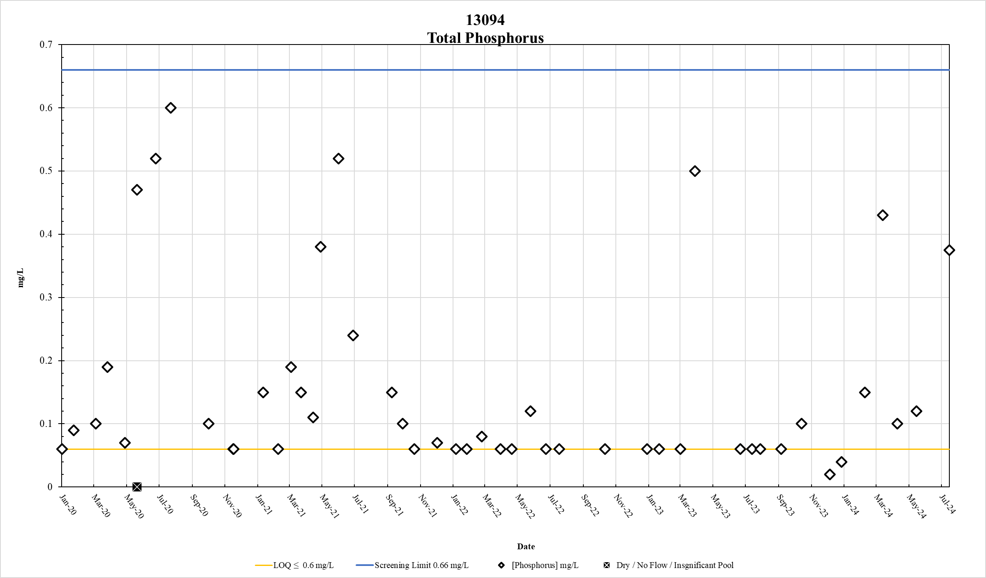
Figure 67. Station 13094 Total Phosphorus results January 2020 – May 2024

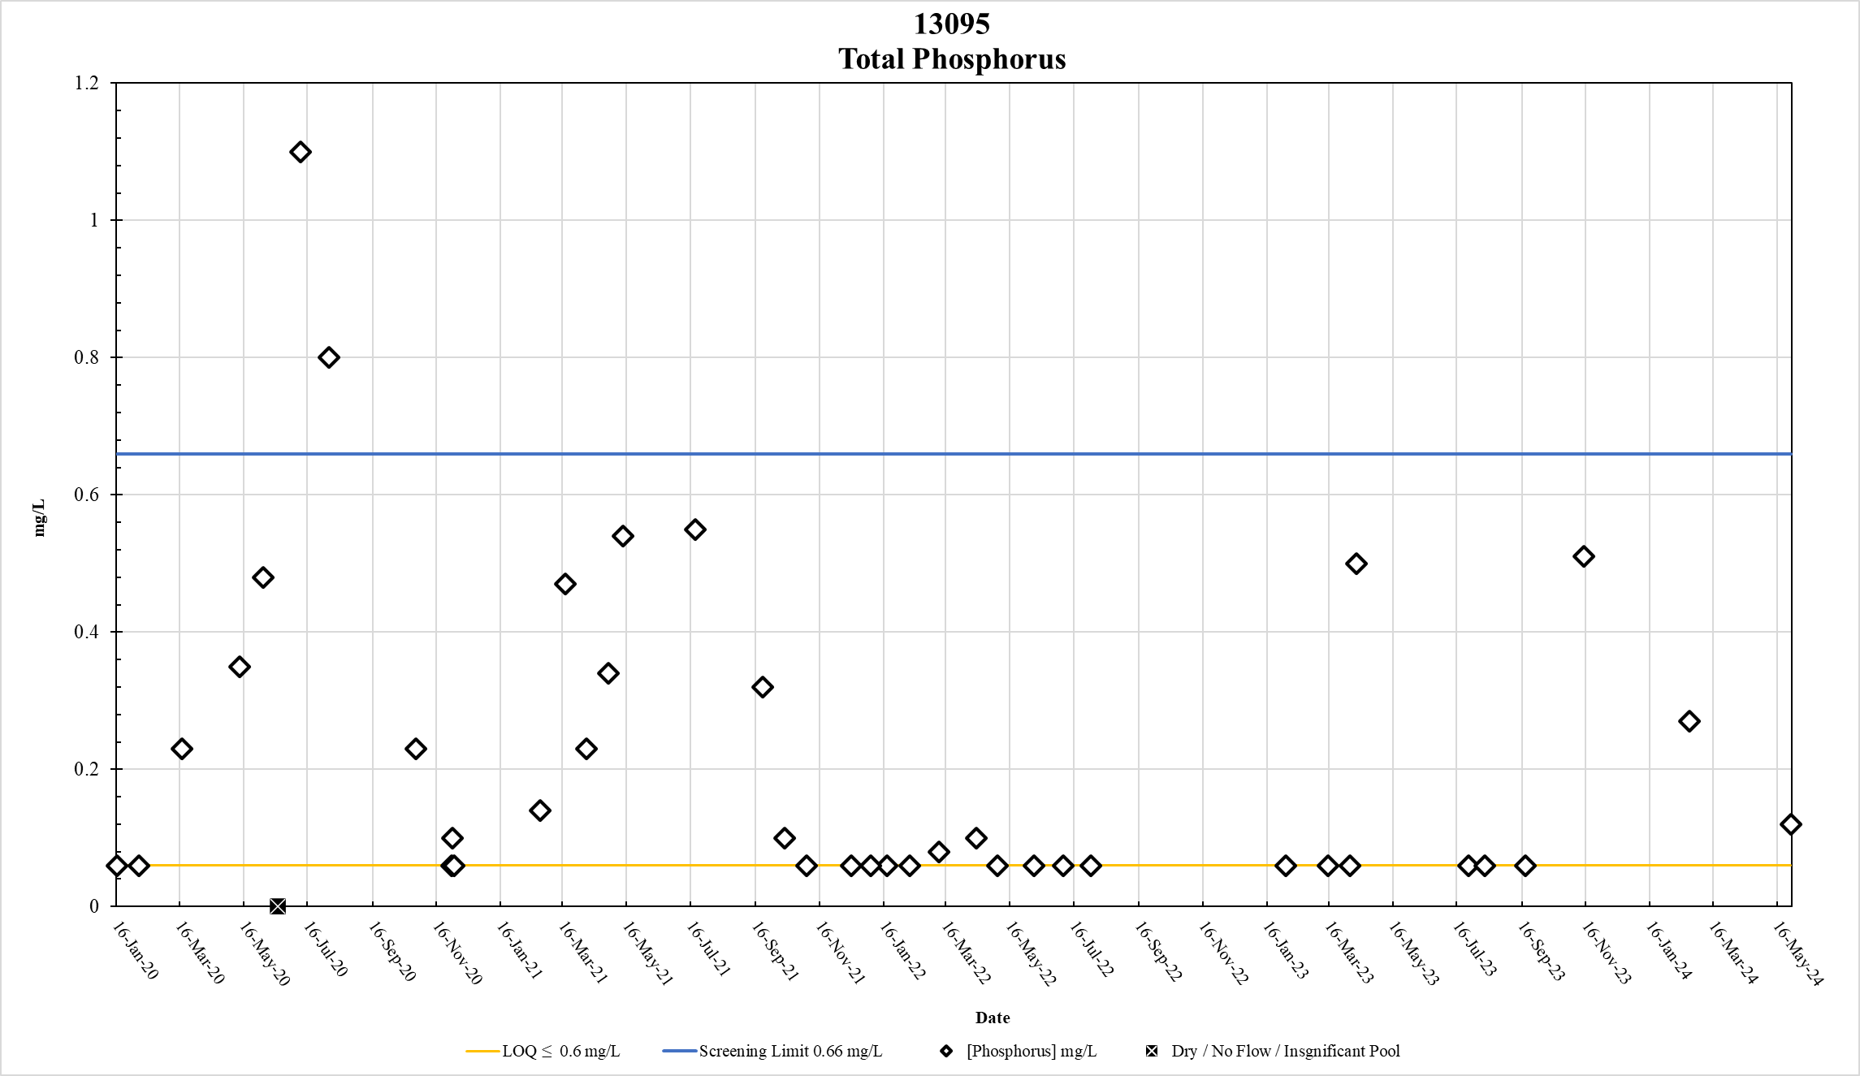
Figure 68. Station 13095 Total Phosphorus results January 2020 – May 2024

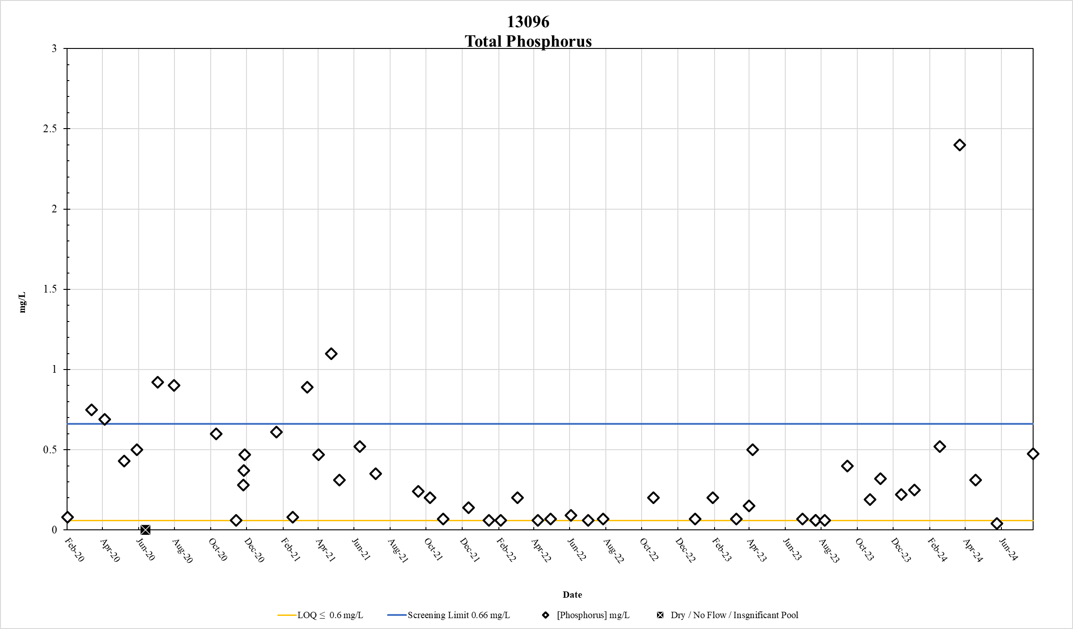
Figure 69. Station 13096 Total Phosphorus results January 2020 – May 2024

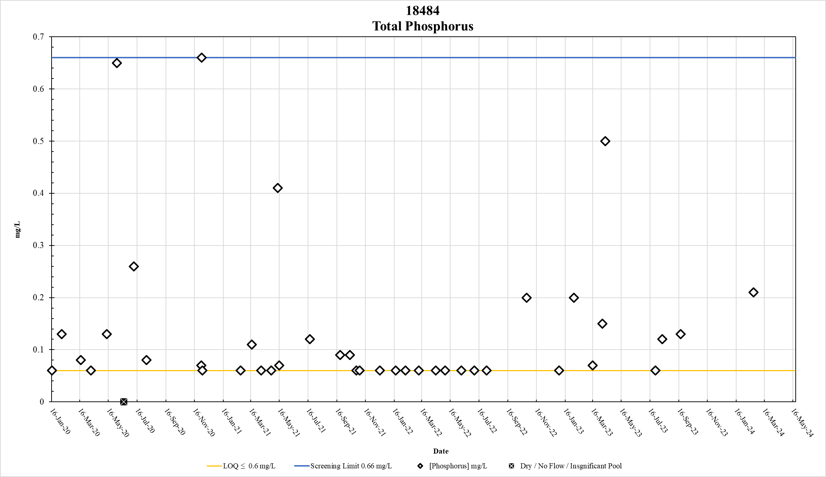
Figure 70. Station 18484 Total Phosphorus results January 2020 – May 2024

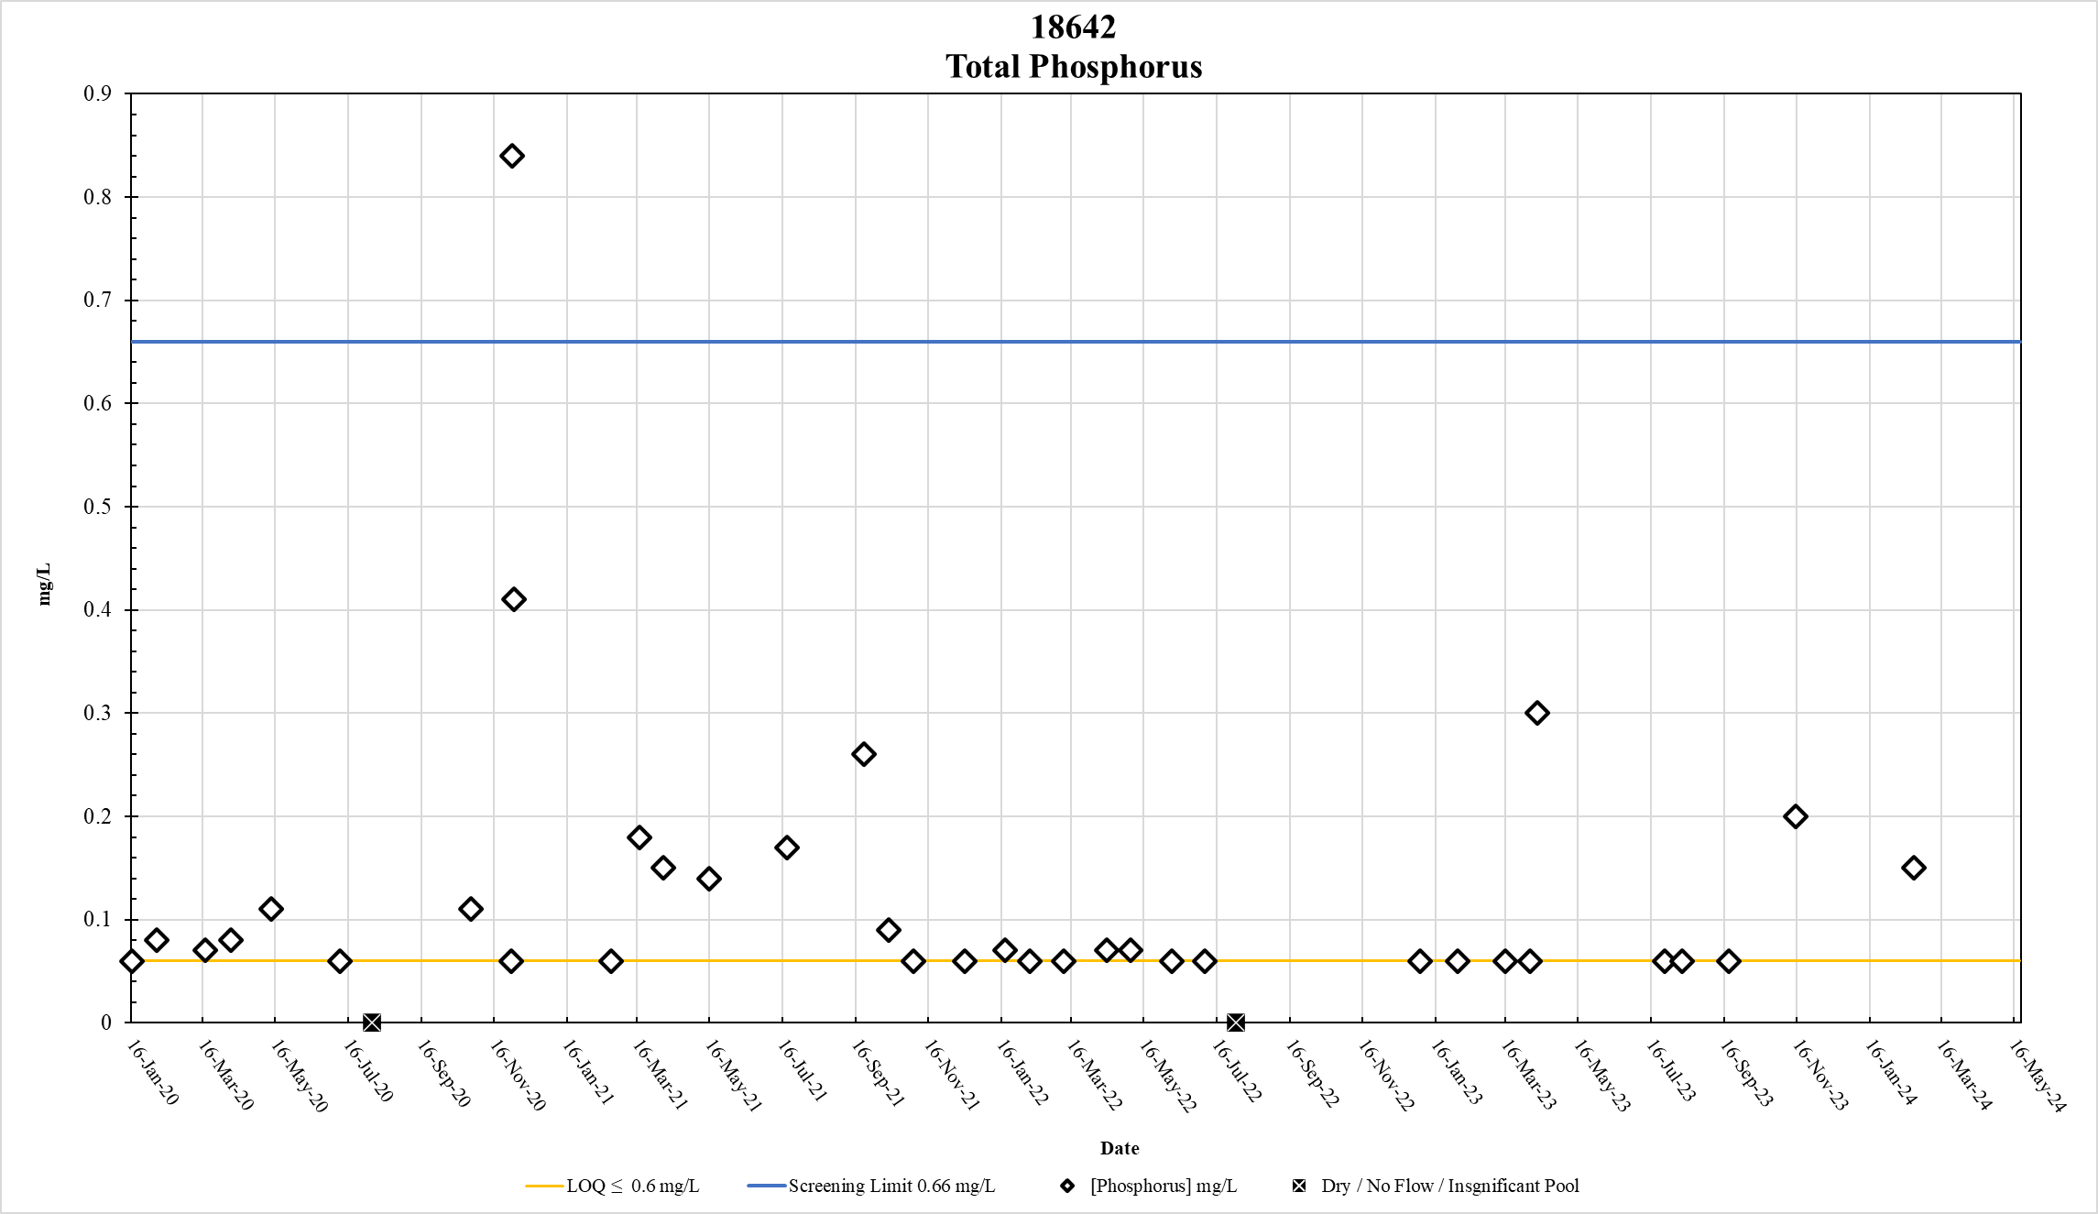
Figure 71. Station 18642 Total Phosphorus results January 2020 – May 2024

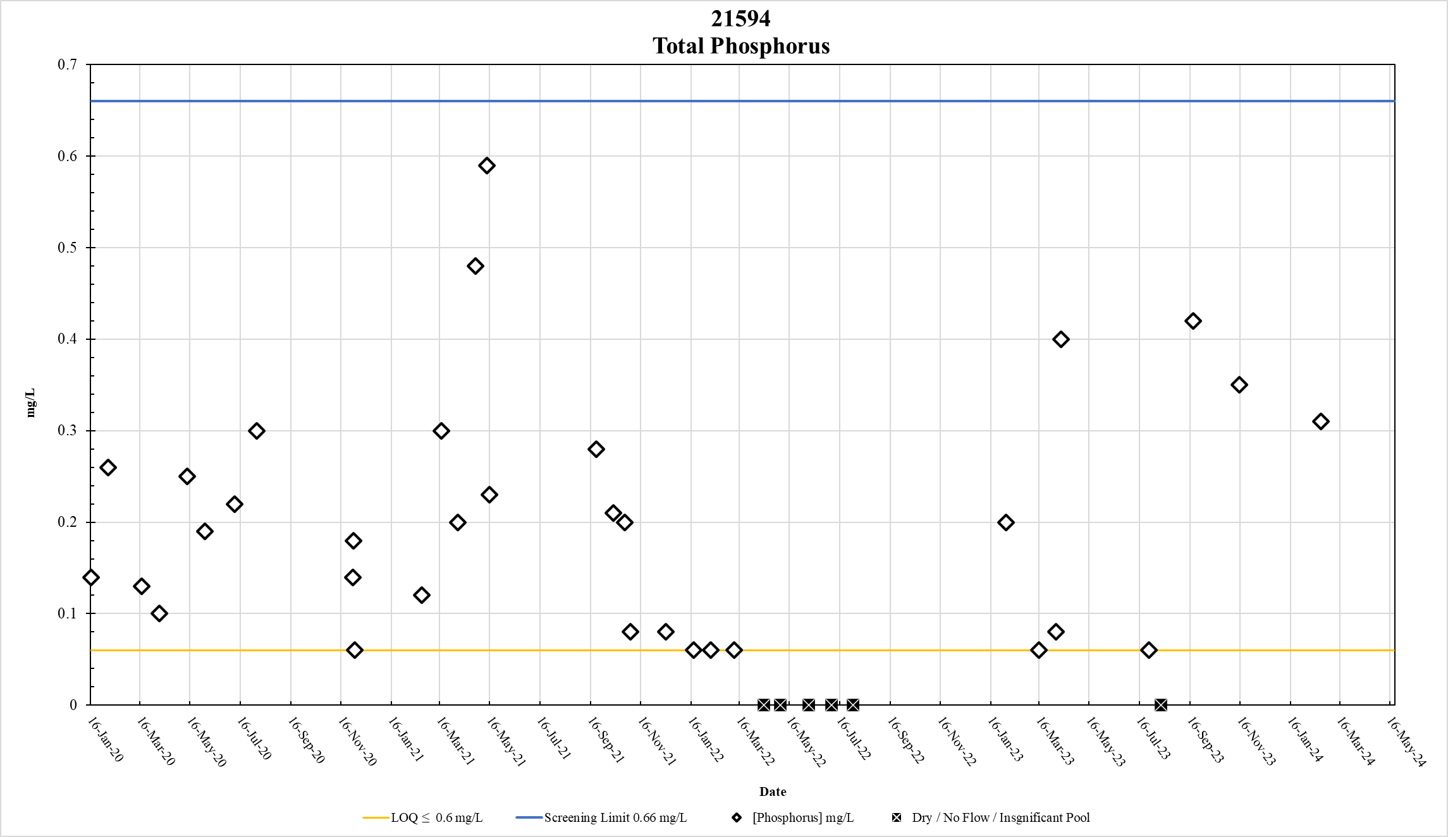
Figure 72. Station 21594 Total Phosphorus results January 2020 – May 2024

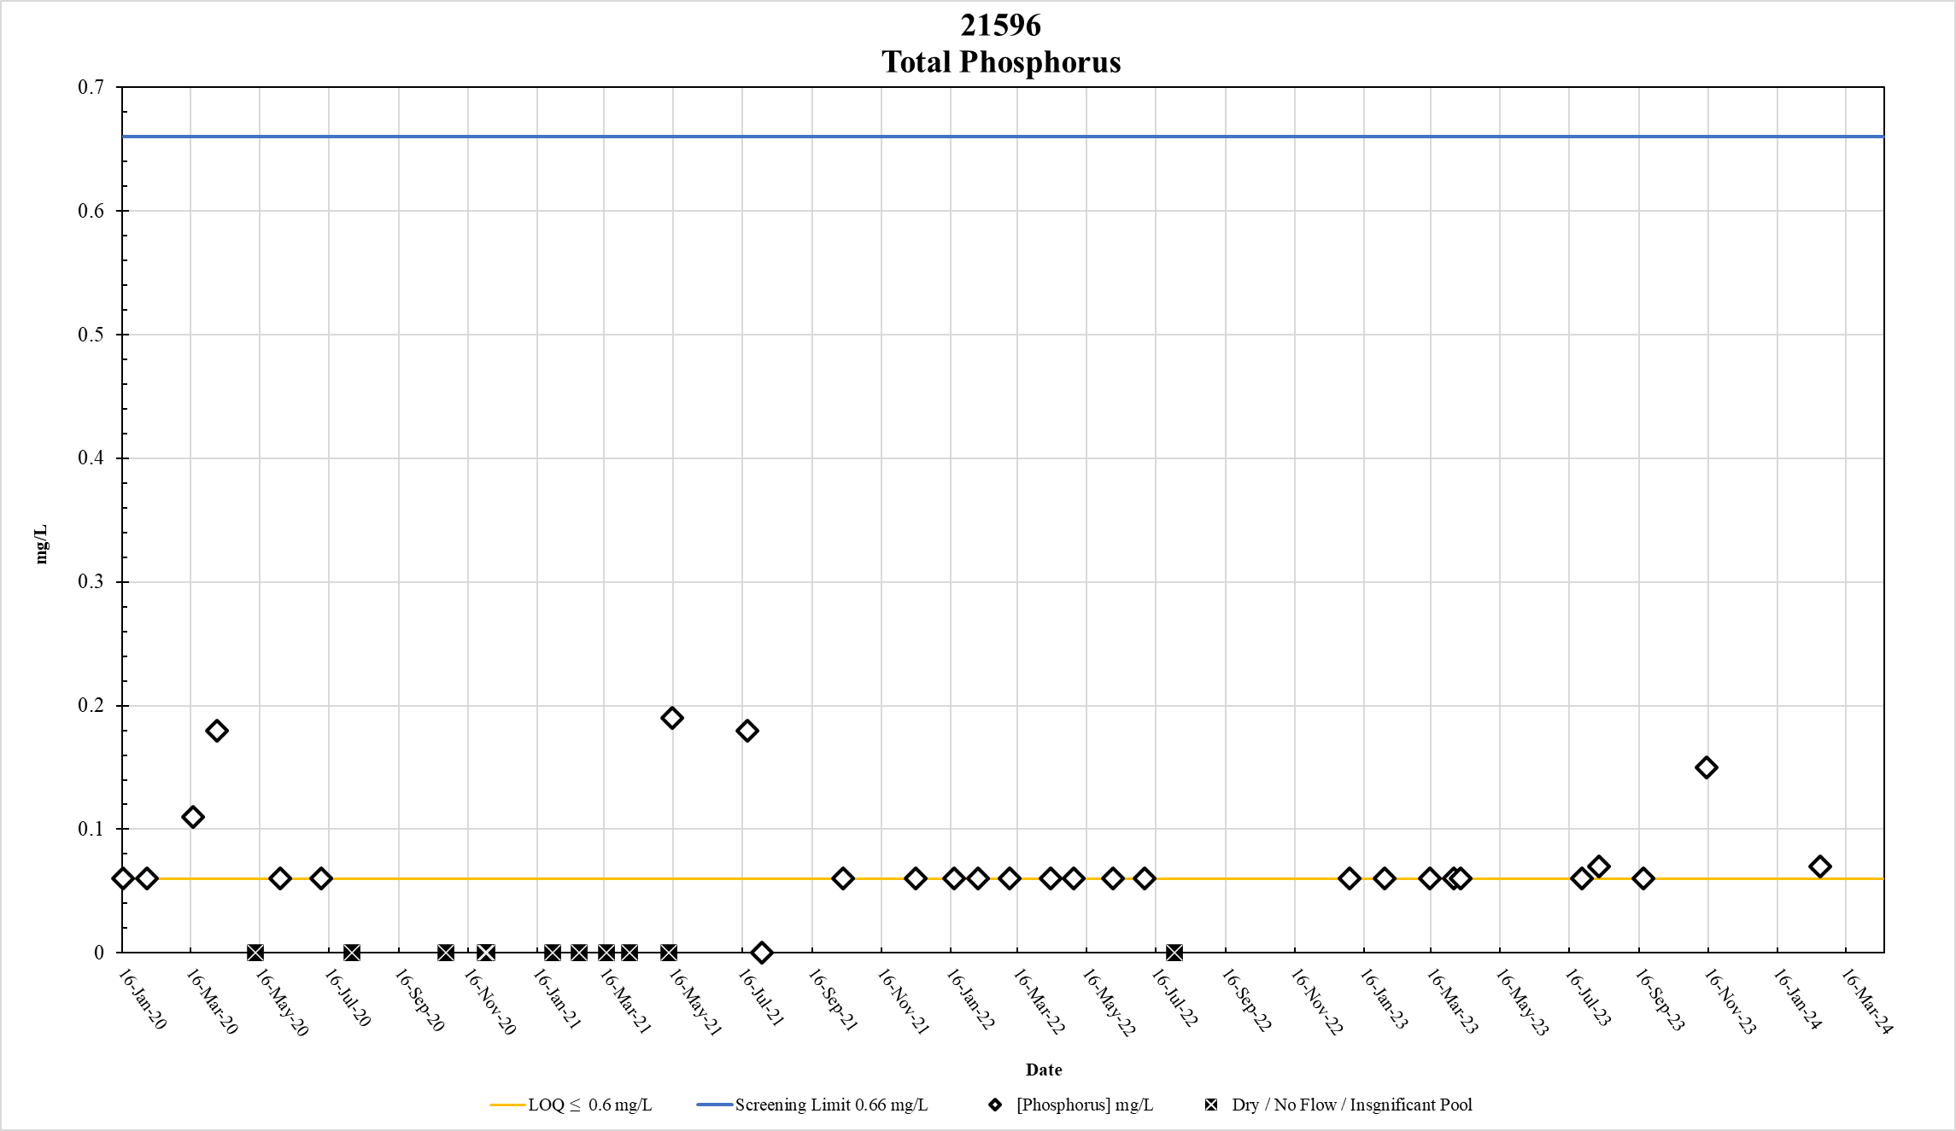
Figure 73. Station 21596 Total Phosphorus results January 2020 – May 2024

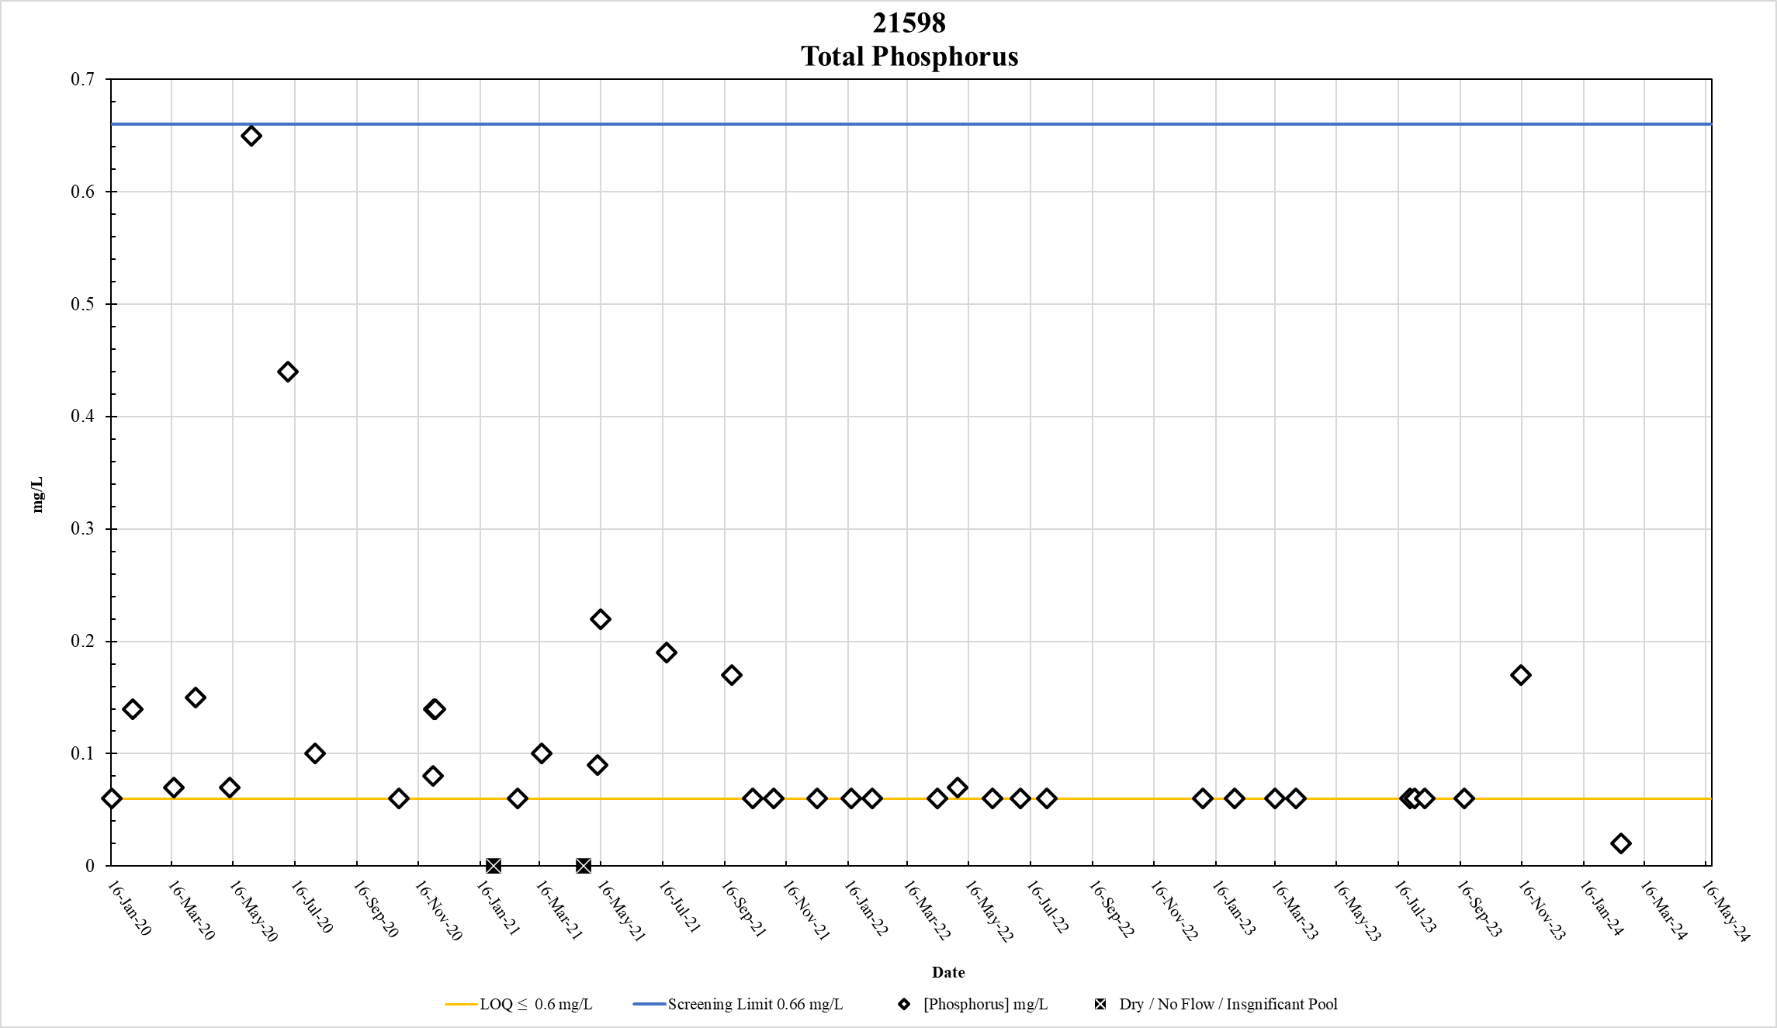
Figure 74. Station 21598 Total Phosphorus results January 2020 – May 2024

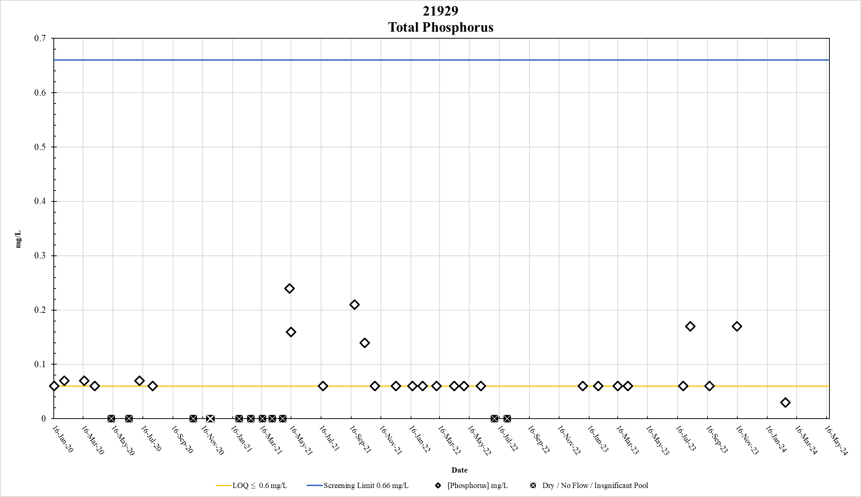
Figure 75. Station 21929 Total Phosphorus results January 2020 – May 2024

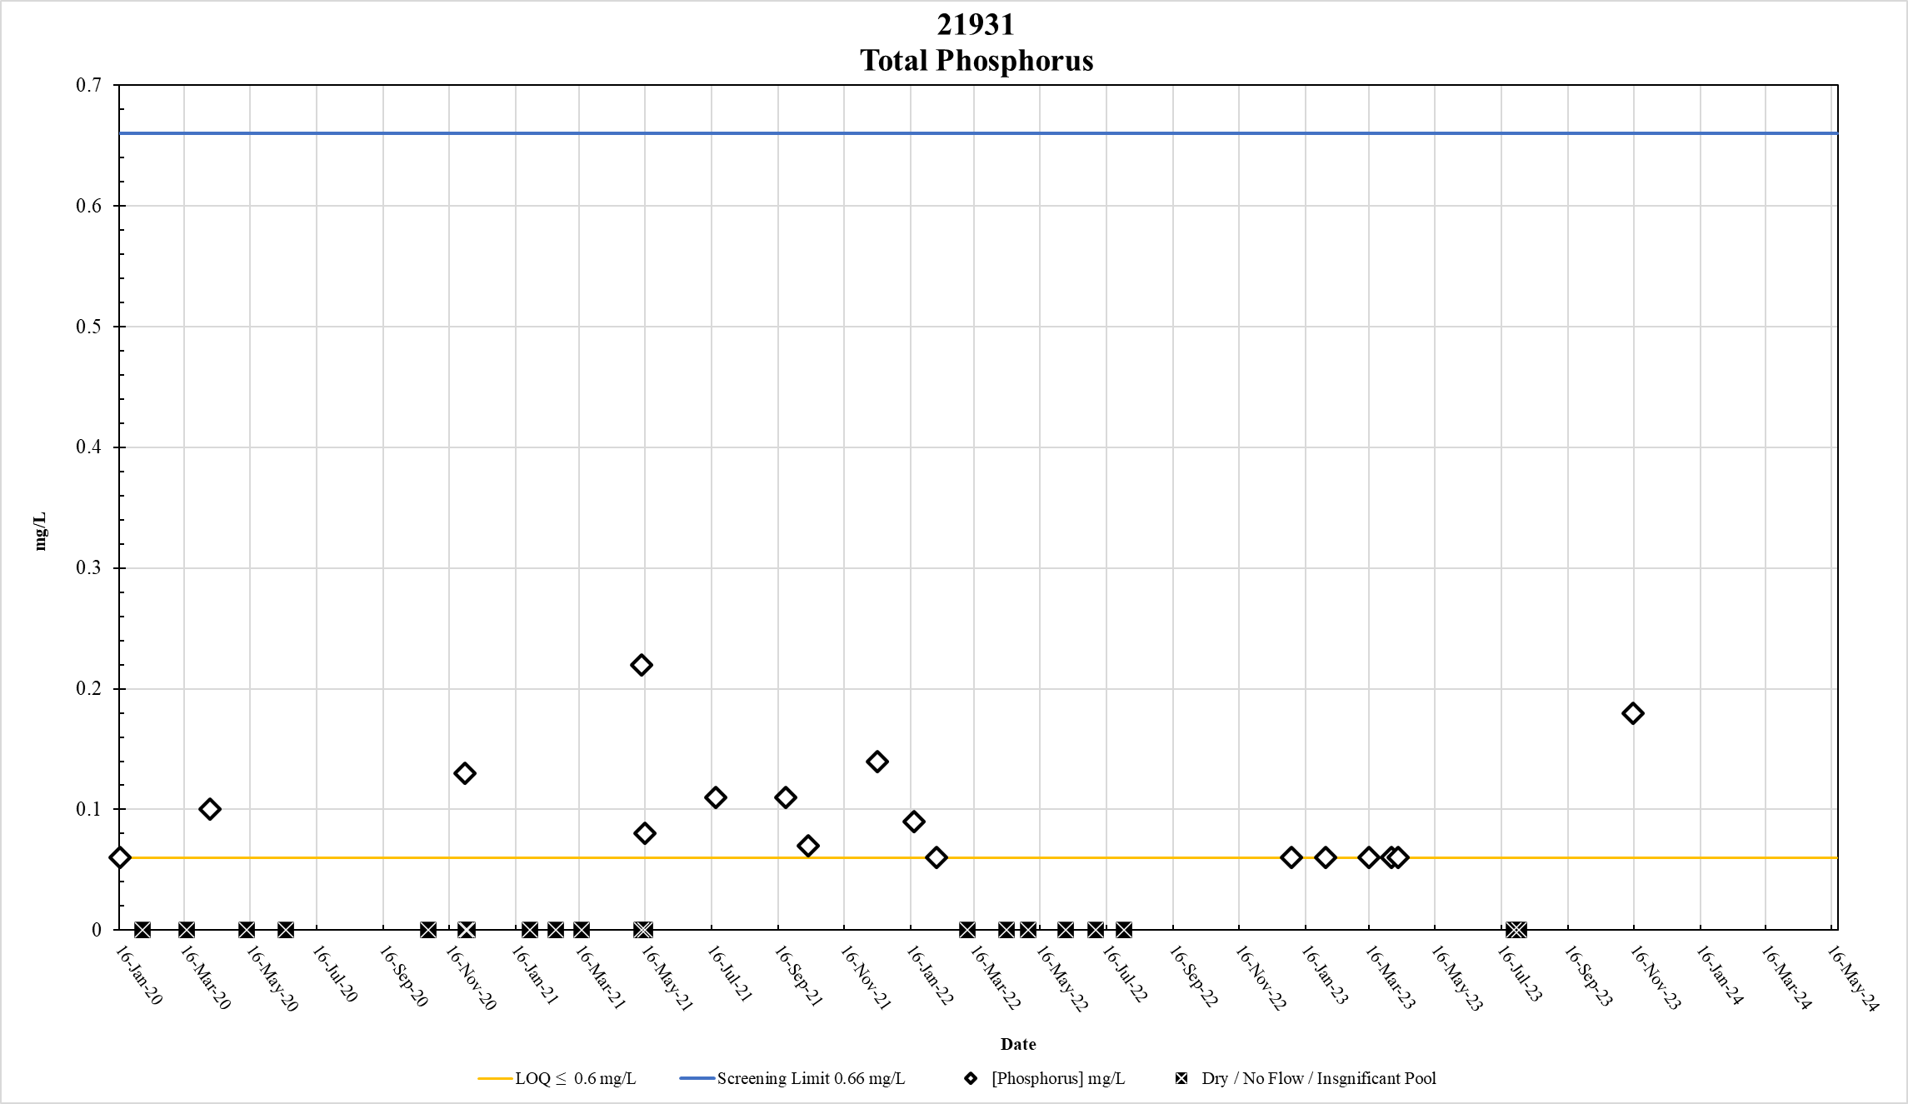
Figure 76. Station 21931 Total Phosphorus results January 2020 – May 2024

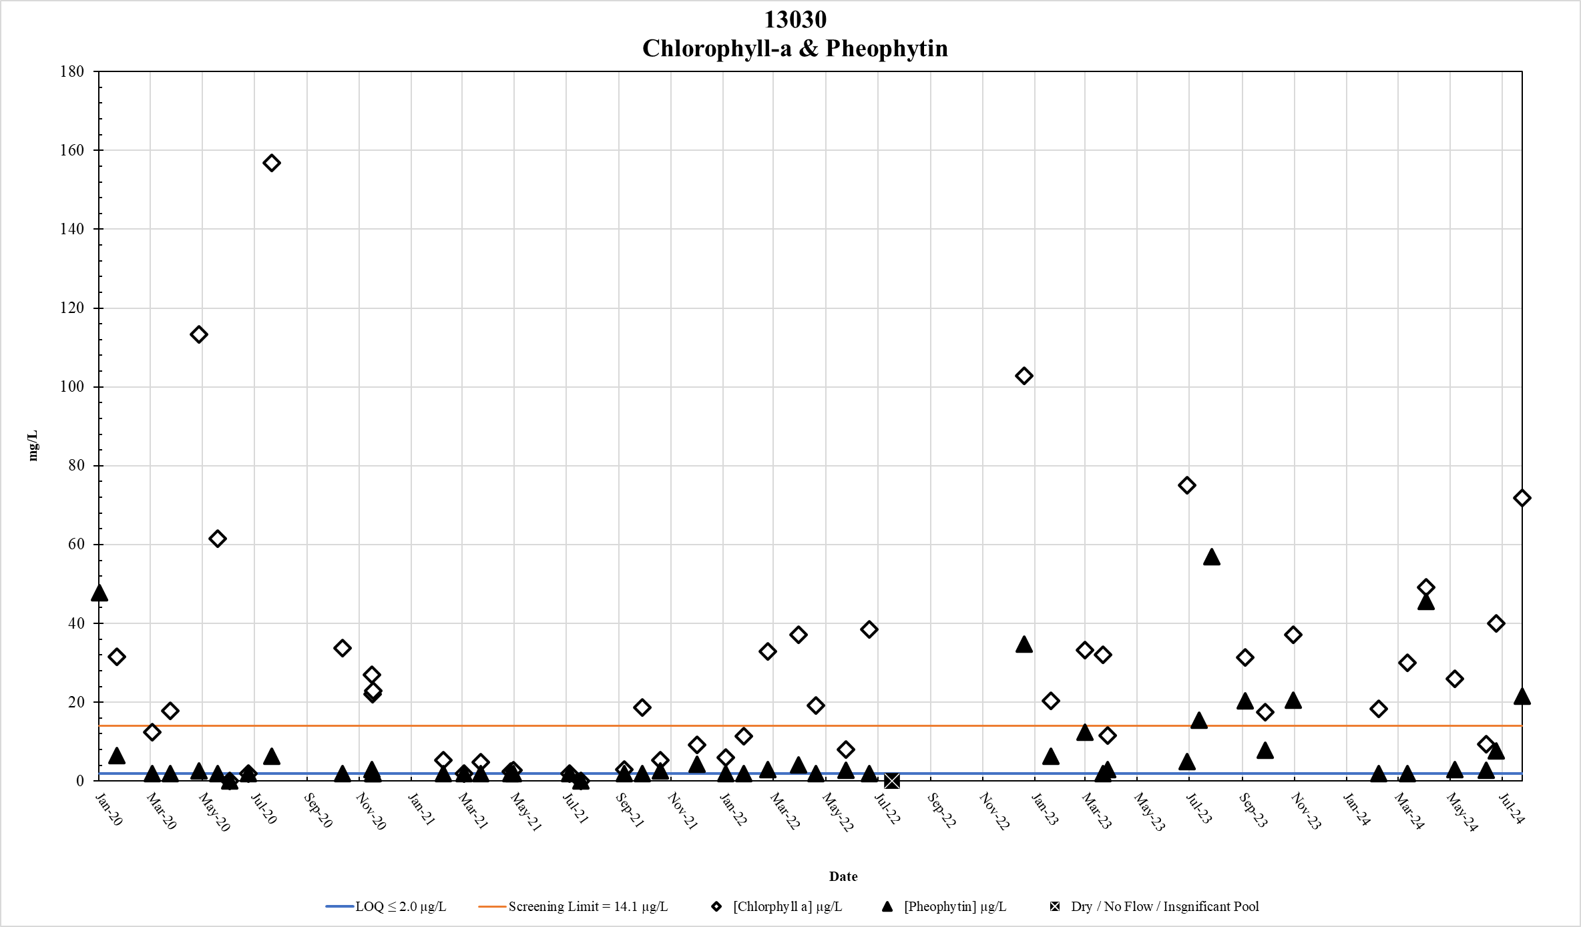
Figure 77. Station 13030 Chlorophyll-a & Pheophytin results January 2020 – May 2024

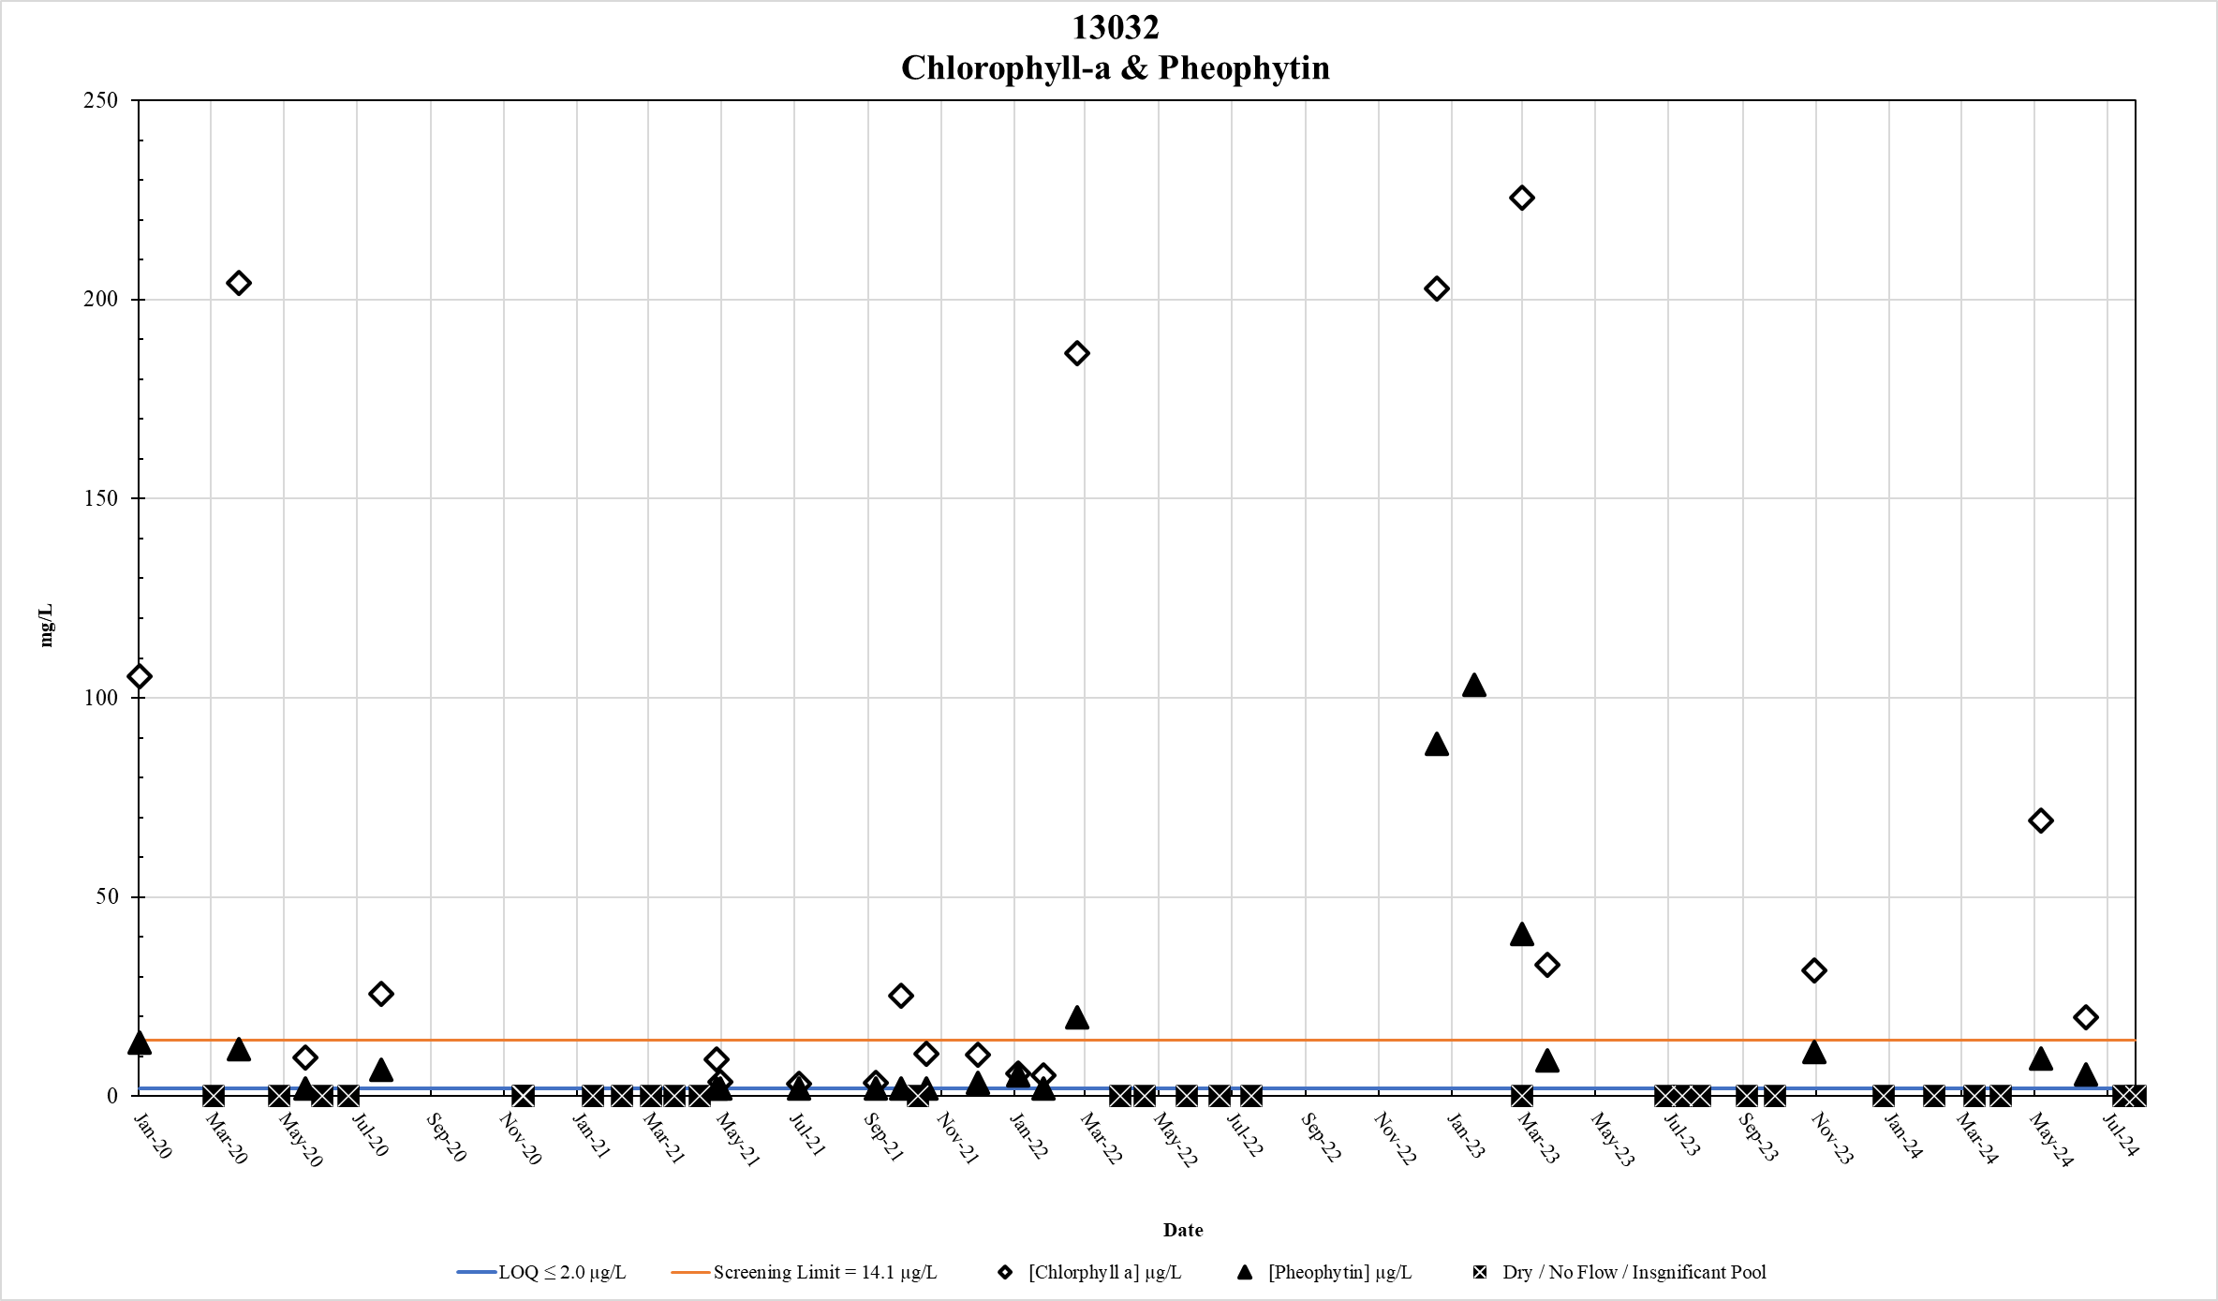
Figure 78. Station 13032 Chlorophyll-a & Pheophytin results January 2020 – May 2024

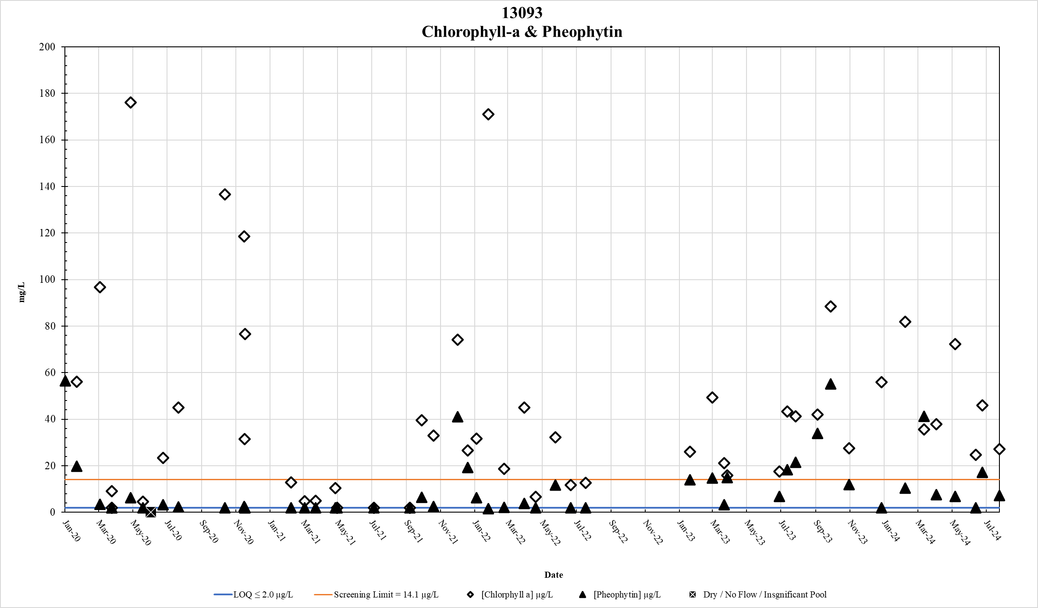
Figure 79. Station 13093 Chlorophyll-a & Pheophytin results January 2020 – May 2024

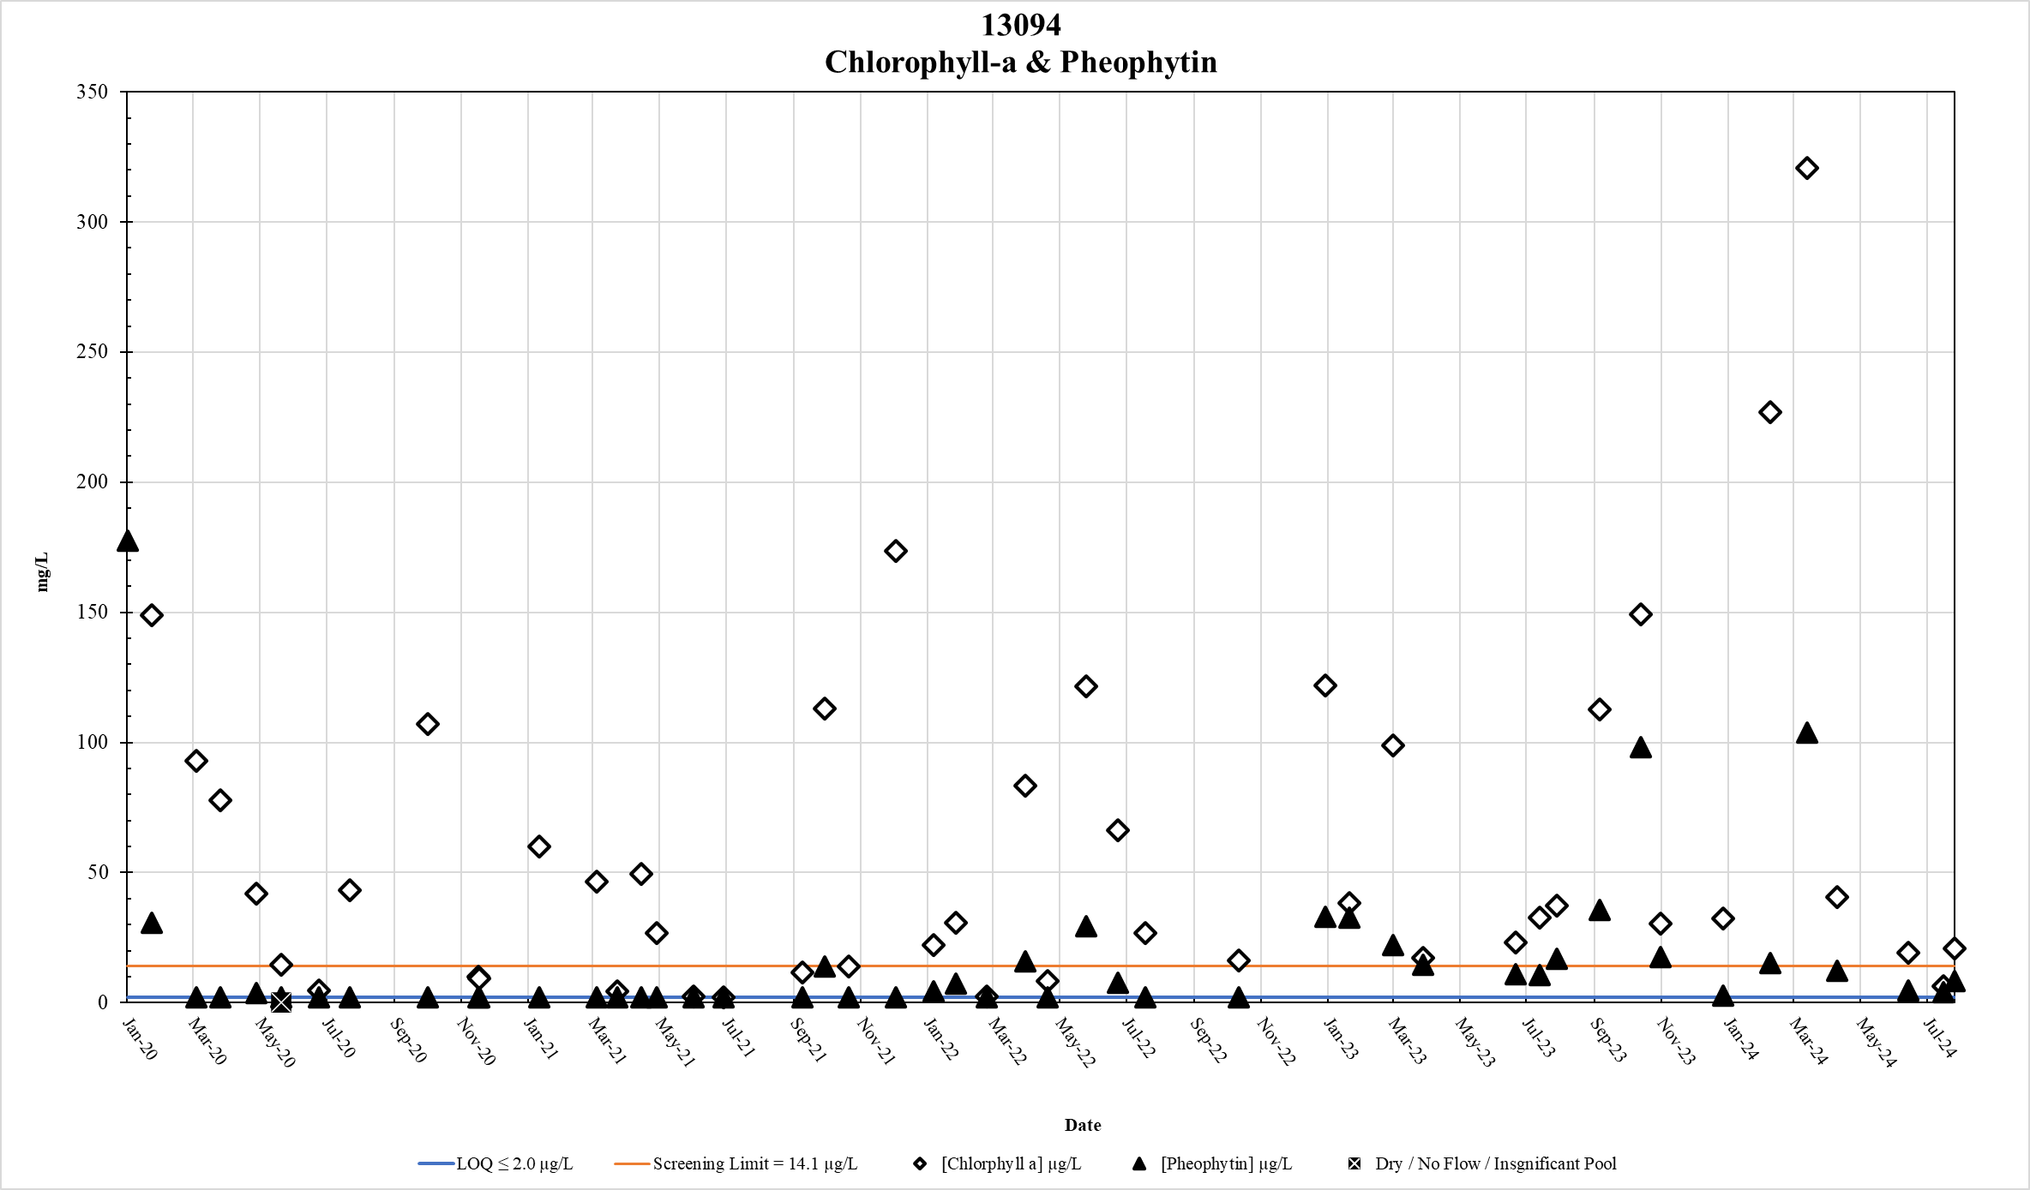
Figure 80. Station 13094 Chlorophyll-a & Pheophytin results January 2020 – May 2024

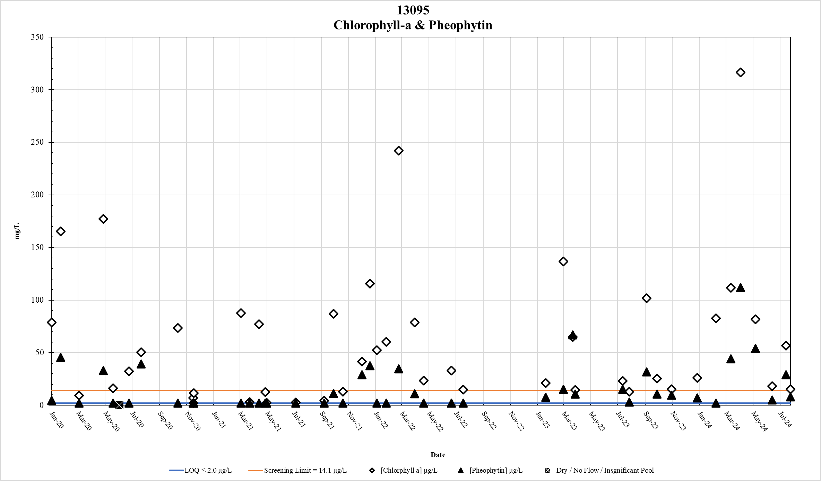
Figure 81. Station 13095 Chlorophyll-a & Pheophytin results January 2020 – May 2024

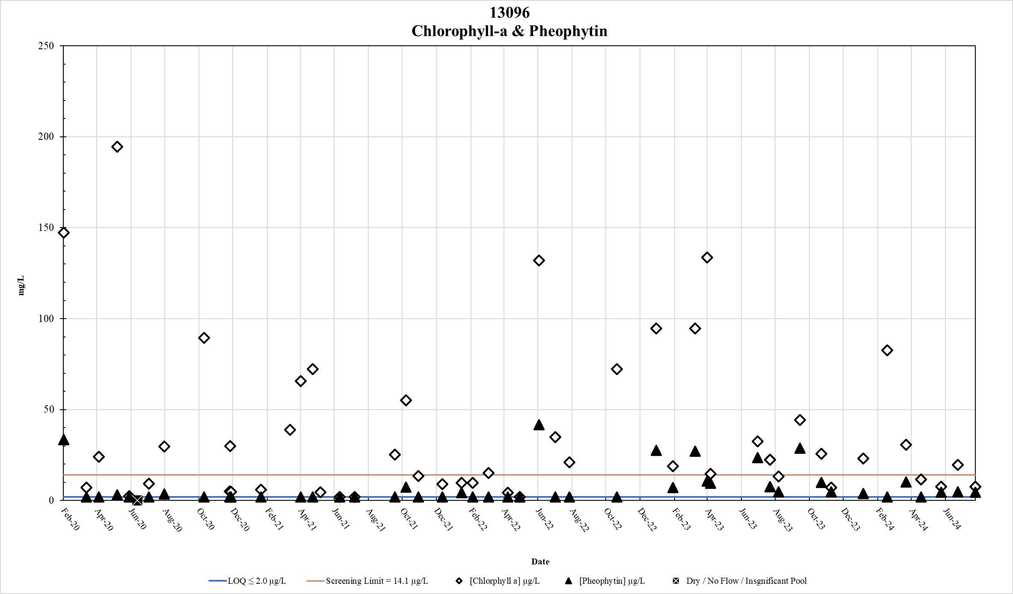
Figure 82. Station 13096 Chlorophyll-a & Pheophytin results January 2020 – May 2024

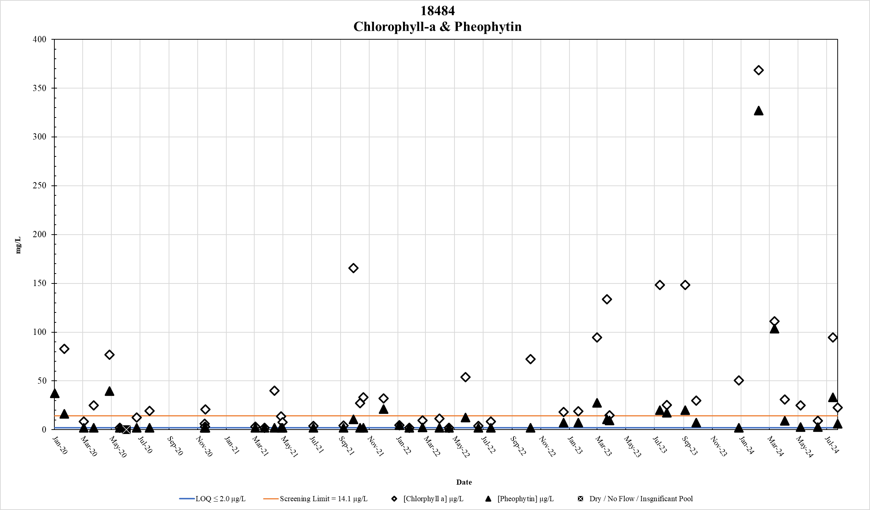
Figure 83. Station 18484 Chlorophyll-a & Pheophytin results January 2020 – May 2024

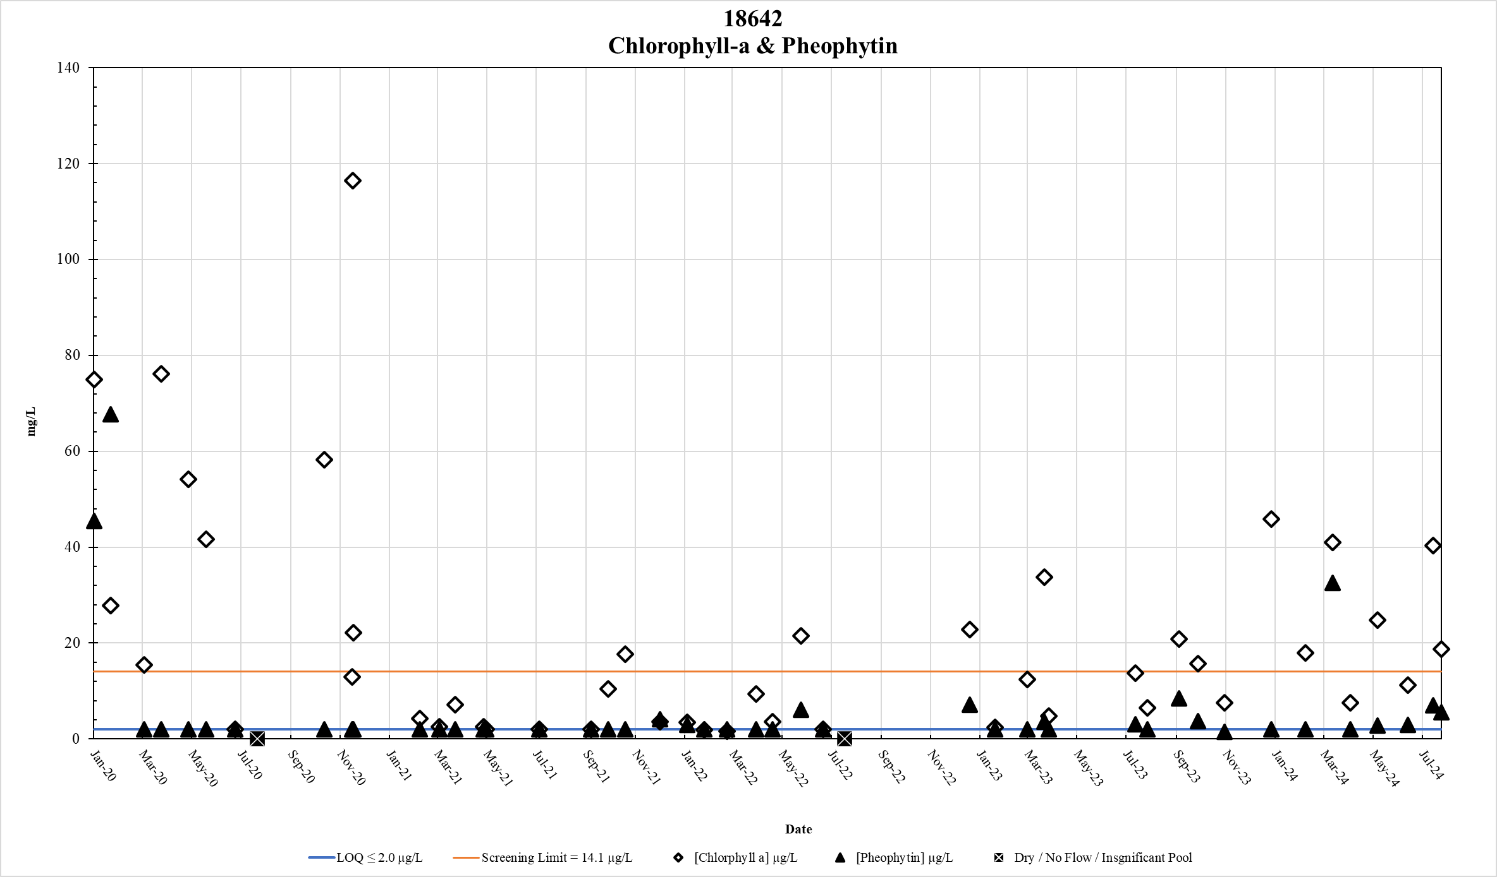
Figure 84. Station 18642 Chlorophyll-a & Pheophytin results January 2020 – May 2024

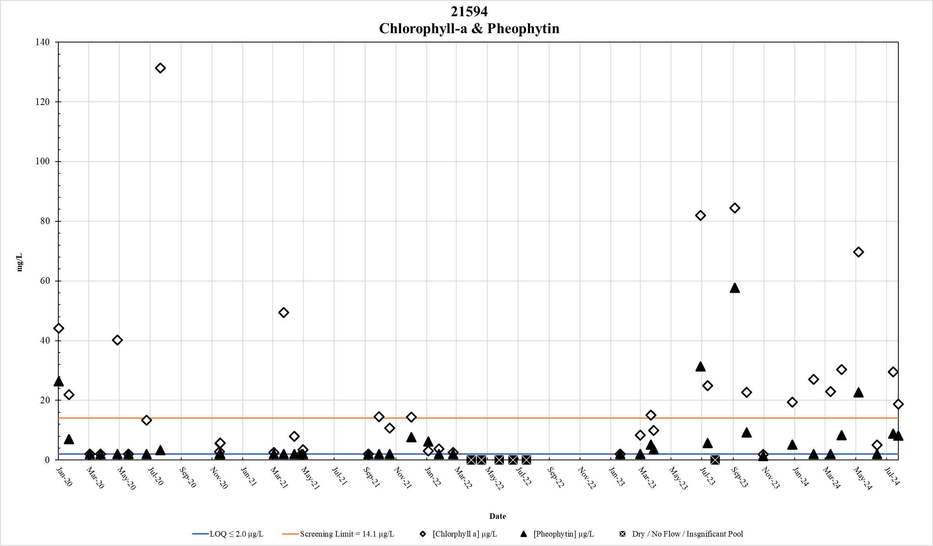
Figure 85. Station 21594 Chlorophyll-a & Pheophytin results January 2020 – May 2024

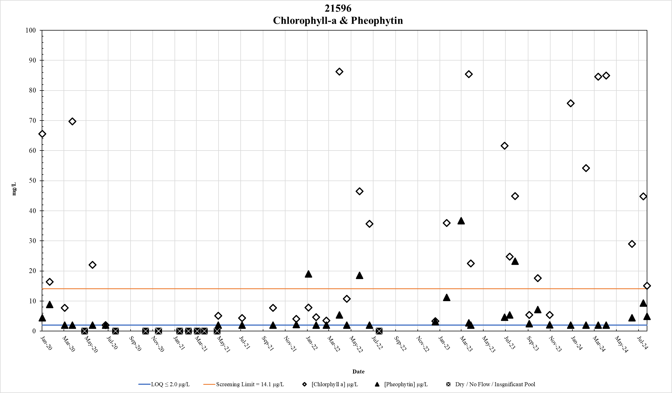
Figure 86. Station 21596 Chlorophyll-a & Pheophytin results January 2020 – May 2024

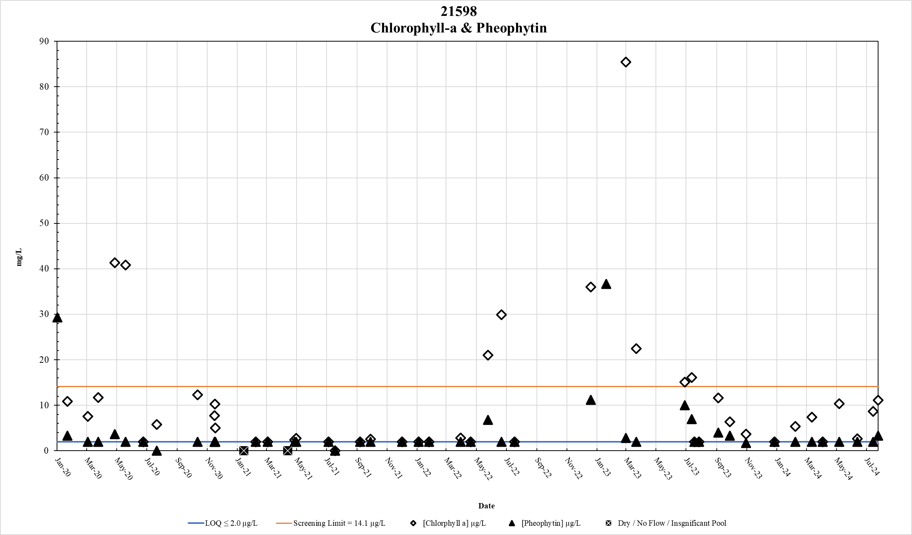
Figure 87. Station 21598 Chlorophyll-a & Pheophytin results January 2020 – May 2024

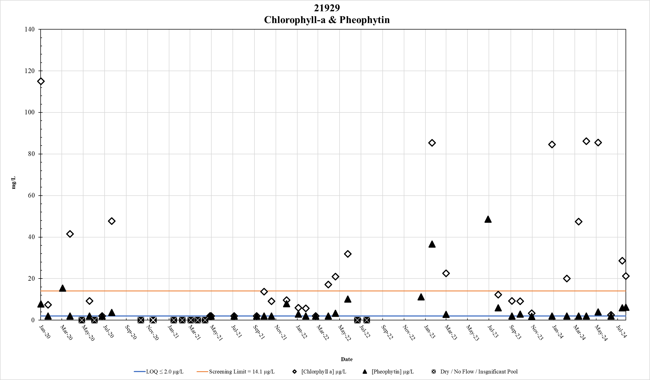
Figure 88. Station 21929 Chlorophyll-a & Pheophytin results January 2020 – May 2024

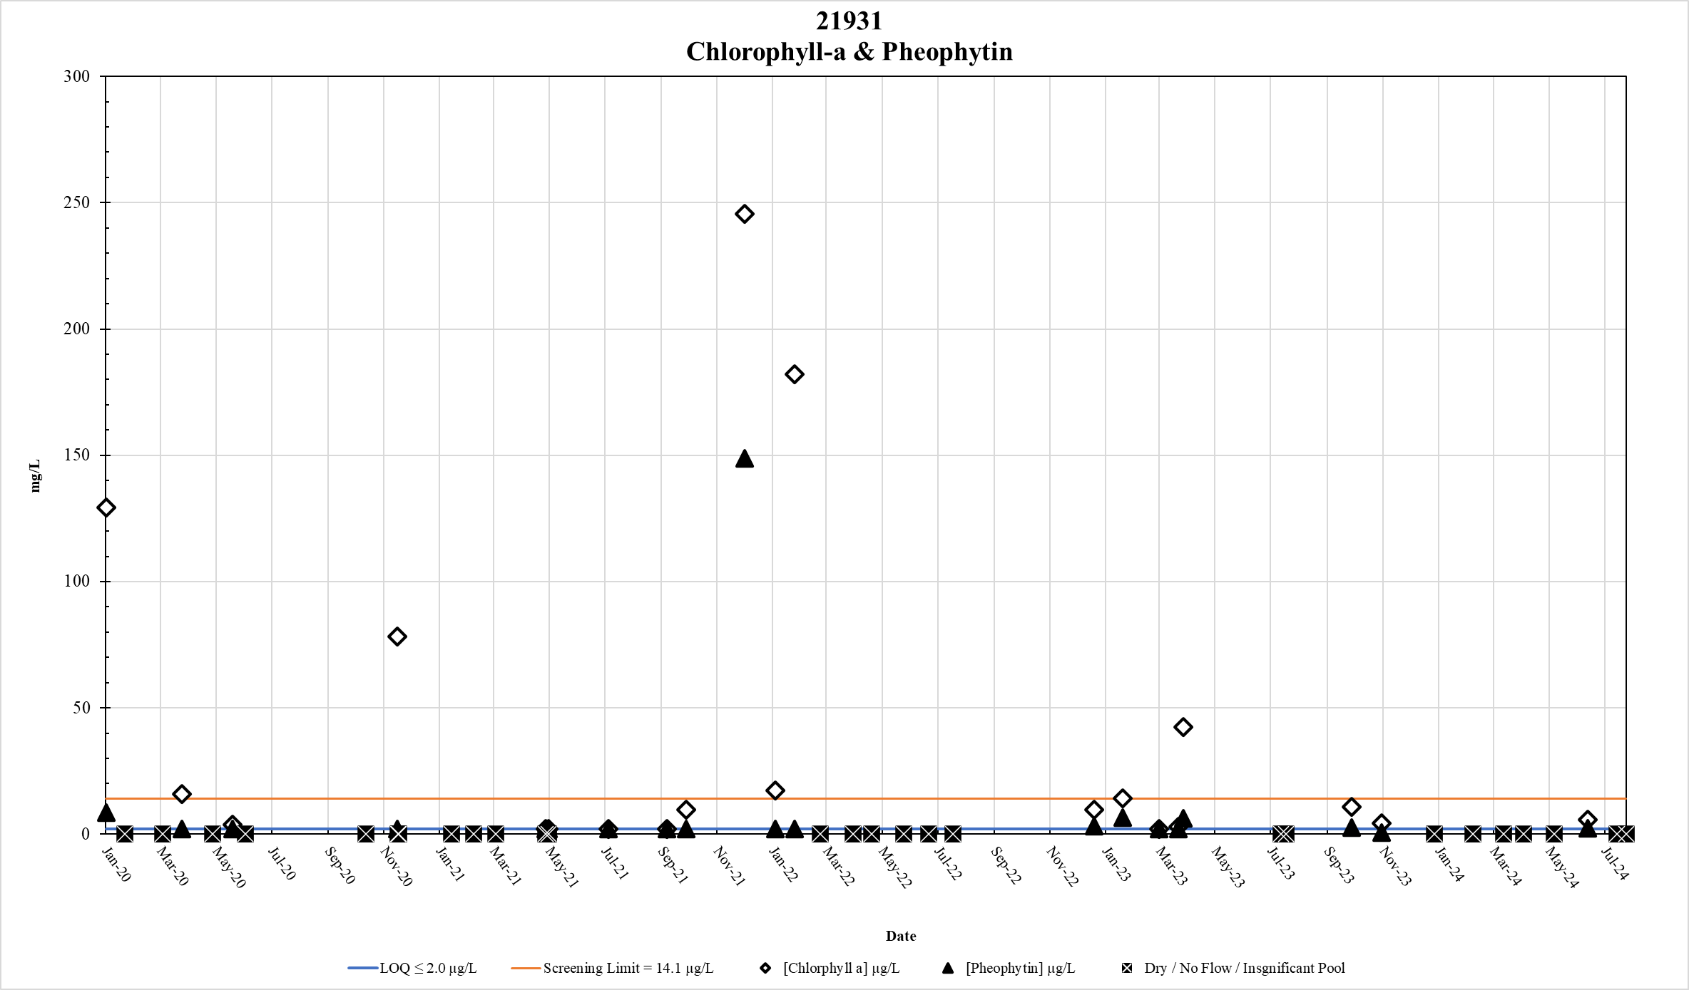
Figure 89. Station 21931 Chlorophyll-a & Pheophytin results January 2020 – May 2024

Conclusion
Nutrient inputs to Petronila Creek Above Tidal (TCEQ Segment 2204) come from a variety of permitted and non-permitted sources including wastewater treatment plants (WWTPs), non- point source (NPS) runoff from cropland, groundwater interactions, wildlife, and other natural sources.
Permitted sources include eight WWTPs that contribute treated domestic wastewater to Petronila Creek Above Tidal or its tributaries, one of which contributes measurable flow to the study area. The City of Driscoll is permitted to release up to 100,000 gpd of treated effluent upstream of station 13096. A ninth source, US Ecology, is permitted for stormwater effluent only (Appendix B).
Water quality monitoring was typically conducted at base flow conditions for much of the study period. Many of the nutrient parameters analyzed in this report show an extremely wide range of concentrations with results spanning from the limits of quantification to values significantly above their respective screening levels. Episodes of highly elevated nutrient concentrations as well as periods of very low concentrations show varying degrees of seasonality and are summarized below:

Ammonia
The LOQ for ammonia is 0.1 mg/L. The TCEQ screening level is 0.33 mg/L.

Ammonia | Minimum | Maximum | Mean
Main steam and Tributary Stations | 0.01 mg/L | 0.8 mg/L | 0.14 mg/L
Main Steam Stations | 0.01 mg/L | 0.5 mg/L | 0.11 mg/L
Tributary Stations | 0.10 mg/L | 0.8 mg/L | 0.14 mg/L

Nitrate-Nitrogen
LOQ for nitrate-nitrogen is 0.025 mg/L. The TCEQ screening level is 1.95 mg/L.

Nitrate-Nitrogen | Minimum | Maximum | Mean
Main steam and Tributary Stations | 0.02 mg/L | 57 mg/L | 3.15 mg/L
Main Steam Stations | 0.02 mg/L | 37.5 mg/L | 2.9 mg/L
Tributary Stations | 0.02 mg/L | 57 mg/L | 3.27 mg/L

Nitrite-Nitrogen
The LOQ for [nitrite-nitrogen] is 0.02 mg/L, however no TCEQ screening level exists for this parameter.

Nitrite-Nitrogen | Minimum | Maximum | Mean
Main steam and Tributary Stations | 0.02 mg/L | 5.3 mg/L | 0.06 mg/L
Main Steam Stations | 0.02 mg/L | 0.15 mg/L | 0.02 mg/L
Tributary Stations | 0.02 mg/L | 5.3 mg/L | 0.08 mg/L

Dissolved Total Kjedahl Nitrogen (Dissolved TKN)
The LOQ for dissolved TKN is 0.2 mg/L, however no TCEQ screening levels exist for this nutrient parameter.

DTKN | Minimum | Maximum | Mean
Main steam and Tributary Stations | 0.20 mg/L | 5.2 mg/L | 1.03 mg/L
Main Steam Stations | 0.20 mg/L | 2.7 mg/L | 0.87 mg/L
Tributary Stations | 0.20 mg/L | 5.2 mg/L | 1.11 mg/L

Total Kjedahl Nitrogen (TKN)
The LOQ for TKN is 0.2 mg/L, however no TCEQ screening levels exist for this nutrient parameter.

TKN | Minimum | Maximum | Mean
Main steam and Tributary Stations | 0.20 mg/L | 12.2 mg/L | 1.29 mg/L
Main Steam Stations | 0.20 mg/L | 4.2 mg/L | 1.07 mg/L
Tributary Stations | 0.20 mg/L | 12.2 mg/L | 1.39 mg/L

Total Phosphorus
The LOQ for TP is 0.06 mg/L. The TCEQ screening level is 0.69 mg/L.

Phosphorus | Minimum | Maximum | Mean
Main steam and Tributary Stations | 0.06 mg/L | 4.75 mg/L | 0.16 mg/L
Main Steam Stations | 0.06 mg/L | 2.88 mg/L | 0.16 mg/L
Tributary Stations | 0.06 mg/L | 4.75 mg/L | 0.17 mg/L

Chlorophyll-a
The LOQ for Chlorophyl-a is 2.0 µg/L. The TCEQ screening level is 14.1 µg/L.

Chlorophyll-a | Minimum | Maximum | Mean
Main steam and Tributary Stations | 2 ug/L | 1321.9 ug/L | 49.1 ug/L
Main Steam Stations | 2 ug/L | 390.4 ug/L | 29.1 ug/L
Tributary Stations | 2 ug/L | 1321.9 ug/L | 58 ug/L

Pheophytin
The LOQ for Pheophytin is 2.0 µg/L, however no TCEQ screening levels exist for this nutrient parameter.

Pheophytin | Minimum | Maximum | Mean
Main steam and Tributary Stations | 2 ug/L | 2415 ug/L | 15.92 ug/L
Main Steam Stations | 2 ug/L | 127.7 ug/L | 27.23 ug/L
Tributary Stations | 2 ug/L | 2415 ug/L | 19.98 ug/L

Recommendations

To adequately quantify the spatial and temporal contribution of nutrient inputs to Petronila Creek Above Tidal (TCEQ Segment 2204), nutrient data collection in the watershed is recommended to continue to further assess hydrologic and climactic variability effects on water quality.

Appendix A: Photographs of Monitoring Stations

Station 21928 – Petronila Tributary @ FM 70 (Cefe #1)

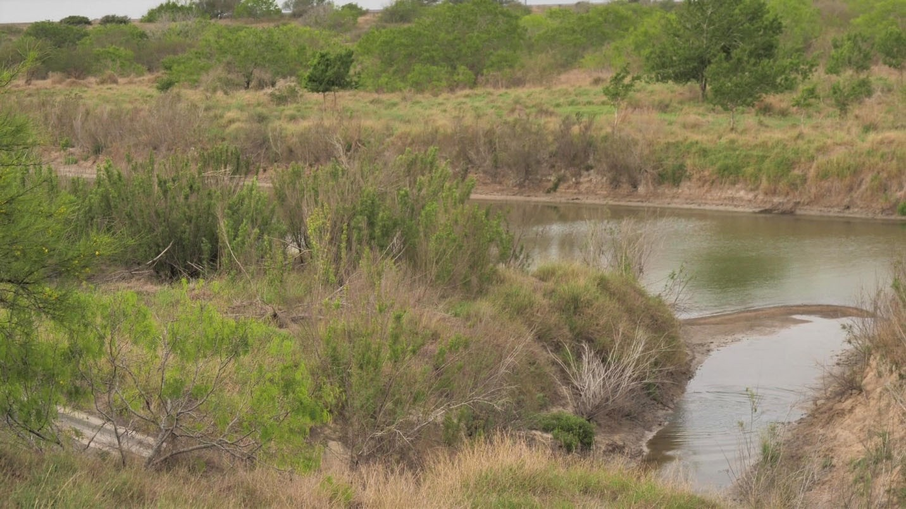
Downstream

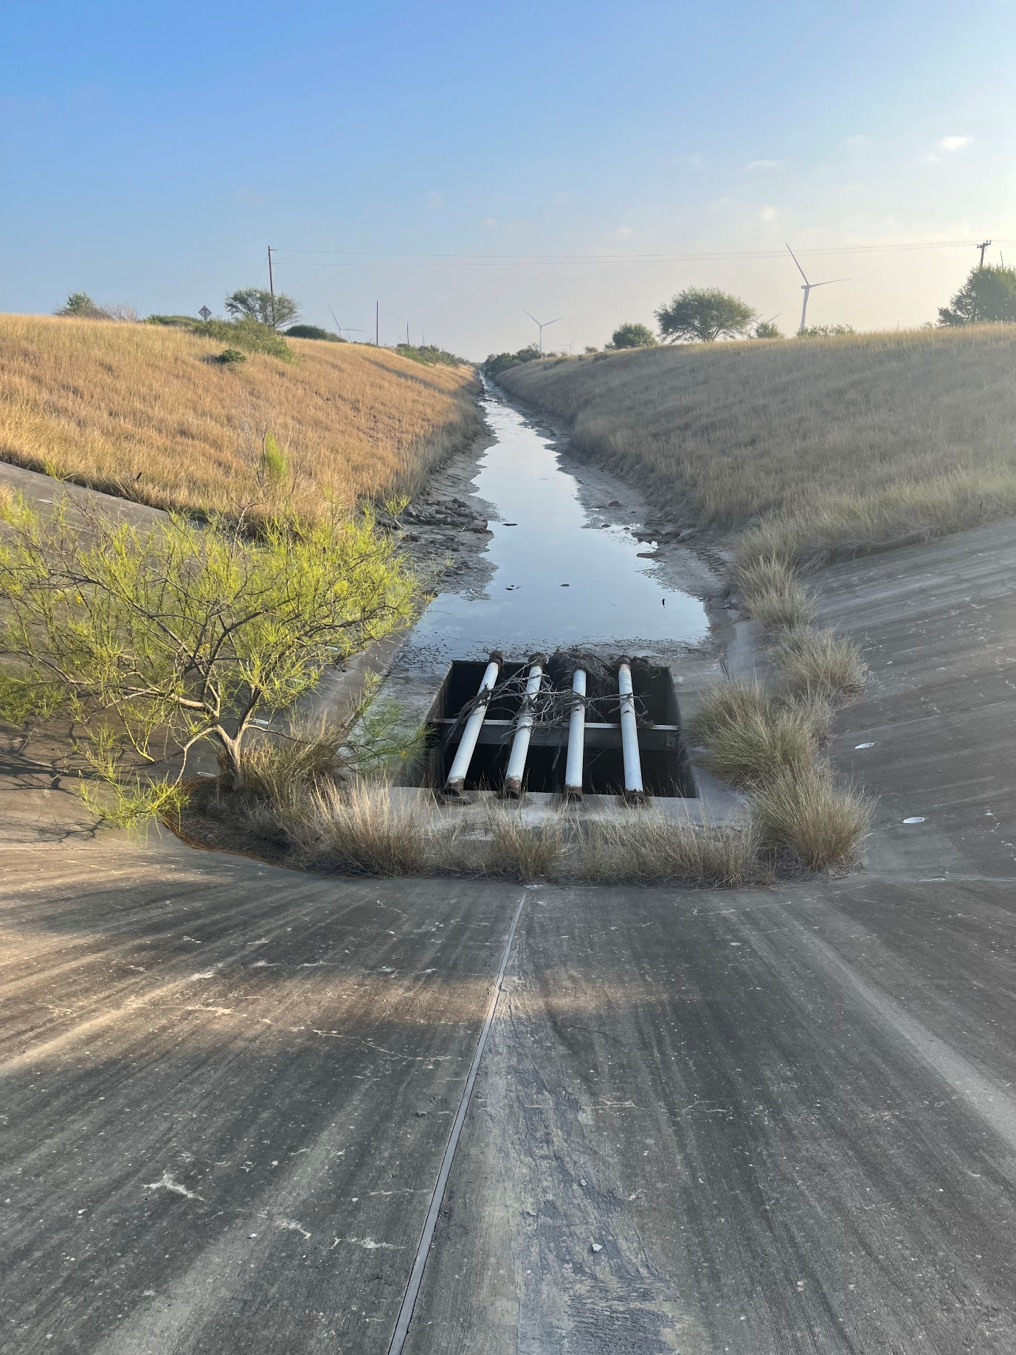
Upstream

Station 21929 – Petronila Tributary @ FM 70 (Cefe #2)

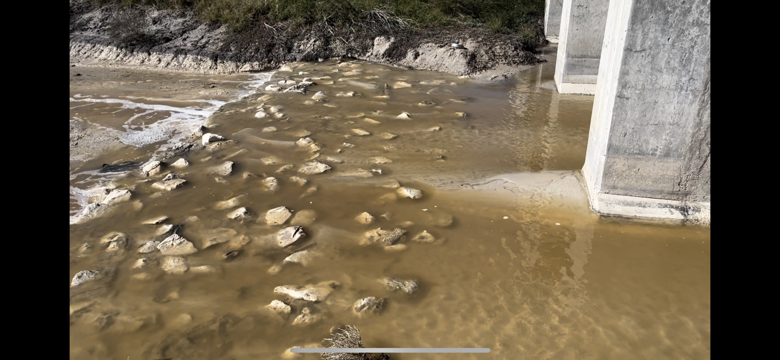
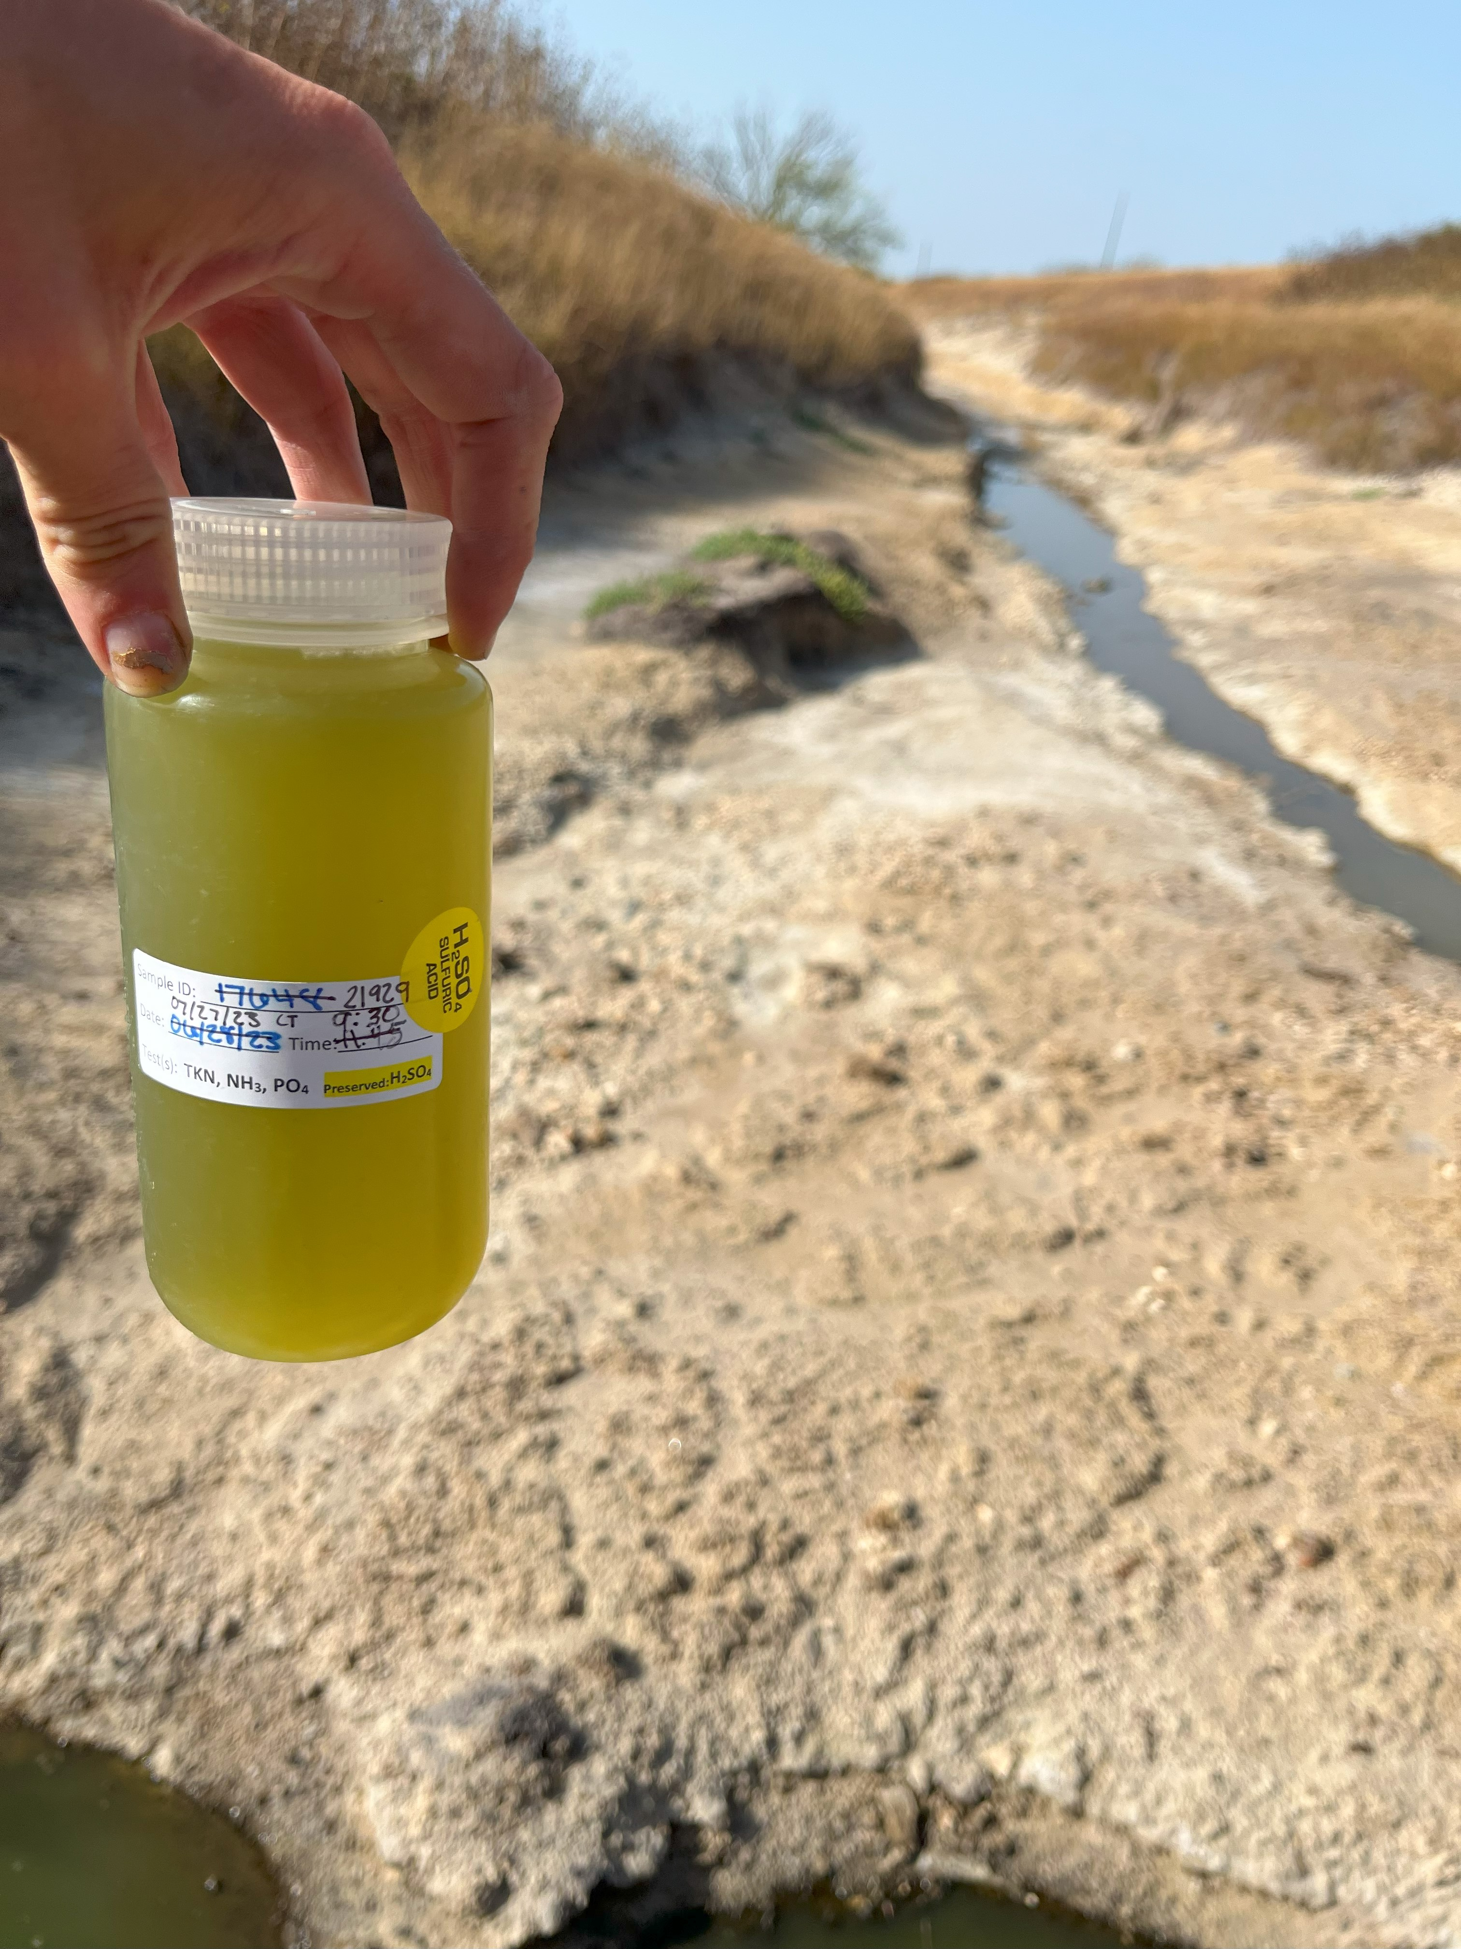
Downstream

Station 13030 – Petronila Tributary @ FM 70

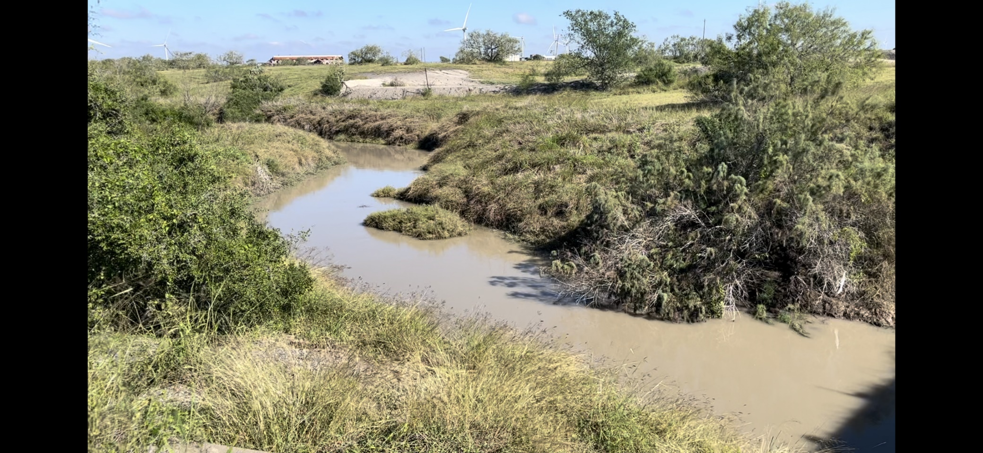
Upstream

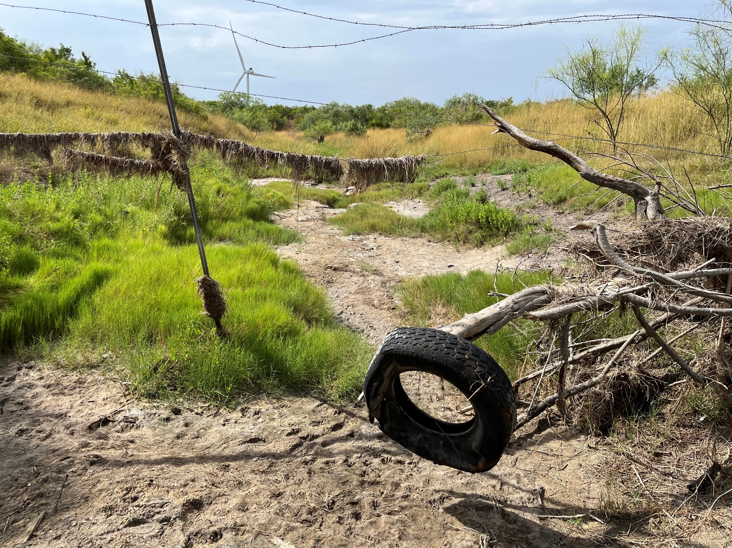
Downstream

Station 13093 – Petronila Creek @ FM 70

Upstream
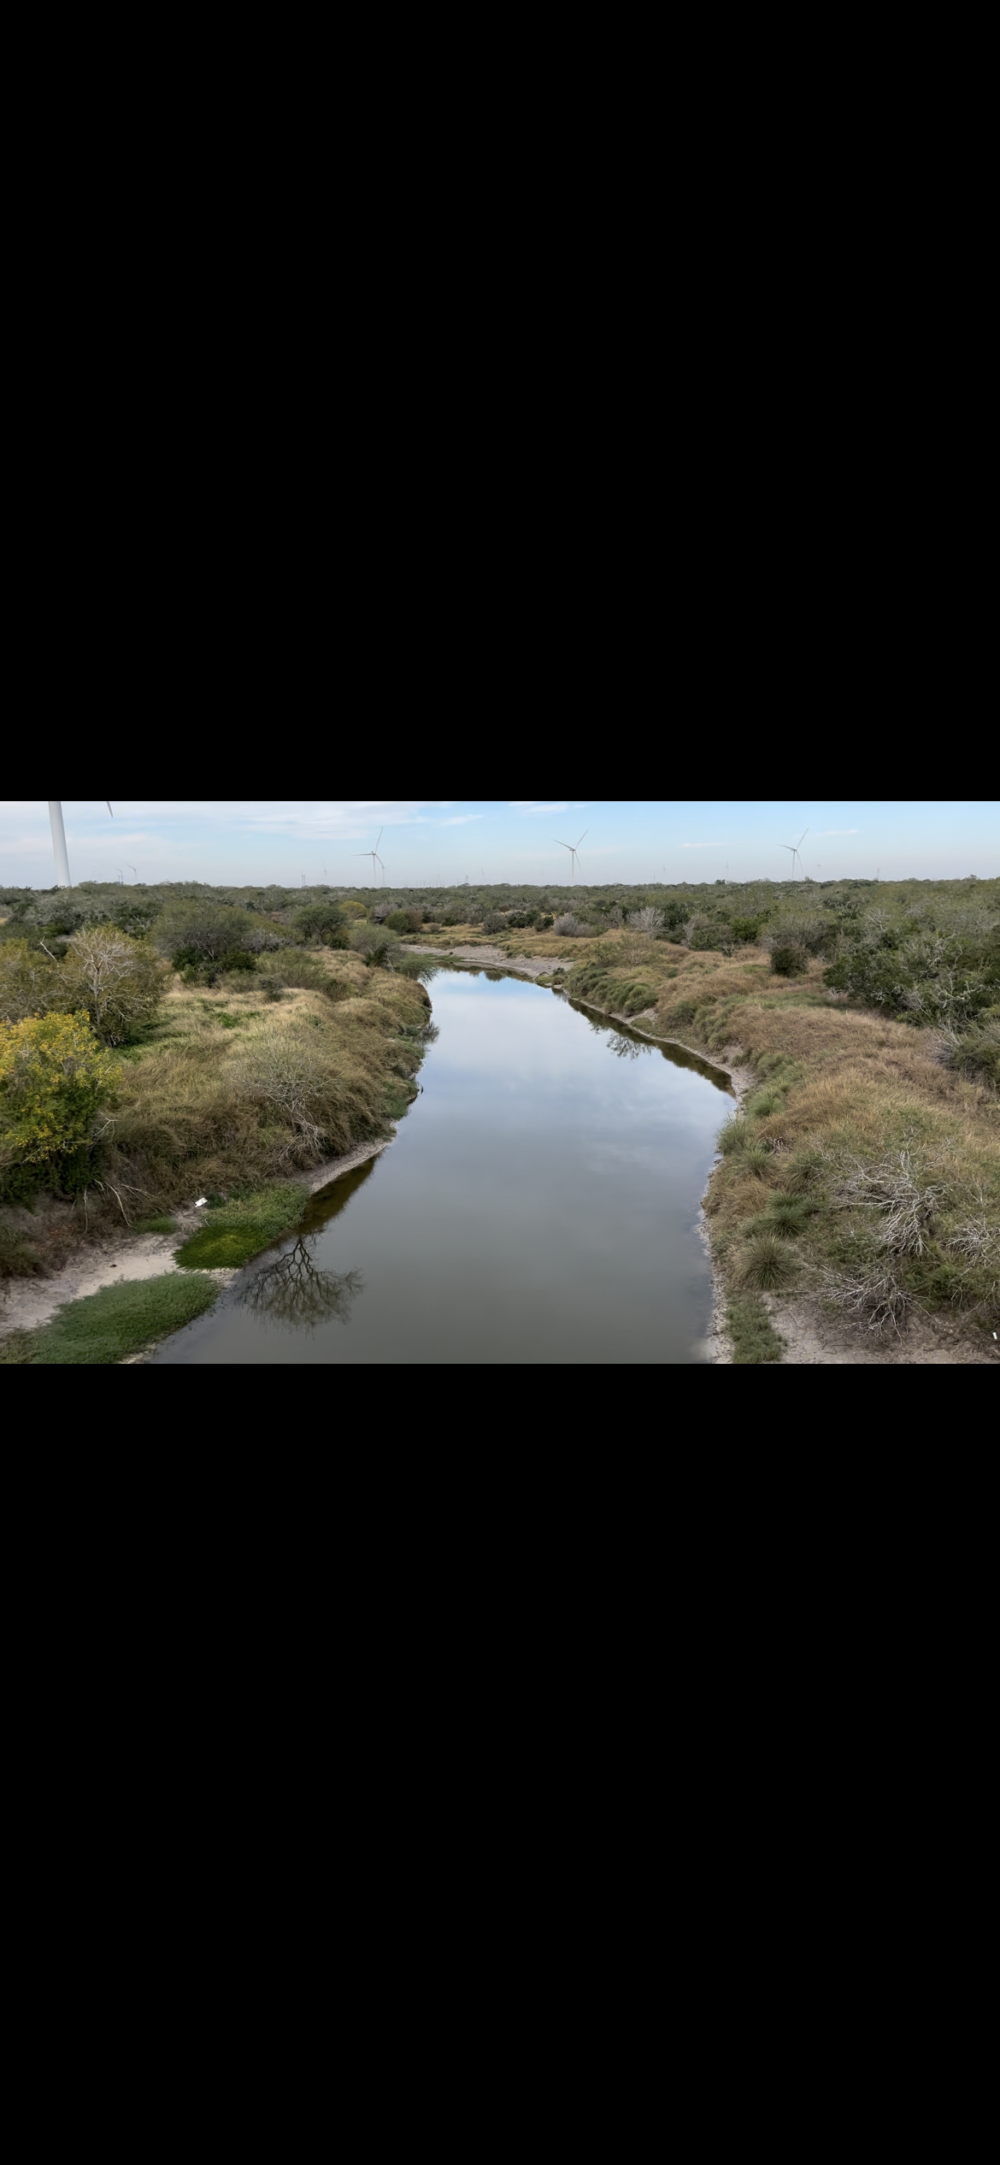

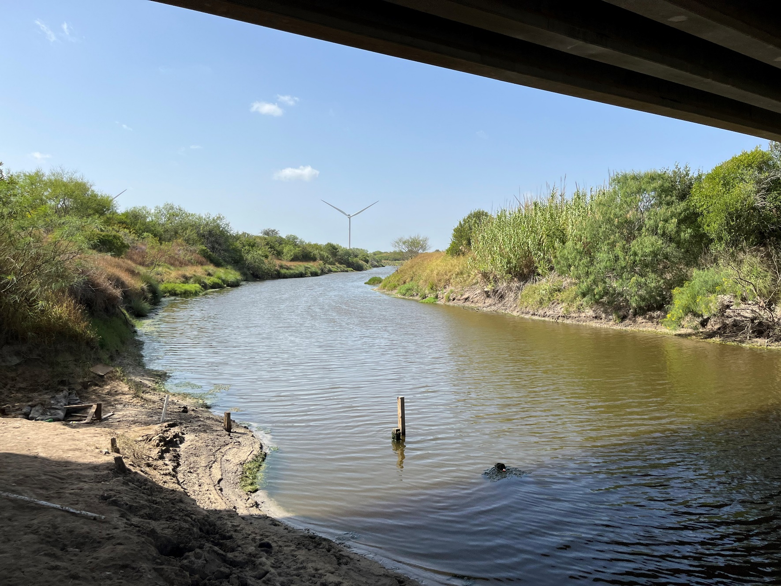
Downstream

Station 21596 – Petronila Tributary @ FM 892

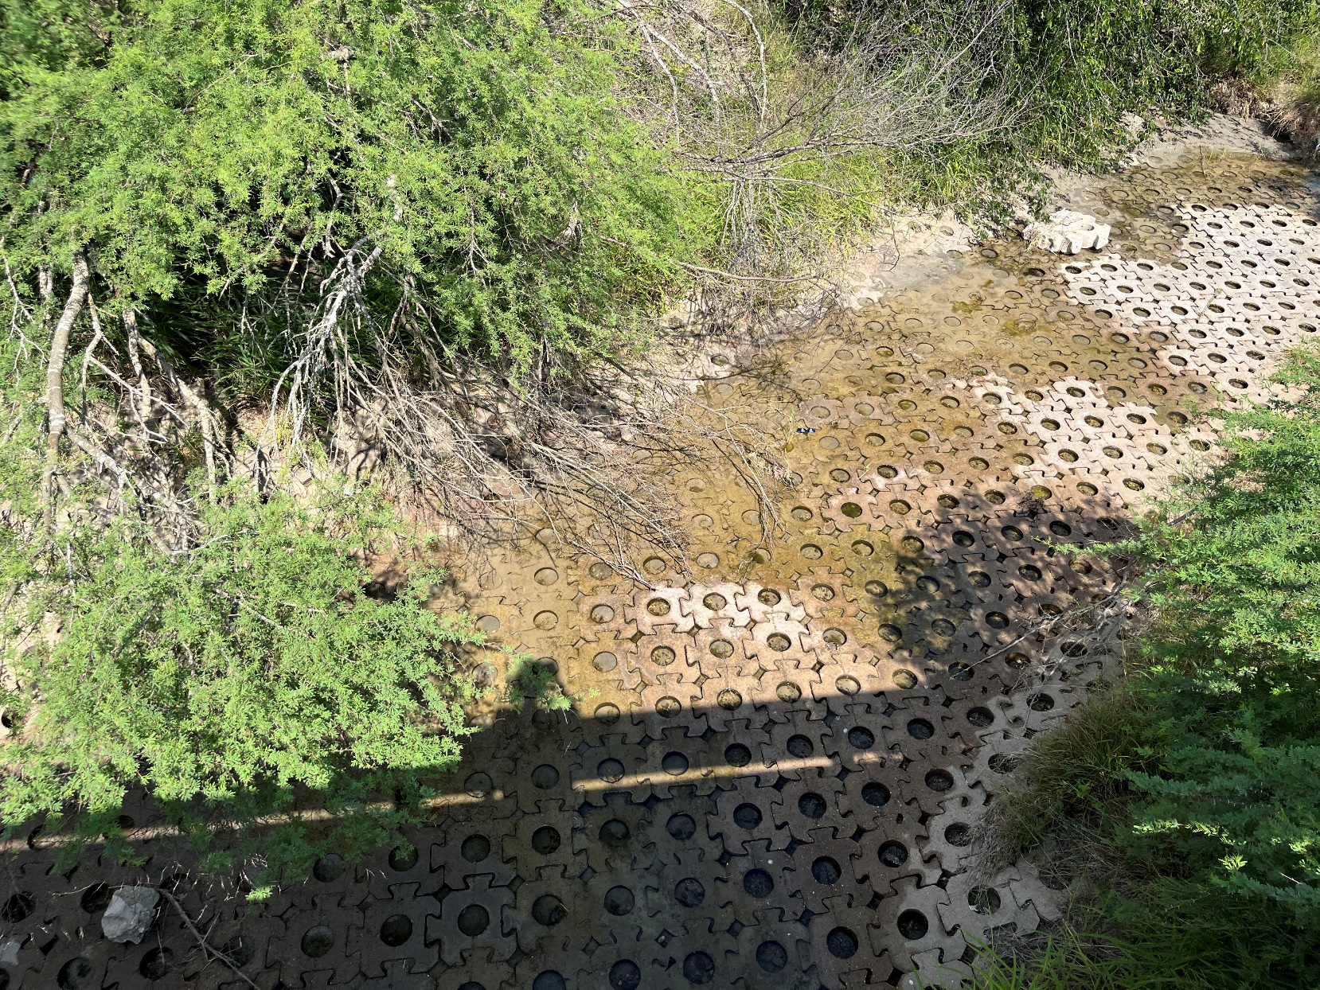
Upstream

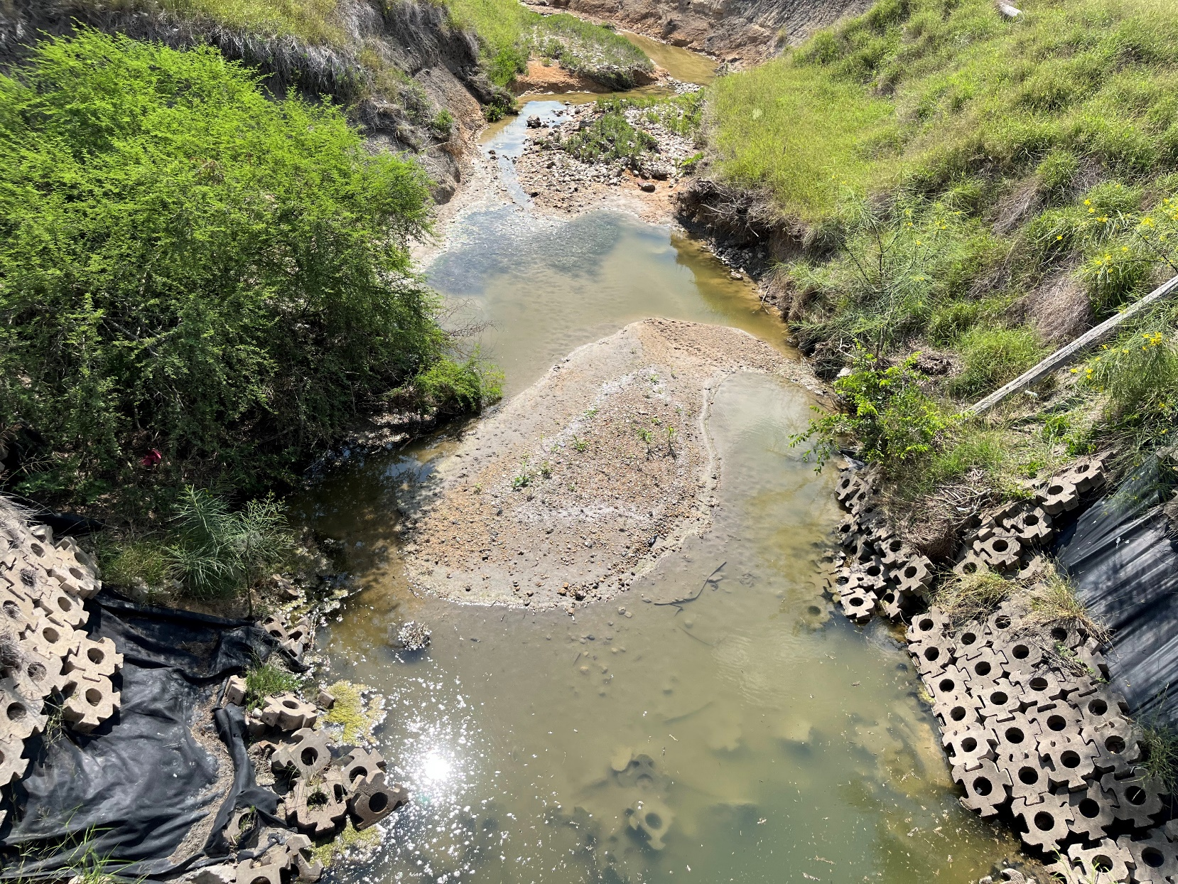
Downstream

Station 18642 – Petronila Tributary @ FM 892
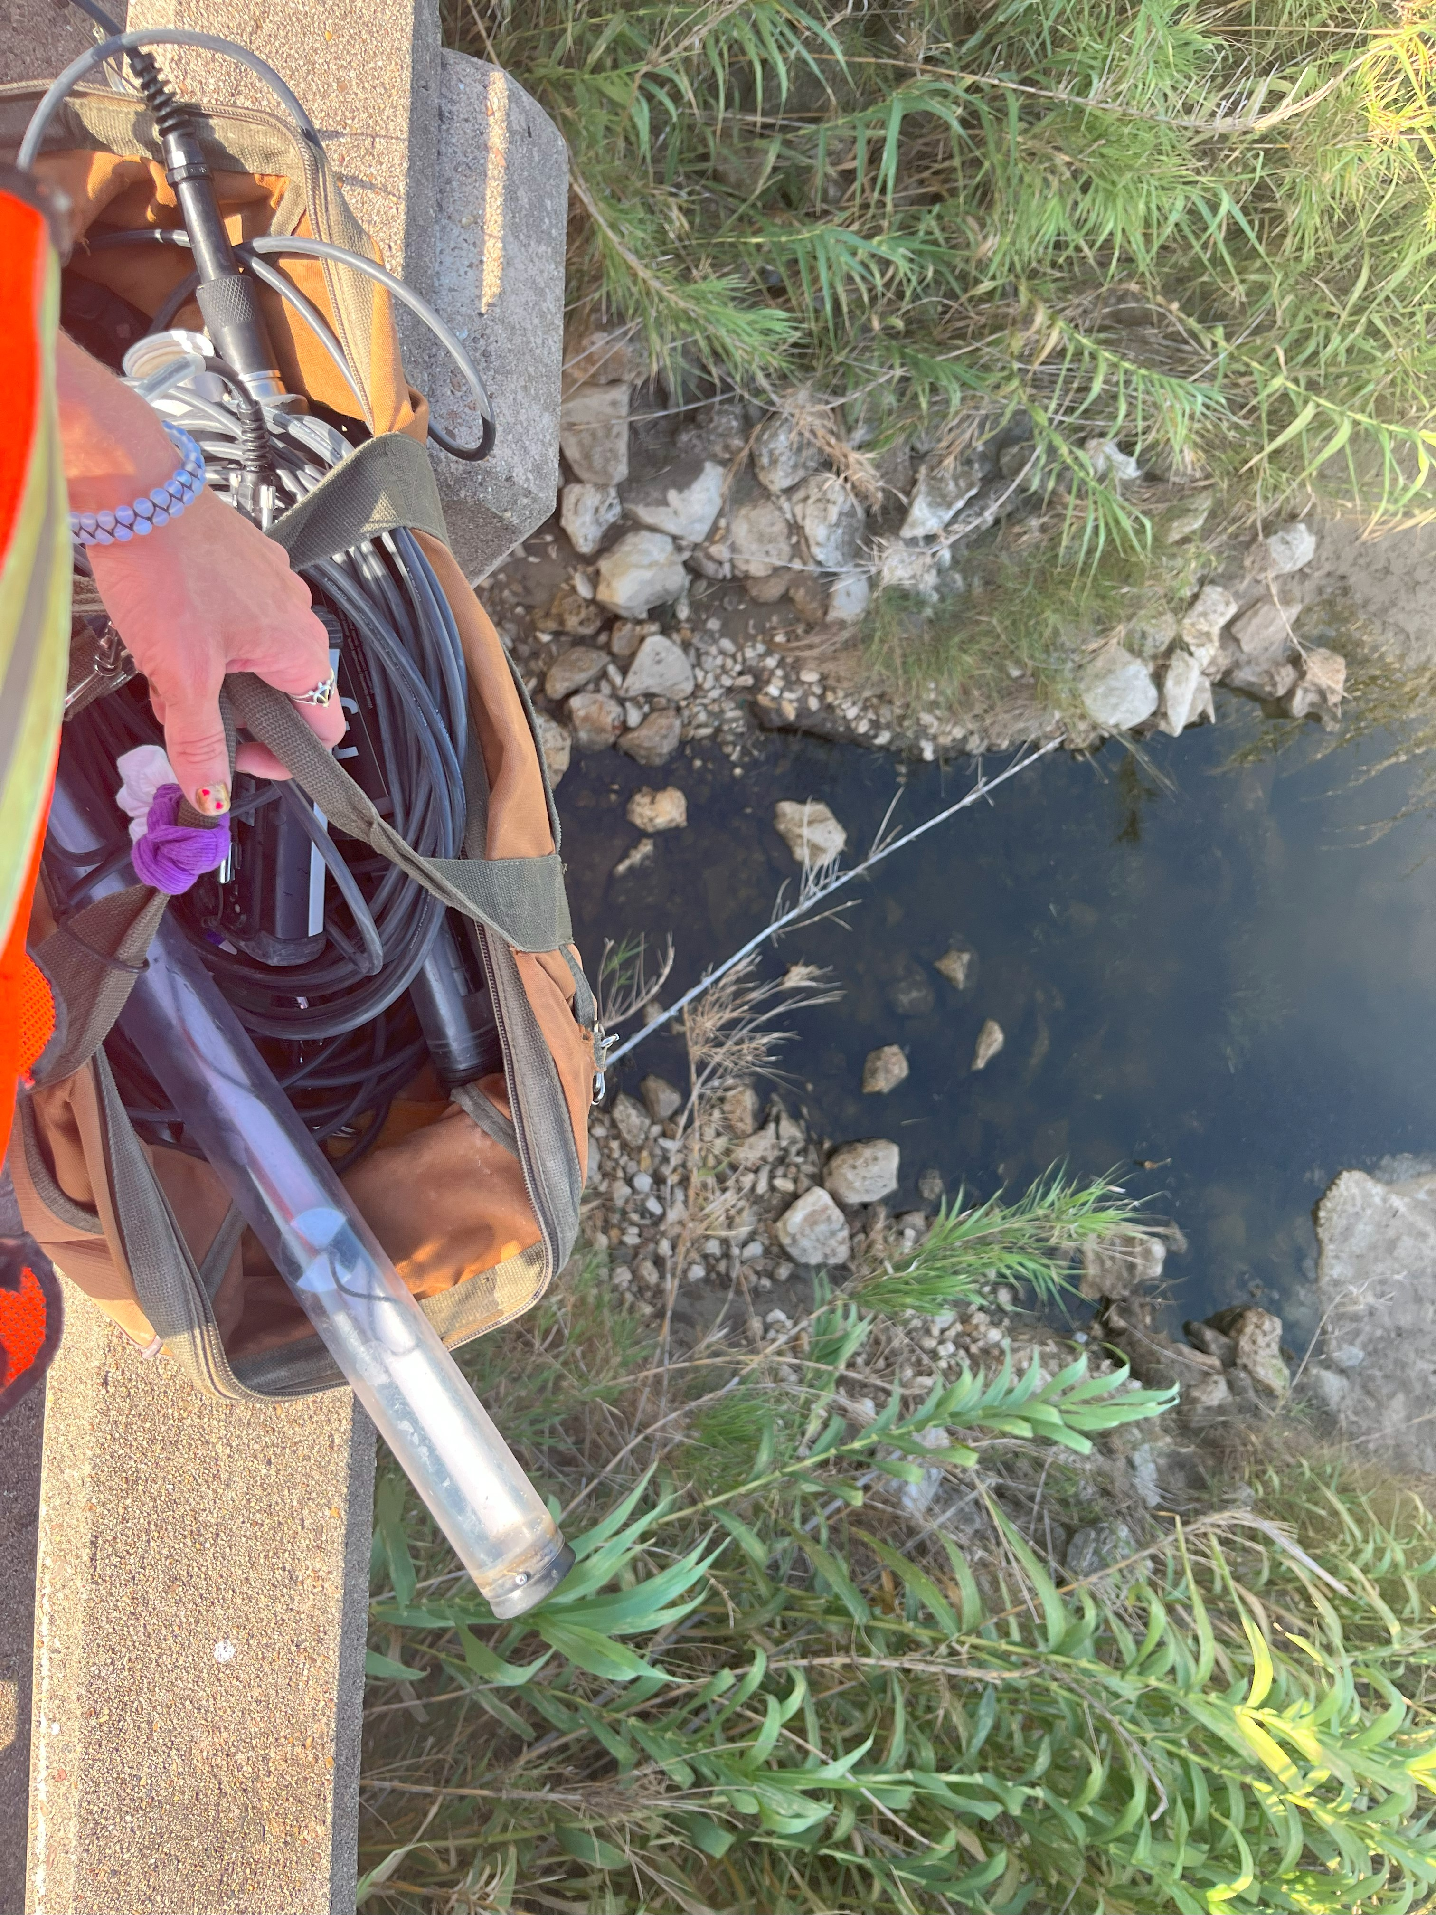
Upstream

Station 13094 – Petronila Creek @ FM 892

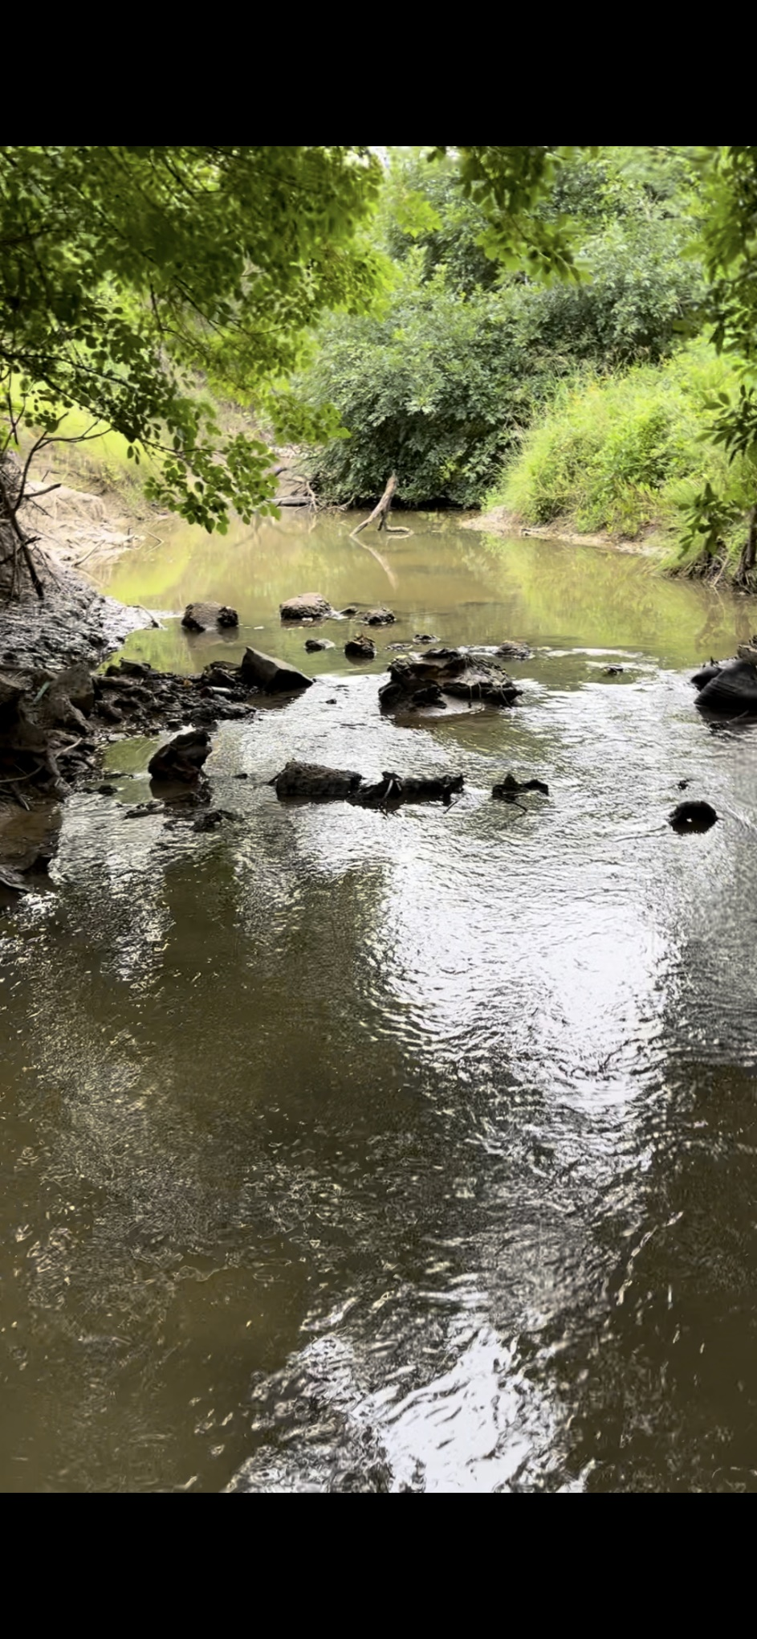
Downstream

Station 21931 – Petronila Tributary @ FM 3354

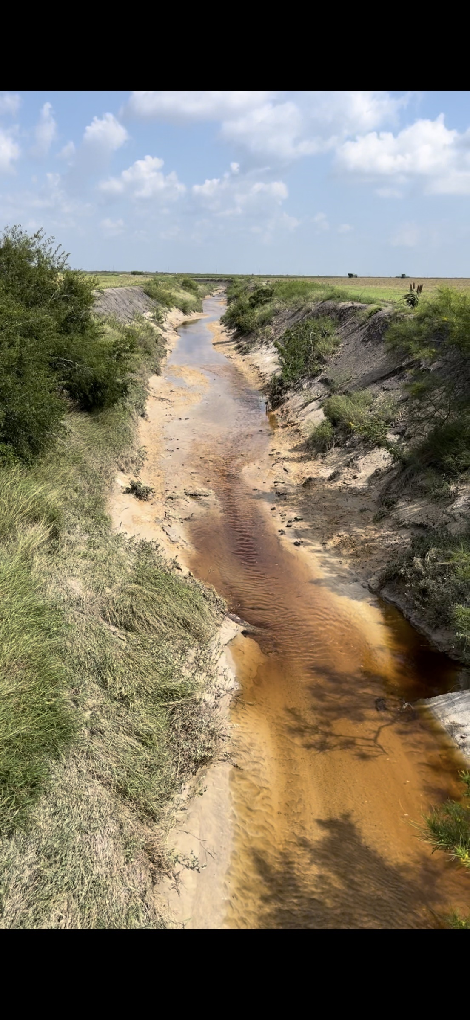
Upstream

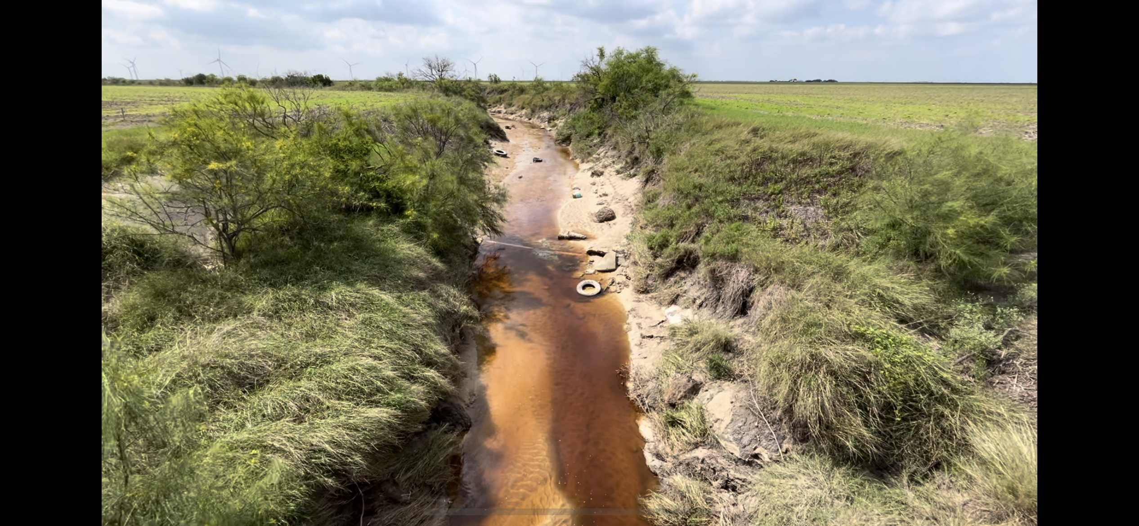
Downstream

Station 13095 - Petronila Creek @ CR 232

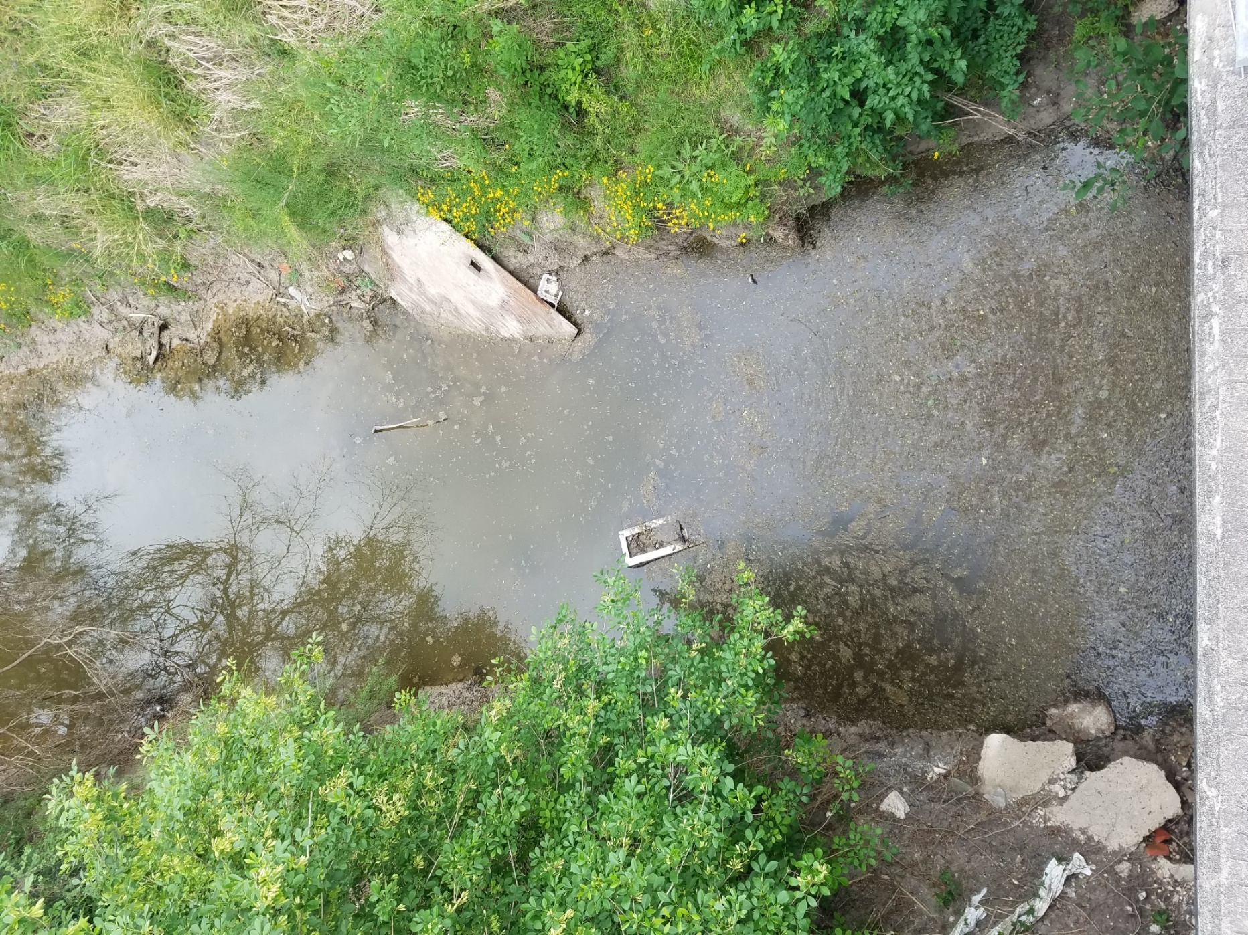
Upstream

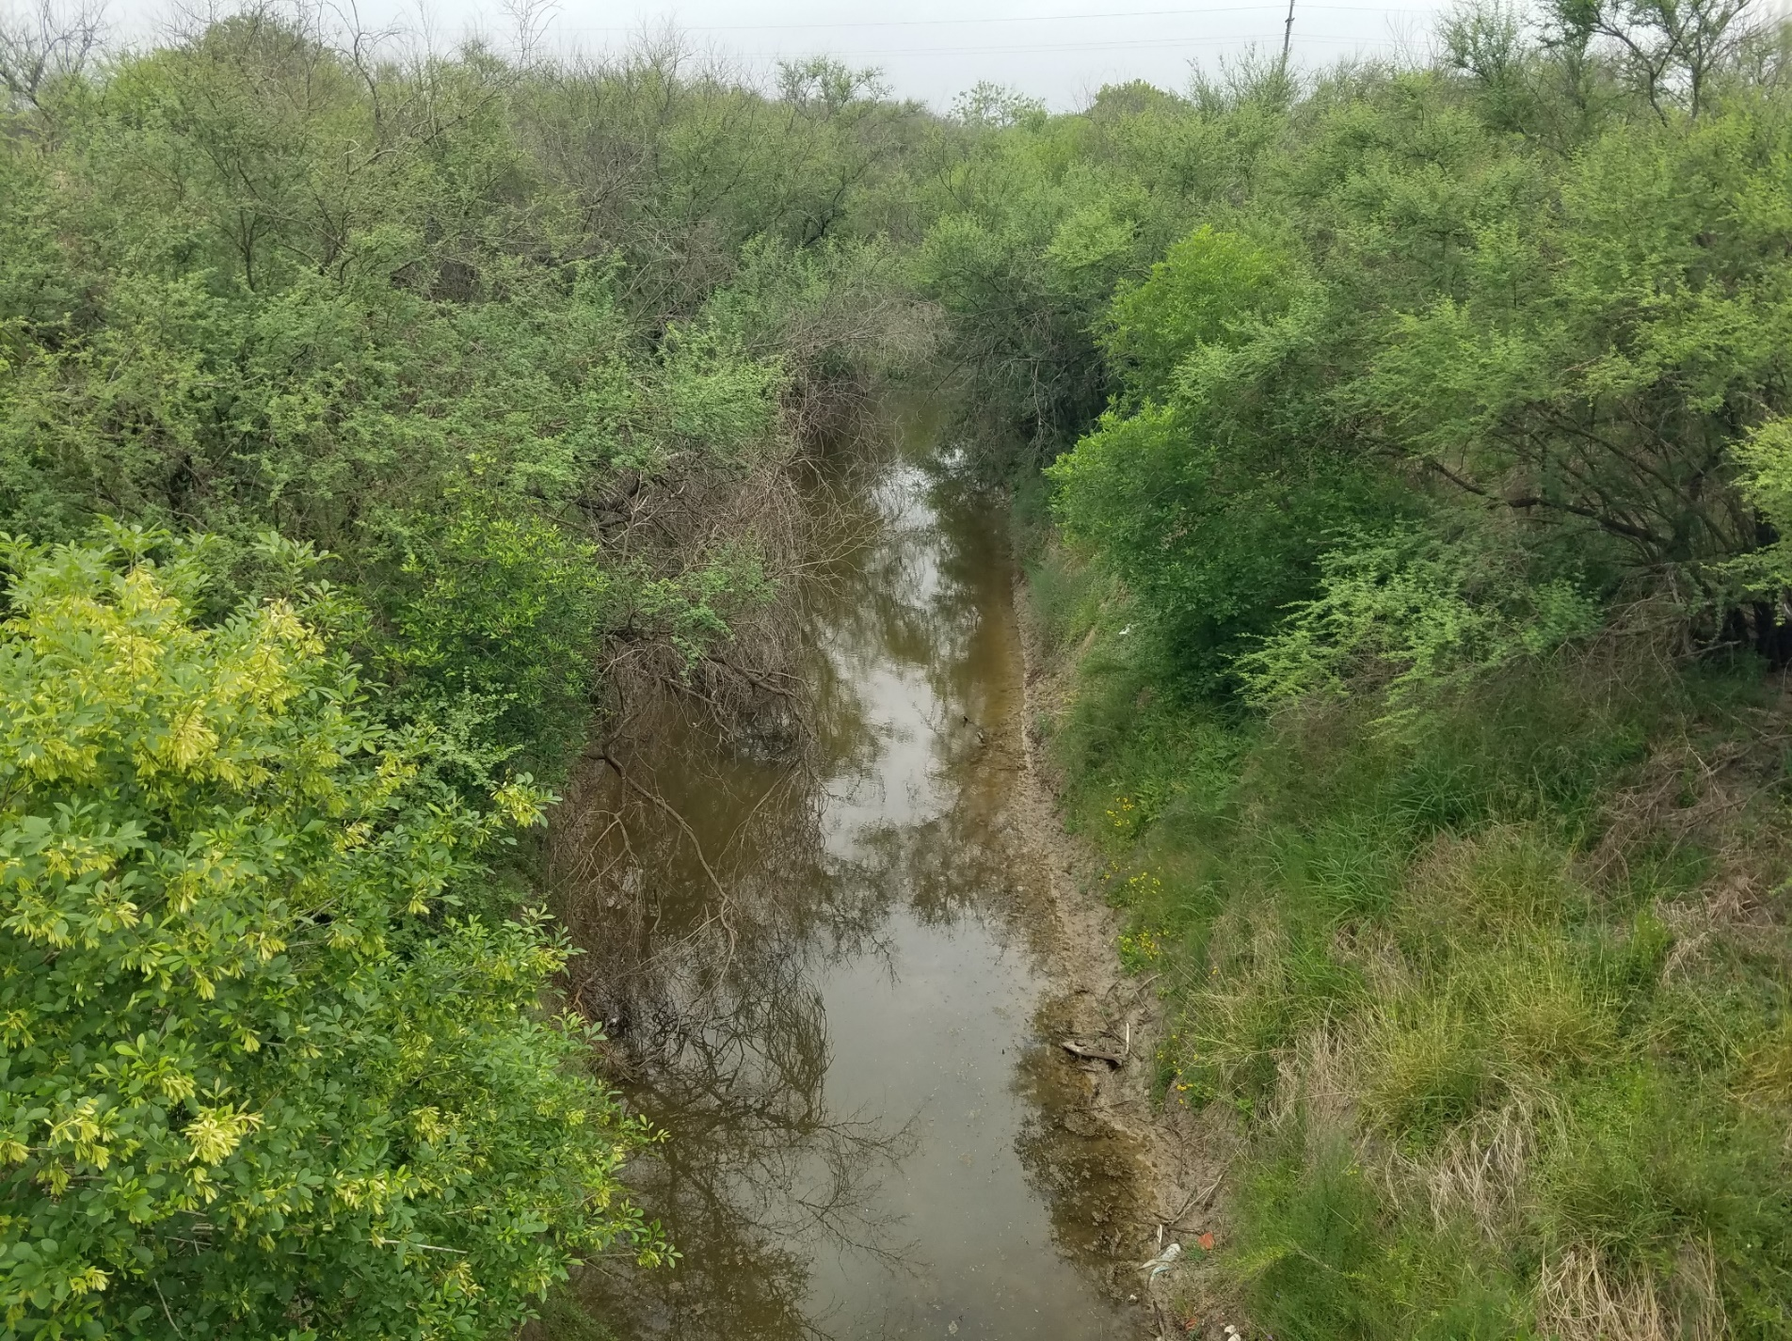
Downstream

Station 13032 – Petronila Tributary @ CR 18 & CR 75

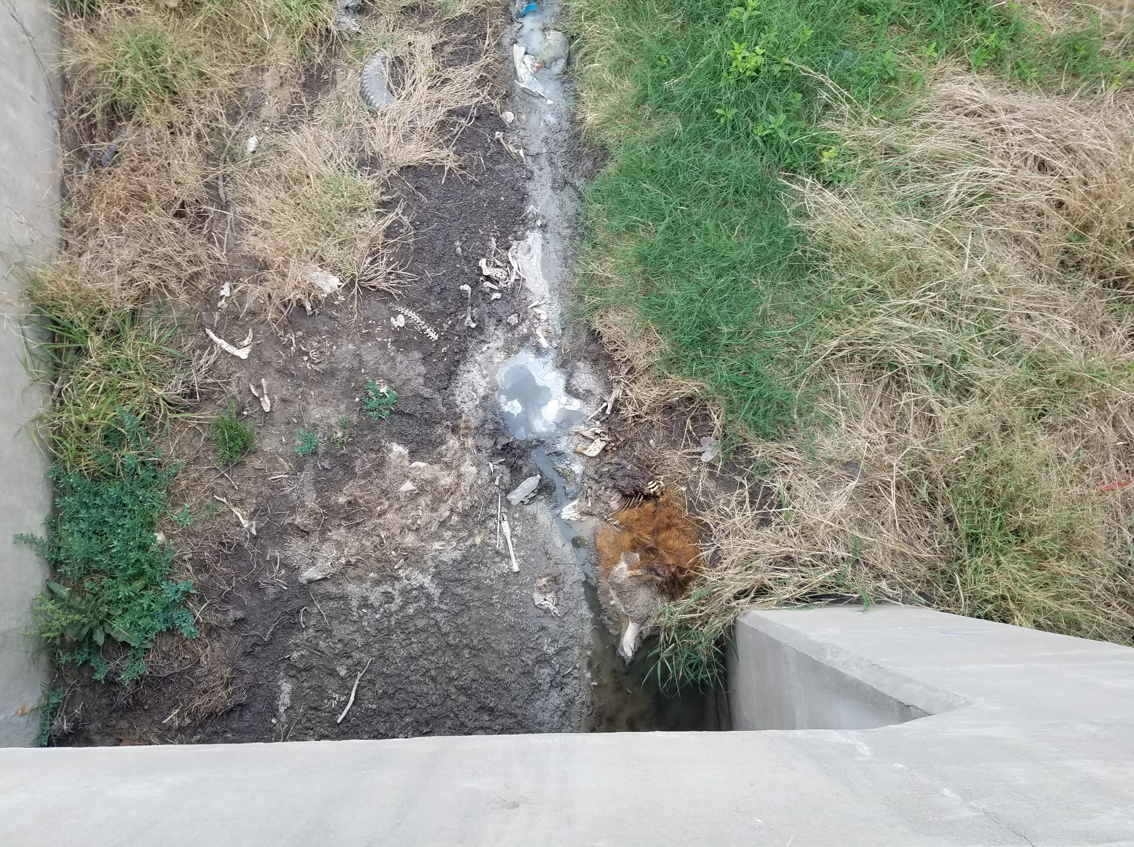
Downstream

Station 13096 – Petronila Creek @ FM 665

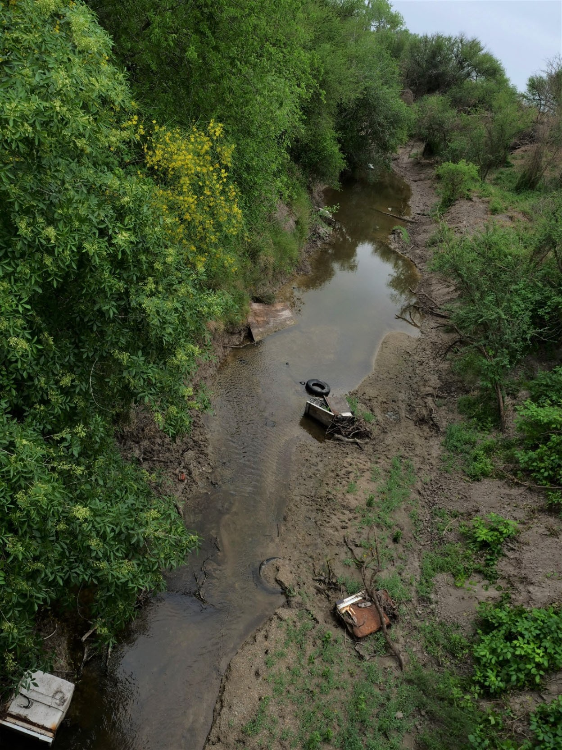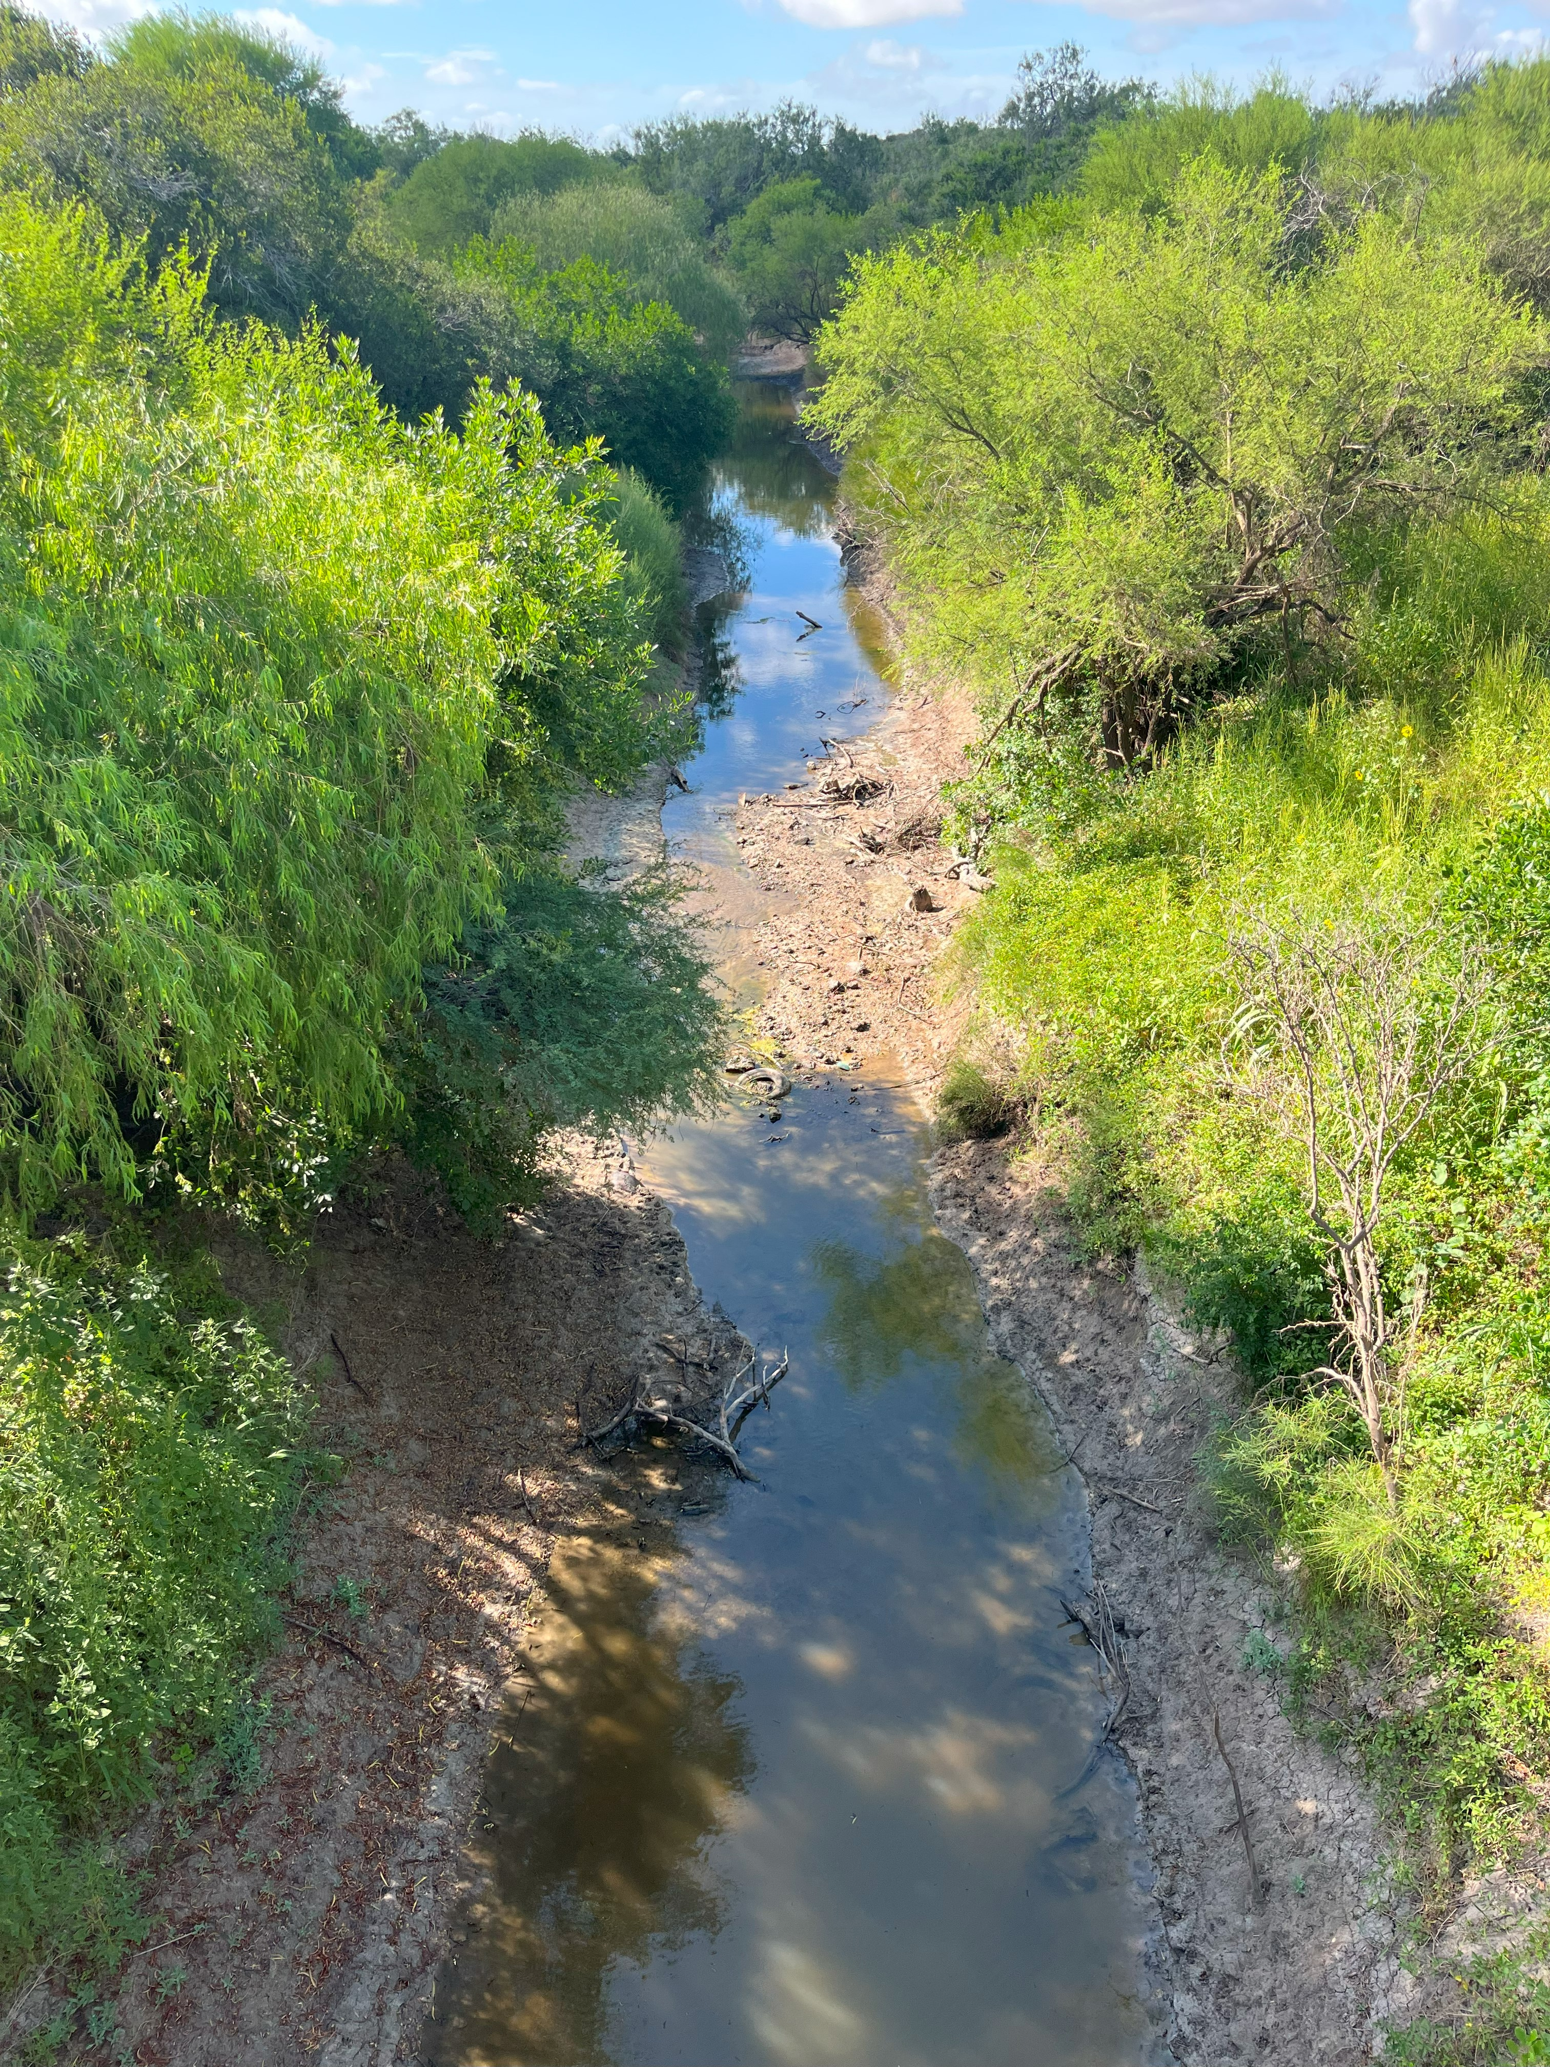
Upstream
Upstream

Station 18484 – Petronila Tributary @ CR 24
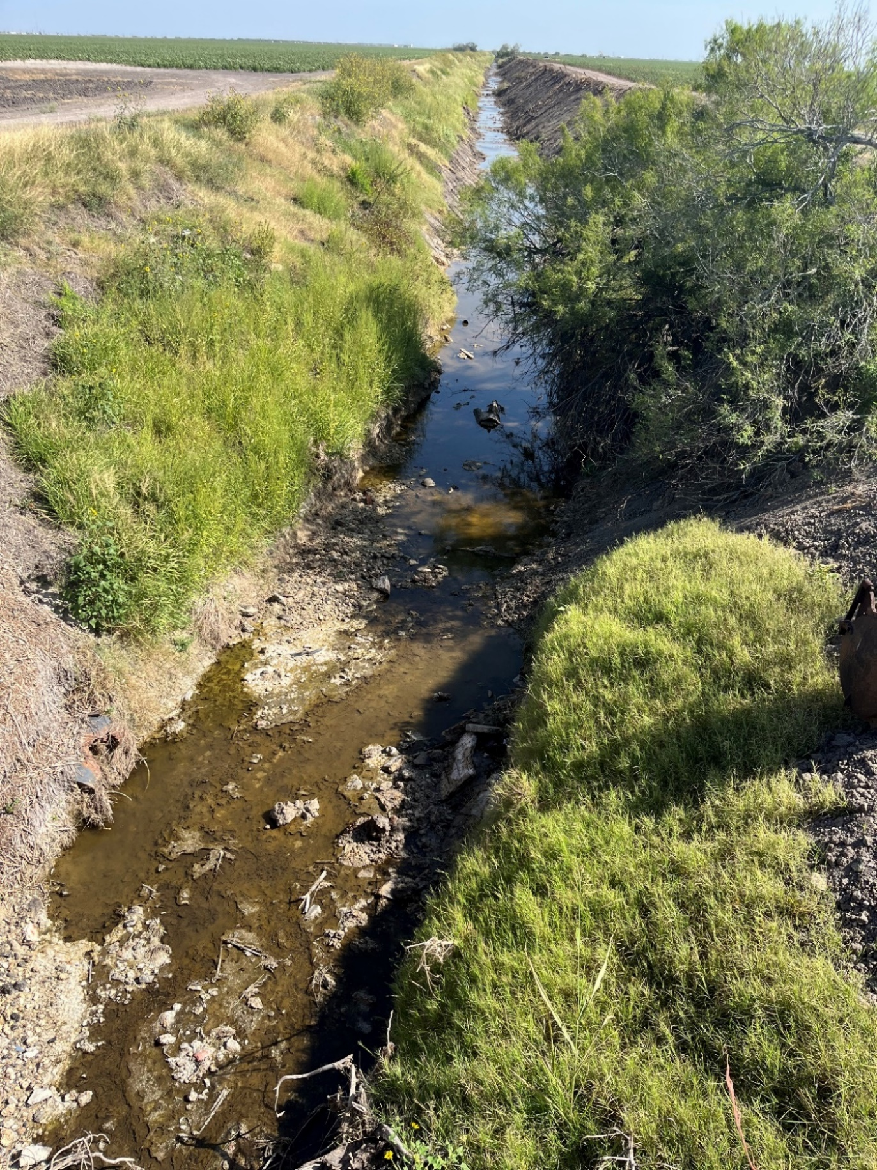
Upstream
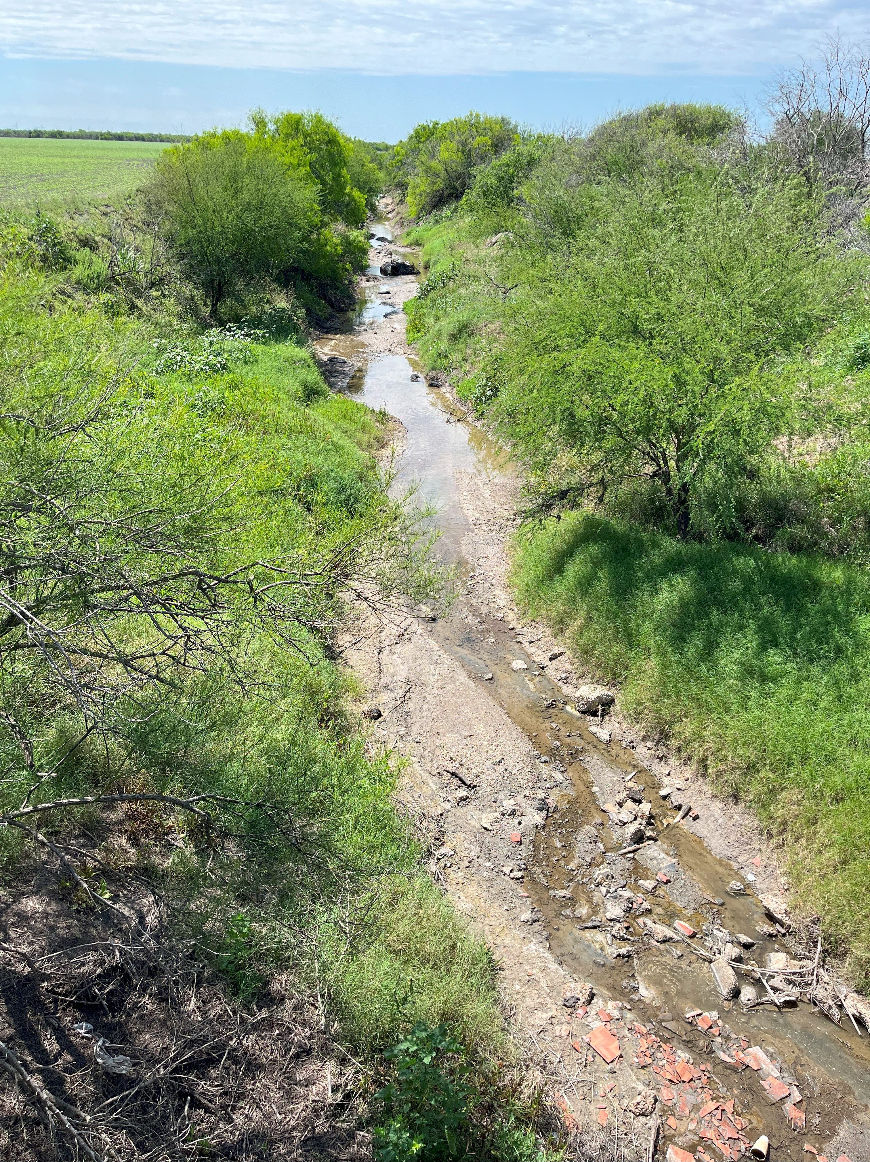
Downstream

Station 21594 – Petronila Tributary @ CR 233
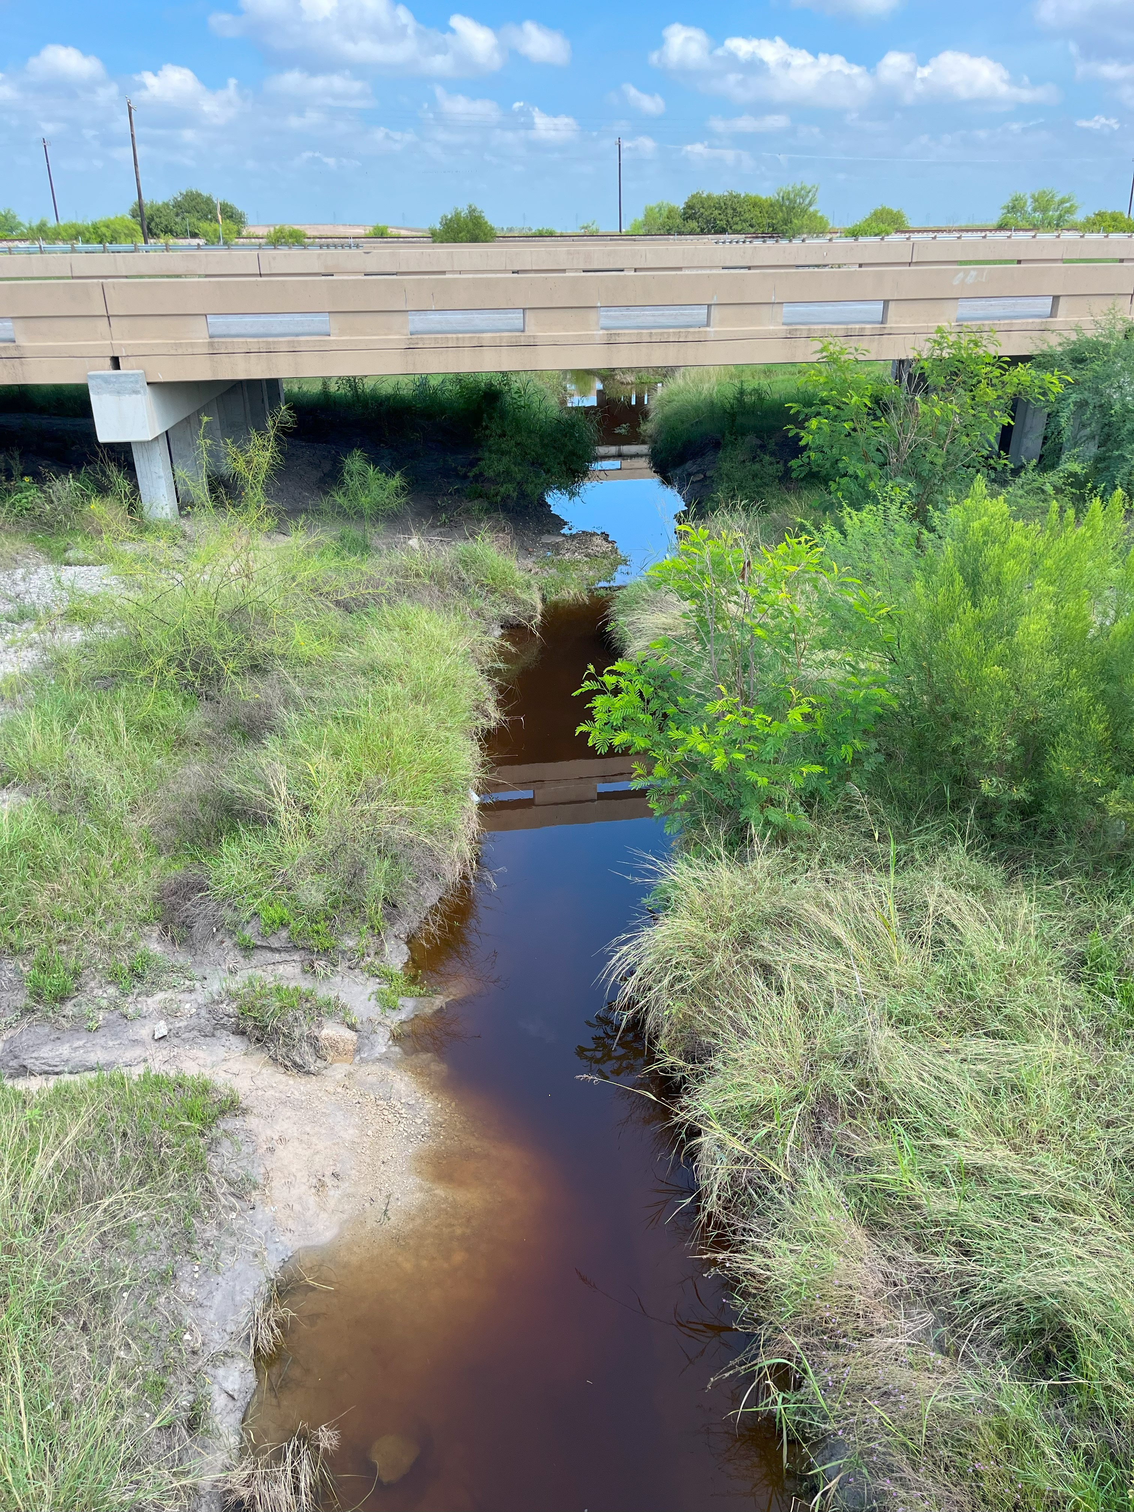

Upstream
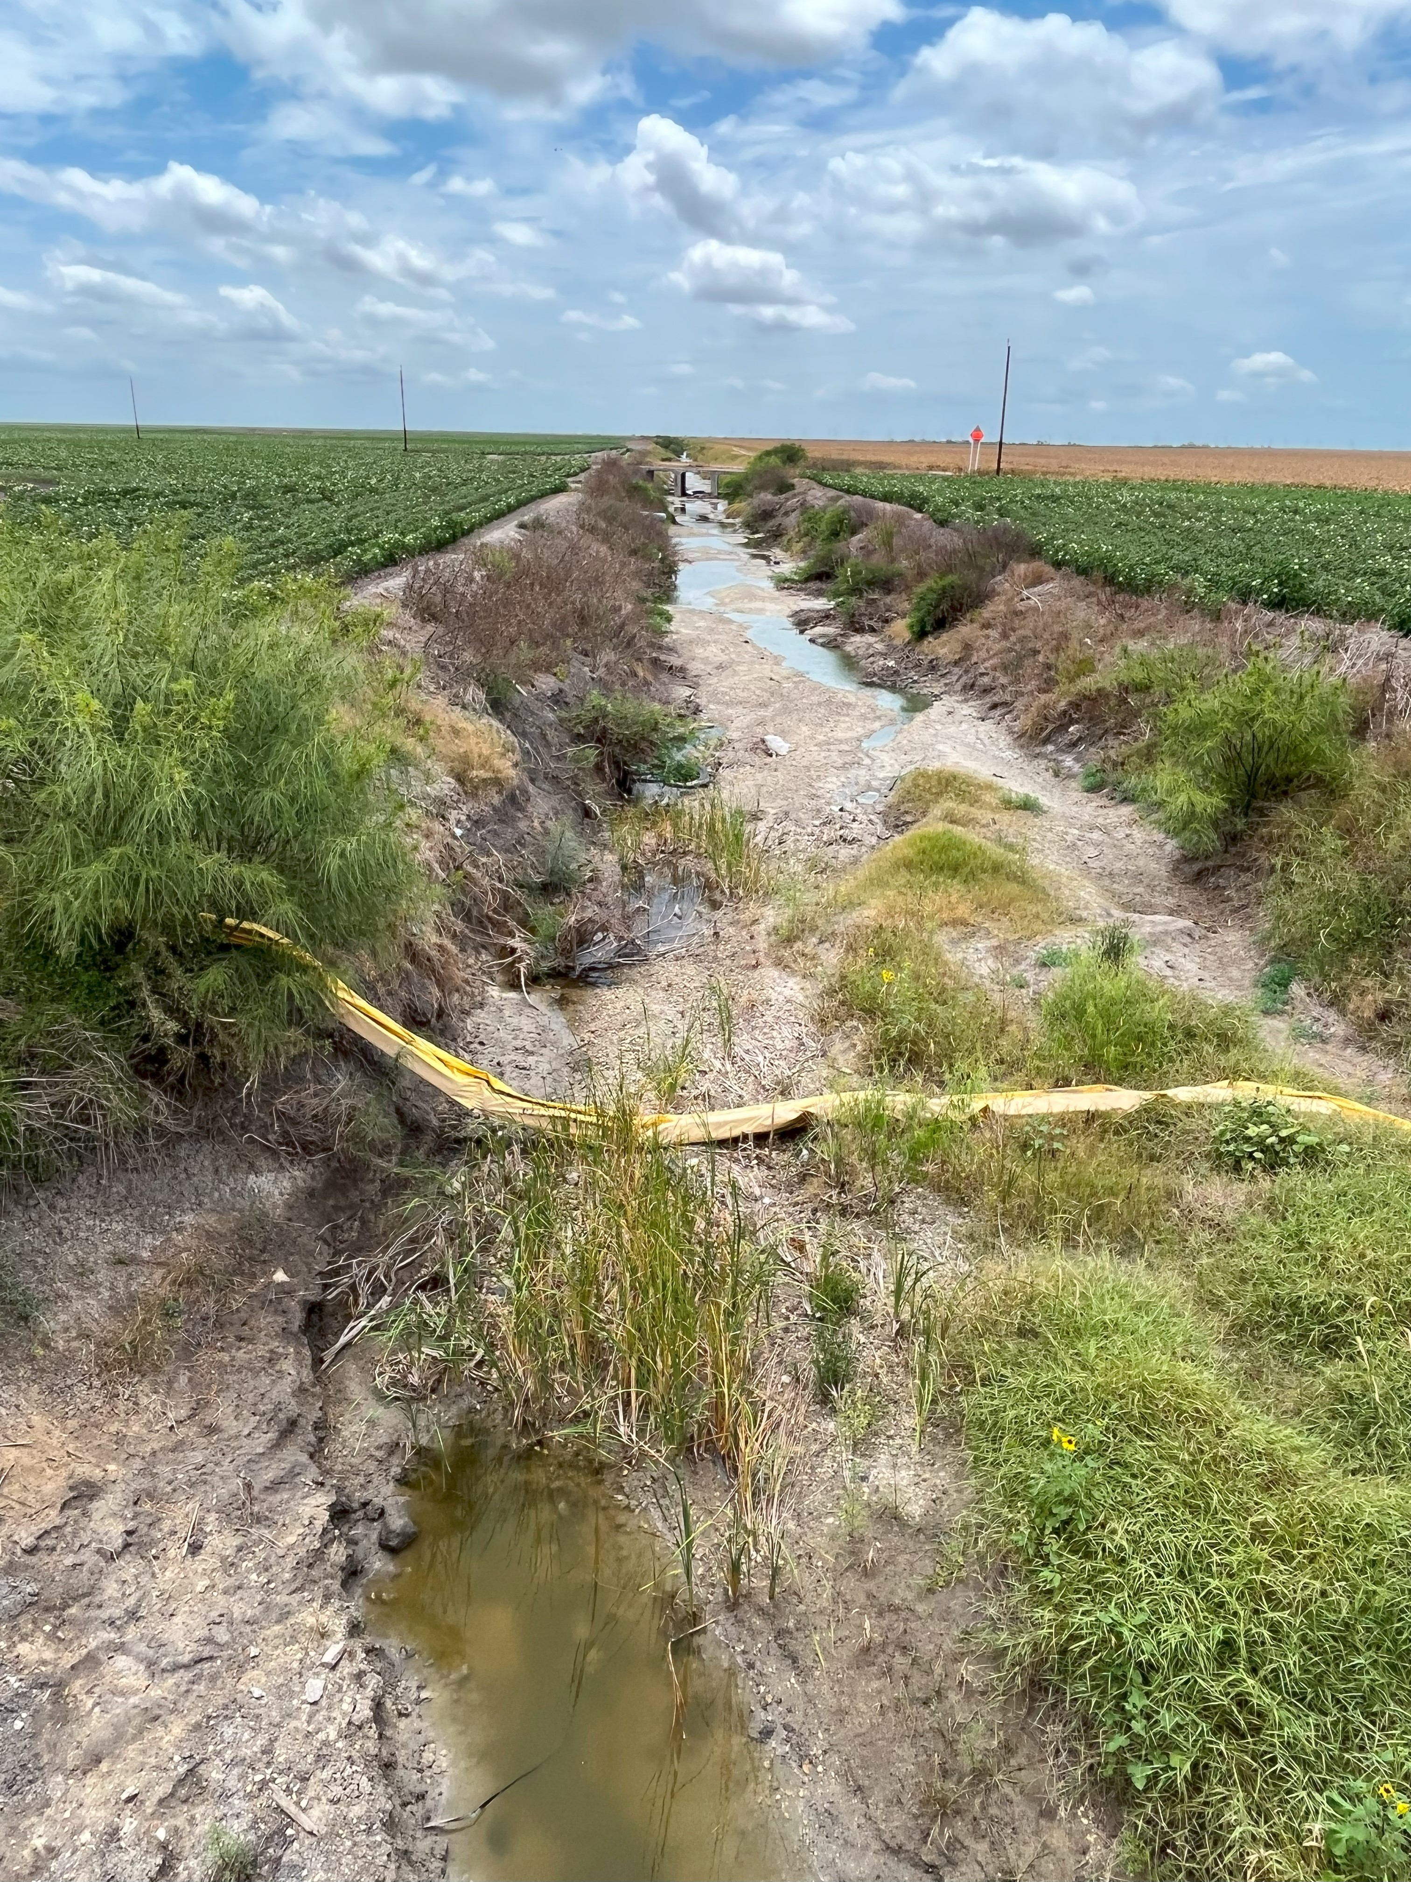
Downstream

Appendix B: Wastewater Discharge Permits

WQ0002888-000 – US Ecology Texas: storm water via Nueces County drainage ditch

WQ0010140-001 – City of Agua Dulce: 160,000 gpd via Agua Dulce Creek

WQ0010592-001 – City of Orange Grove: 200,000 gpd via Agua Dulce Creek

WQ0011541-001 – City of Driscoll: 100,000 gpd

WQ0011583-002 – Nueces County WCID #5: 8,000,000 gpd via Banquete Creek

WQ0011754-001 – Bishop Consolidated ISD: 8,000 gpd via drainage ditch

WQ0014802-001 – Geo Group: 150,000 gpd via drainage ditch

WQ0014981-002 – KB Foundation of Texas: 9,000 gpd

Please note that gpd = gallons per day

